**ELECTROMAGNETIC INDUCTION**

## **Exercises**

**Sections 27.2 Faraday’s Law and 27.3 Induction and Energy**

**12. Interpret** In this problem we are asked to verify that the SI unit of the rate of change of magnetic flux is volt.

**Develop** We first note that the left-hand-side of Equation 27.2, 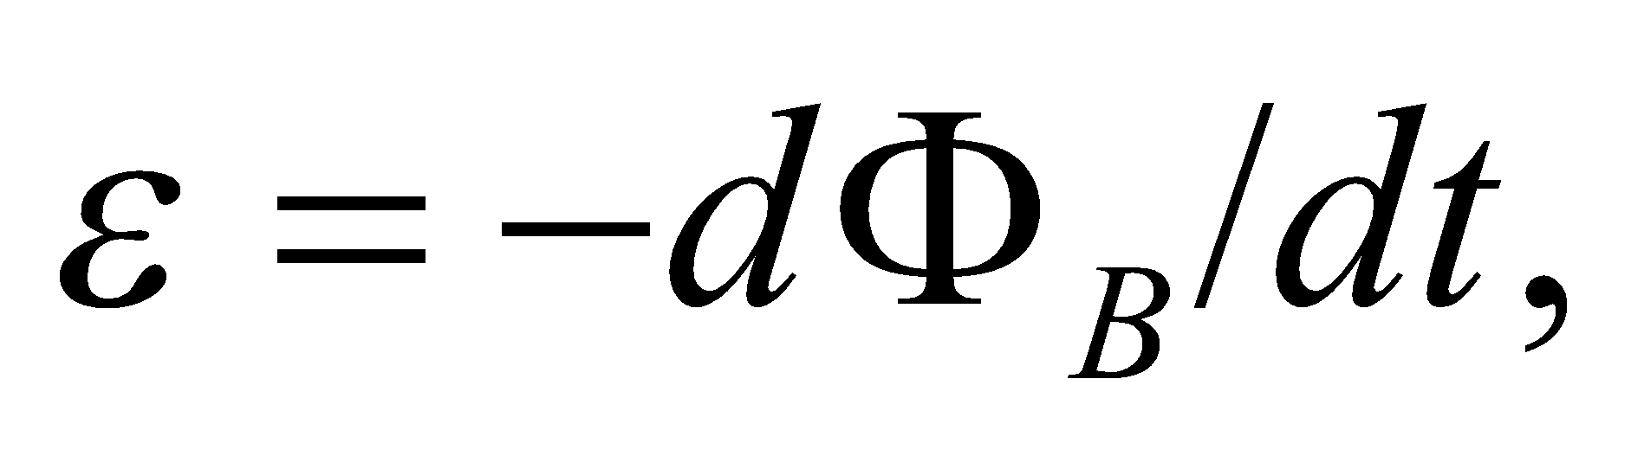 represents the induced emf which has units of volt. From the definition of magnetic flux given in Equation 27.1a, we see that it has SI units of 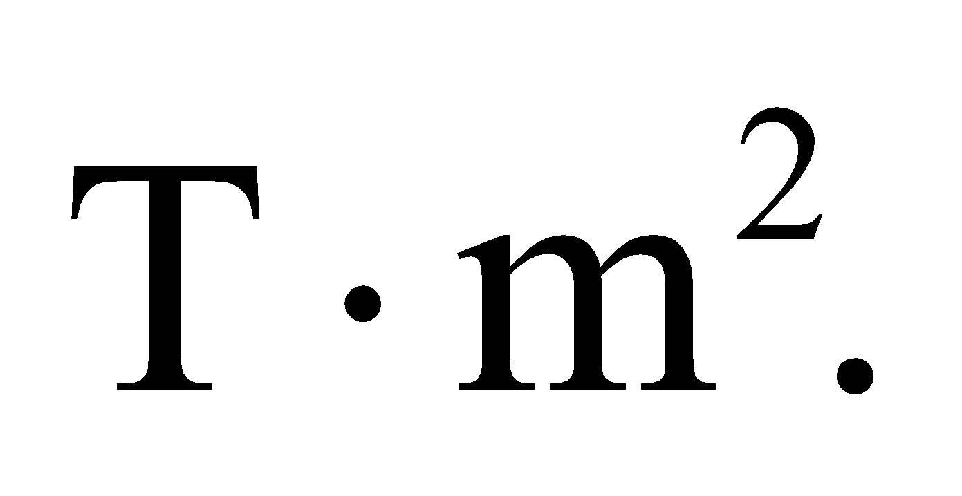

**Evaluate** The reasoning above shows that the units of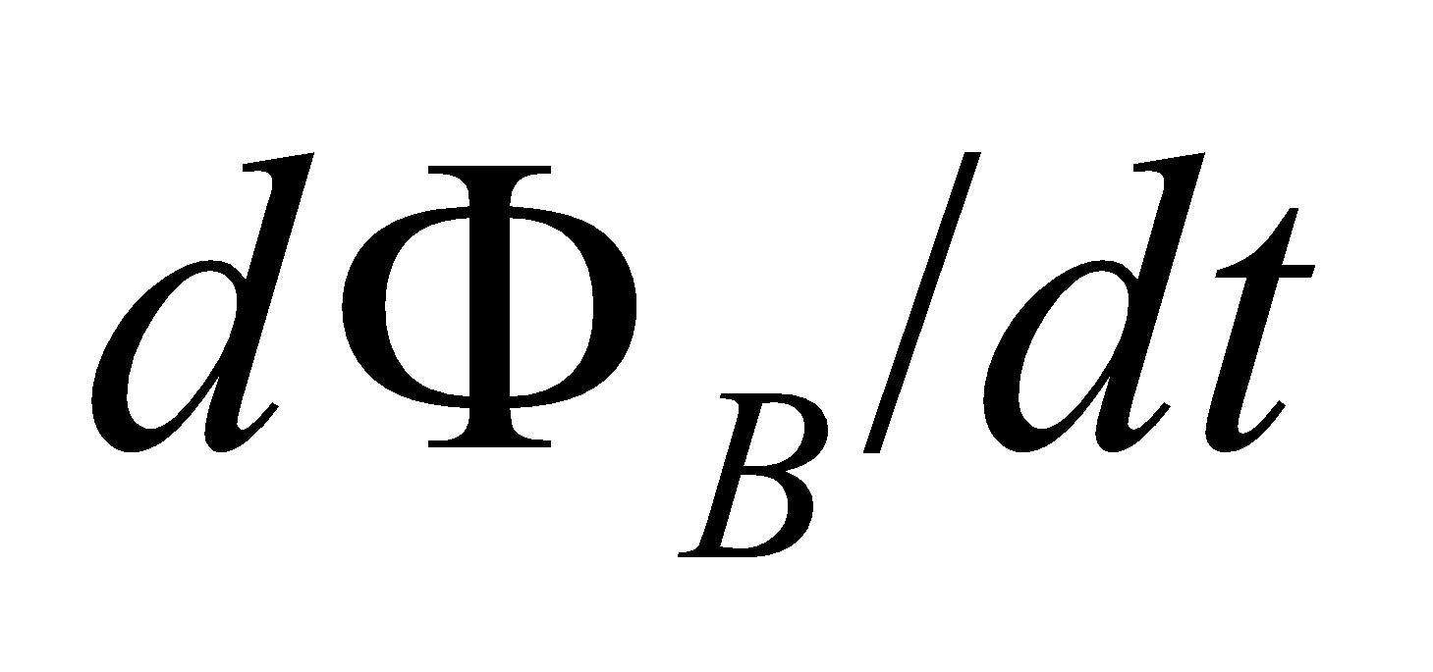are



**Assess** Faraday’s law relates the induced emf to the change in flux. It is the rate of change of flux, and not the flux or the magnetic field that gives rise to an induced emf.

**13. Interpret** Given a constant magnetic field, we are to find the magnetic flux that passes through the given loop.

**Develop**  For a stationary plane loop in a uniform magnetic field, the integral for the flux in Equation 27.1a is just 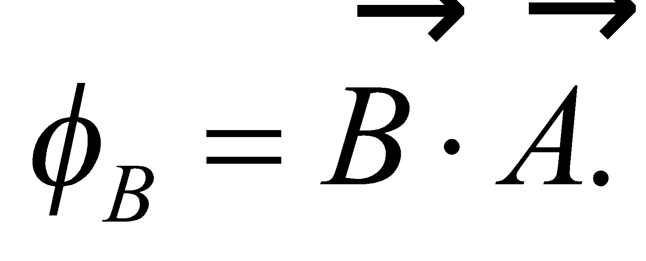

**Evaluate** Evaluating the dot product gives



**Assess** The SI unit of flux,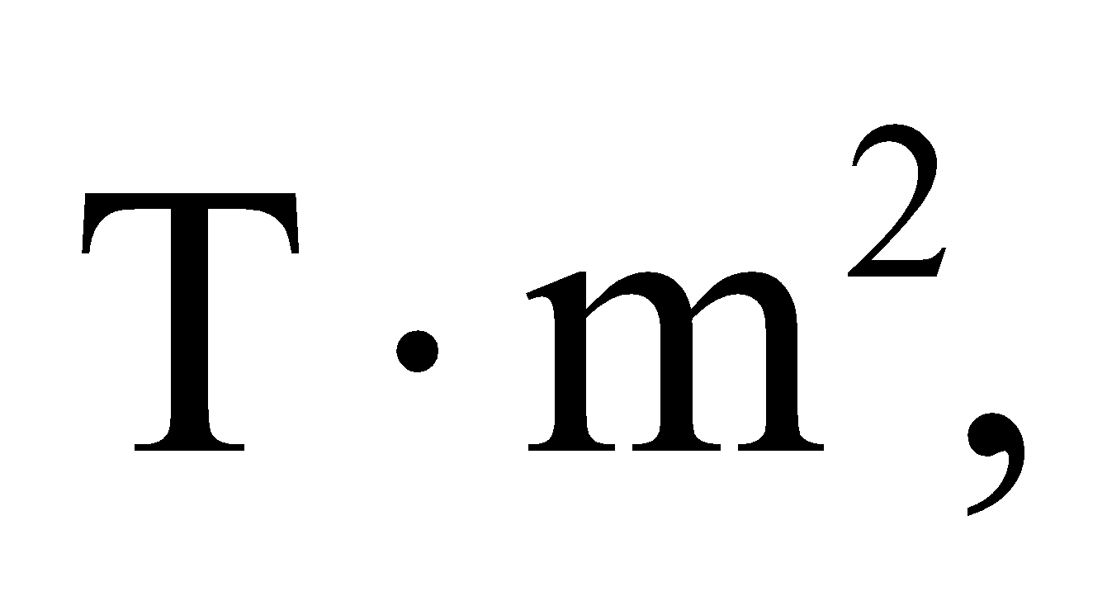is also called a weber (Wb).

**14. Interpret** This problem is about the rate of change of magnetic flux through a loop due to a changing magnetic field.

**Develop** For a stationary plane loop in a uniform magnetic field, the magnetic flux is given by Equation 27.1b, 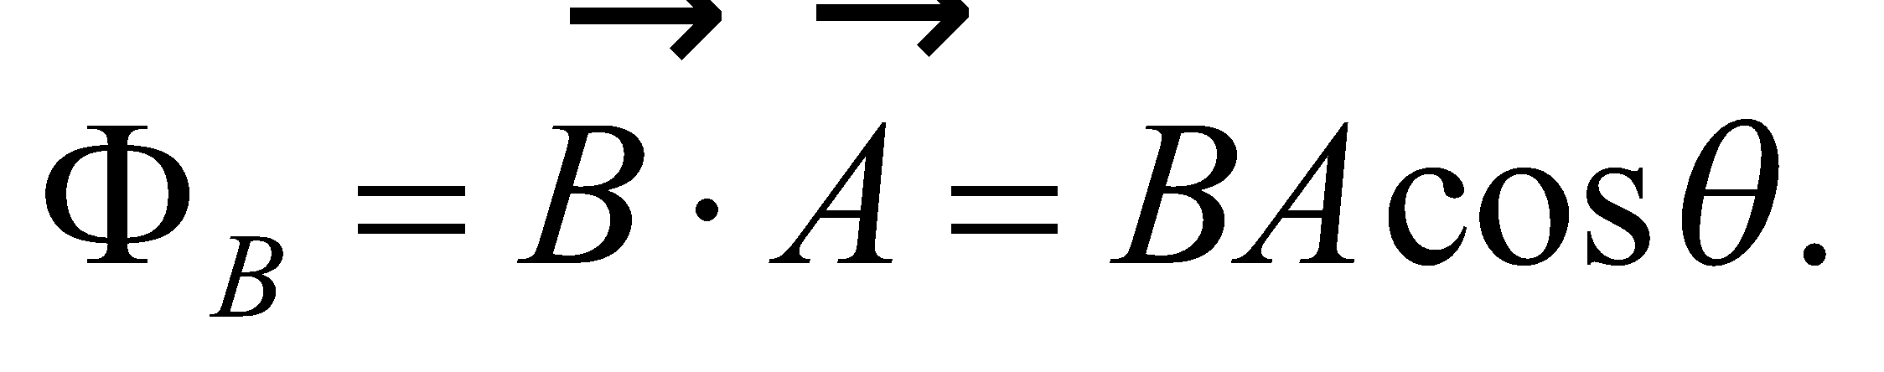 Note that the SI unit of flux, 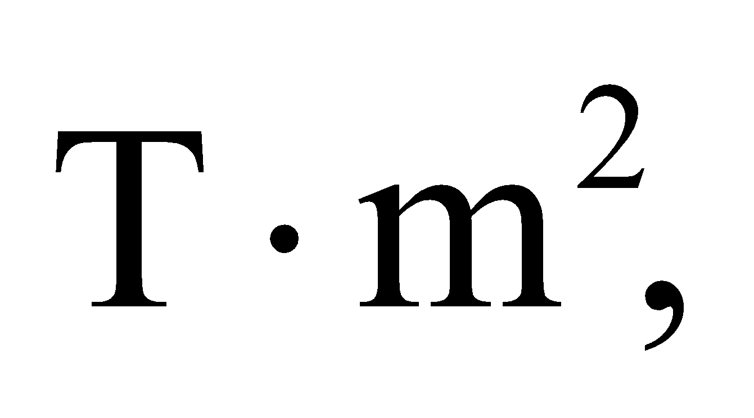 is also called a weber, Wb. The rate of change of

magnetic flux is 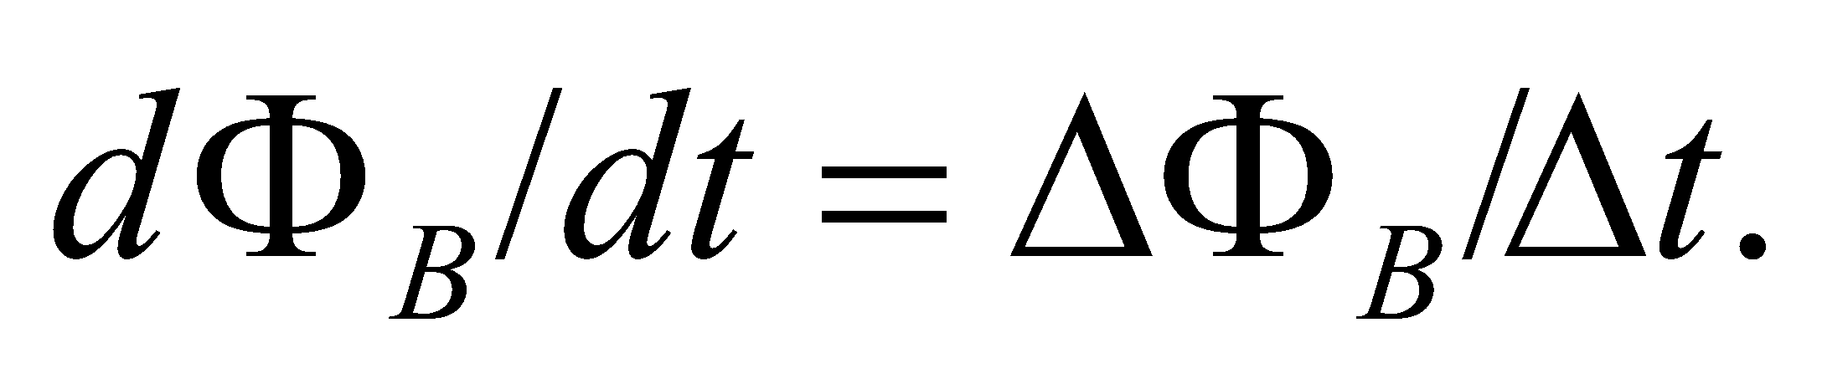

**Evaluate** **(a)** The magnetic field at the beginning 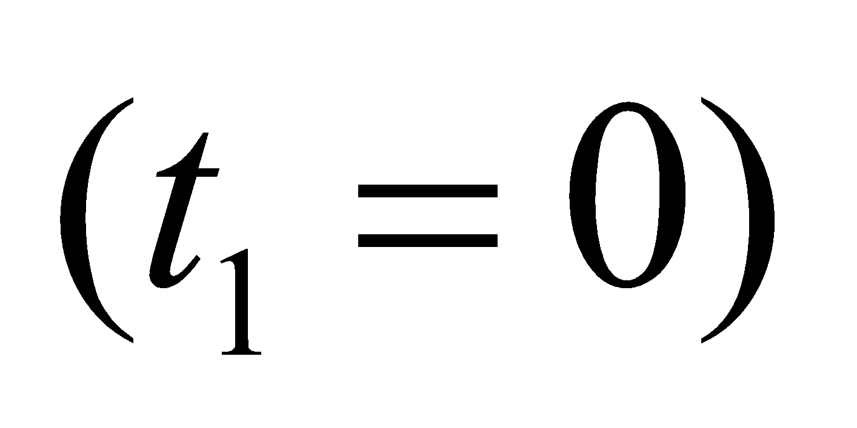 is

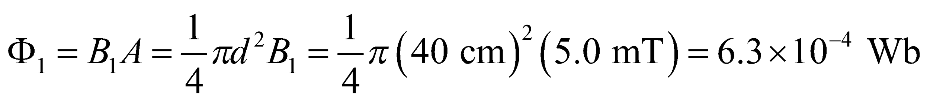

**(b)** The magnetic field at 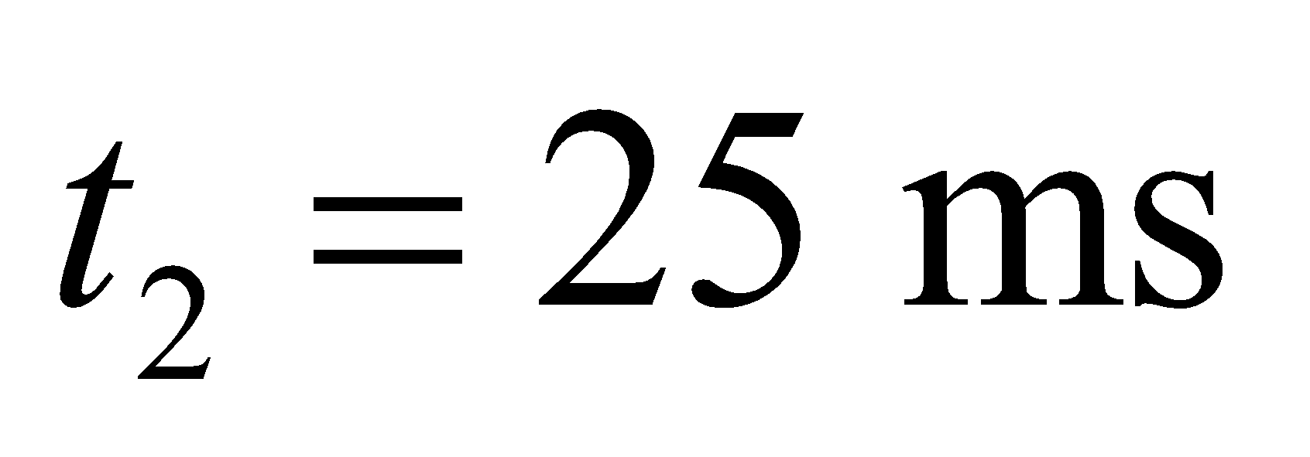 is

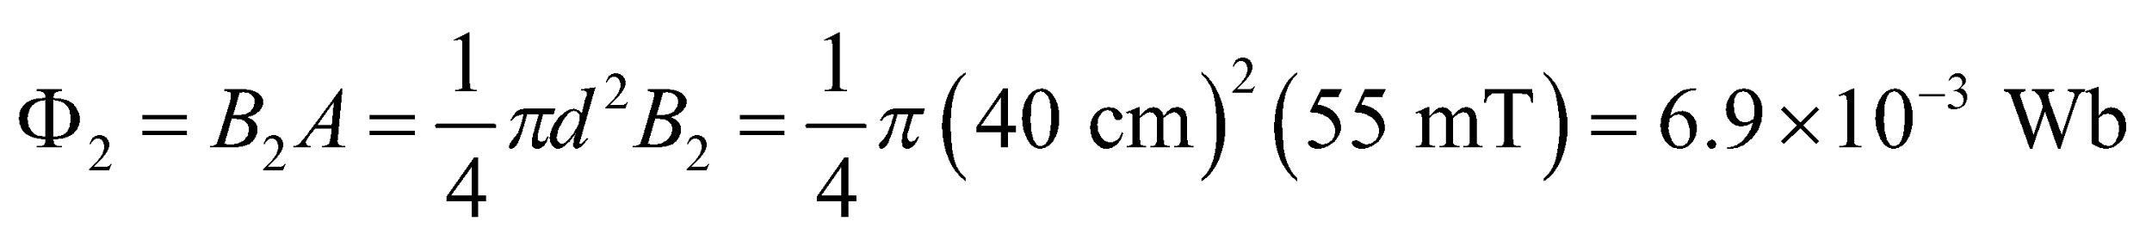

**(c)** Since the field increases linearly, the rate of change of magnetic flux is

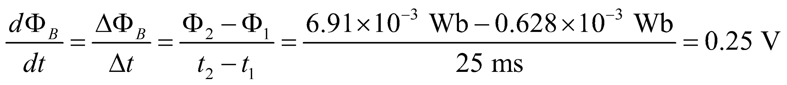

From Faraday’s law, this is equal to the magnitude of the induced emf, which causes a current

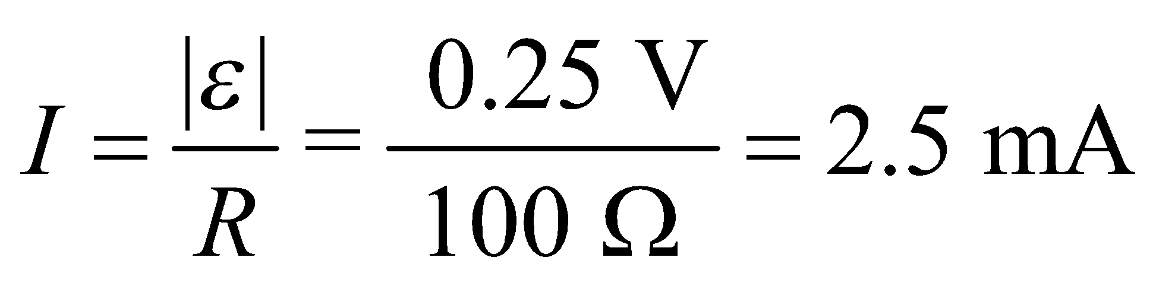

in the loop.

**(d)** The direction must oppose the increase of the external field downward, hence the induced field is upward and *I* is counter clockwise when viewed from above the loop.

**Assess** Since 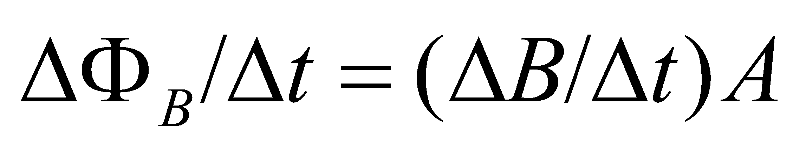 with the area of the loop kept fixed, the induced emf and hence the current scale linearly with 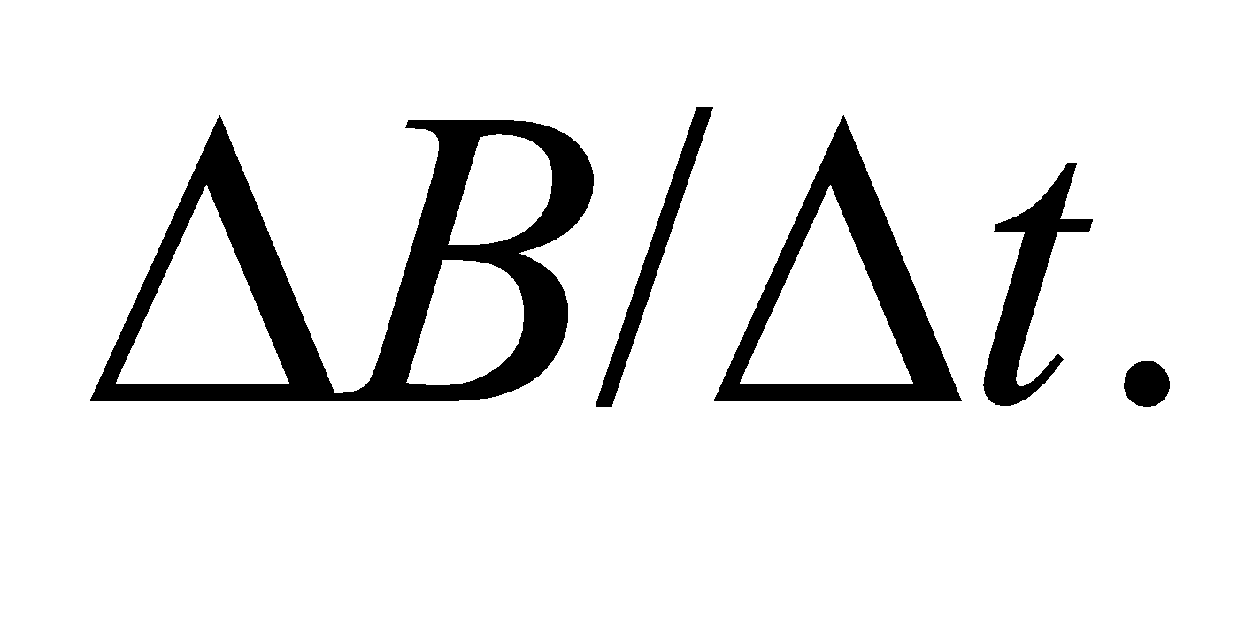

**15. Interpret** This problem involves Faraday’s law, which we can use to find the rate at which the magnetic field is changing given the current in the loop.

**Develop** The flux through a stationary loop perpendicular to a magnetic field is 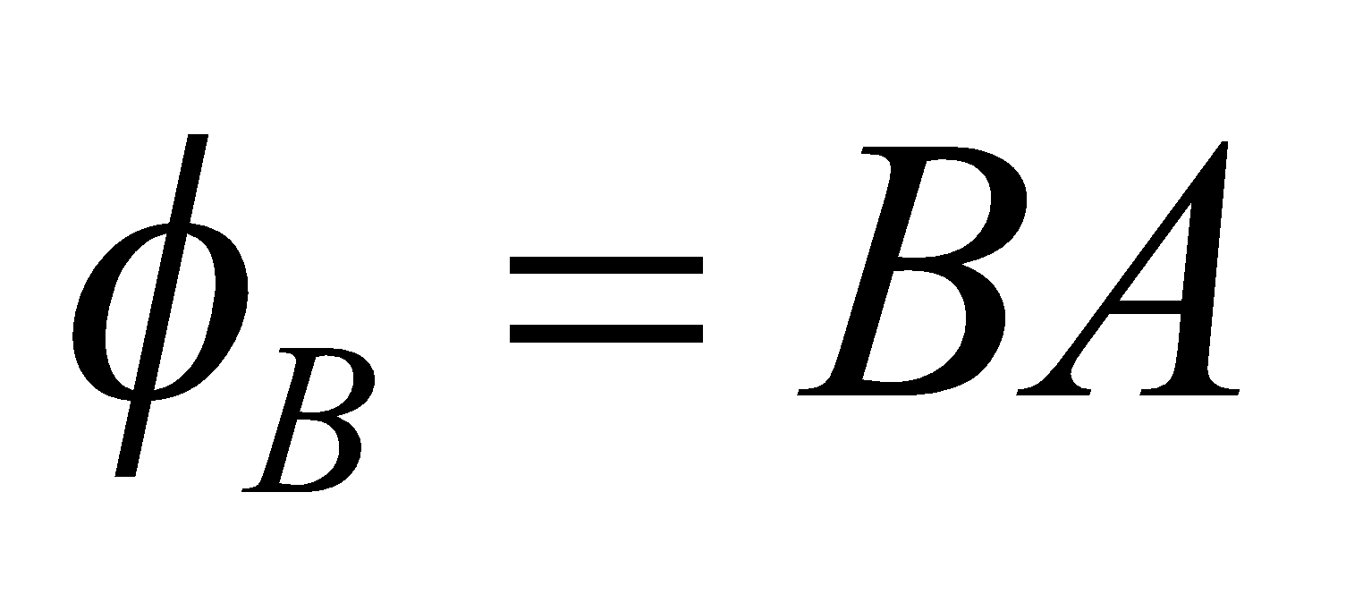, so Faraday’s law (Equation 27.2) and Ohm’s law (Equation 24.5) relate this to the magnitude of the induced current:

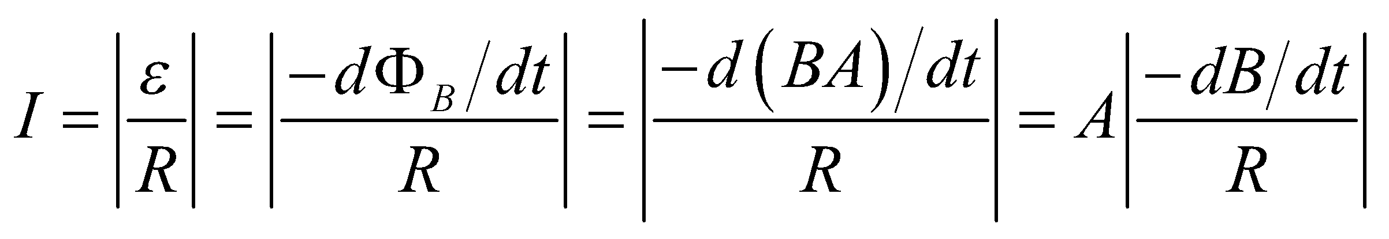

**Evaluate** Solving this expression for the rate of change of the magnetic field gives

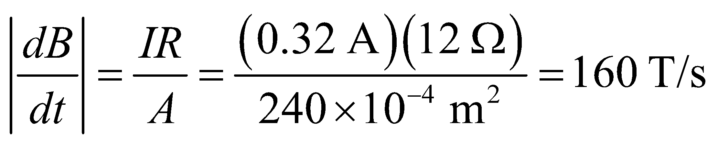

**Assess** Whether the magnetic field is increasing or decreasing depends on the direction in which the current is circulating with respect to the magnetic field.

**16. Interpret** The problem asks for the number of turns the coil must have in order to produce a given emf when it is placed in a time-varying magnetic field, which we can find using Faraday’s law.

**Develop** When the coil is wrapped around the solenoid, all of the flux in the solenoid (*B*sol *A*sol, for a long thin solenoid) goes through each of the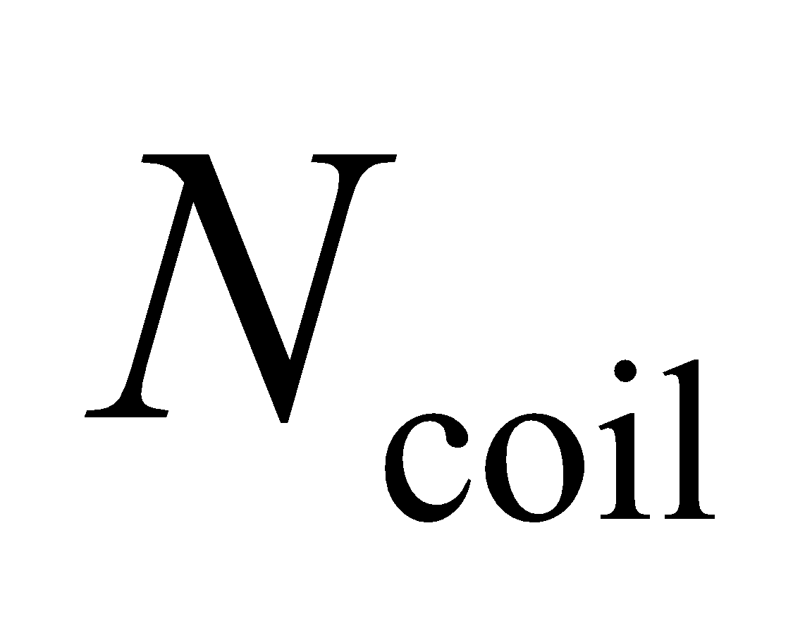turns of the coil. Using Faraday’s law (Equation 27.2), the induced emf in the coil is

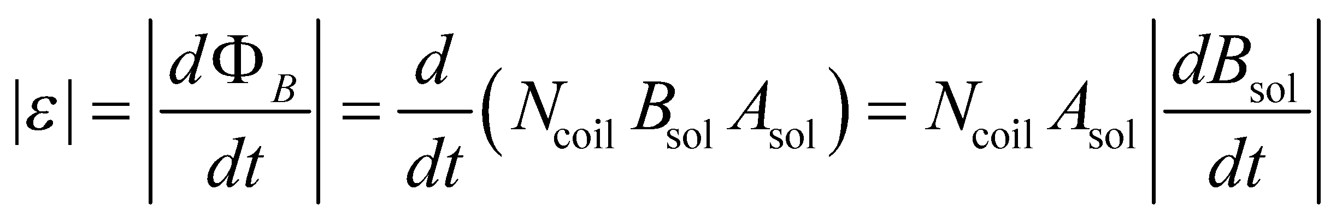

**Evaluate** Substituting the values given in the problem statement, the number of turns in the coil is

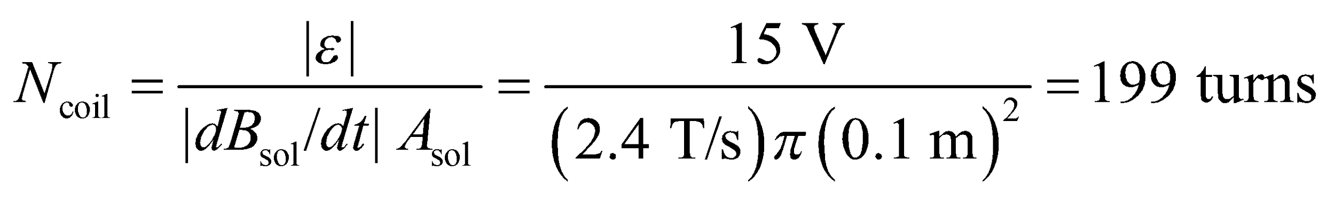

**Assess** The number of turns is proportional to the induced emf, but inversely proportional to the rate of change of magnetic field.

**Section 27.4 Inductance**

**17. Interpret** We are to find the self inductance of the given solenoid.

**Develop** This problem is treated in Example 27.6. Apply Equation 27.4.

**Evaluate** Equation 27.4 gives

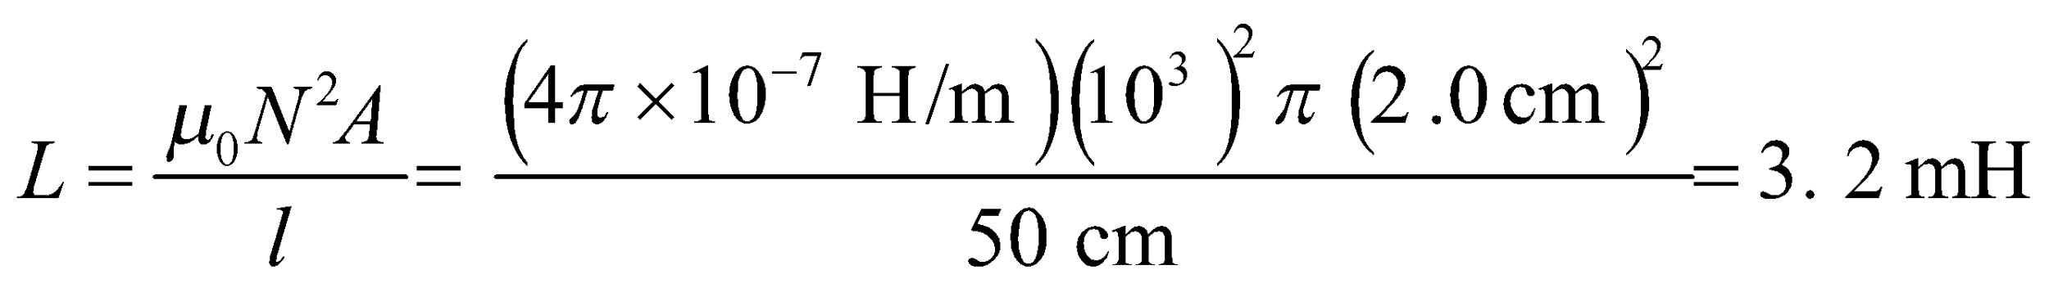(

**Assess** Note that Equation 27.4 make use of the assumption that the solenoid length is much greater than its diameter, which holds for this problem.

**18. Interpret** This problem asks for the self-inductance of an inductor, given its emf and the rate of change of its current.

**Develop** The induced emf in an inductor is given by Equation 27.5: 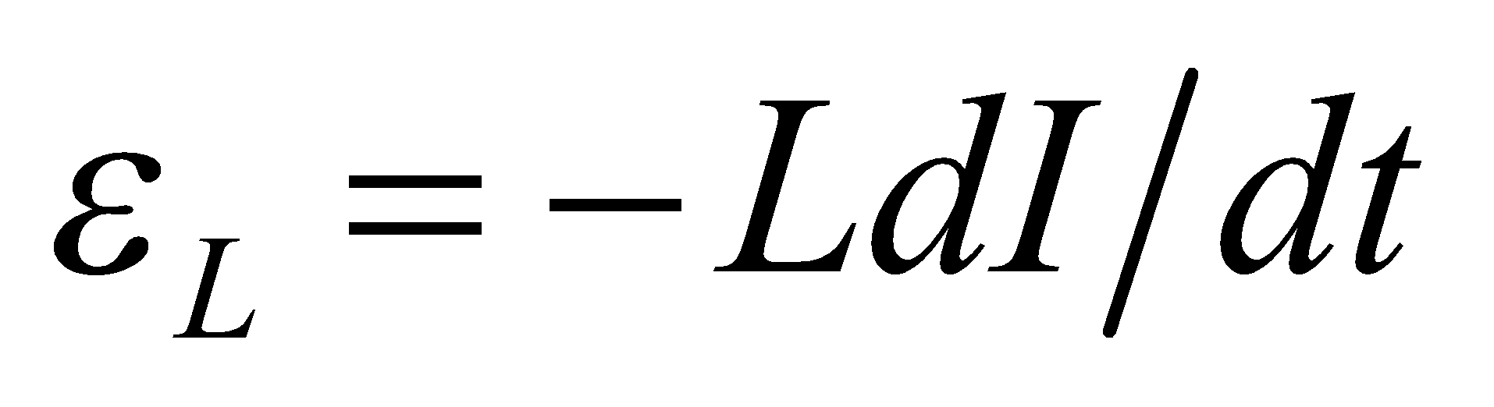. With 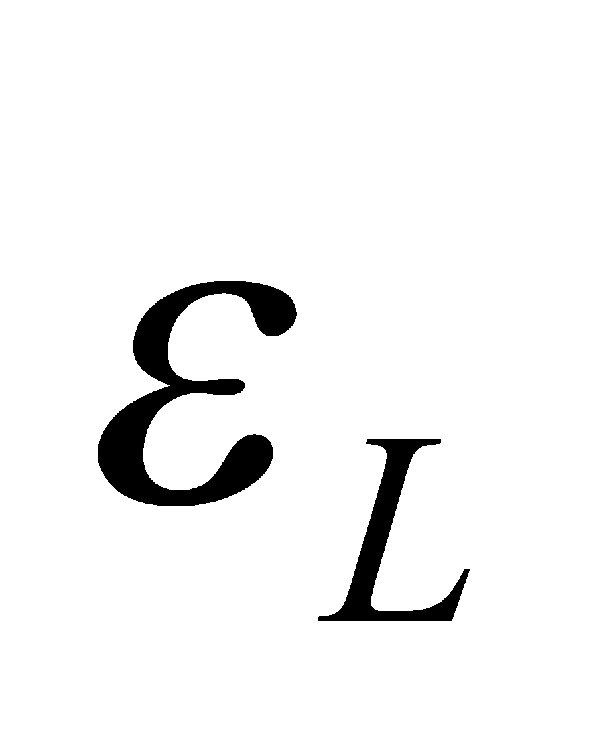 and 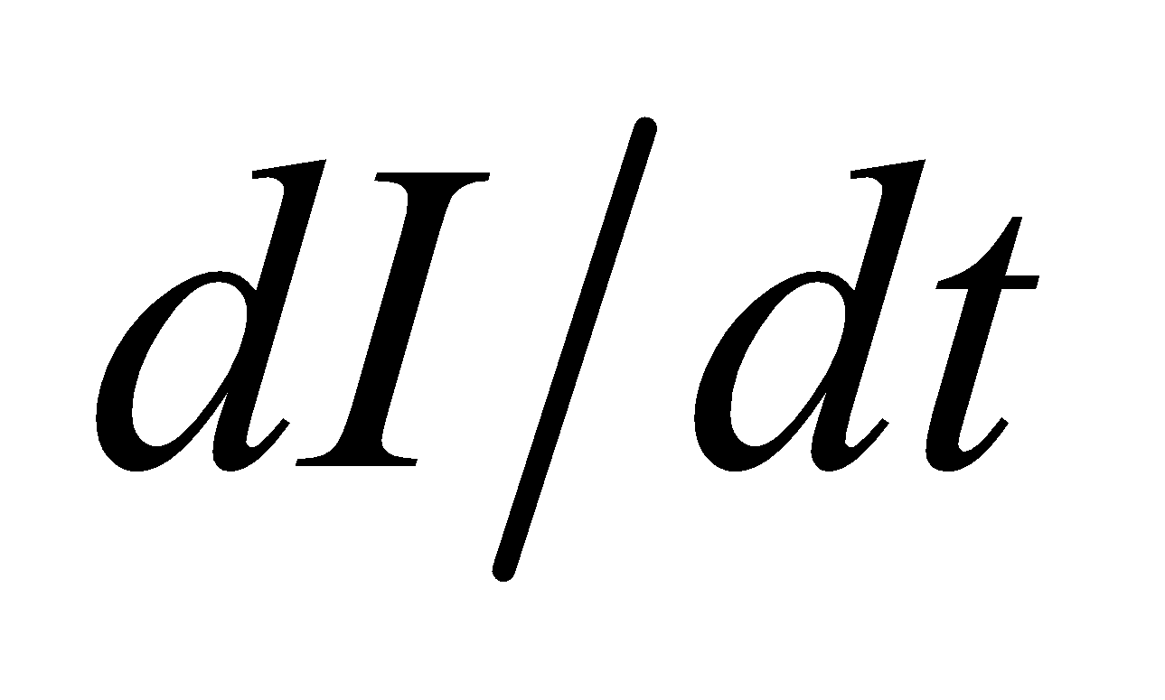 given, we can use this equation to compute the self-inductance *L*.

**Evaluate** From Equation 27.5, we find the self-inductance to be

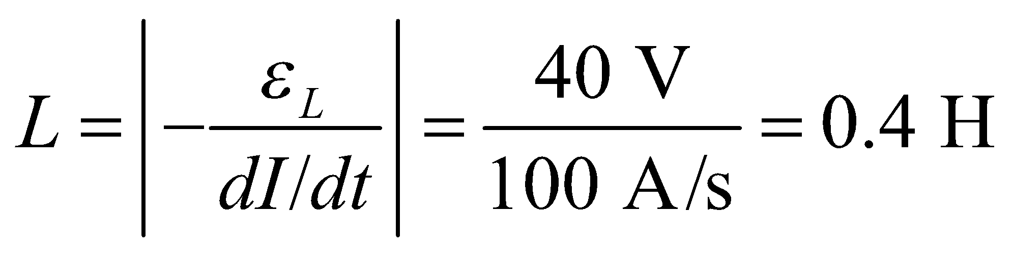

**Assess** Our value of self-inductance is reasonable; inductances in common electronic circuits usually range from micro-henrys to several henrys.

**19. Interpret** We are to find the induced emf in a circuit given the rate of change of the current and the circuit’s inductance.

**Develop** Assume that the current changes uniformly from 2.0 A to zero in 1.0 ms (or consider average values). Then  and we can apply Eqution 27.5 to find the emf.

**Evaluate** The emf is

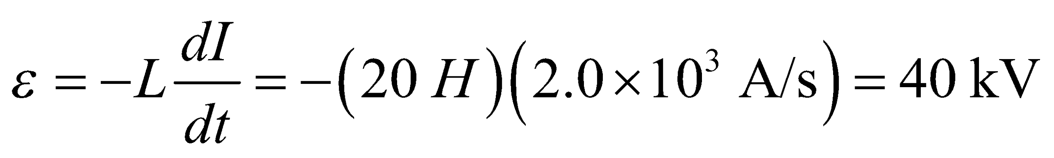

**Assess** The negative sign indicates that the emf opposes the change in the current.

**20. Interpret** Your sister is constructing a solenoid that will work as an inductor. She asks you the number of turns it will need to have the desired inductance.

**Develop**The inductance of a solenoid was derived in Example 27.6: 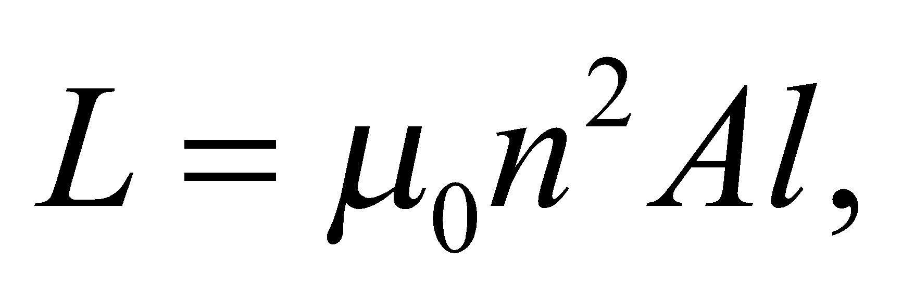 where *n* is the number of turns per unit length, *A* is the cross-sectional area, and *l* is the length. Your sister is asking for the total number of turns: 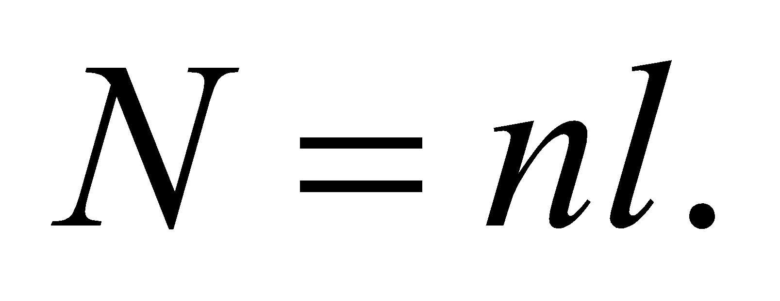

**Evaluate**Using the given values, the number of turns is

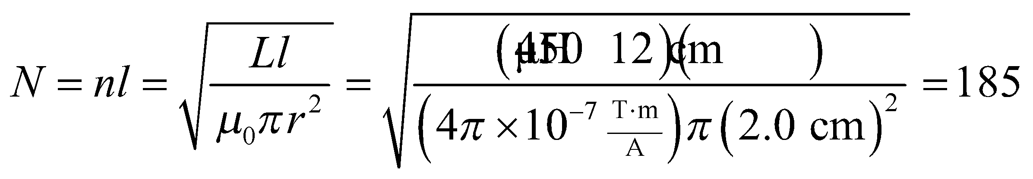

**Assess**This seems like a reasonable number of turns for your sister to do. The units work out since 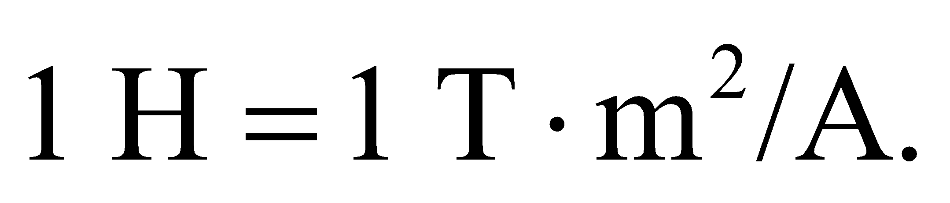

**21. Interpret** We are to find the time constant of a circuit, given its resistance and its inductance.

**Develop** From Equations 27.6 and 27.7, we see that the time constant is *τ* = *L*/*R*, which we can solve for the inductance given the time constant and the resistance.

**Evaluate** Inserting the given quantities gives

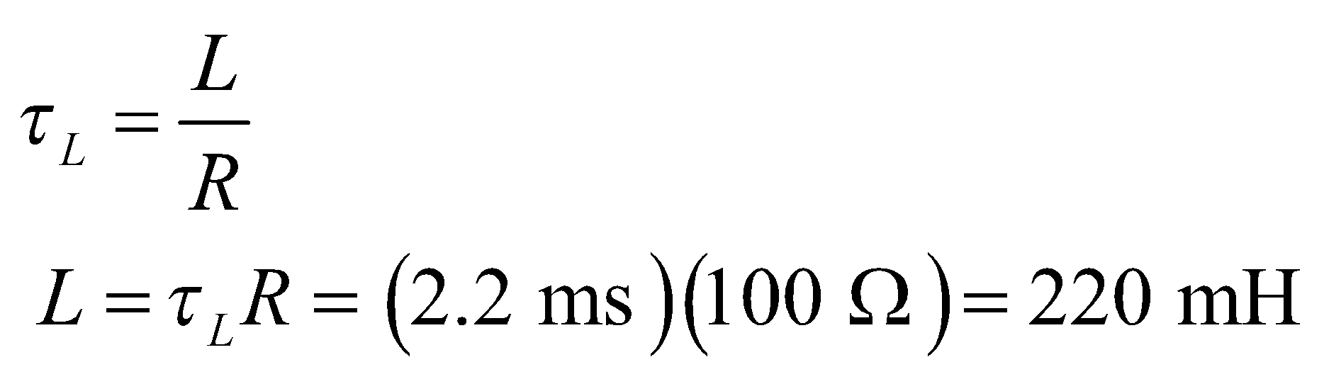

**Assess** To verify that the units work out correctly, note that a henry is a T·m2/A and an ohm is m2·kg·s−3·A−2. Expressing teslas in terms of SI base units gives (kg·s−2·A−2)



**22. Interpret** This problem is about the resistance in a series *RL* circuit. We are given the current at a given time, and are asked to find the resistance of the *RL* circuit given its time constant and its inductance.

**Develop** The buildup of current in an *RL* circuit with a battery is given by Equation 27.7:

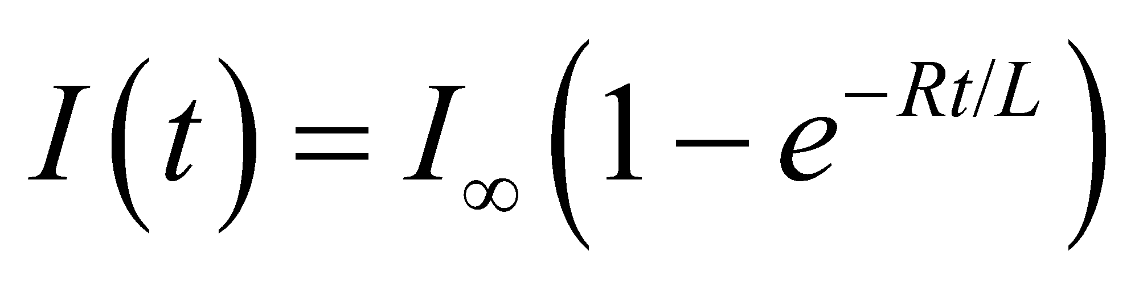

where 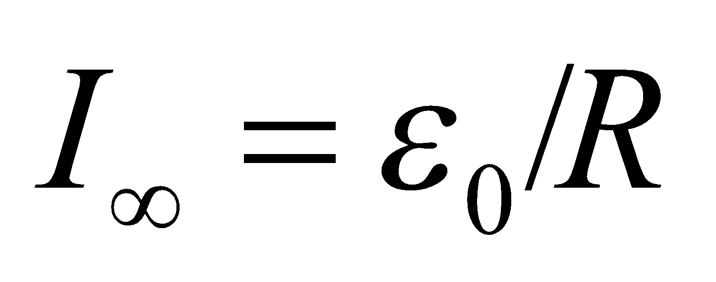 is the final current. We are given that 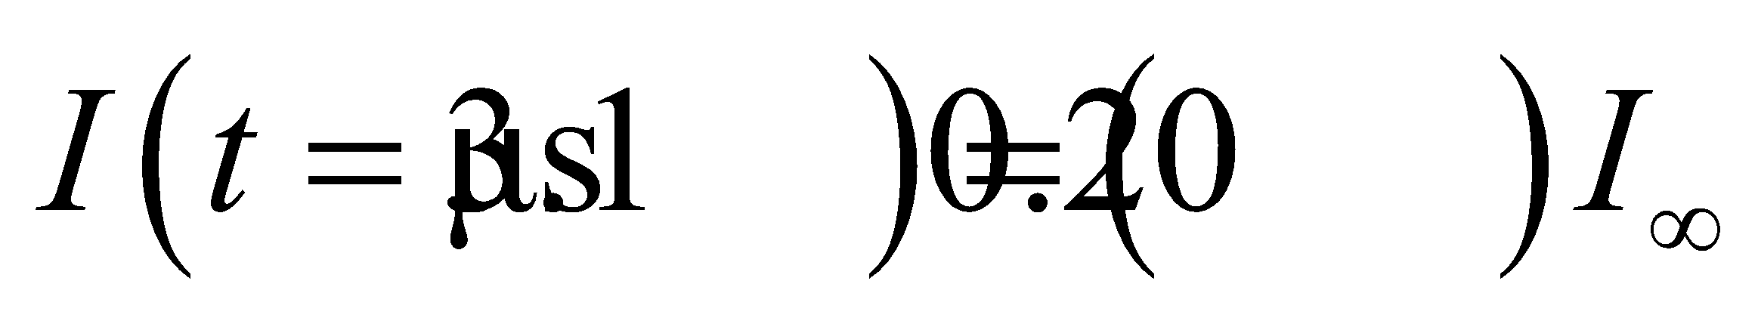, so we can solve for *R*.

**Evaluate** Solving the expression above for R and inserting the values given, one finds the resistance to be

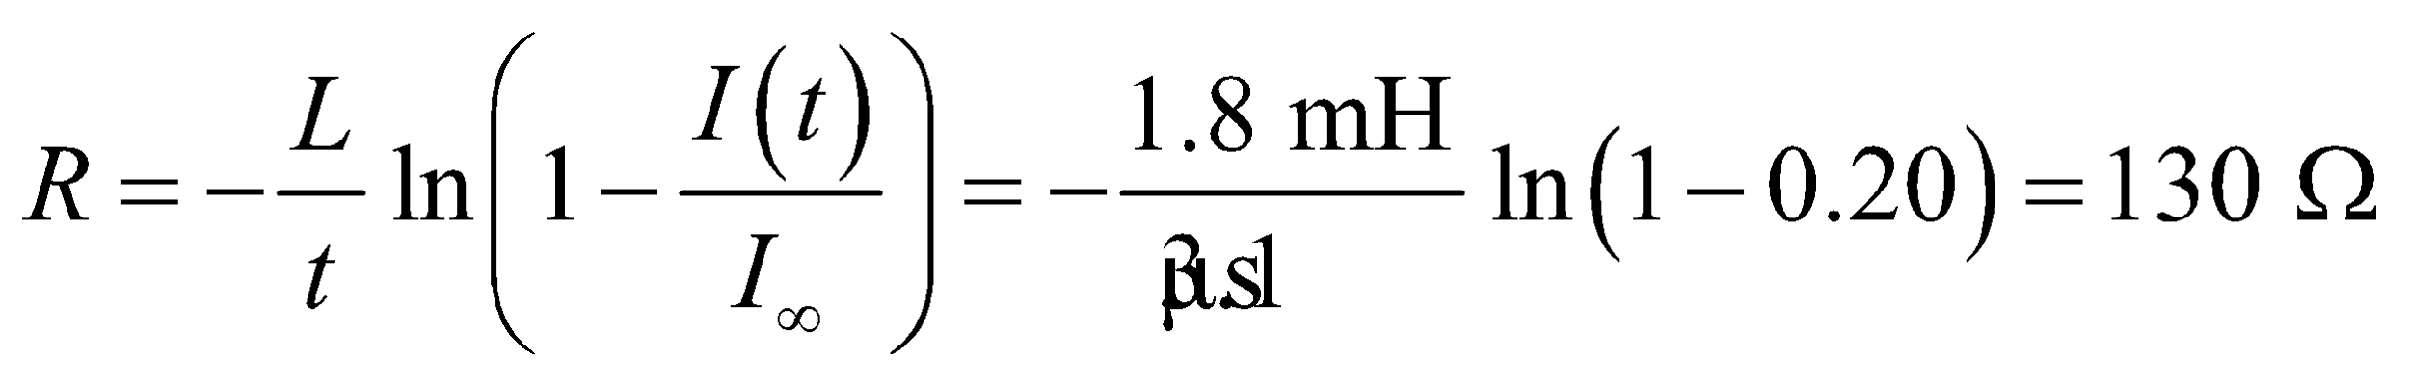

**Assess** We find *R* to be inversely proportional to *t*. This means that the greater the value of *R*, the shorter the time it takes for the current to increase to 20% of its final value.

**Section 27.5 Magnetic Energy**

**23. Interpret** We are to find the energy stored in the given inductor through which flows the given current.

**Develop** Apply Equation 27.9.

**Evaluate** Inserting the given quantities into Equation 27.9 gives

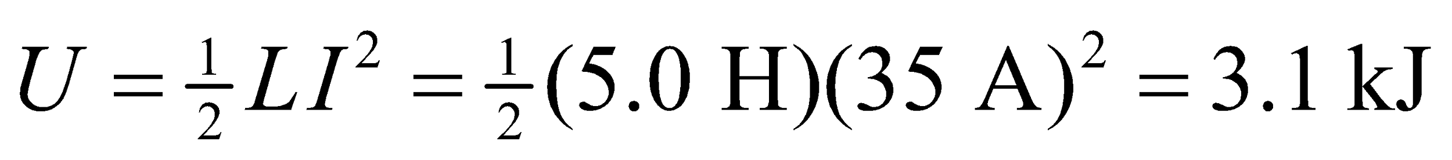

**Assess** This is the energy it would take to lift one liter of water a height *h* of

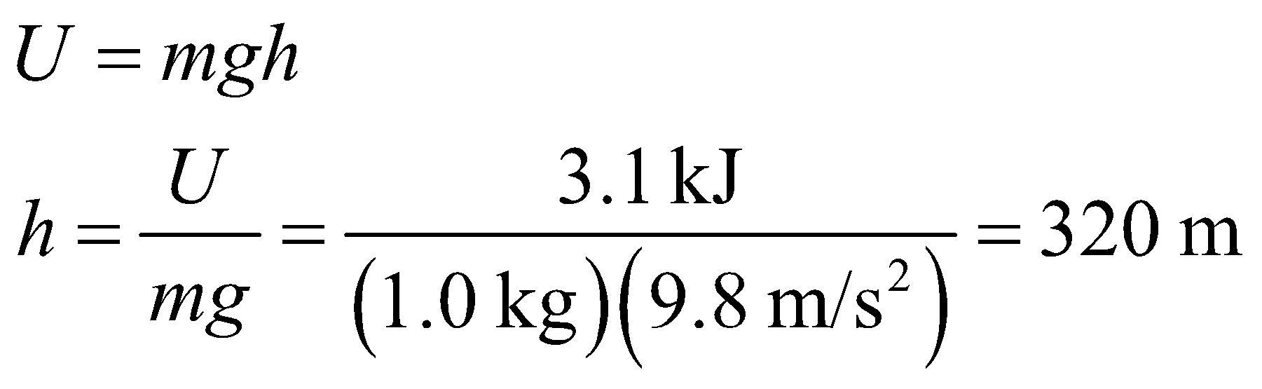

**24. Interpret** This problem is about magnetic energy stored in an inductor. Given the inductance and the energy stored, we are to find the current.

**Develop** The amount of energy stored in an inductor is given by Equation 27.9: 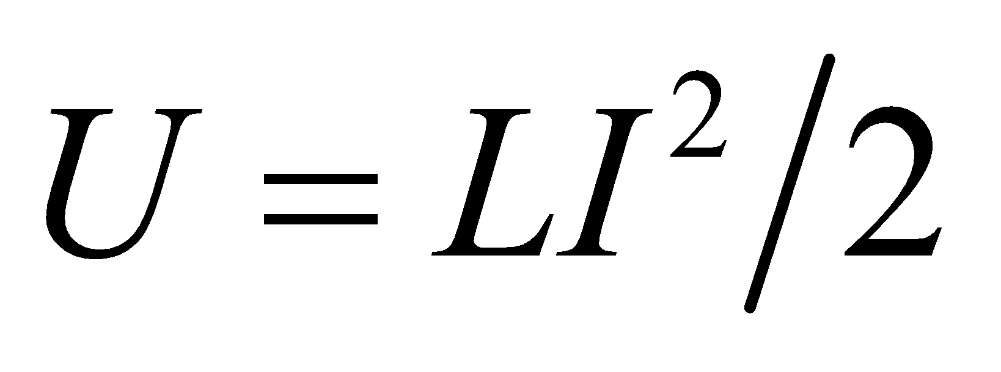. This equation allows us to determine the current *I*.

**Evaluate** From the equation above, we find the current to be

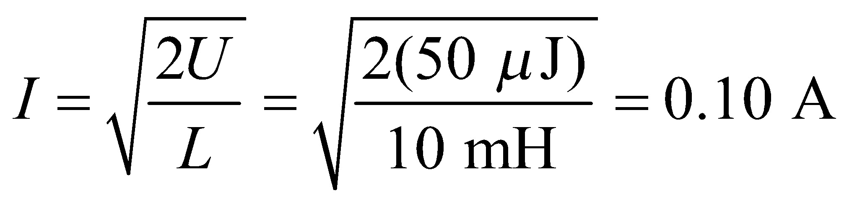

**Assess** Since the energy stored in the inductor is small, we expect the current (which is proportional to 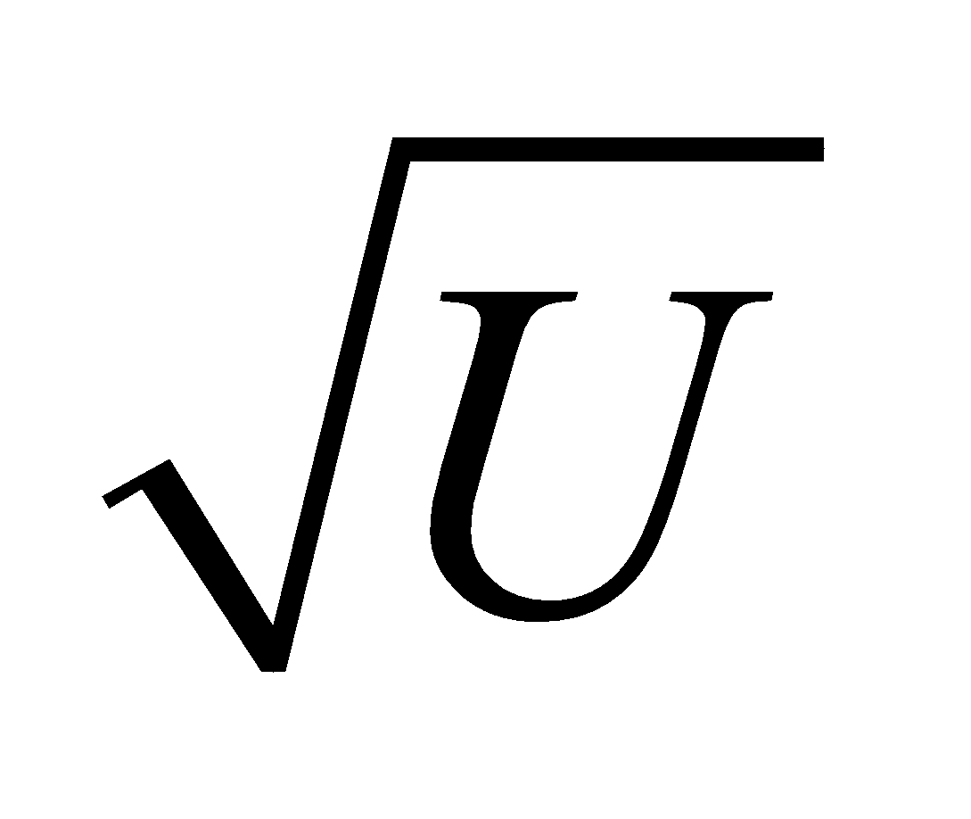) to be small as well.

**25. Interpret** This problem involves the energy stored in the magnetic field of an inductor. We are to find the energy needed to raise the current of the inductor the given amount.

**Develop** From Equation 27.9, the energy required to raise the current from zero to I1 = 350 mA is 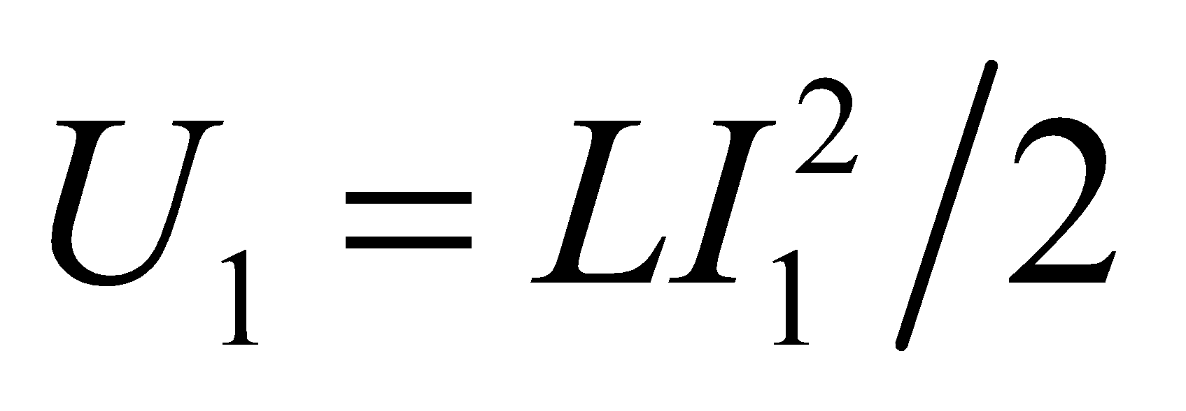. Likewise, the energy required to raise the current from zero to I2 is 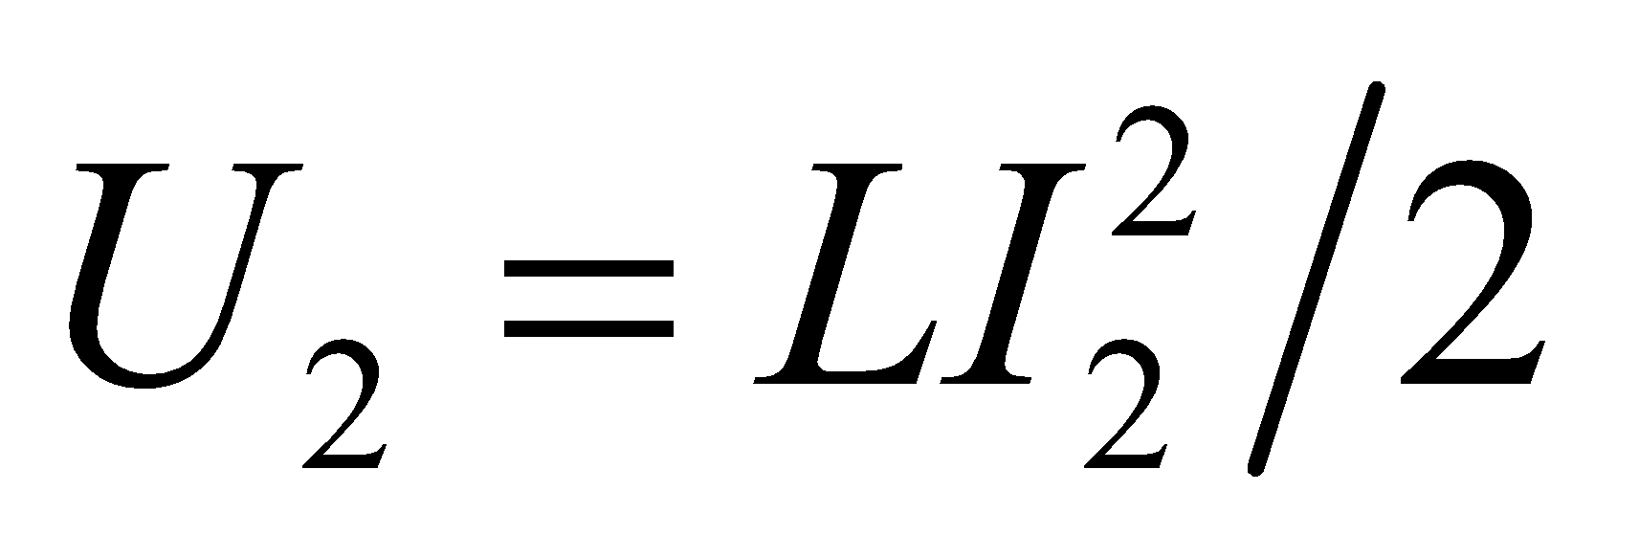. The energy required to raise the current from I1 to I2 is the difference,

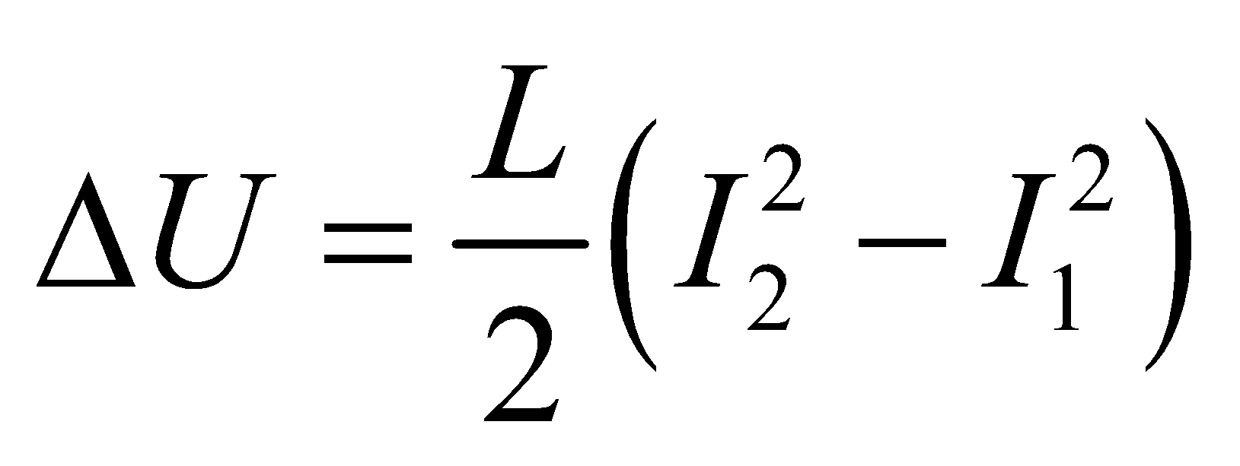

**Evaluate** Inserting the given quantities yields

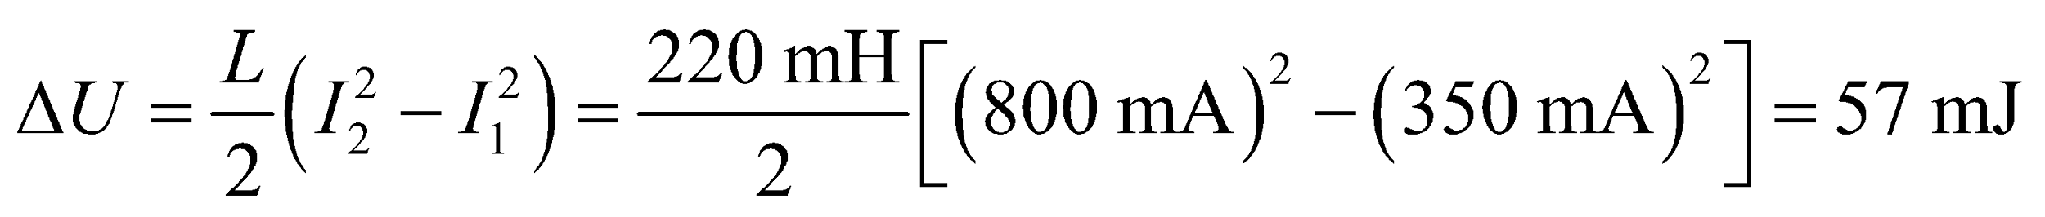

**Assess** The energy in the magnetic field is proportional to the current squared, analogous to kinetic energy, which is proportional to the velocity squared.

**26. Interpret** This problem is about the energy stored in the magnetic field of a solenoid. Given the solenoid parameters (number of turns, current, diameter), we are to find the energy stored in the magnetic field of the solenoid.

**Develop** We first note that the inductance of a solenoid is given by Equation 27.4: 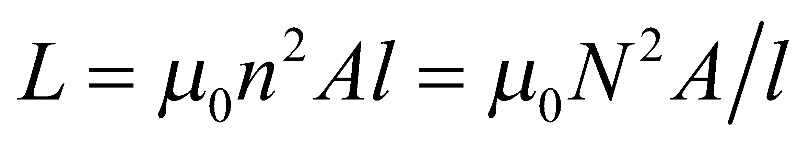. Equation 27.9,  can then be used to find the energy stored in the solenoid.

**Evaluate** Combining Equations 27.4 and 27.9, we find the stored energy to be

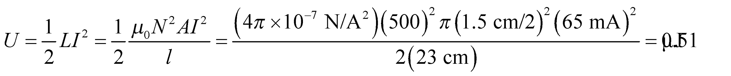

**Assess** This inductance of the solenoid is about 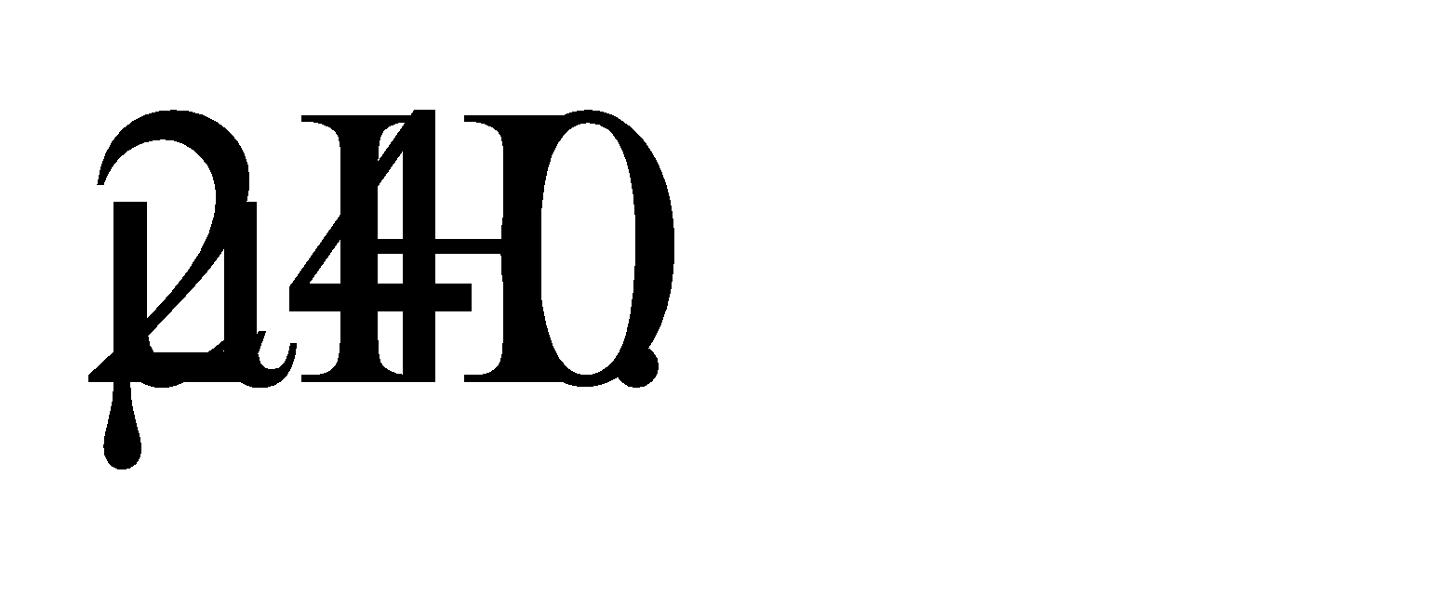 The stored energy is typical for a small inductor with a small current.

**27. Interpret** This problem is an exercise in dimensional analysis. We are to show that the given expression has units of energy density (i.e., J/m3).

**Develop** The permeability constant *μ*0 has units of N/A2 =N·C−2·s2 (see discussion accompanying Equation 26.7) and the magnetic field has units of N·s/(C·m) (see discussion accompanying Equation 26.1). Combine these factors in the indicated fashion to find the units of *B*2/ *μ*0.

**Evaluate** The units of *B*2/ *μ*0 are

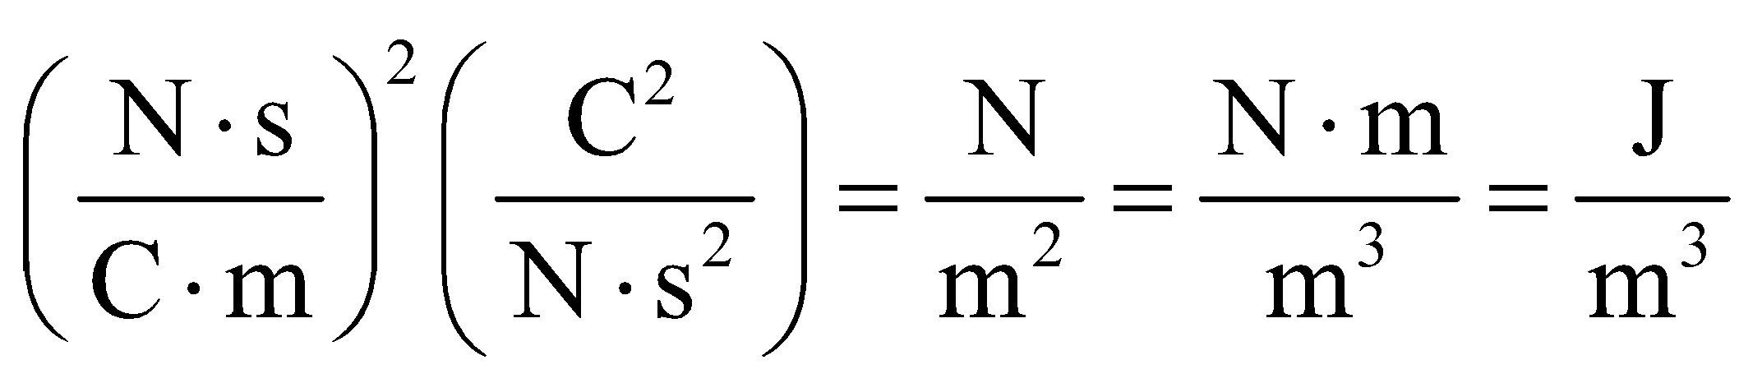

**Assess** The factor 2 in the denominator does not affect the result.

**28. Interpret** The problem concerns the energy stored in the world's largest sustained magnetic field.

**Develop**The energy density of a magnetic field is given in Equation 27.10: 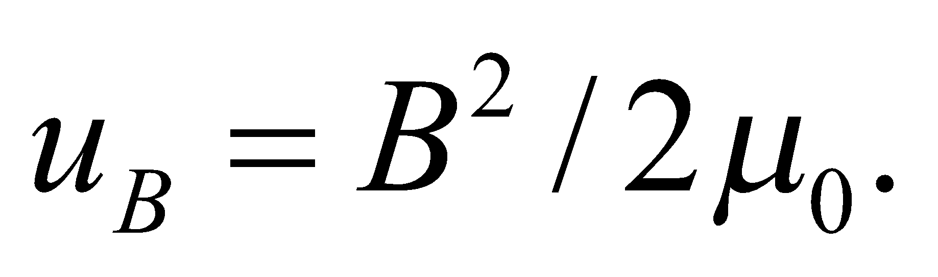

**Evaluate**A 45-T field stores energy in the amount of

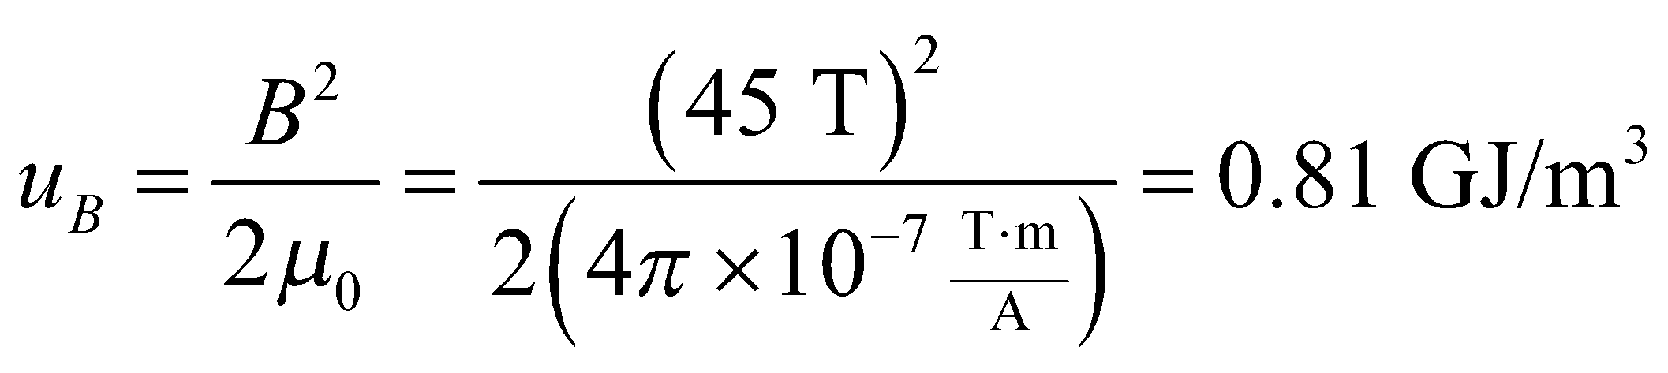

**Assess**This is a lot of energy stored in something we can't see or touch. To put some perspective on this, the energy density of gasoline is only about 40 times larger.

**29. Interpret** We are to find the magnetic field strength in a region with the given magnetic energy density.

**Develop** Apply Equation 27.10.

**Evaluate** Solving Equation 27.10 for the magnetic field strength B gives

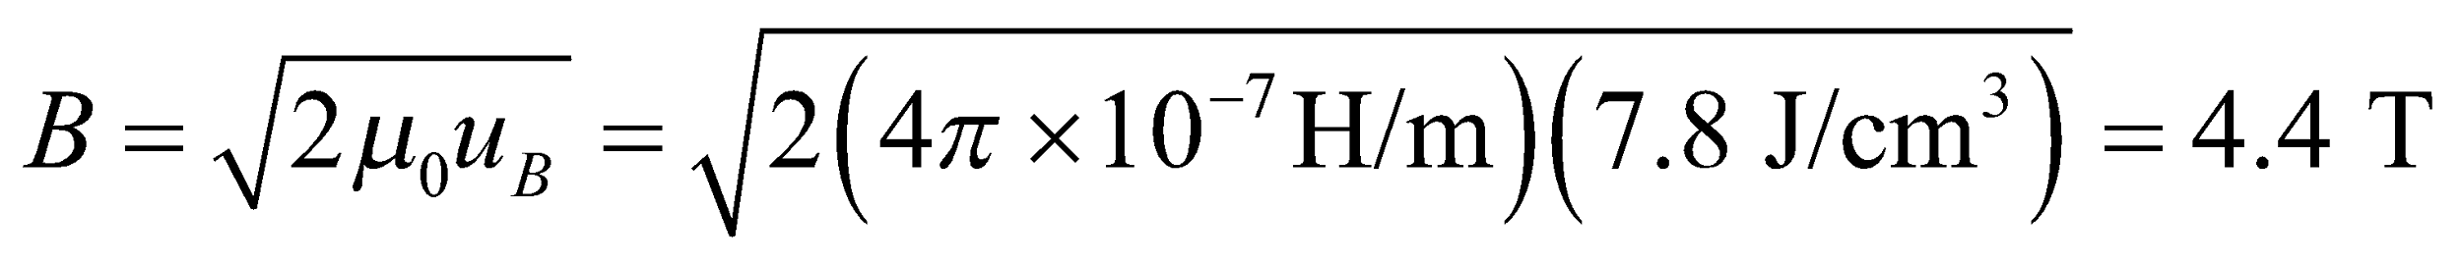

**Assess** This result is for free space (i.e., empty space). If a material occupies the space, Equation 27.10 is not valid.

**Section 27.6 Induced Electric Fields**

**30. Interpret** We are given the induced electric field and asked to find the rate of change of the magnetic field.

**Develop** The connection between the induced electric field and the rate of change of the magnetic field is given by the integral form of Faraday’s law (Equation 27.11):

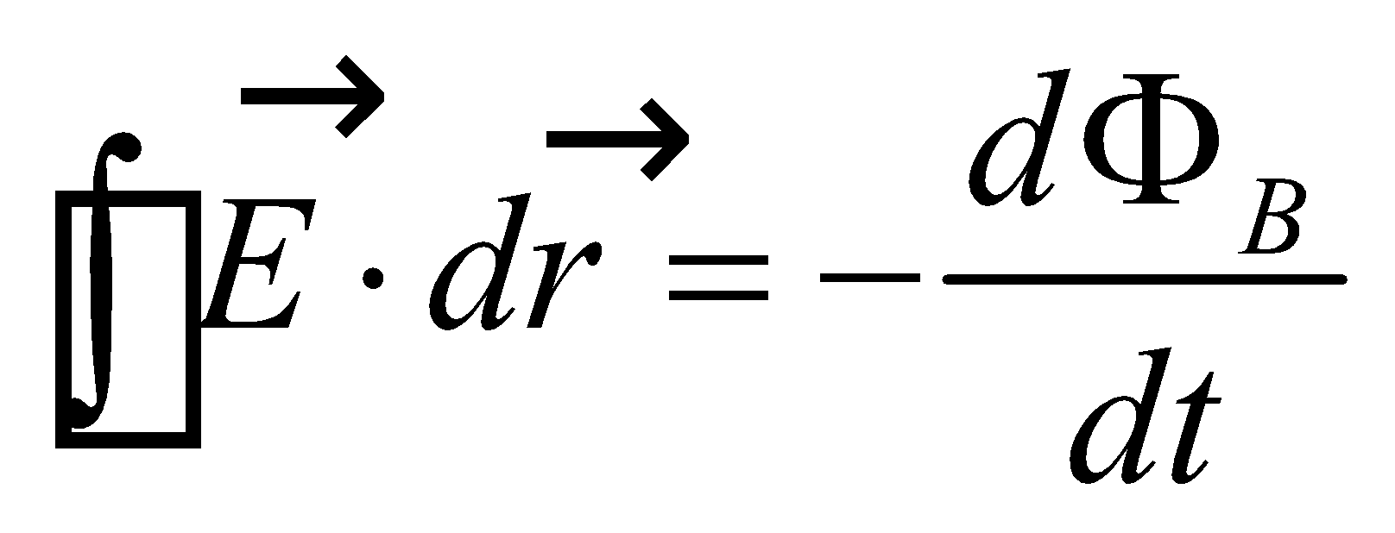

The geometry of the induced electric field from the solenoid is described in Example 27.11, where it is shown that Faraday’s law leads to

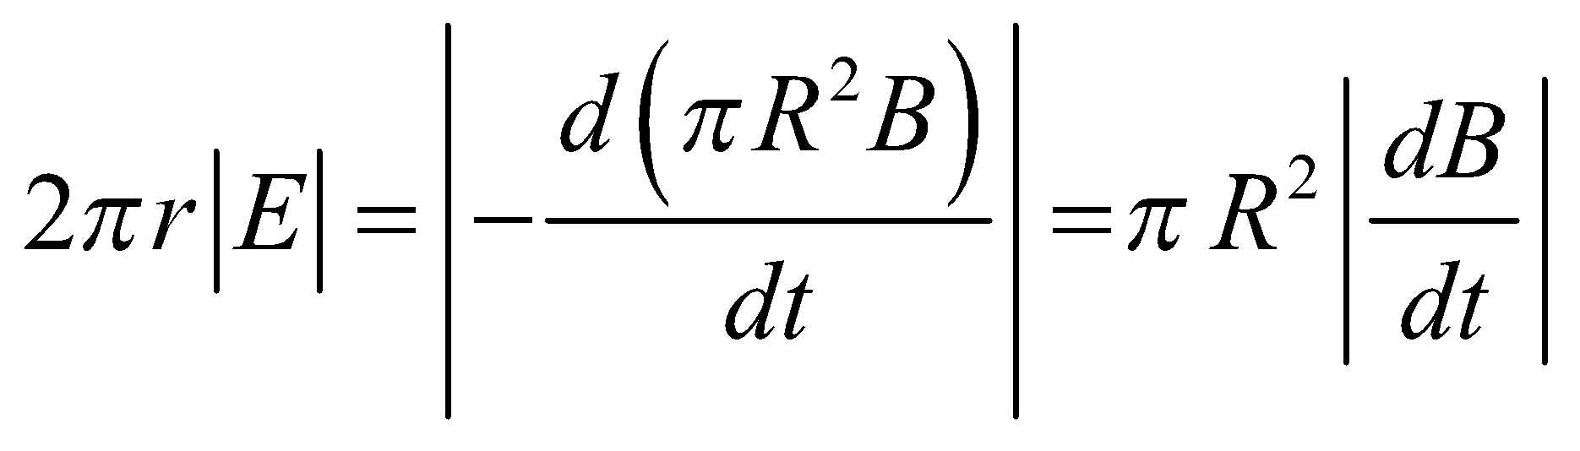

**Evaluate** Solving the expression above for the rate of change of the magnetic field gives

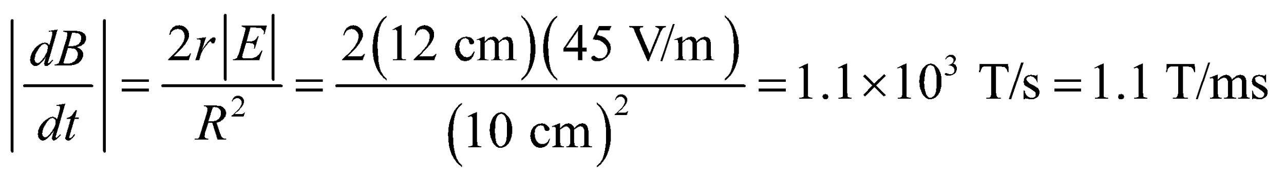

**Assess** The magnetic field is changing at a very fast rate. Note that the sign of 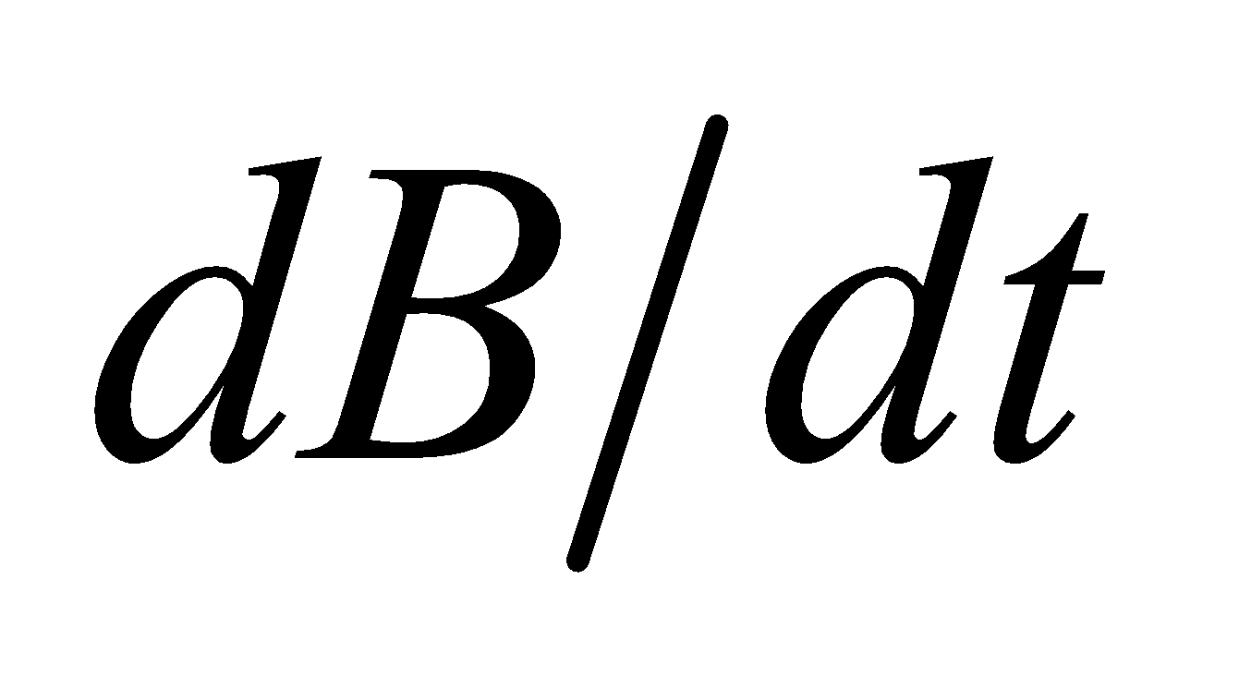 and the direction of the induced electric field are related by Lenz’s law.

**31. Interpret** This problem involves a solenoid in which the current is changing, so it has a time-varying magnetic field and thus an electric field as well. We can use Faraday’s law to find the electric field as a function of *r* inside a solenoid.

**Develop** We’ll use a circular Ampérian loop, of radius *r*, centered inside the solenoid. The flux through this loop is 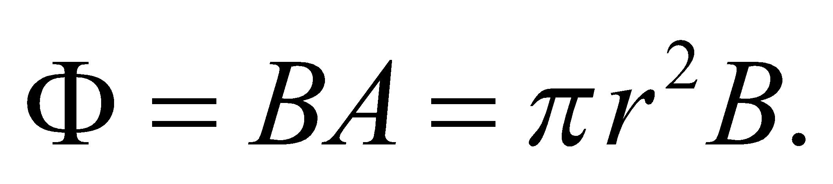 We are told that the field in the solenoid is *B* = *bt*. Faraday’s law, integrated around this loop, gives us

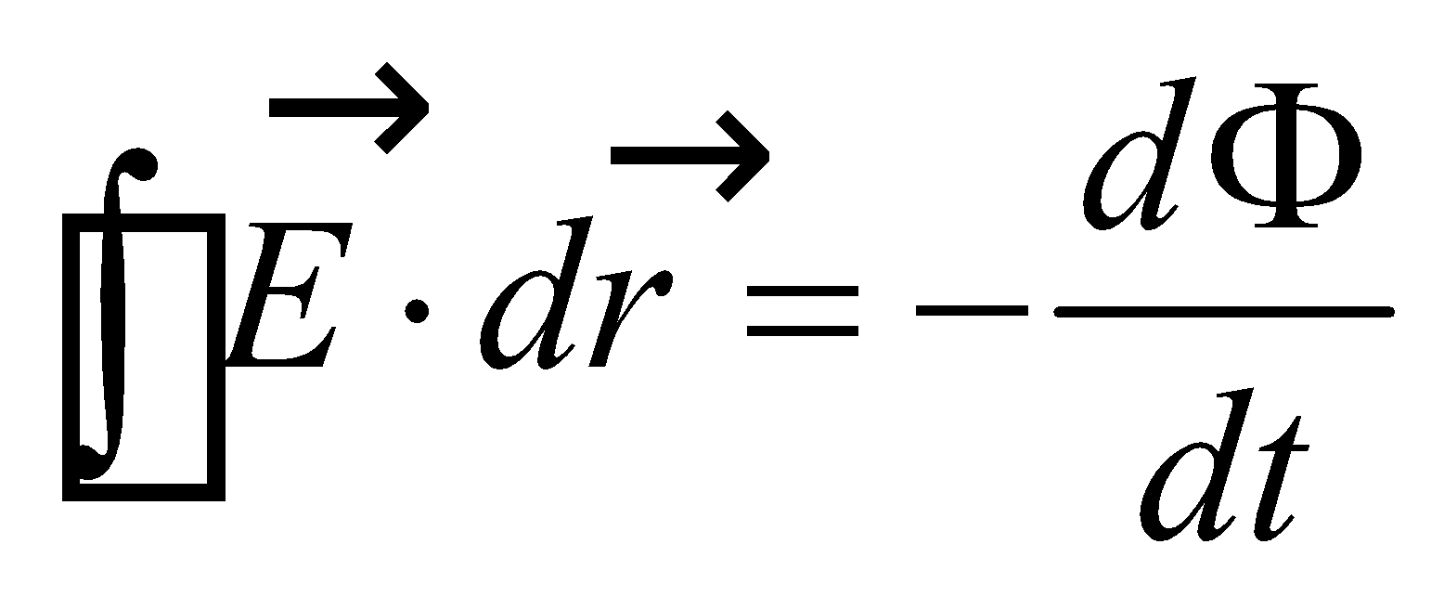

By symmetry, the electric field is constant around any loop of a given radius, which makes the integration easy.

**Evaluate**

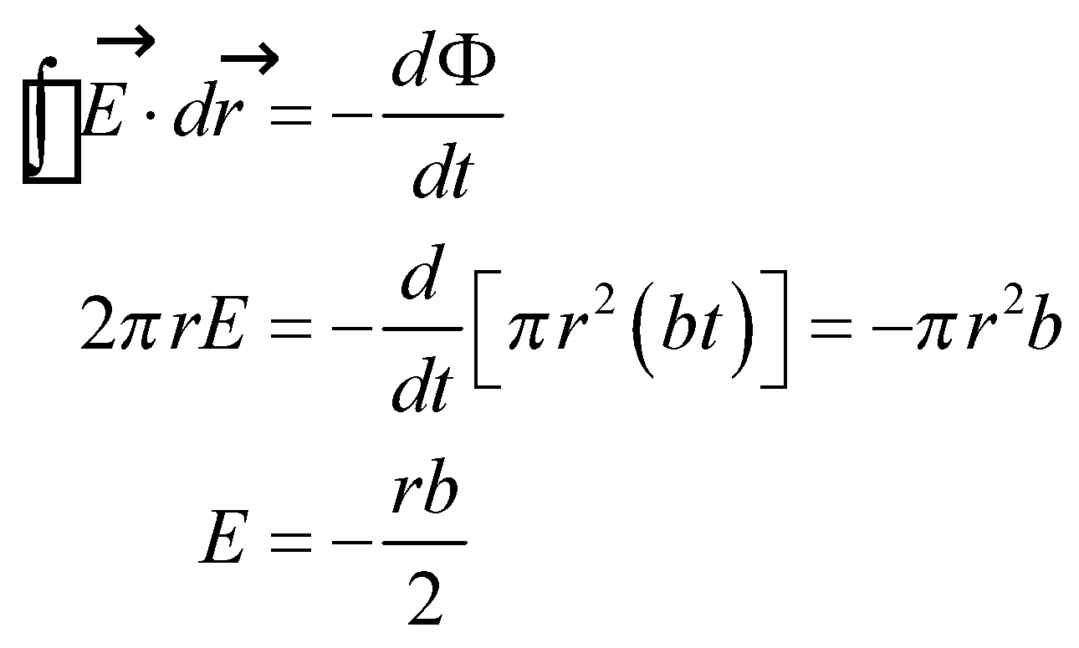

**Assess** Just as in previous problems that use Gauss’s and Ampère’s laws, it is important to choose our symmetry to make things easy on ourselves.

**Problems**

**32. Interpret** This problem involves the rate of change of magnetic field strength, given the induced current as a function of time.

**Develop** The flux through a stationary loop of area A perpendicular to a magnetic field is 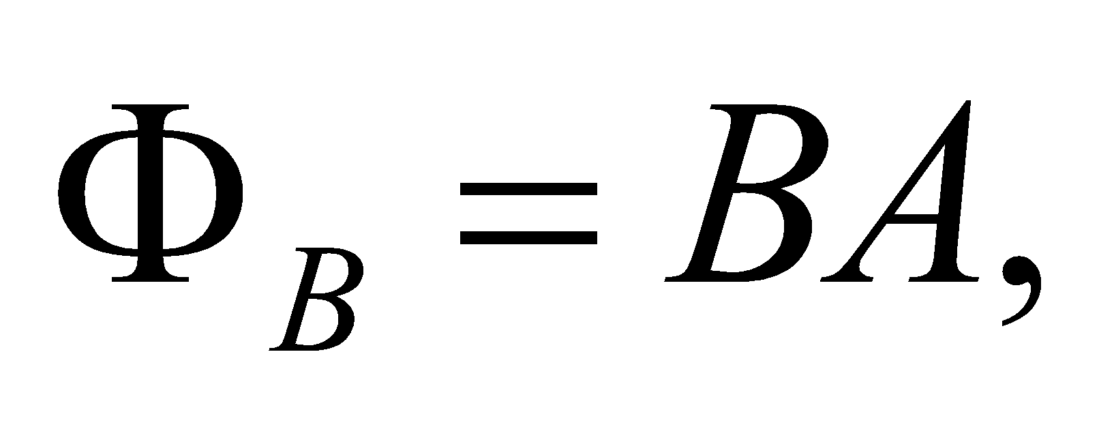 so Faraday’s law (Equation 27.2) and Ohm’s law (Equation 24.5) relate this to the magnitude of the induced current:

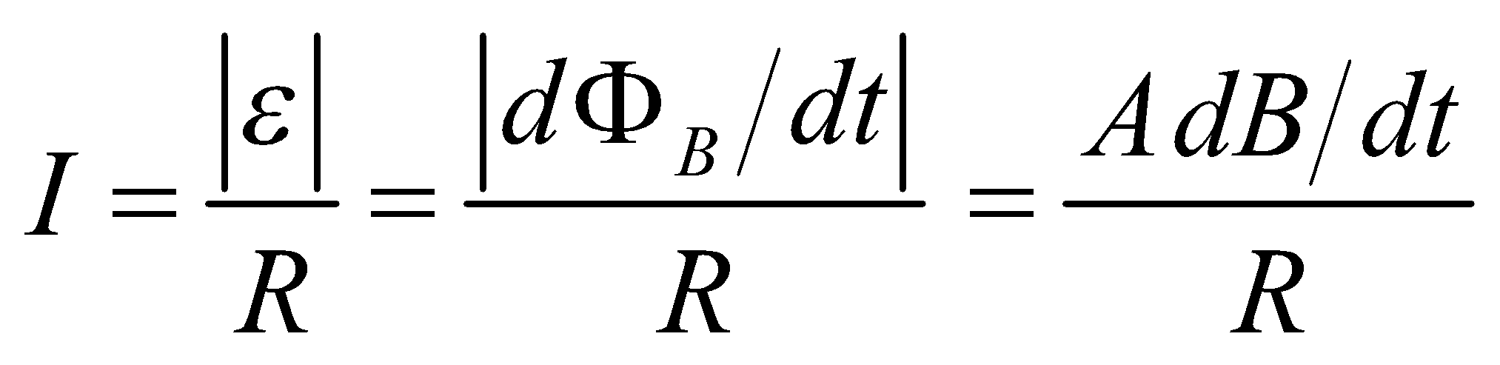

**Evaluate** From the above expression, we find the rate of change of the magnetic field to be

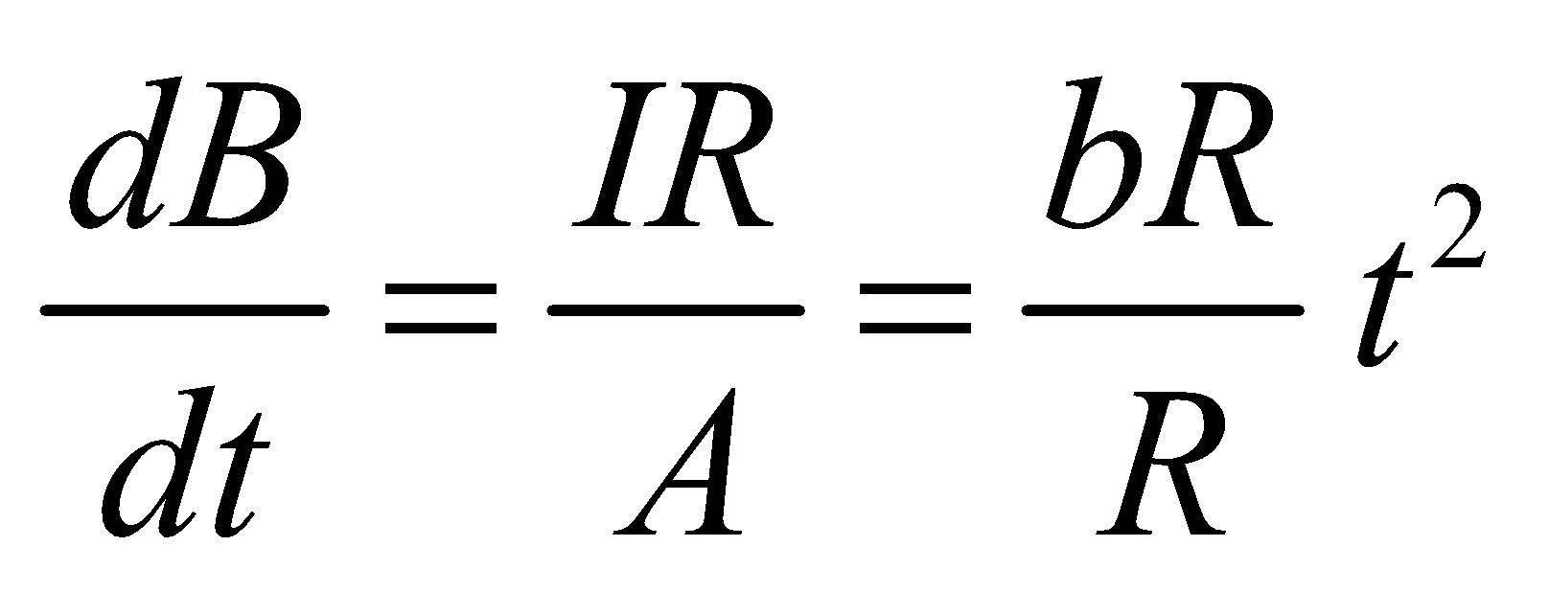

Integration yields 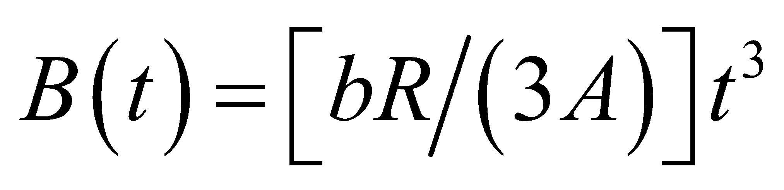 where 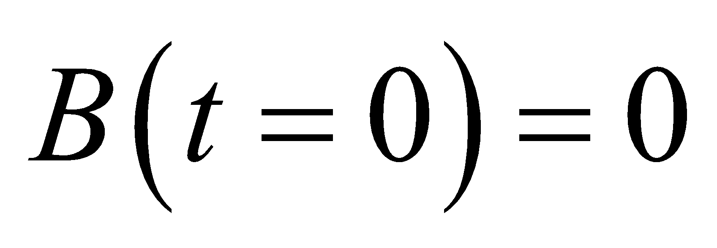 was specified.

**Assess** Since the current increases as 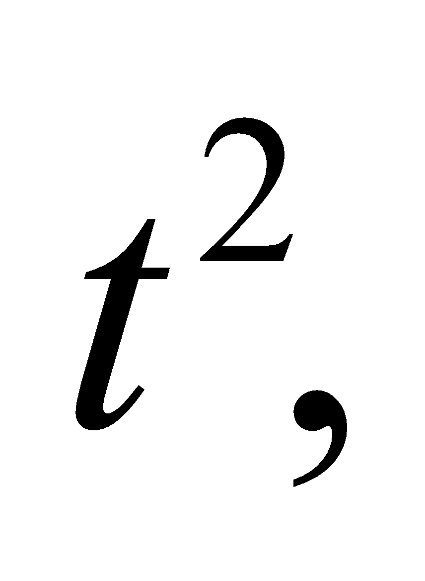 we expect the magnetic field strength to increase as 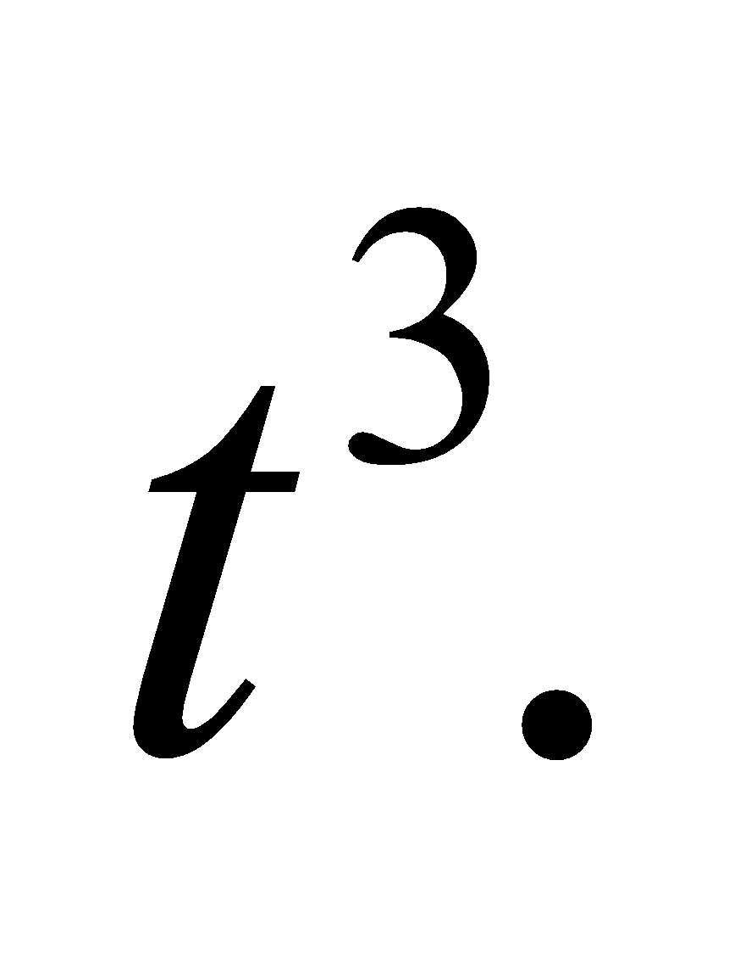

**33. Interpret** This problem involves Faraday’s law, which we can use to find current in the loop under the given conditions.

**Develop** Apply Faraday’s law (Equation 27.2) and Ohm’s law (Equation 27.5) to the circuit to find

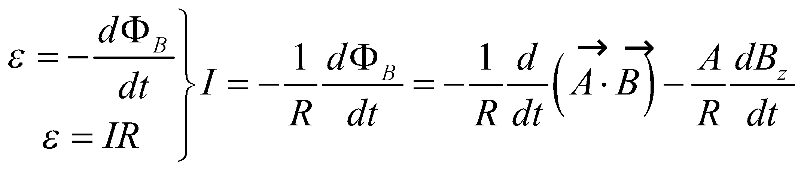

Inserting *Bz* = *at*2 − *b* gives

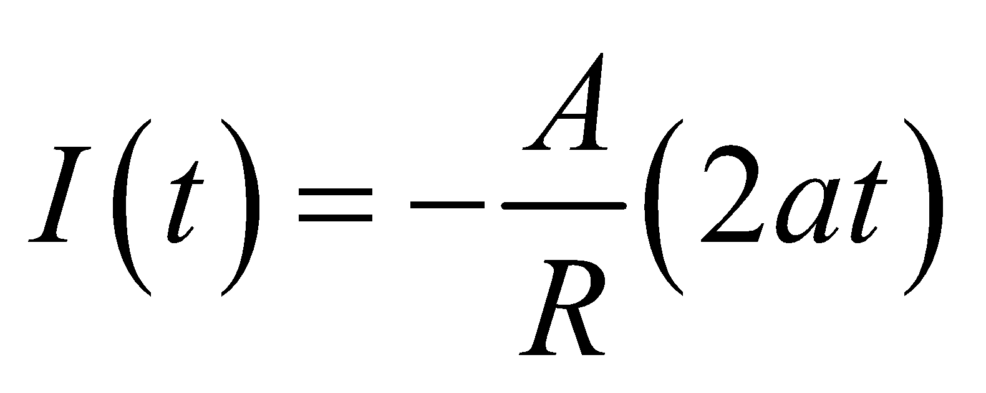

**Evaluate** (**a**) Inserting *t* = 3 s gives

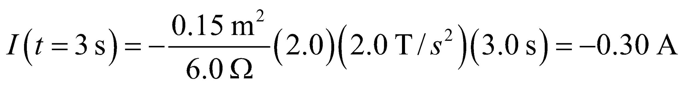

(**b**) *B*z = 0 implies *at*2 = *b*, or 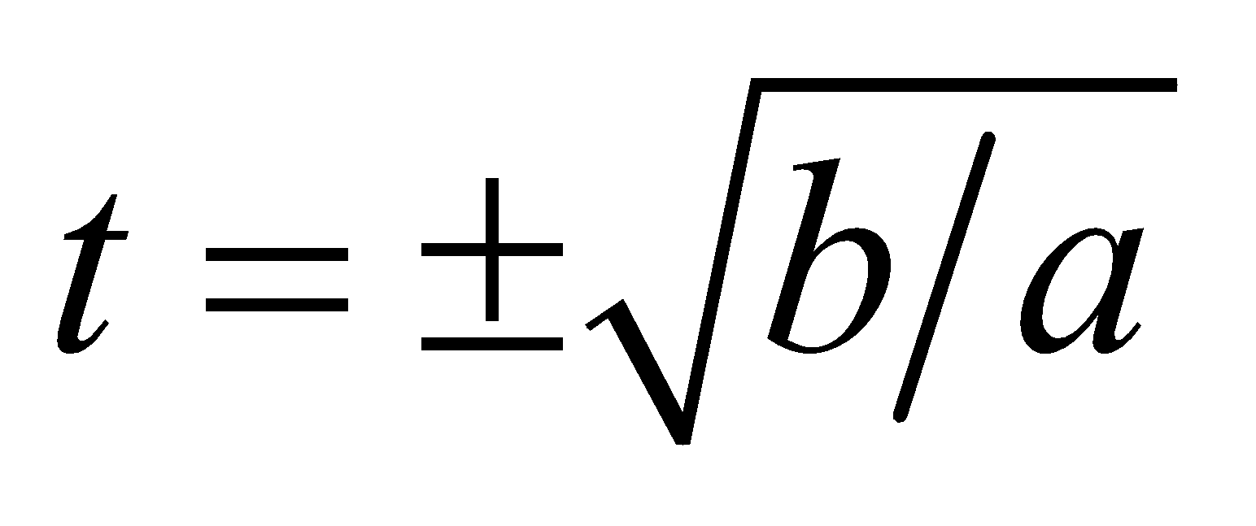. At this time, the current is

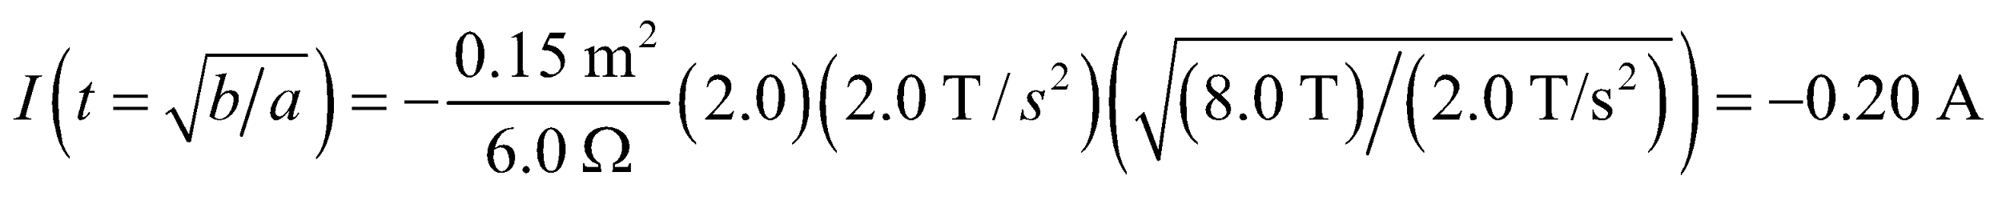

**Assess** The negative sign indicates the current direction with respect to the direction of the magnetic field. If the *x-y* axes are as shown below and the *z* axis is out of the page, then 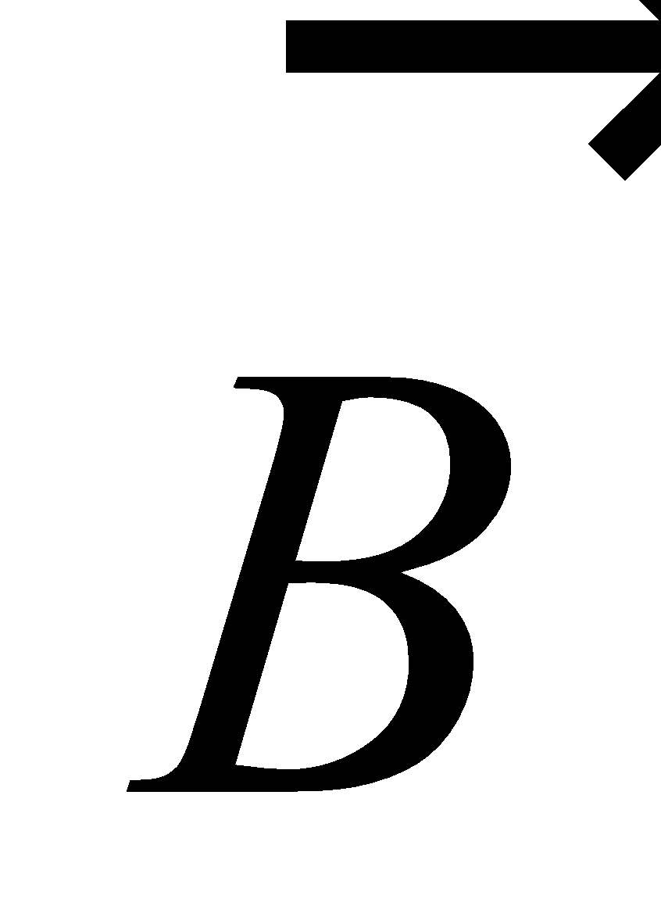 is in the same direction as 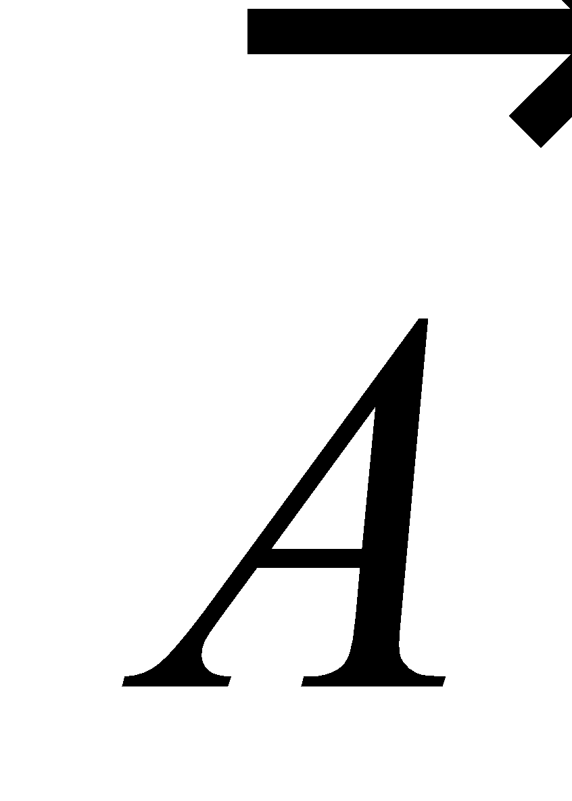 (out of the page). Using the right-hand rule, positive currents run counterclockwise and negative currents run clockwise around the loop.



**34. Interpret** This problem is about the work done by an external agent to move a loop at a constant speed across a region with uniform magnetic field.

**Develop** The loop can be treated analogously to the situation analyzed in Section 27.3, under the heading “Motional EMF and Lenz’s Law”; but instead of exiting the field region at constant velocity, the loop is entering. All quantities have the same magnitudes, except the current in the loop is CCW instead of CW, as in Fig. 27.13.

**Evaluate** Since the applied force acts over a displacement equal to the side-length of the loop, the work done can be calculated directly:

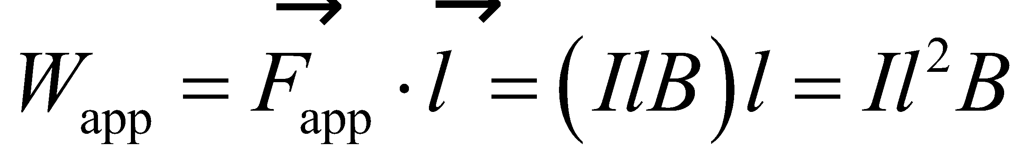

Since the induced current is

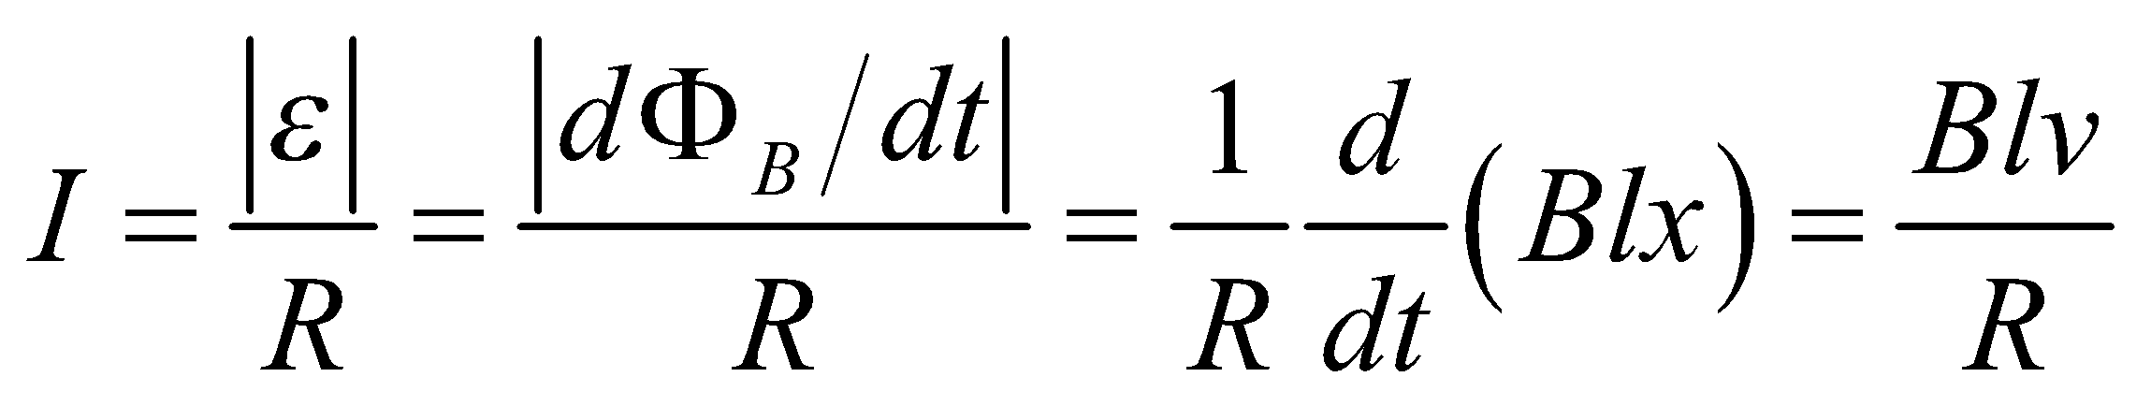

the work applied by the external agent is

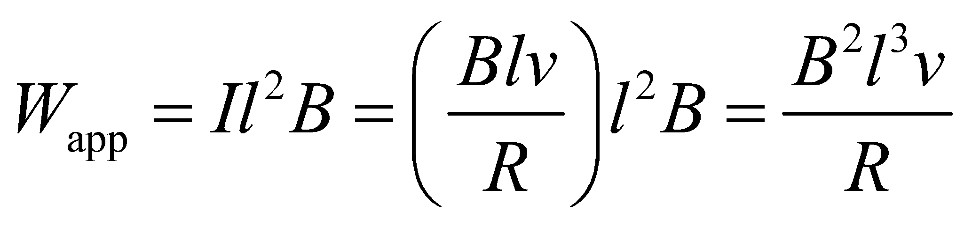

**Assess** Alternatively, the work can be calculated from conservation of energy:

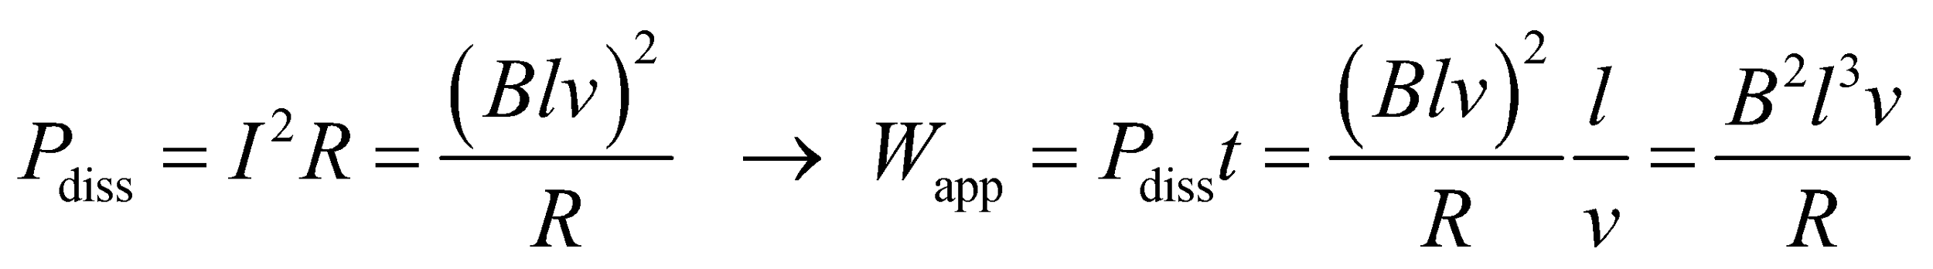

**35. Interpret** This problem is similar to Example 27.5; it involves a conducting loop rotating in a uniform, static magnetic field, so the change in the magnetic field flux through the loop results from the rotation.

**Develop** Use the result of Example 27.5, which shows that

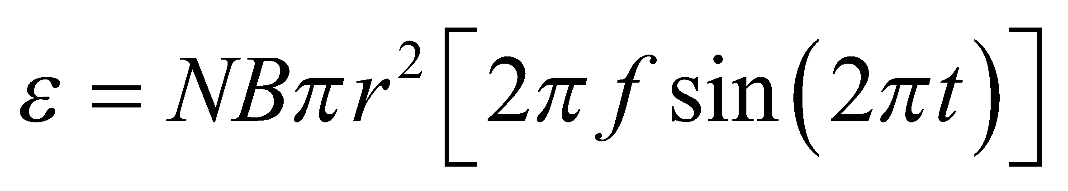

**Evaluate** The maximum emf occurs at

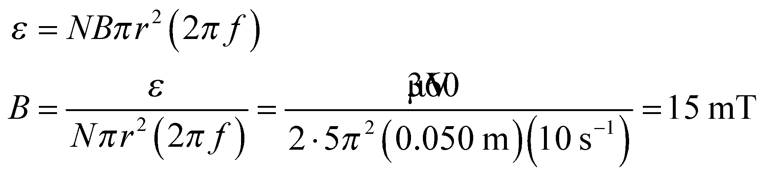

**Assess** Because the maximum of the sine function is unity, we do not need to know at what time the maximum occurs.

**36. Interpret** This problem involves finding the magnetic flux through a square in a nonuniform magnetic field.

**Develop** Use the coordinate system sketched below. We take elements of area to be 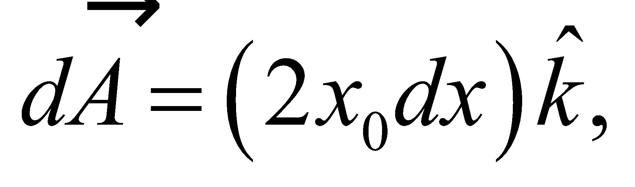 which are rectangular strips parallel to the *y* axis. The flux through the loop is then equal to 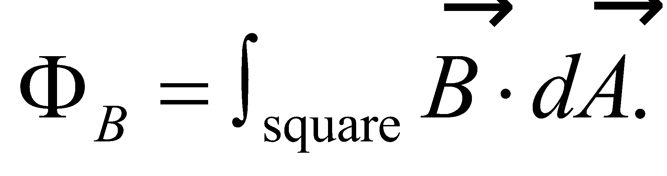



**Evaluate** The integral gives

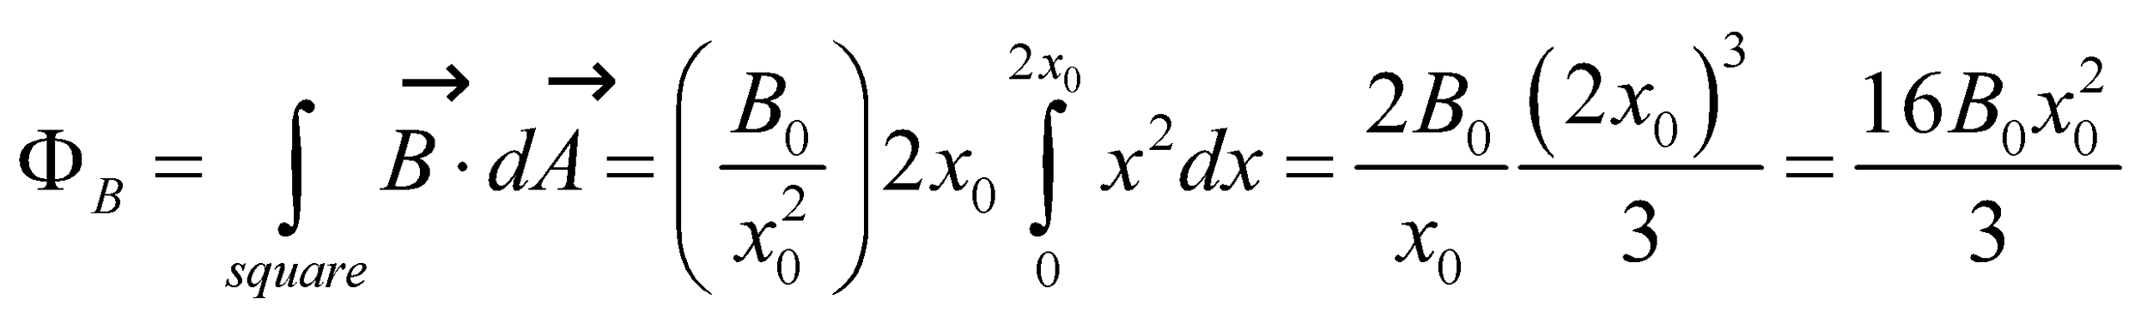

**Assess** The quantity 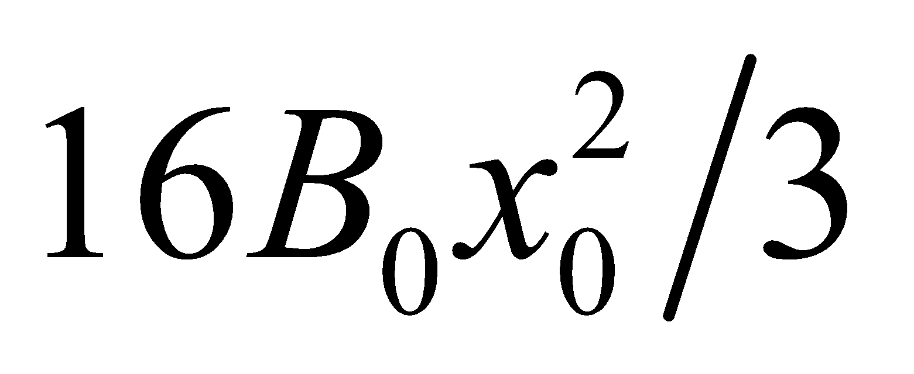 has units of  which is what we expect of a magnetic flux.

**37. Interpret** This problem involves a magnetic field that is changing in time, so that the flux through a loop in this field changes. Thus, we can apply Faraday’s law to find the induced emf.

**Develop** To shine at full brightness, the potential drop across the bulb must be 6 V. This is equal to the induced emf, if we neglect the resistance of the rest of the loop circuit. From Faraday’s law (Equation 27.2),

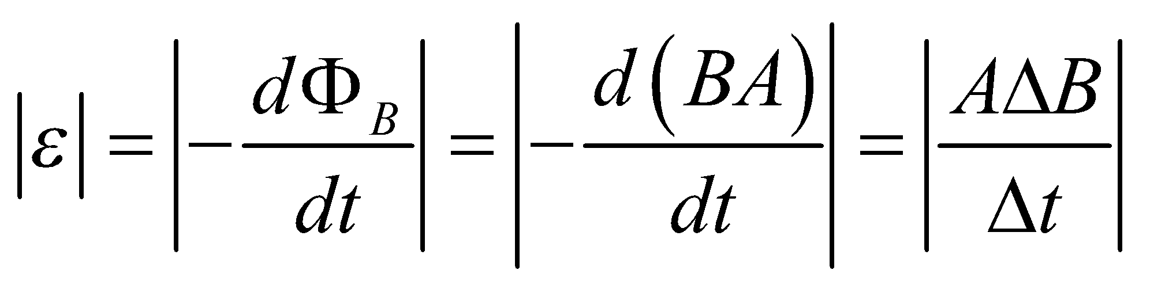

**Evaluate** (**a**) Inserting the given quantities gives

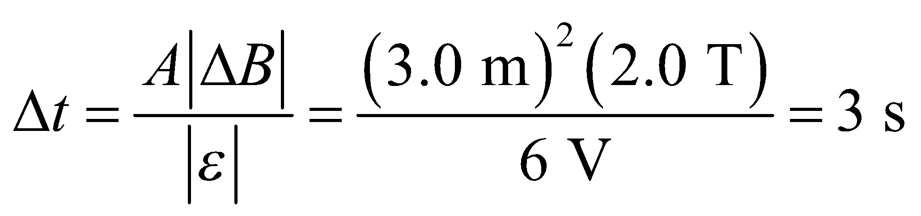

(**b**) The direction of current opposes the decrease of  into the page, and thus must act to increase  into the page. From the right-hand rule, this corresponds to a clockwise current in Fig. 27.38.

**Assess** The units of the expression work out to be units of time:

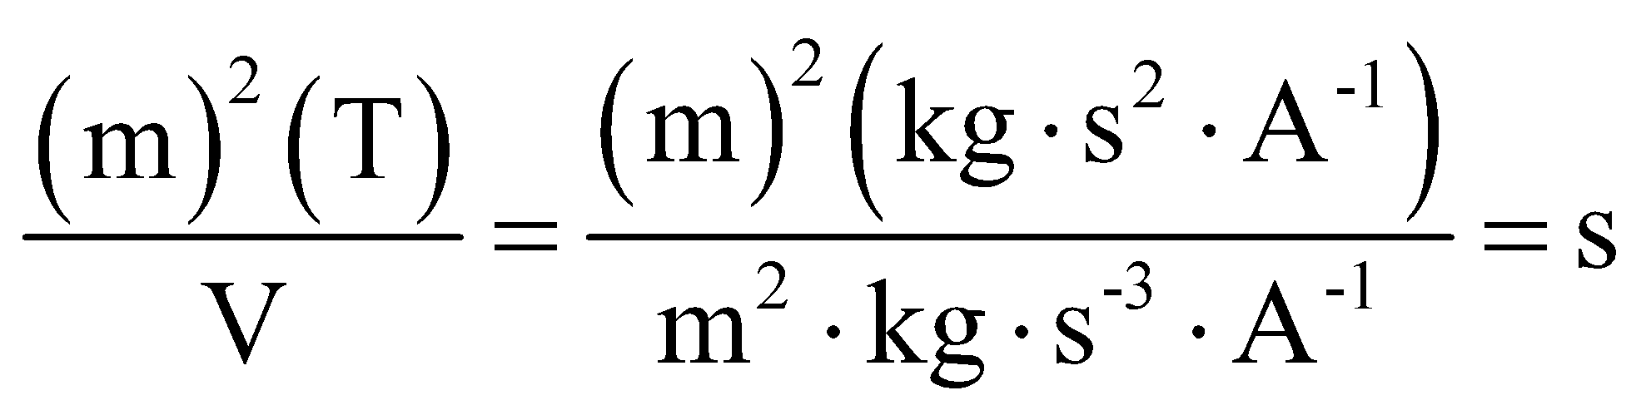

**38. Interpret** This problem involves a current induced in a rectangular loop due to a nearby time-varying current source. The time-varying current source creates a time-varying magnetic field, so Faraday’s law will be involved.

**Develop** The normal to the loop in Fig. 27.7 is taken to be in the direction of the magnetic field of the wire, or into the page, so the positive sense of circulation around the loop is clockwise (from the right-hand rule). Faraday’s and Ohm’s laws (Equations 27.2 and 26.5) give an induced current in the loop of

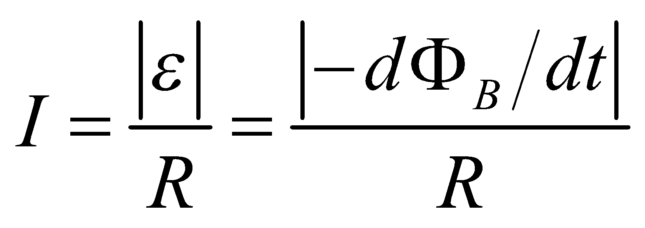

The magnetic flux has been calculated in Example 27.2:

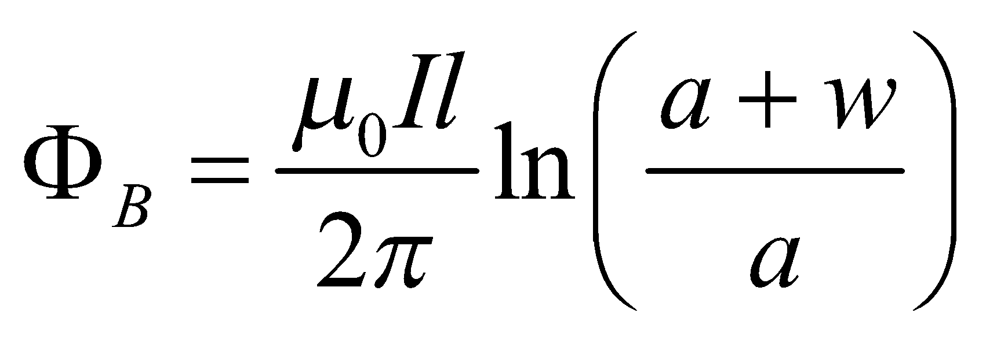

**Evaluate** Combining the above expressions gives

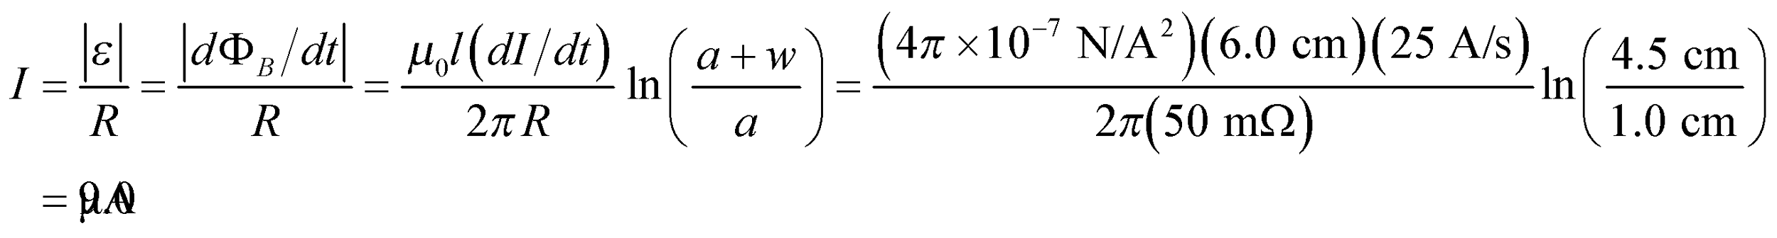

By Lenz’s law, the induced current is counterclockwise in the loop.

**Assess** As the inward flux increases (because the current in the long wire is increasing), by Lenz’s law, the induced current must flow in the counterclockwise direction to produce an outward flux to oppose the change.

**39. Interpret** The solenoid current is varying in time, so the magnetic field in the solenoid varies in time and Faraday’s law will be involved in finding the current induced through the wire loop in the solenoid.

**Develop**  The magnetic field inside the solenoid is 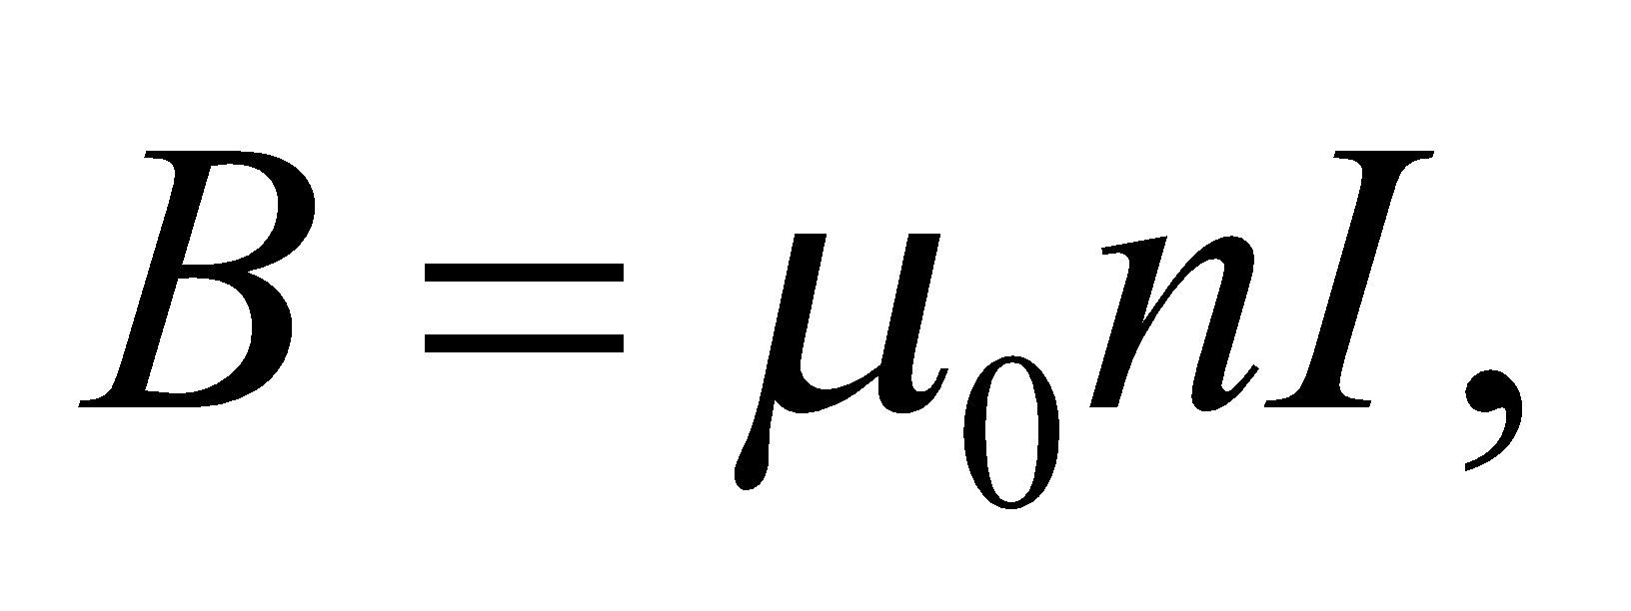 so the flux through the loop is 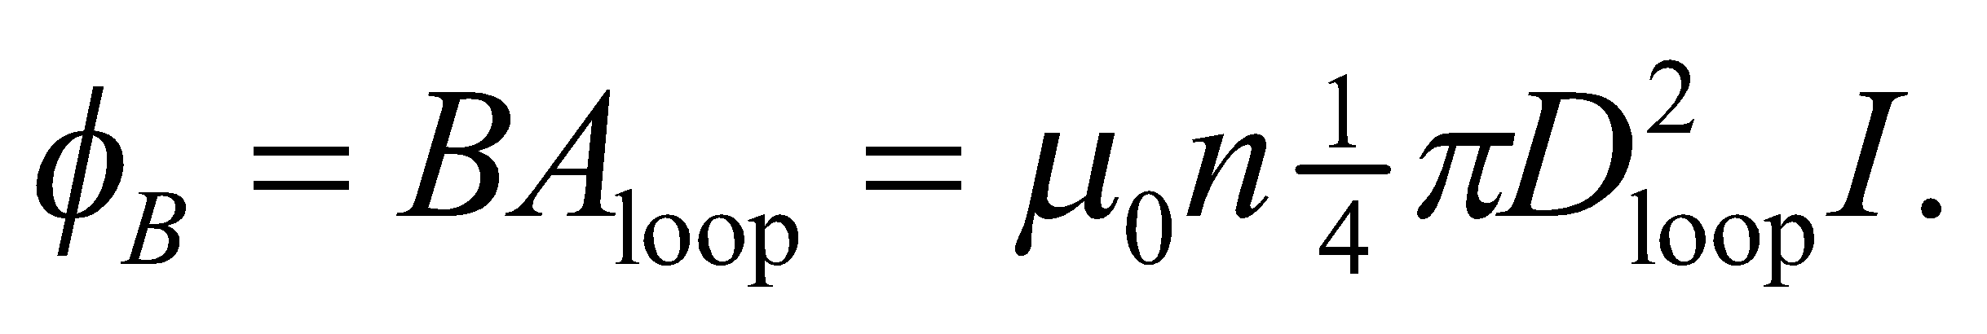 From Faraday’s and Ohm’s laws (Equations 27.2 and 26.5), the magnitude of the induced current is

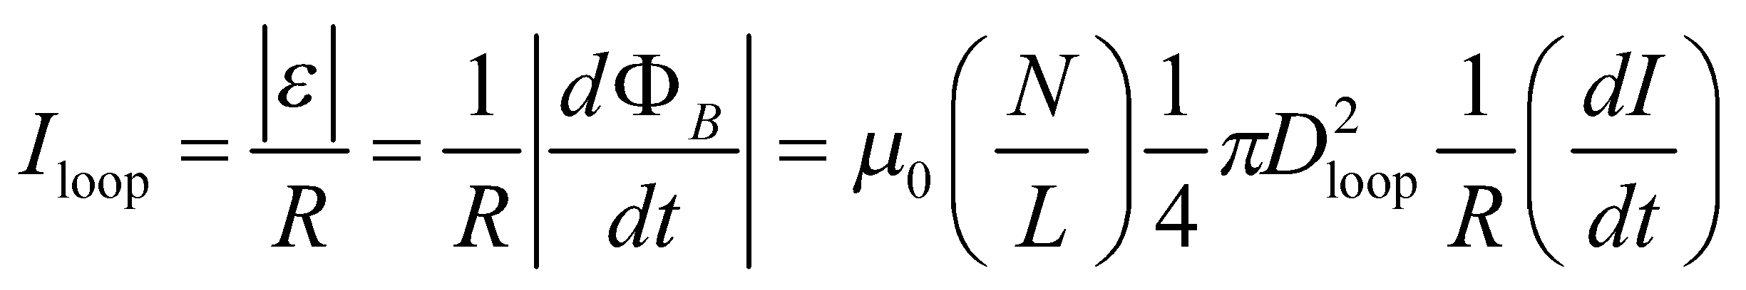

**Evaluate** (a) Inserting the given quantities gives

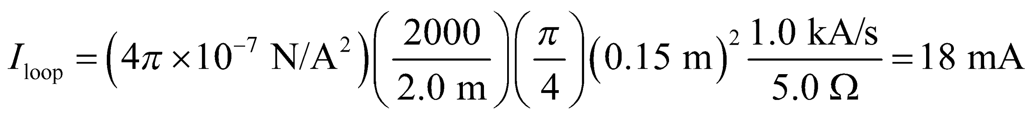

(b) If the loop encloses the solenoid, then 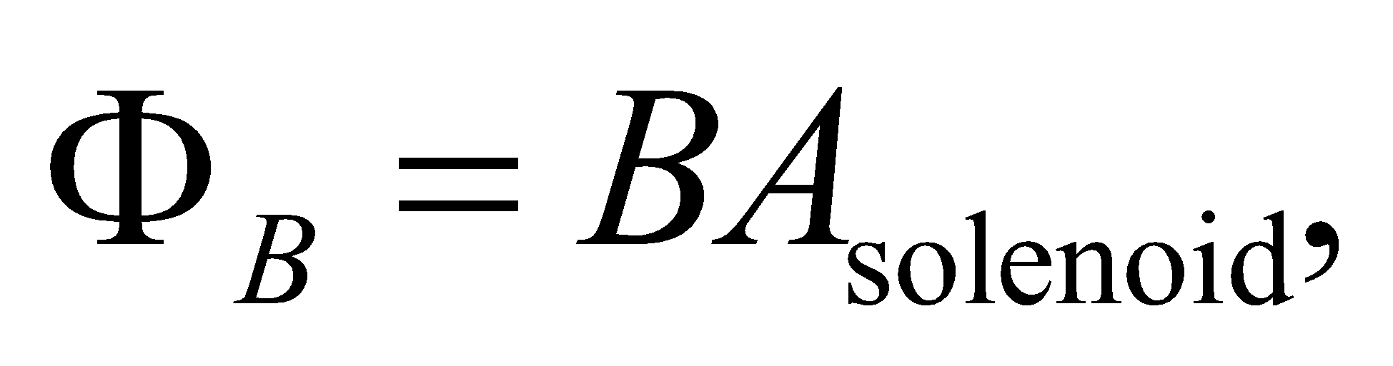 and the induced current would increase to 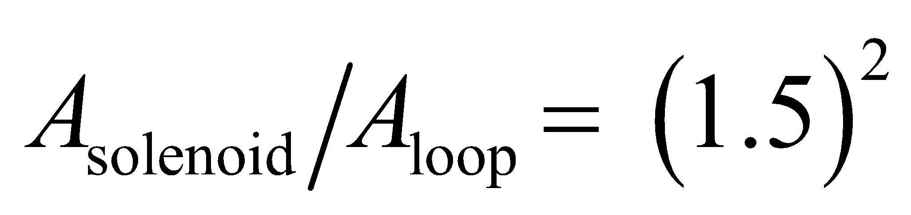 times the value in part **(a)**, or 40 mA.

**Assess** The current is greater in the outer loop because the loop encircles greater flux.

**40. Interpret** We're asked what rate an applied magnetic field should be changed to heat a stent inside a person's body. The changing magnetic field will induce an emf according to Faraday's law, and the stent's inherent resistance will dissipate the heat.

**Develop**Faraday's law says that the induced emf in the stent will be equal to the change in the magnetic flux: 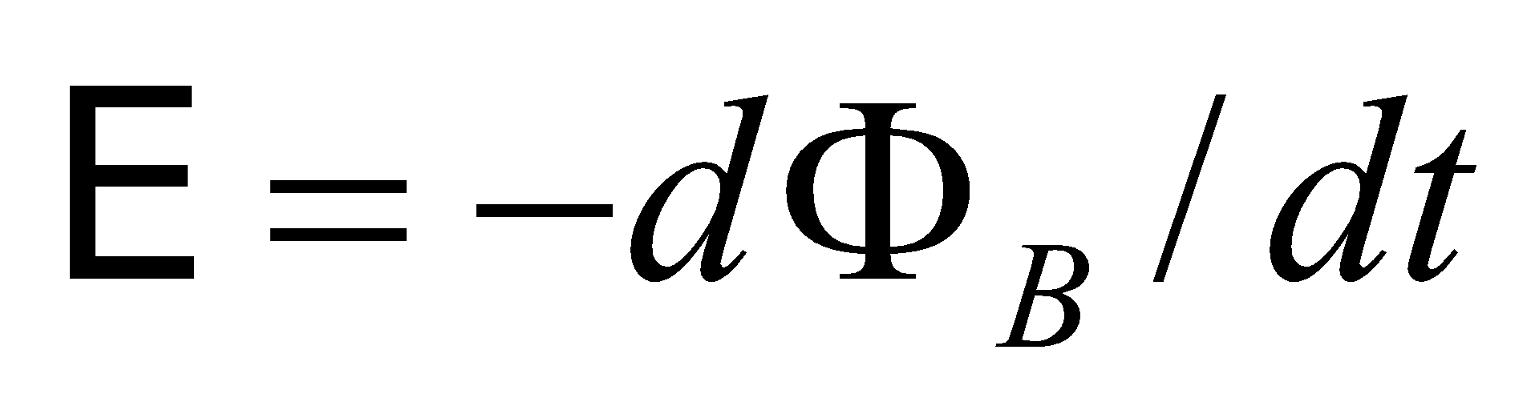 (Equation 27.2). We won't worry about the minus sign, since we're only interested in the magnitude of the current generated, not its direction. If we treat the stent as a loop, the magnetic flux through it is given in Equation 27.1b: 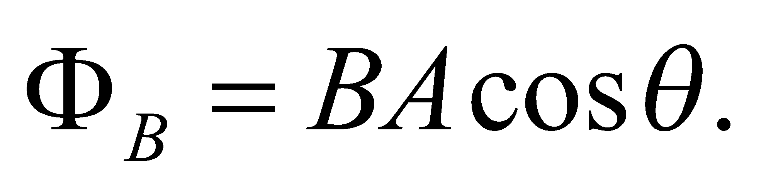 The magnetic field is the only thing that is changing 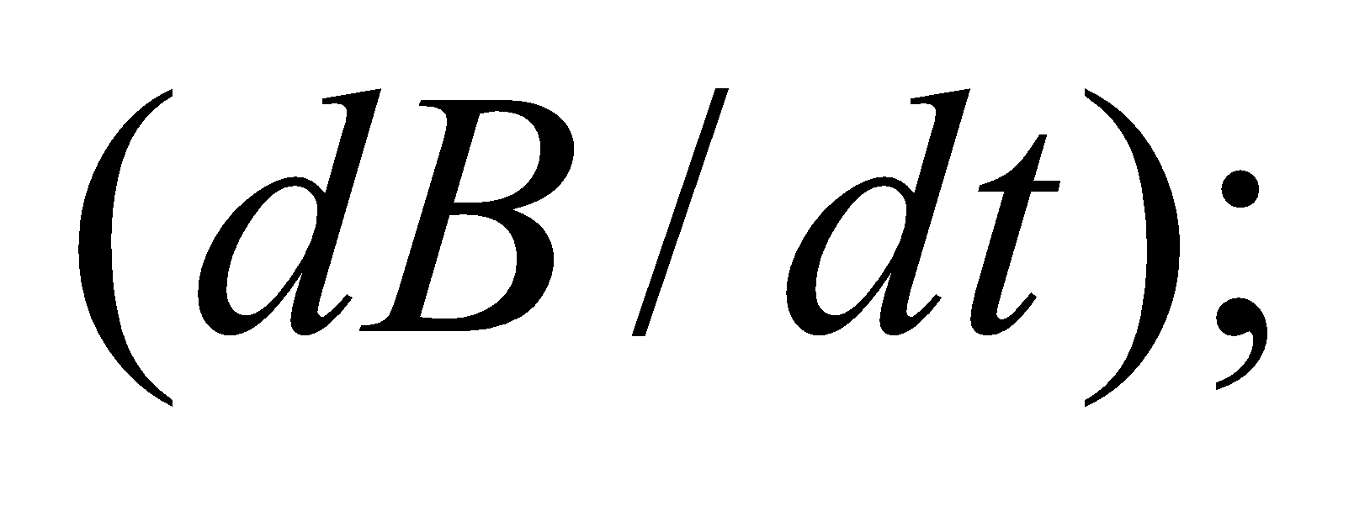 the area and the orientation are constant. We're told the stent is oriented optimally, which means its area is perpendicular to the field 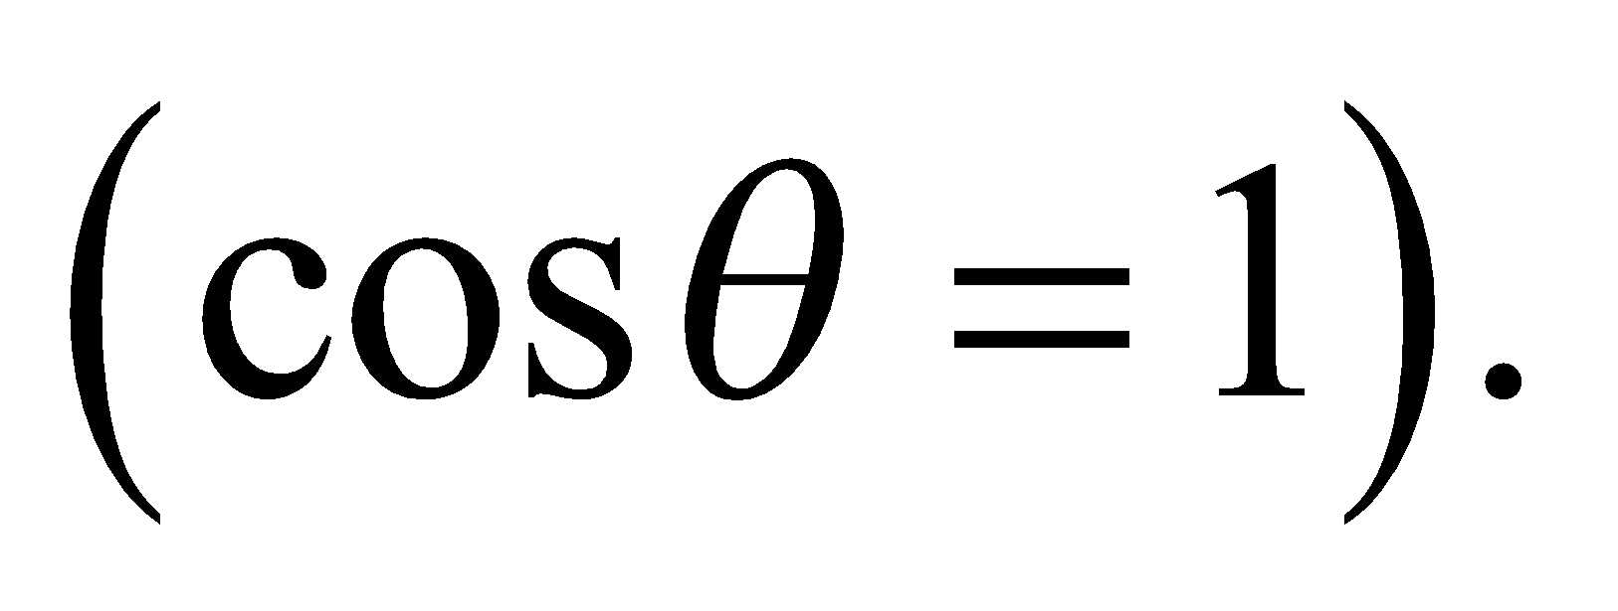

**Evaluate**We're given the desired power output of the circuit, which in terms of the induced emf is 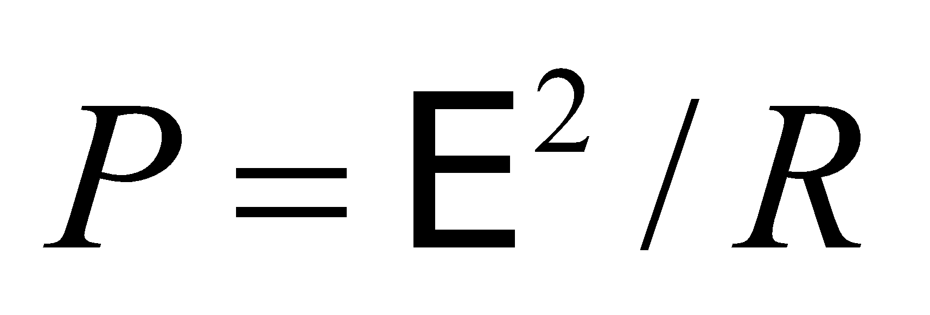 (Equation 24.8b). Solving for the rate of magnetic field change gives

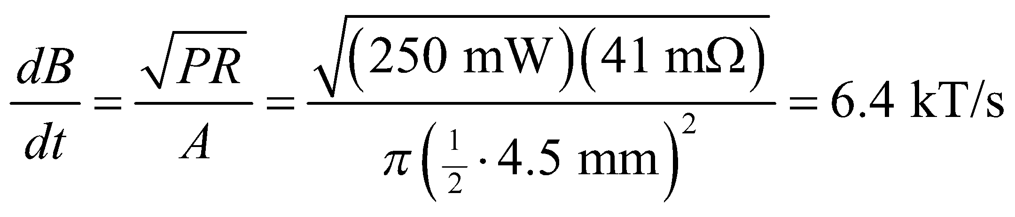

**Assess**This might seem surprisingly large, but remember that this is not the magnitude of the field but the rate that the field changes. One way to obtain the necessary emf is by turning on and off a 6.4-T field every millisecond, or by turning on and off a 6.4-mT field every microsecond.

**41. Interpret** This problem involves a time-varying magnetic field that is spatially uniform. This causes a changing magnetic flux through a conducting loop, so Faraday’s law will lead to an induced emf.

**Develop** Faraday’s and Ohm’s laws give the current in the loop:

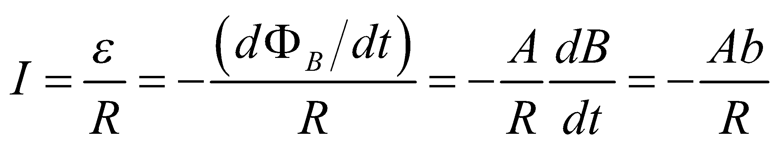

**Evaluate** (**a**) Inserting the given values leads to

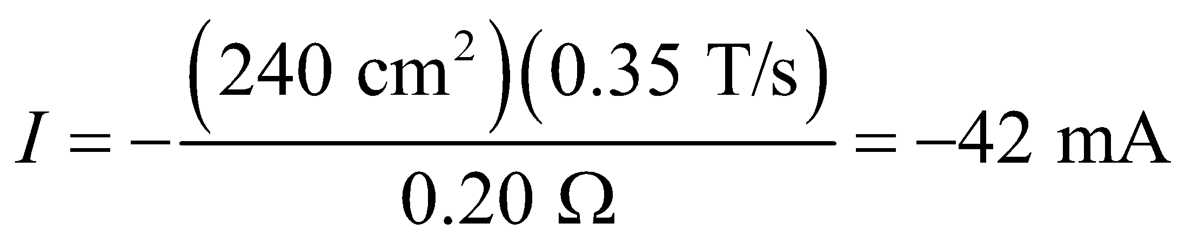

A normal to the loop is parallel to the *z*-axis and corresponds to counterclockwise positive circulation (via the right-hand rule), when viewed from above. The minus sign thus indicates a clockwise circulation when viewed from the positive *z*-axis.

**Assess** The time-varying magnetic field causes a current to pass through the conducting loop.

**42. Interpret** An alternator is basically an electric generator running off of a fraction of the power supplied by a car's engine. You need to determine the magnetic field for a new alternator design, given the desired peak voltage and the coil size and turning rate. The magnetic field is needed to induce an emf in the rotating coil, according to Faraday's law.

**Develop**The magnetic flux in this case is changing due to the changing orientation of the coil. As in Example 27.5 for a generator, you can write the flux through the multi-turn coil as

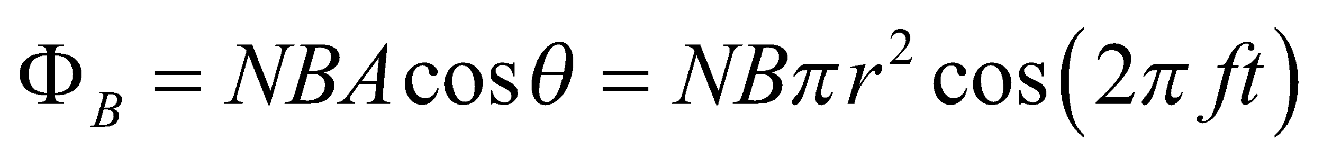

where the frequency *f* is the number of revolutions per second.

**Evaluate**When the coil rotates, the induced emf is

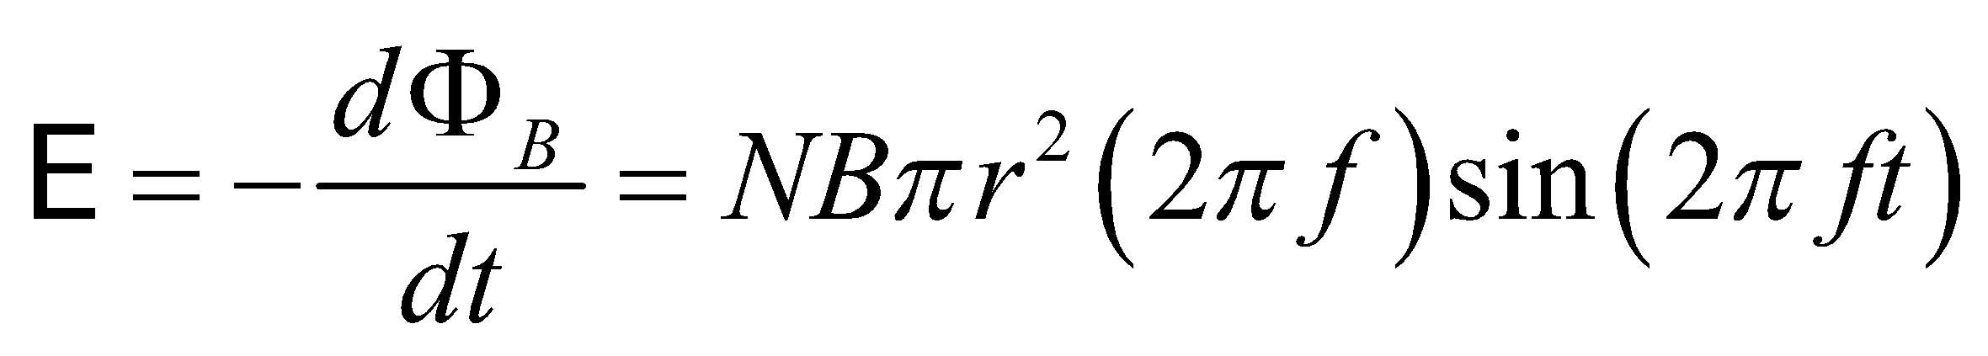

The magnitude of the emf will vary with time, but you need the peak voltage (when the sine term is 1) to be 14 V. From this, you can solve for the magnetic field strength:

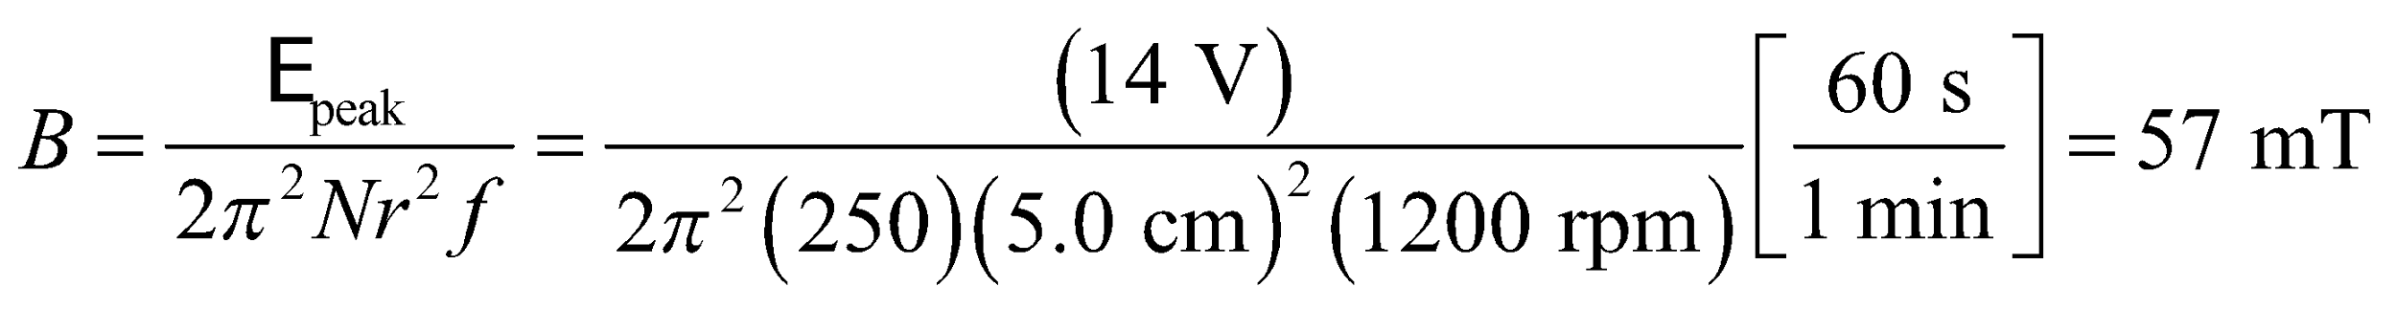

**Assess**This is a reasonable magnetic field for such an application.

**43. Interpret** The aim here is to find the number of turns for the rectangular coil in a generator in order to produce an alternating emf: 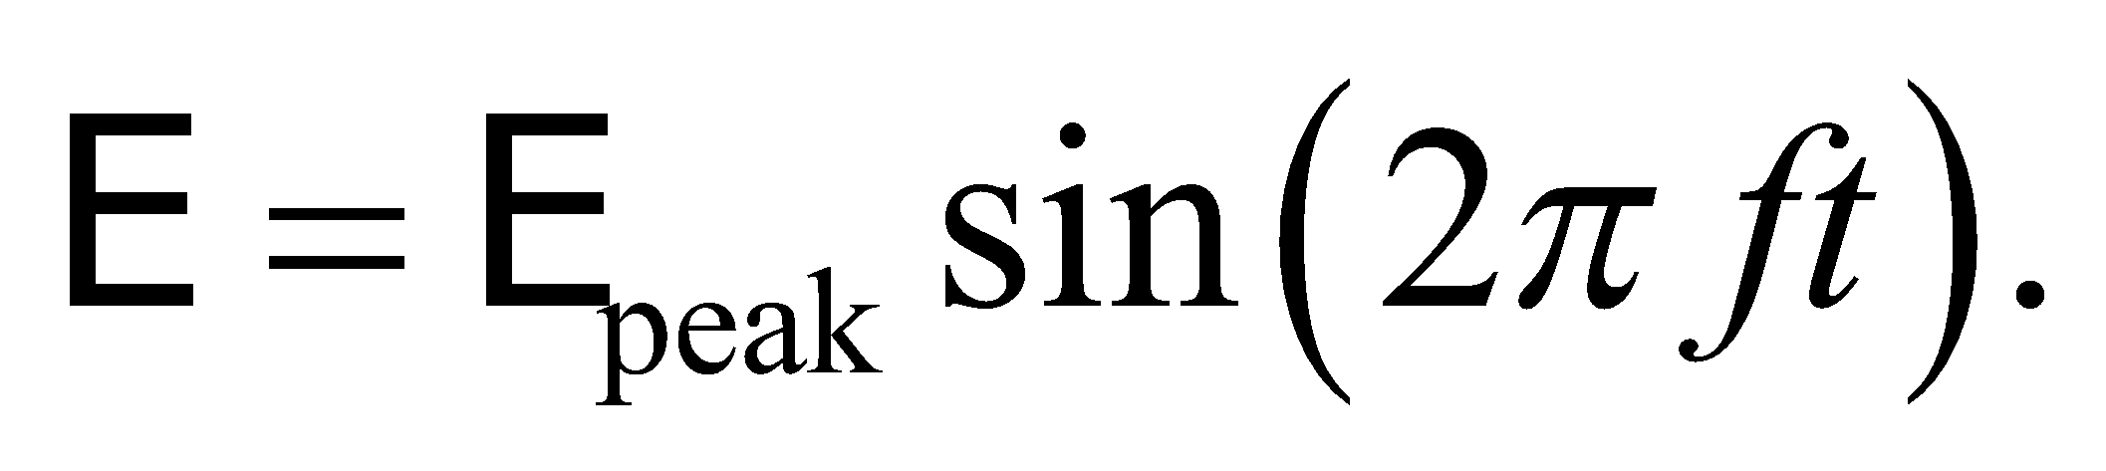

**Develop**In Example 27.5, the expression for the emf from a generator was derived. The only difference in this case is that the coil is rectangular not circular:

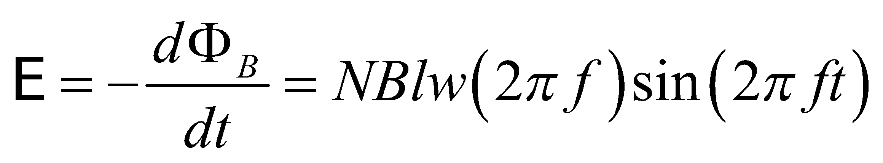

**Evaluate**Solving for *N*, the number of turns, gives

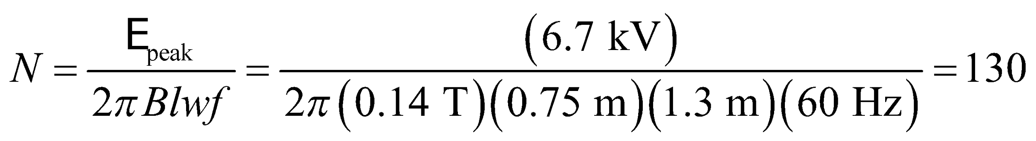

**Assess**Notice that the alternating emf frequency is simply set by the rotation rate of the coil.

**44. Interpret** We have a circuit formed by the rails, a resistance, and a conducting bar. As the bar slides along the rails, the circuit area increases and a current is induced because the circuit encloses more flux (i.e., Faraday’s law). We are interested in the rate of work done by an external agent to move the conducting bar.

**Develop** To find the direction of the current in the loop, we note that since the area enclosed by the circuit, and the magnetic flux through it, are increasing, Lenz’s law requires that the induced current opposes this with an upward induced magnetic field. To answer part **(b)**, we make use of the result obtained in Example 27.4, which analyzes the same situation. In this example, the current in the bar is found to be 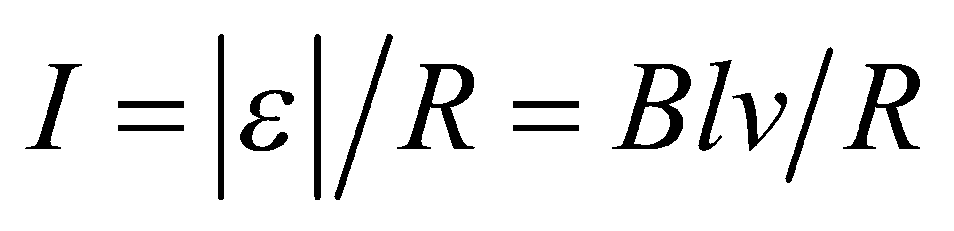. Because this is perpendicular to the magnetic field, the magnetic force on the bar is 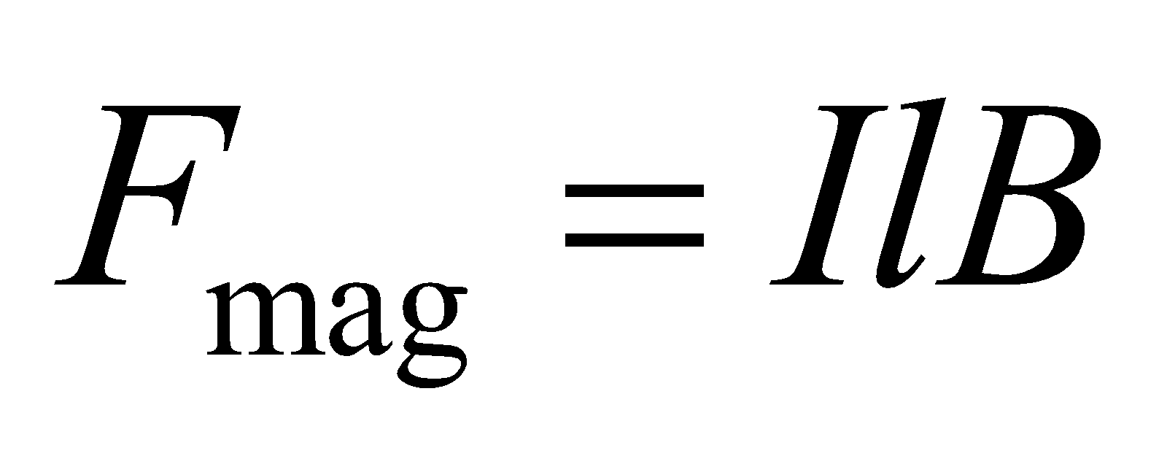 (to the left in Fig. 27.39). The agent pulling the bar at constant velocity must exert an equal force in the direction of *v*.

**Evaluate** **(a)** From the right-hand rule, the induced current must circulate counterclockwise. Take the positive sense of circulation around the circuit to be clockwise, so that the normal to the area is in the direction of *B* (i.e., into the page).

**(b)** The rate of work done by the external agent is

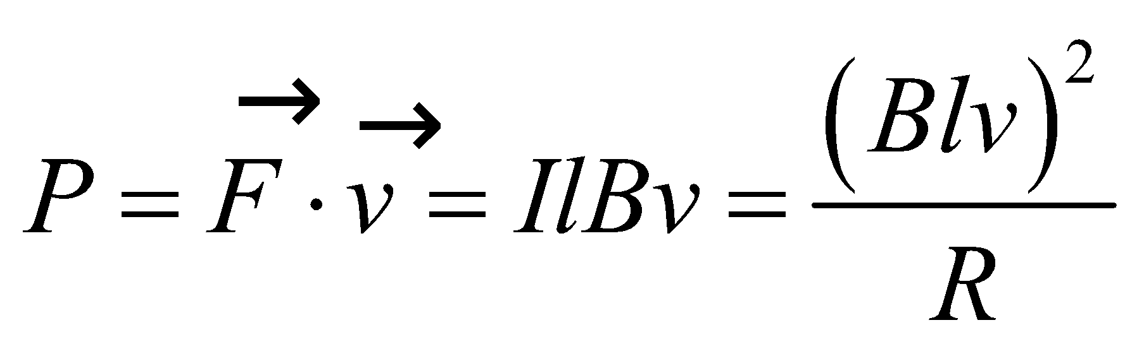

**Assess** The conservation of energy requires that the work done by the agent be equal to the rate energy is dissipated in the resistor (we neglected the resistance of the bar and the rails), 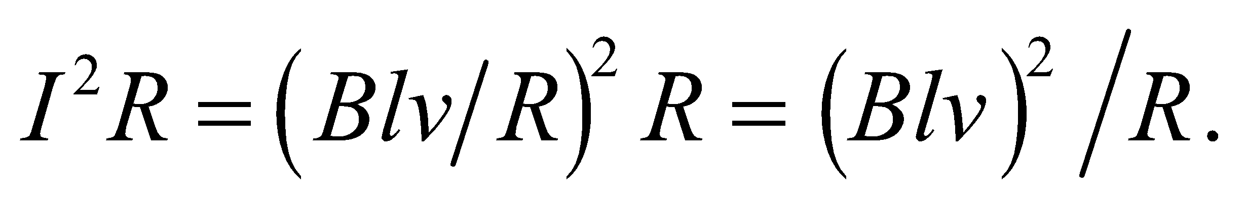 An alternative way to determine the direction of the current is to note that the force on a (hypothetical) positive charge carrier in the bar, 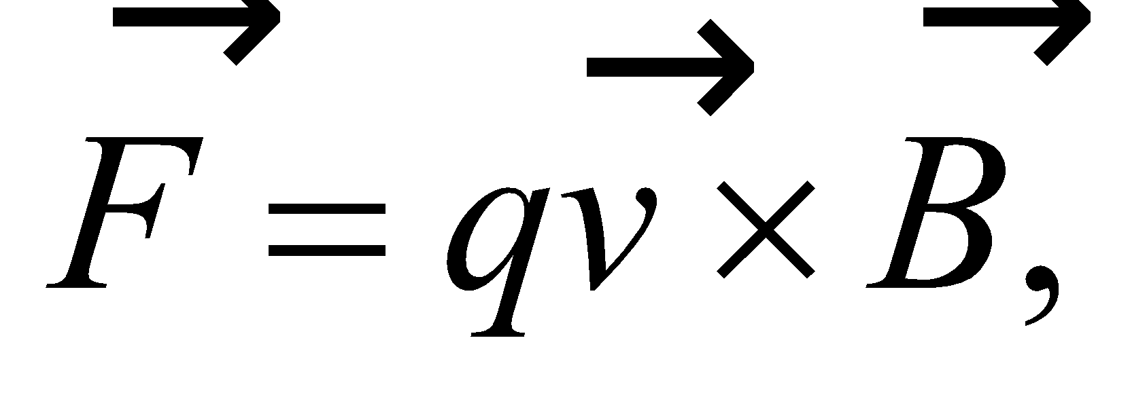 is upward in Fig. 27.39, so current will circulate counterclockwise around the loop containing the bar, the resistor, and the rails (i.e., downward in the resistor. The force per unit positive charge is the motional emf in the bar.

**45. Interpret** This problem involves using Lenz’s law to find the sign of the voltage across the two rails in the preceding problem.

**Develop** As per the discussion for Problem 27.44, Lenz’s law requires the current to try to circulate counterclockwise to generate an upward magnetic field to compensate for the increased downward magnetic field enclosed by the circuit.

**Evaluate** Because current flows from the positive to the negative terminal of a battery, the positive terminal will be the top bar. Thus, the positive terminal of the voltmeter must be connected to the top bar in Figure 27.39.

(b) When an ideal voltmeter replaces the resistor, no current flows (since its resistance is infinite) so no work is done moving the bar.

**Assess** Note that work is done in accelerating the bar, because charge is separated in this process to charge the capacitor formed by the gap between the upper and lower bars. But once the bar is moving at constant velocity, n work is done.

**46. Interpret** The circuit consists of the rails, the resistance, the conducting bar, and the battery. The emf of the battery will cause a current to circulate in the circuit, which will create a magnetic field. Lenz’s law will tell us the subsequent motion of the conducting bar.

**Develop** To analyze the subsequent motion of the bar, we first note that the battery causes a clockwise current (downward in the bar) to flow around the circuit, as indicated in the sketch below. Thus, there is a magnetic force on the conducting bar of

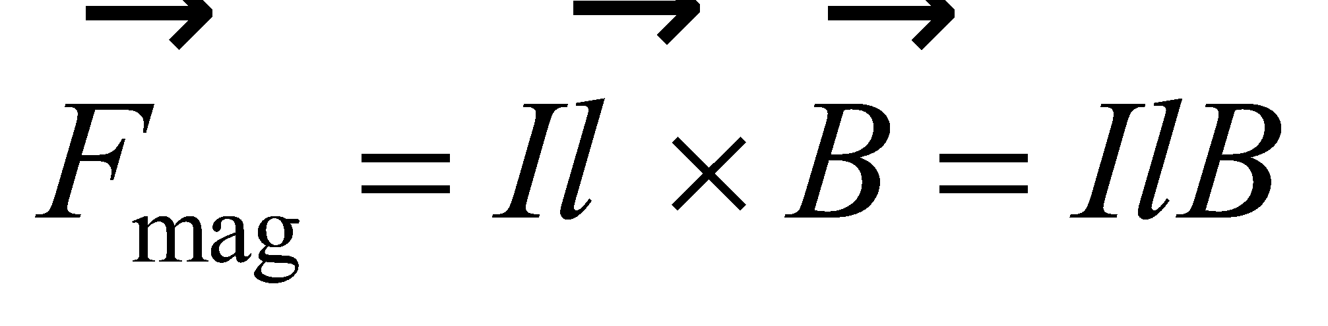

which, using the right-hand rule, is to the right. This force accelerates the bar in that direction. However, as in Example 27.4, the the motion of the bar creates an induced emf 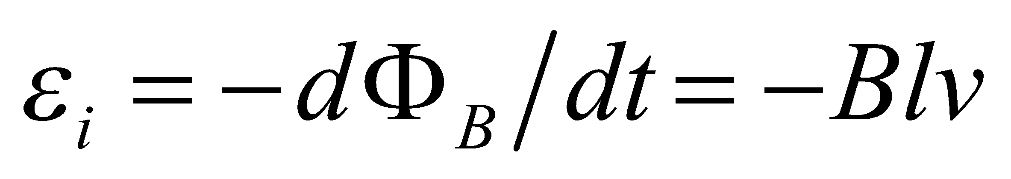 that opposes the battery. By Ohm’s law (Equation 26.5), the instantaneous current is

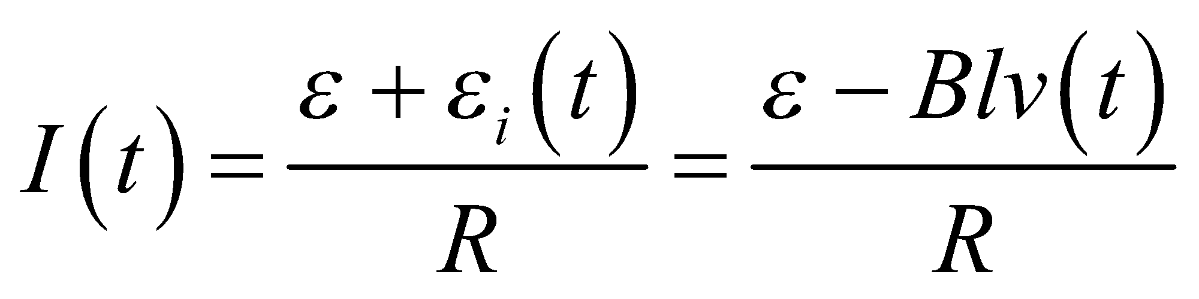

Thus, as the speed *v* increases, the induced current *I* (and the accelerating force) decreases.



**Evaluate** **(a)** The bar will accelerate to the right until it reaches a constant velocity.

**(b)** When 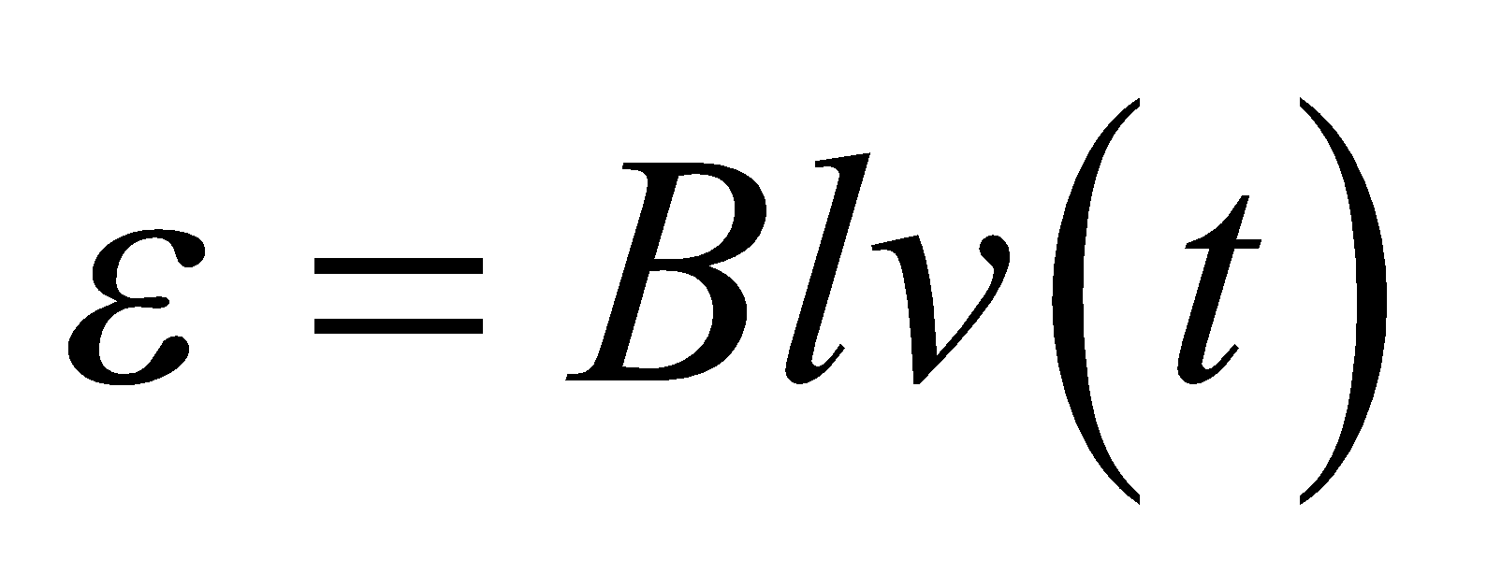, *F*mag = 0 and Newton’s second law tells us that the bar will move with a constant velocity.

**(c)** Solving the expression of part (b) for the velocity, we find that 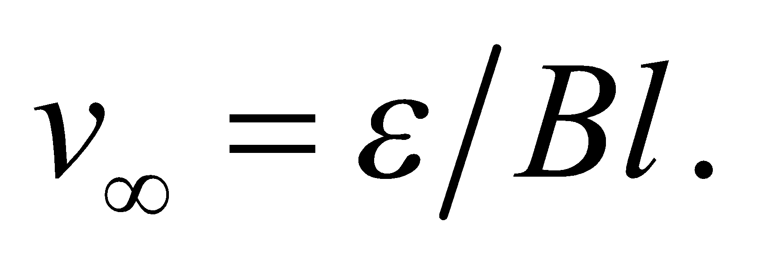 Although 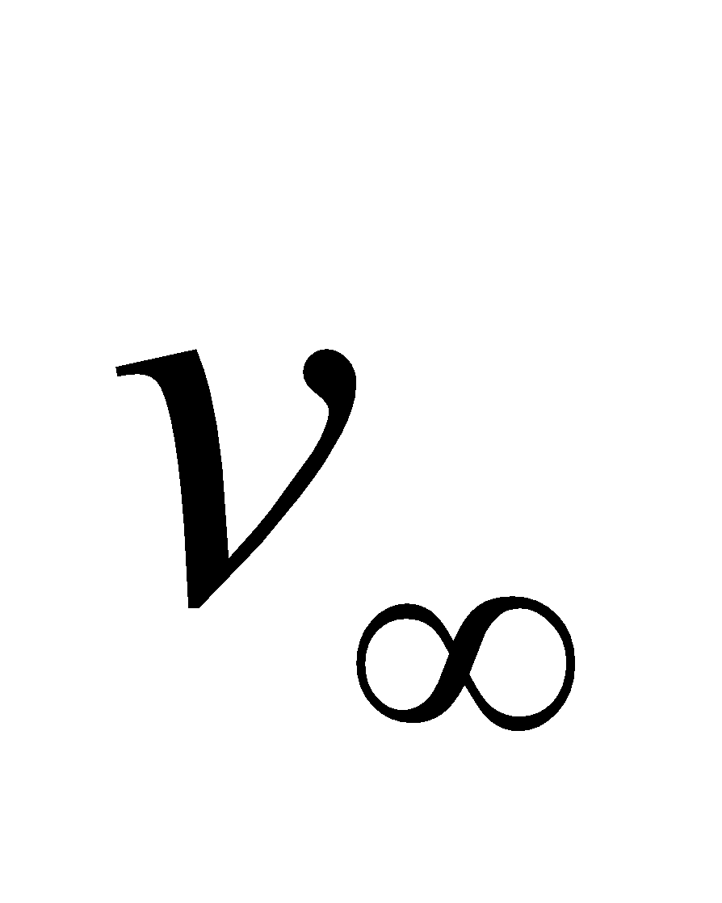 doesn’t depend on the resistance, the value of *R* does affect how rapidly *v* approaches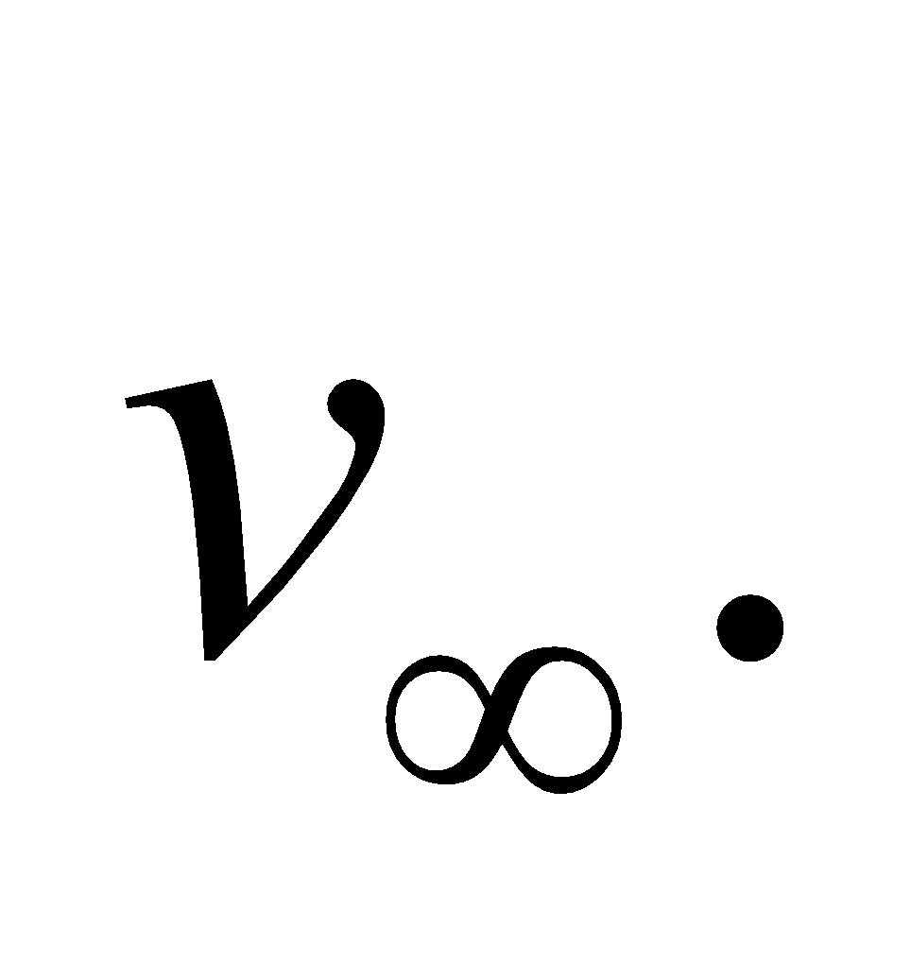For large *R*, *I* charges slowly and *v* takes a long time to reach

**Assess** In this problem, the equation of motion of the bar (mass m) is

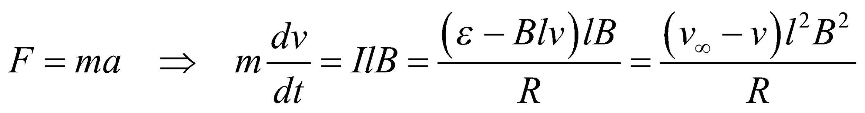

which can be rewritten as

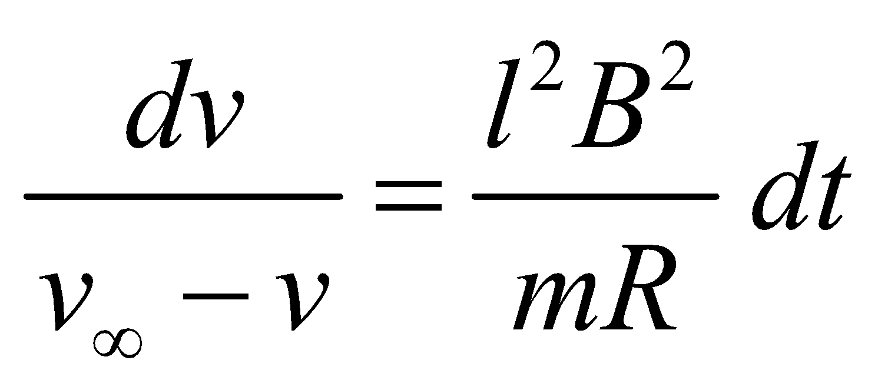

For 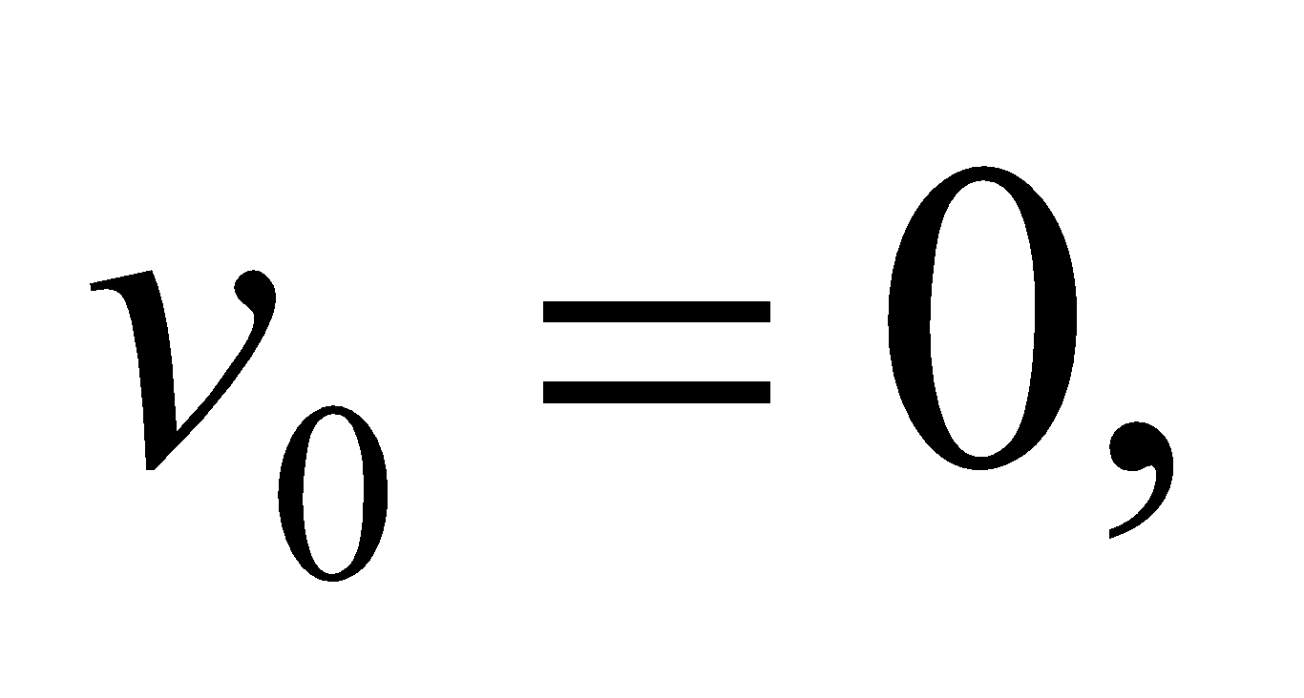 this integrates to 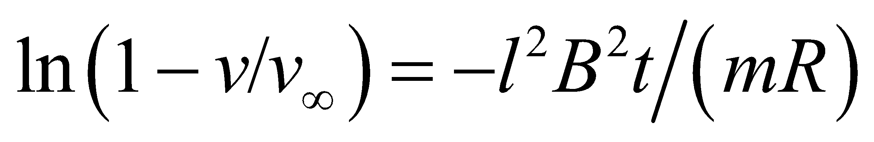 or 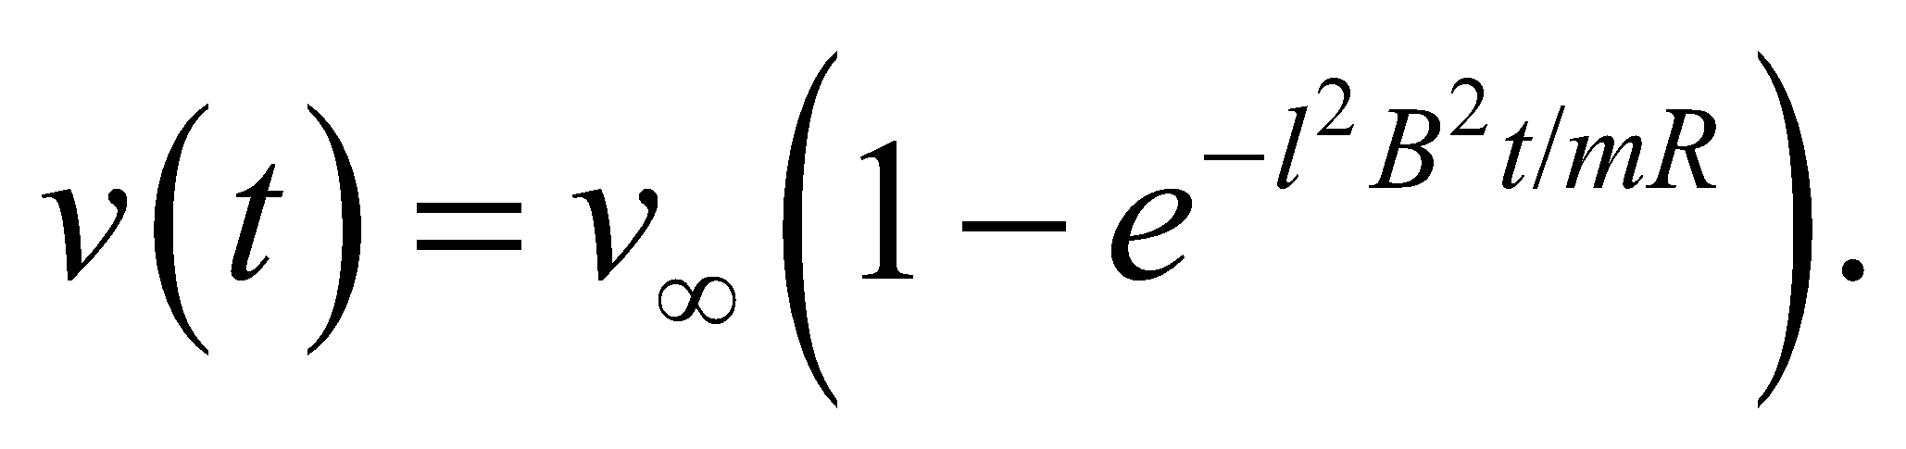 The time constant 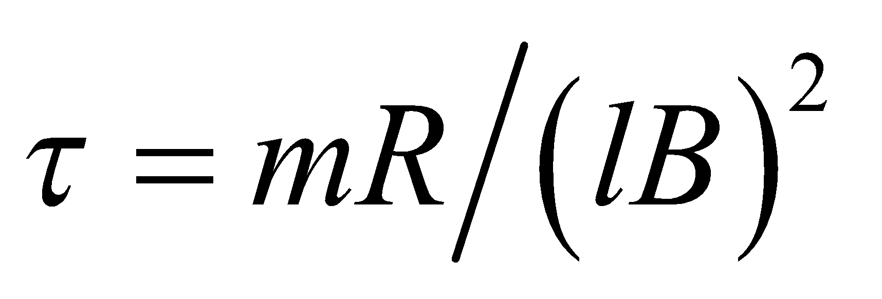 depends on the resistance.

**47. Interpret** This problem is a continuation of Problem 27.44. We are given values for the circuit elements and are asked to quantitatively characterize the circuit’s response to the agent that moves the conducting bar.

**Develop** The situation is like that described in Example 27.4 and the solution to Problem 27.44.

**Evaluate**  **(a)** The current is

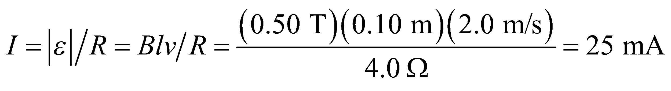

**(b)** The magnetic force on the conducting bar is



to the left.

(**c**) The power dissipated in the resistor is

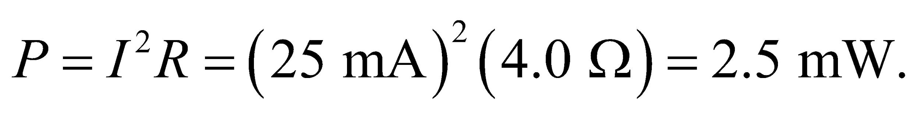

(**d**) The agent pulling the bar must exert a force equal in magnitude to 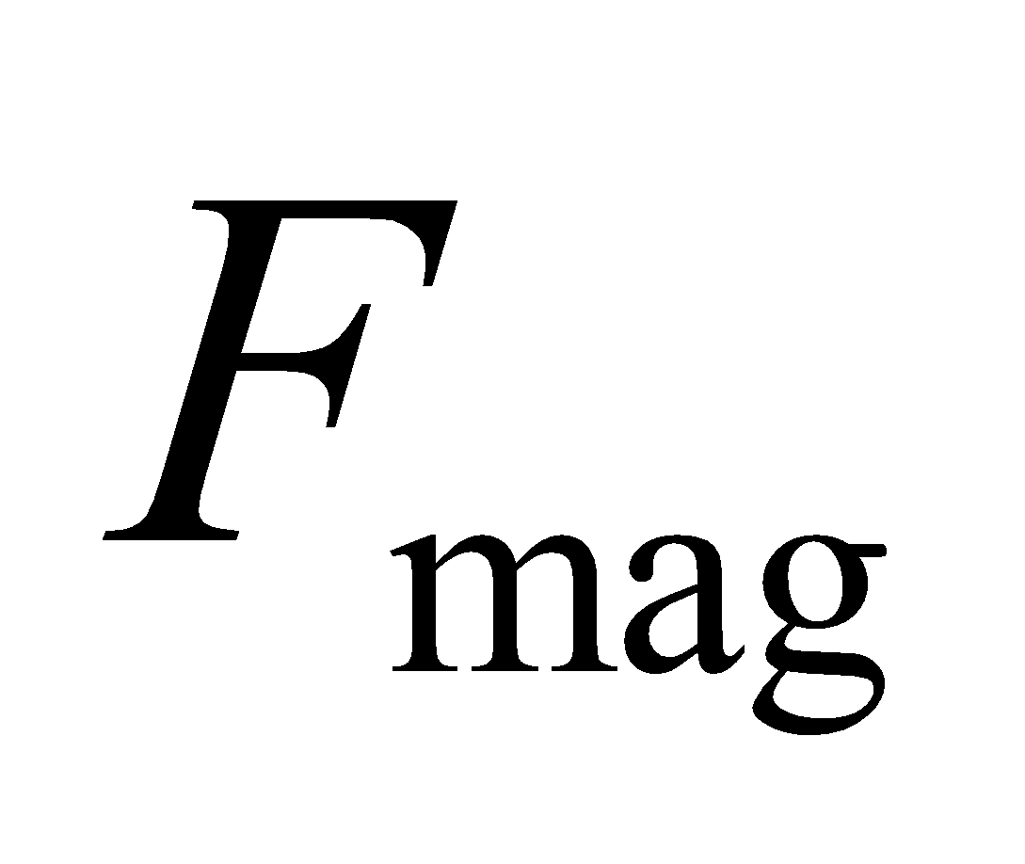 and parallel to *v*. Therefore, it does work at a rate

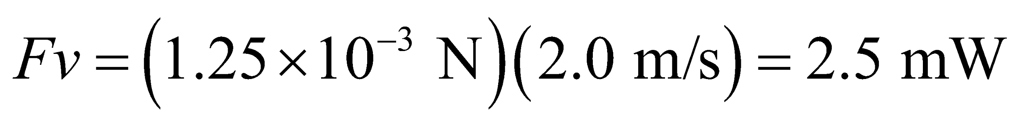

Conservation of energy requires the answers to parts **(c)** and **(d)** to be the same.

**Assess** Note that the answer to part (d) uses the result of part (c) to three significant figures because the result of part (c) serves as an intermediate result in part (d).

**48. Interpret** The problem involves a changing magnetic field that induces an electric field. Both fields exert a force on a proton.

**Develop** The induced electric field inside a long thin cylindrical solenoid, whose magnetic field is increasing with time as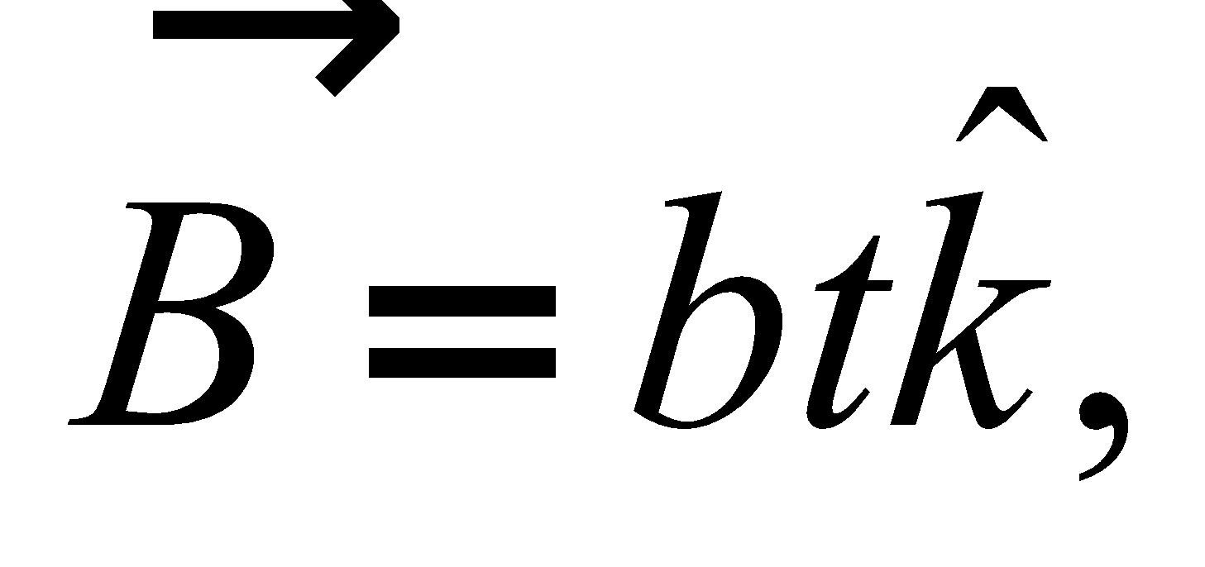(take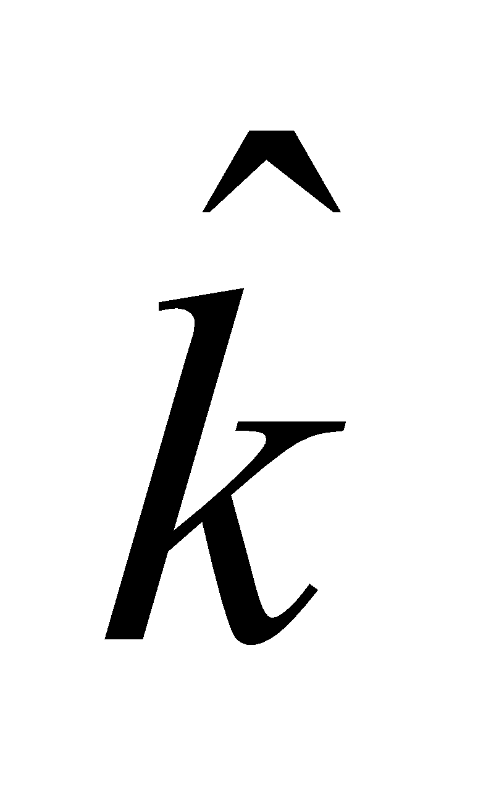into the page as in Fig. 27.30), can be found by modifying the argument in Example 27.11 for radius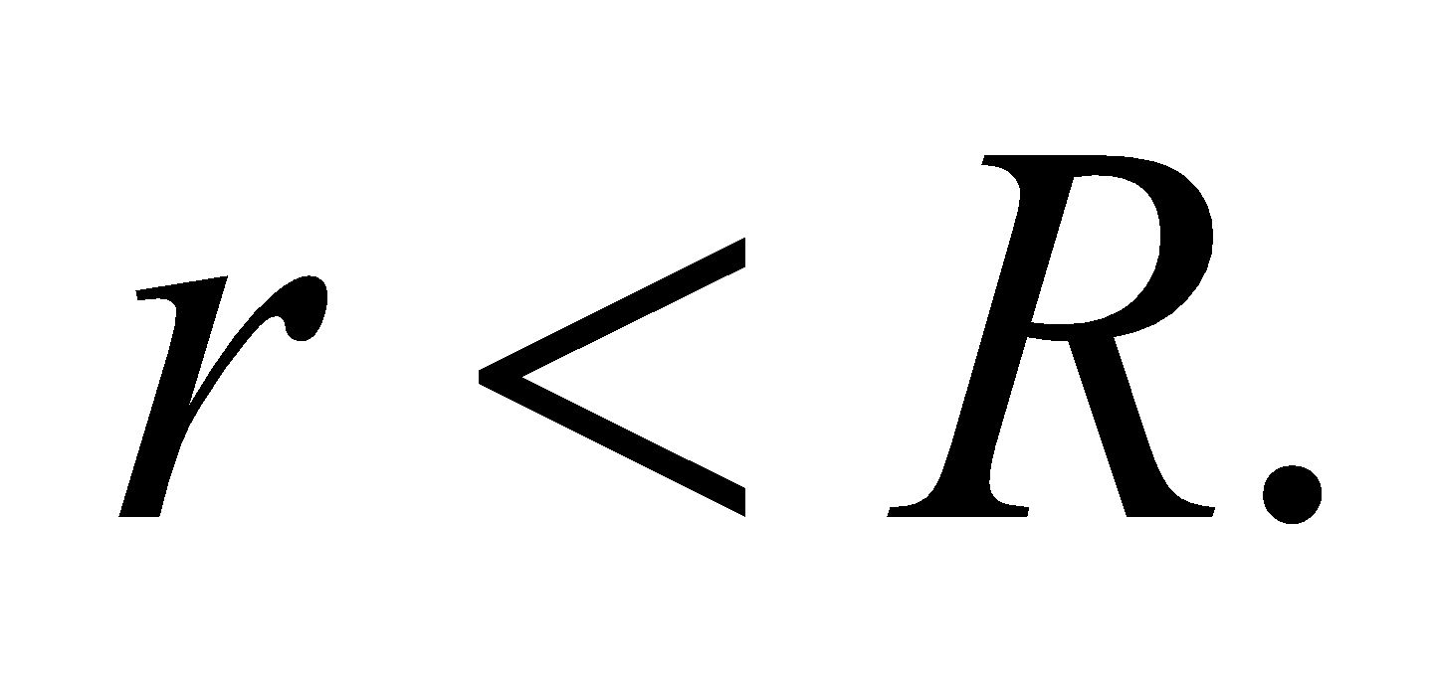The magnitude of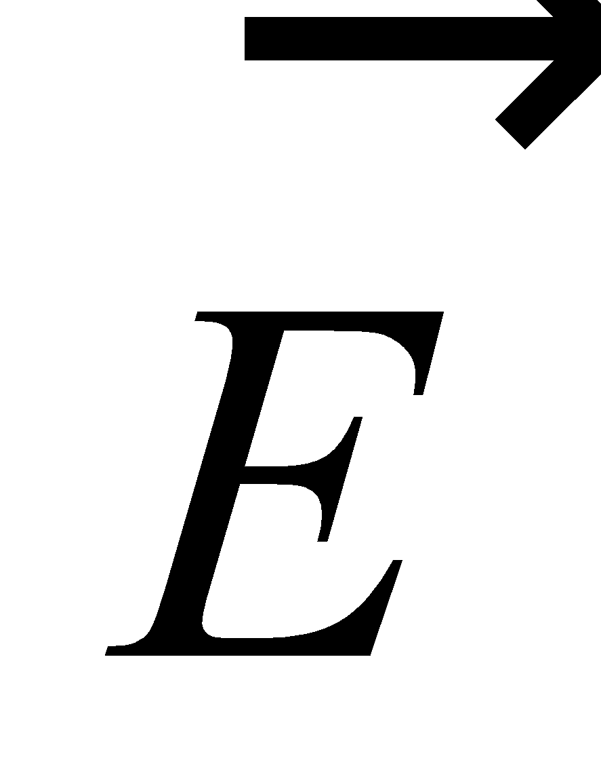is

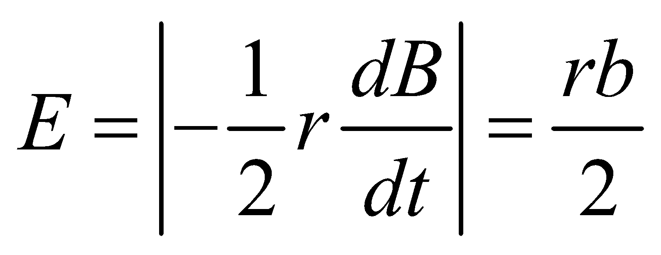

The induced electric field circulates CCW around the direction of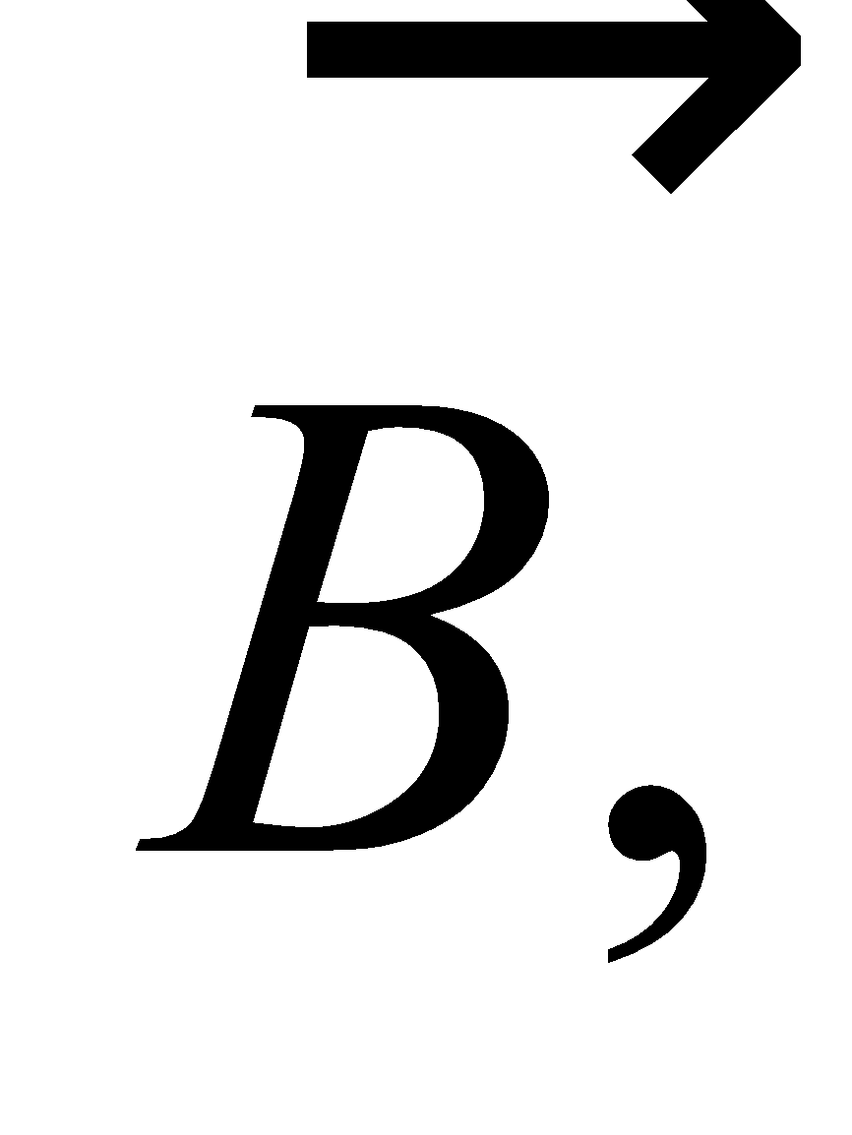or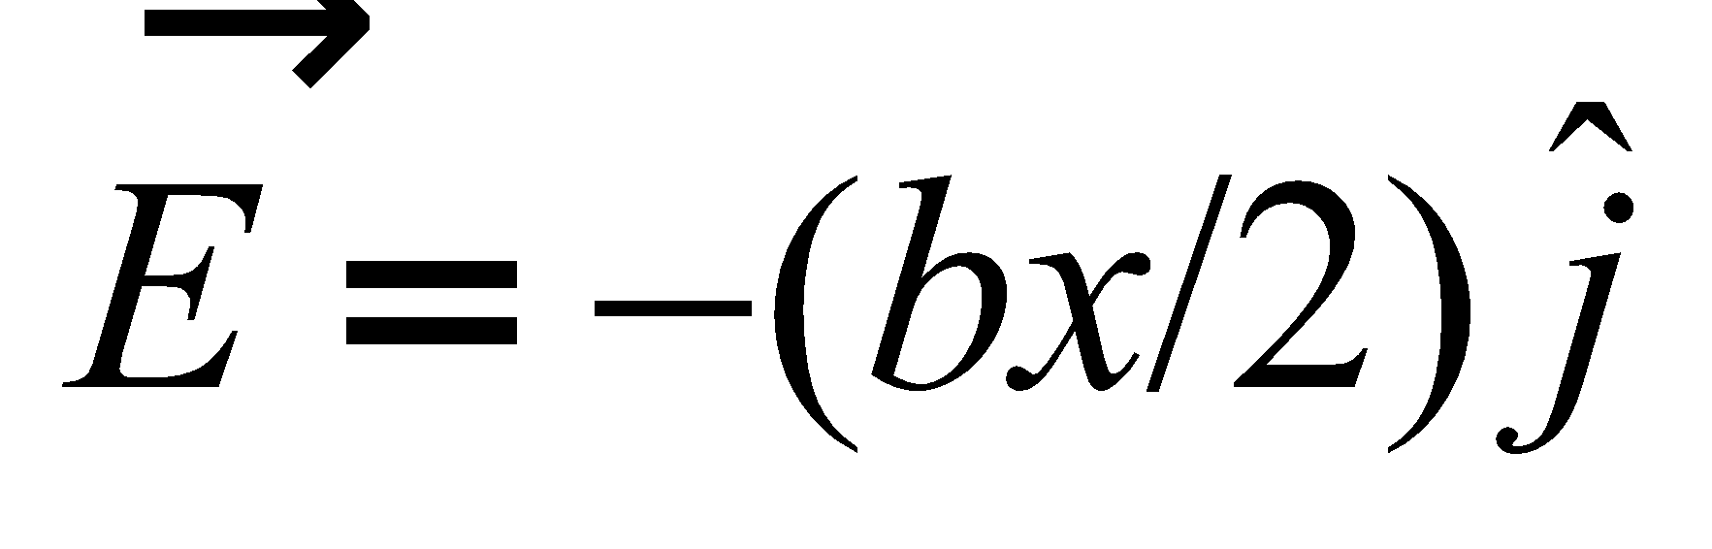for the given point on the  
*x* axis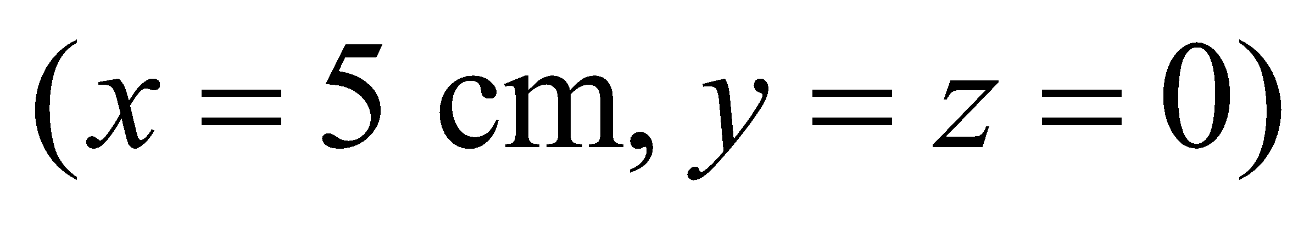inside the solenoid (whose axis we assume is the *z* axis). At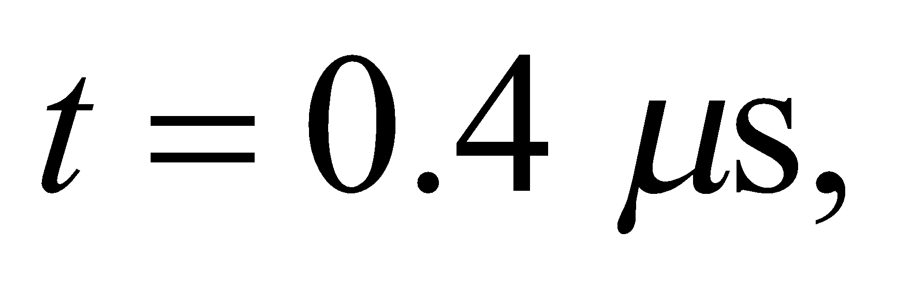the uniform magnetic field is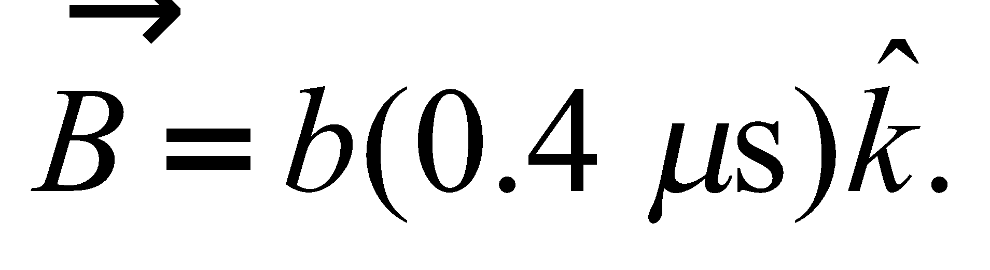The electromagnetic force on a proton with the given velocity is

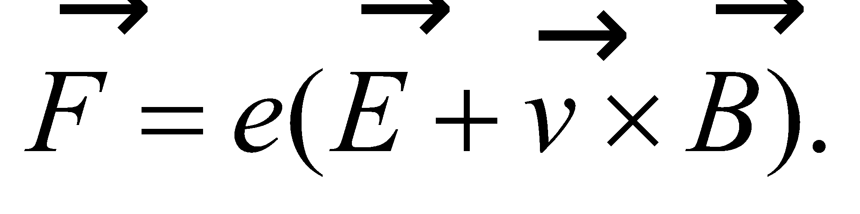

**Evaluate** Substituting the values given, we find the net force on the proton to be

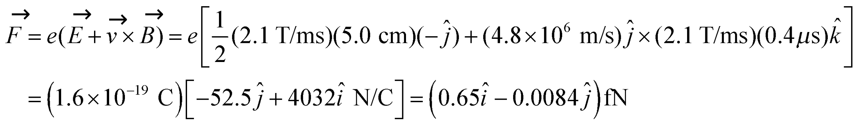



**Assess** In the region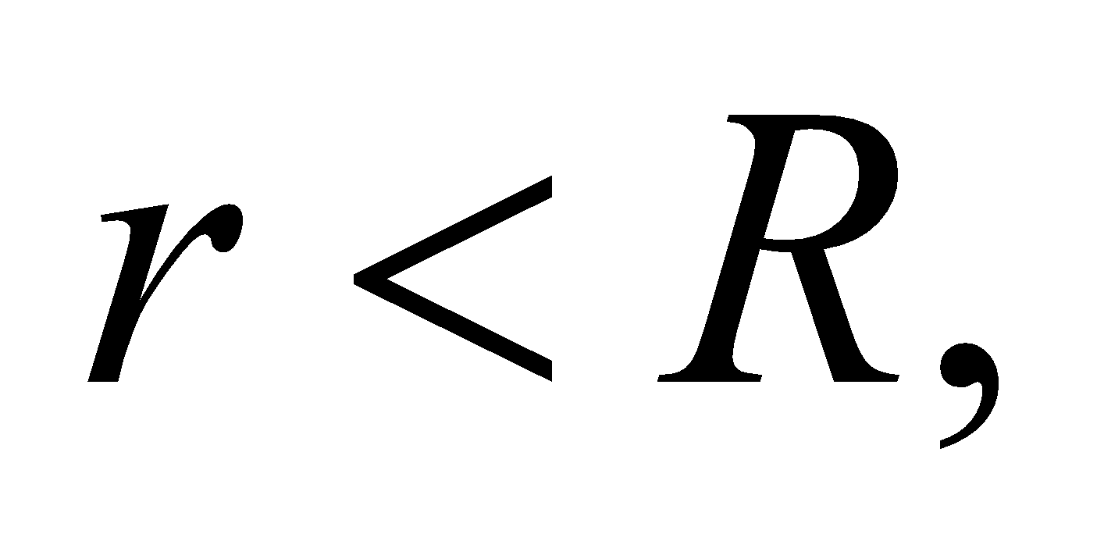the induced electric field rises linearly with *r*. Since the proton is moving, the net force on the proton is a vector sum of electric and magnetic force (i.e., the electromagnetic force).

**49. Interpret** This problem involves a changing magnetic field that induces an electric field. Thus, Faraday’s law (Equation 27.11) applies. We can use this to find the rate at which the magnetic field changes given the electric field strength. In using Faraday’s law, we can make use of the line symmetry of the problem, which tells us that the electric field will be constant along circles concentric with the solenoid axis.

**Develop** The magnitude of the electric field is E = F/e. Faradays law tells us that

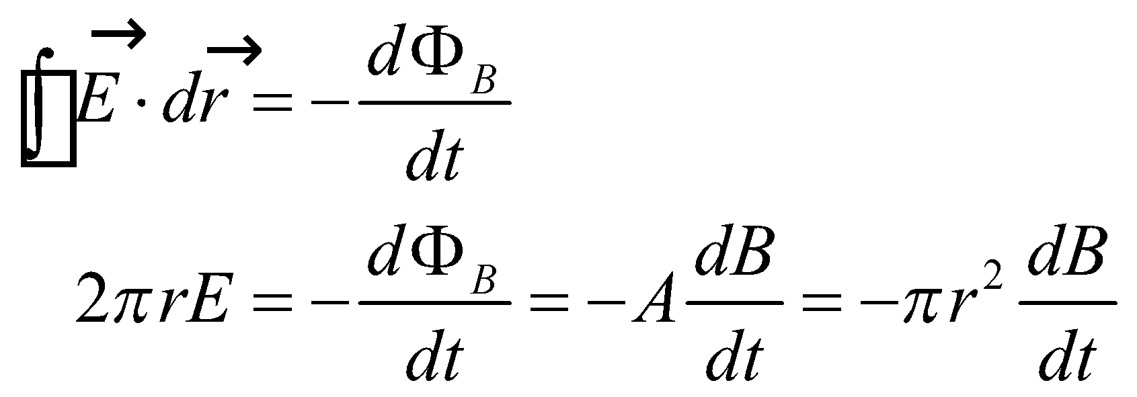

**Evaluate** Solving for the rate of change of the magnetic field gives

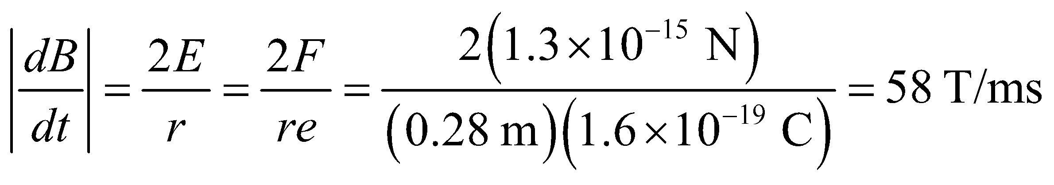

**Assess** We cannot tell if the magnetic field is increasing or decreasing because we do not have information about the direction of the force.

**50. Interpret** You want to show that the total amount of charge that an induced emf causes to move is independent of how the magnetic field changes.

**Develop**The flux through a stationary loop perpendicular to a magnetic field isso Faraday’s law (Equation 27.2) and Ohm’s law (Equation 24.5) relate this to the magnitude of the induced current:

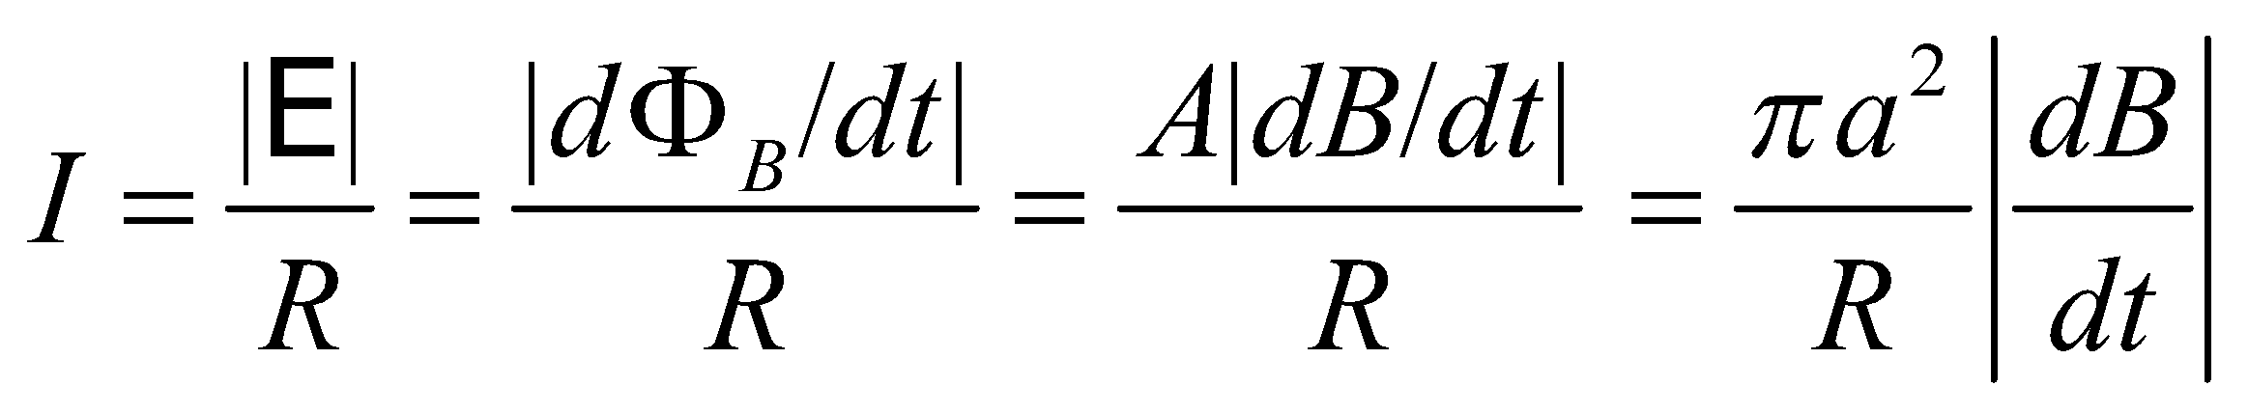

Over time, this current will result in the displacement of charge equal to the integral: 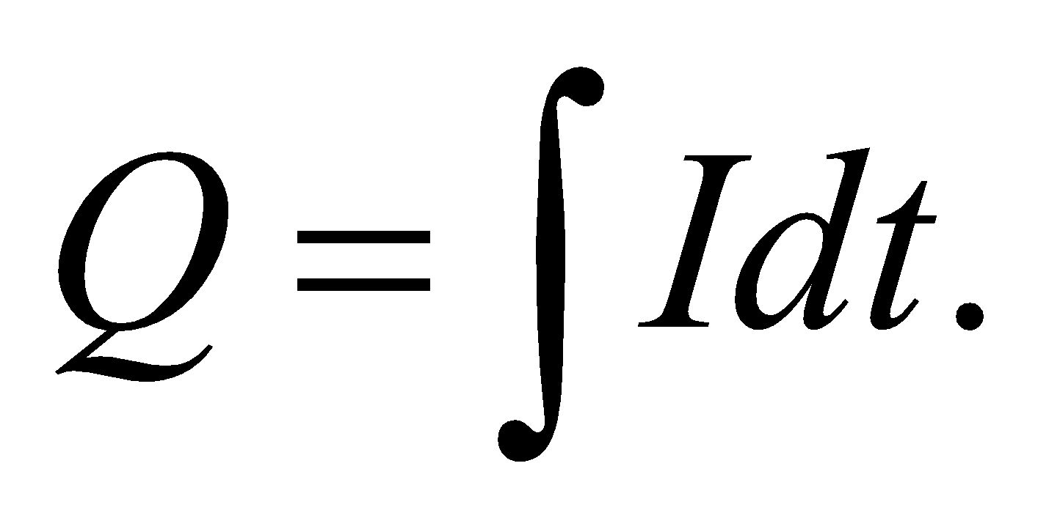

**Evaluate**Substituting the current expression into the charge integral gives

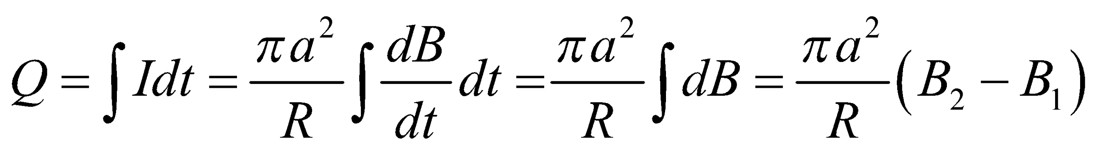

The absolute value symbols were dropped, since you don't have enough information to calculate the sign of the charge. But note that this expression is independent of how the field is varied, just as you expected.

**Assess**This makes sense, since if you vary the magnetic field more slowly, the induced current will be smaller, but it will flow a longer time, as you still have to change the field by the given amount. Interestingly, if you varied the magnetic field but then returned it to its initial value,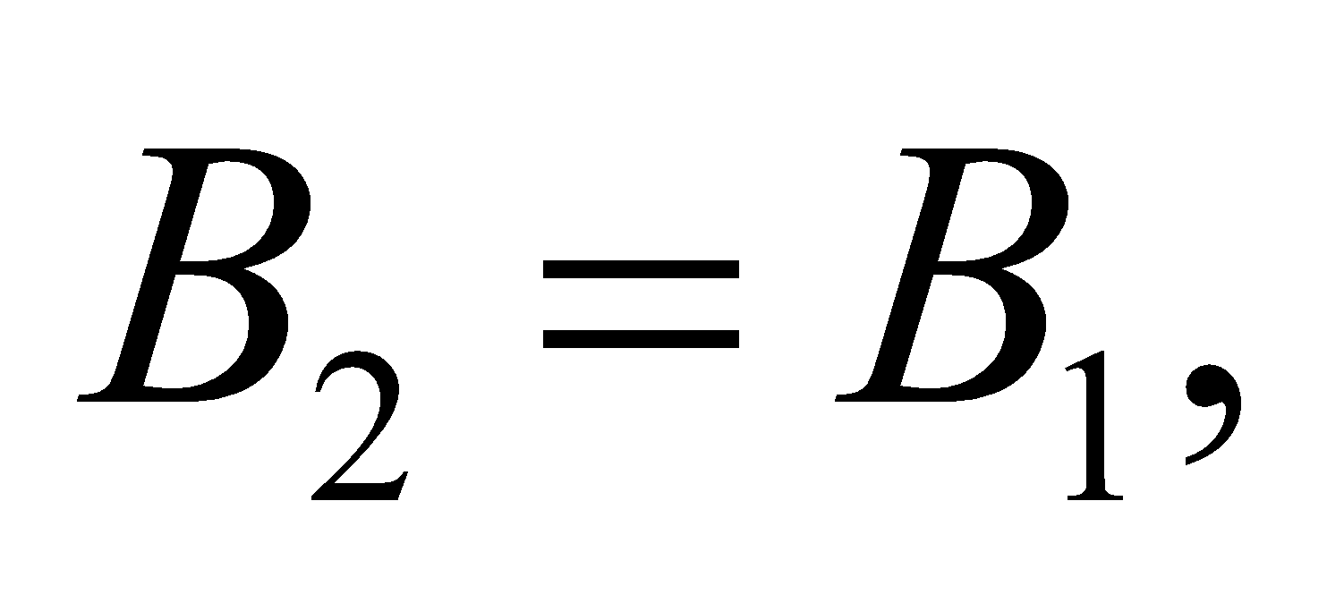 then the net charge moved around the loop would be zero.

**51. Interpret** This problem involves a coil that is moved through a magnetic field, so Faraday’s law can be used to relate the changing magnetic flux through the coil to the electric field and thus to the current.

**Develop** Initially, the flux through the flip coil is 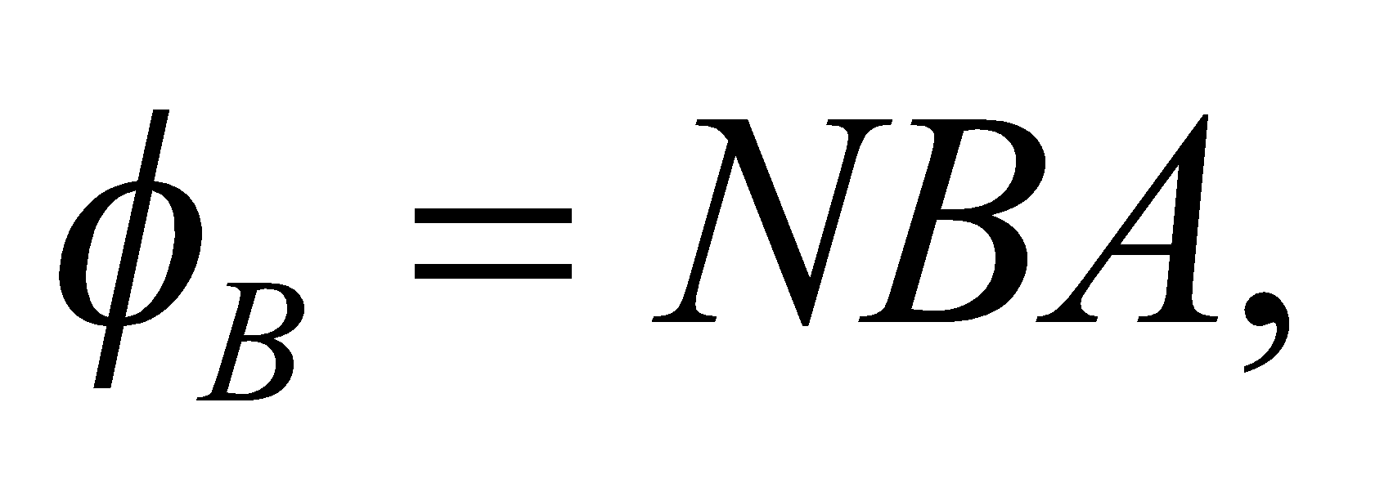 but is reversed to 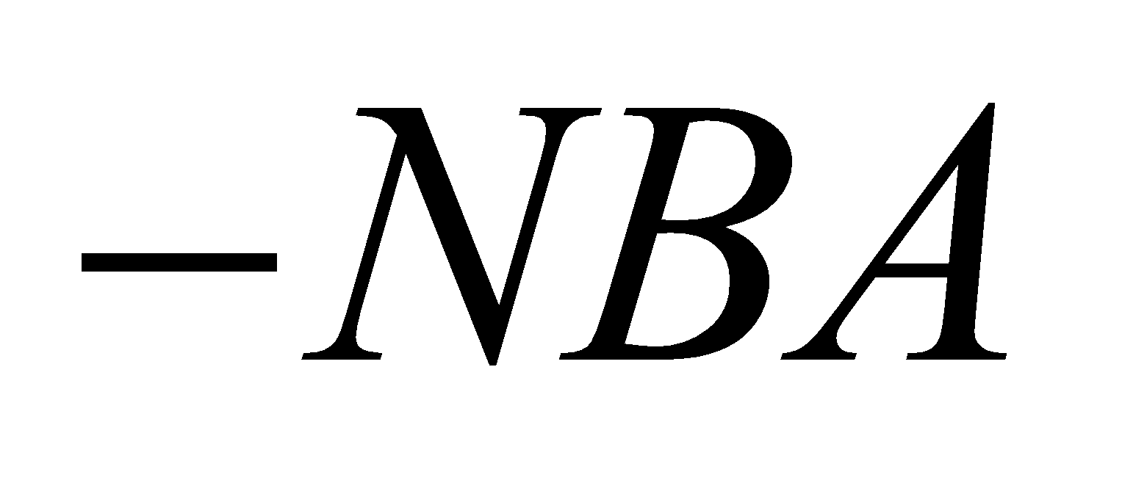 when the coil is rotated 180°, so 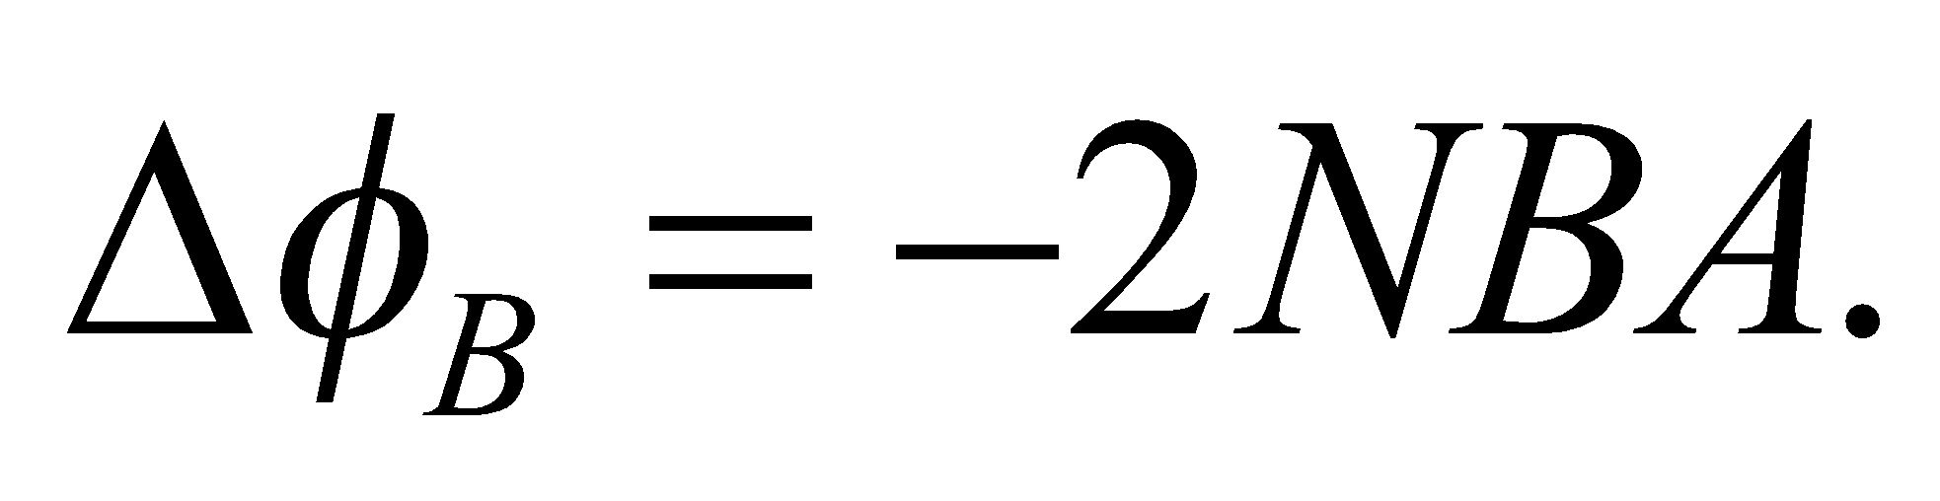 The total charge that flows is 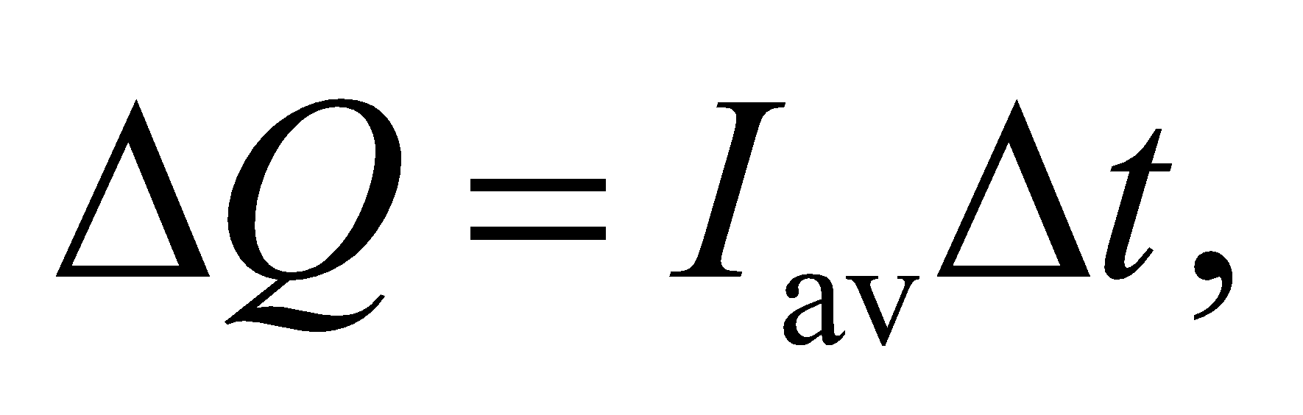 where *I*av is the average induced current and *Δt* is the time for the rotation. Use Faraday’s law and Ohm’s law to relate the charge to the magnetic field strength.

**Evaluate** From Faraday’s and Ohm’s laws,

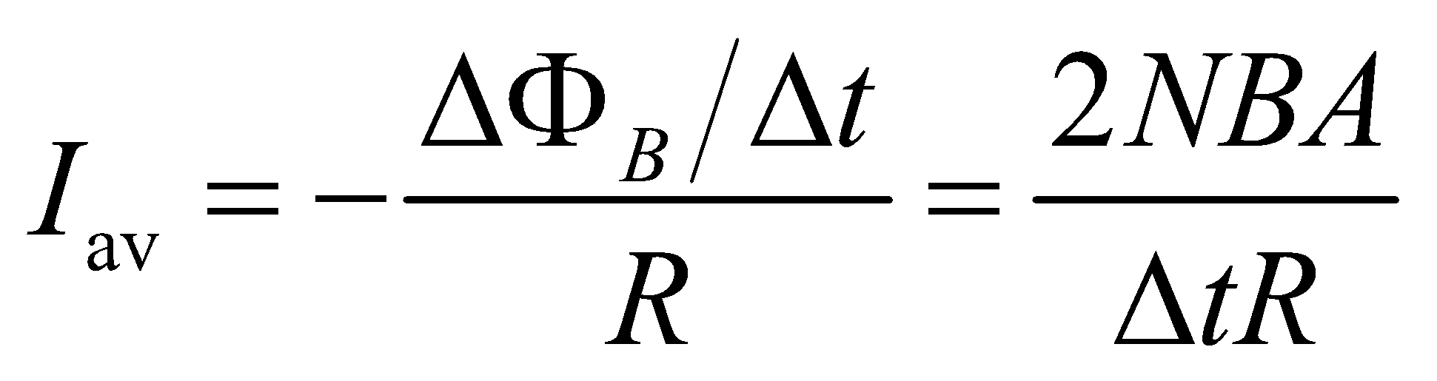

so

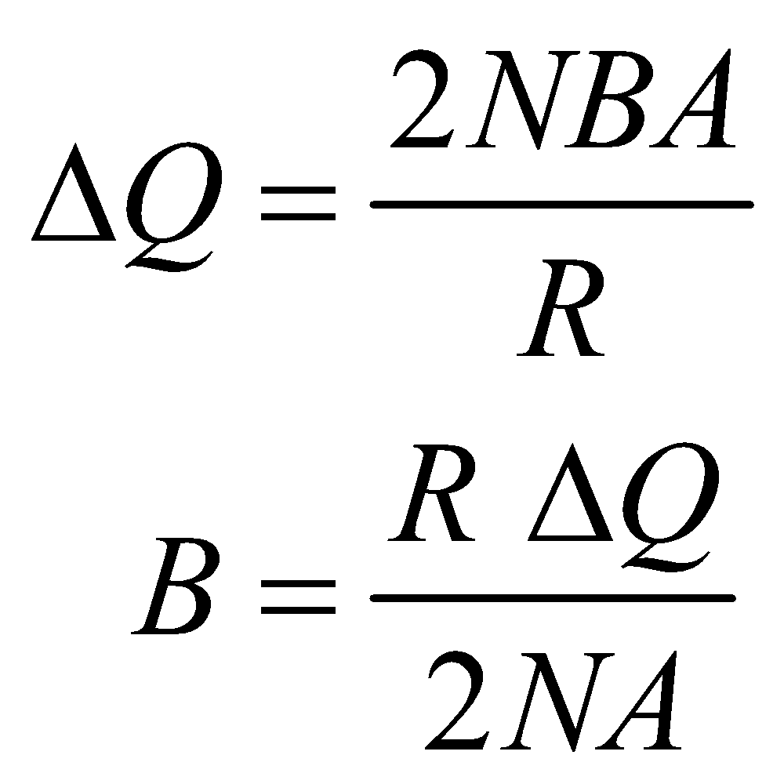

**Assess** This result agrees with that given in the problem statement.

**52. Interpret** We are to find the time constant of a series *RL* circuit, given the time it takes for the current in the circuit to rise to half its final value.

**Develop** In a series *RL* circuit, the current as a function of time is given by Equation 27.7:



where 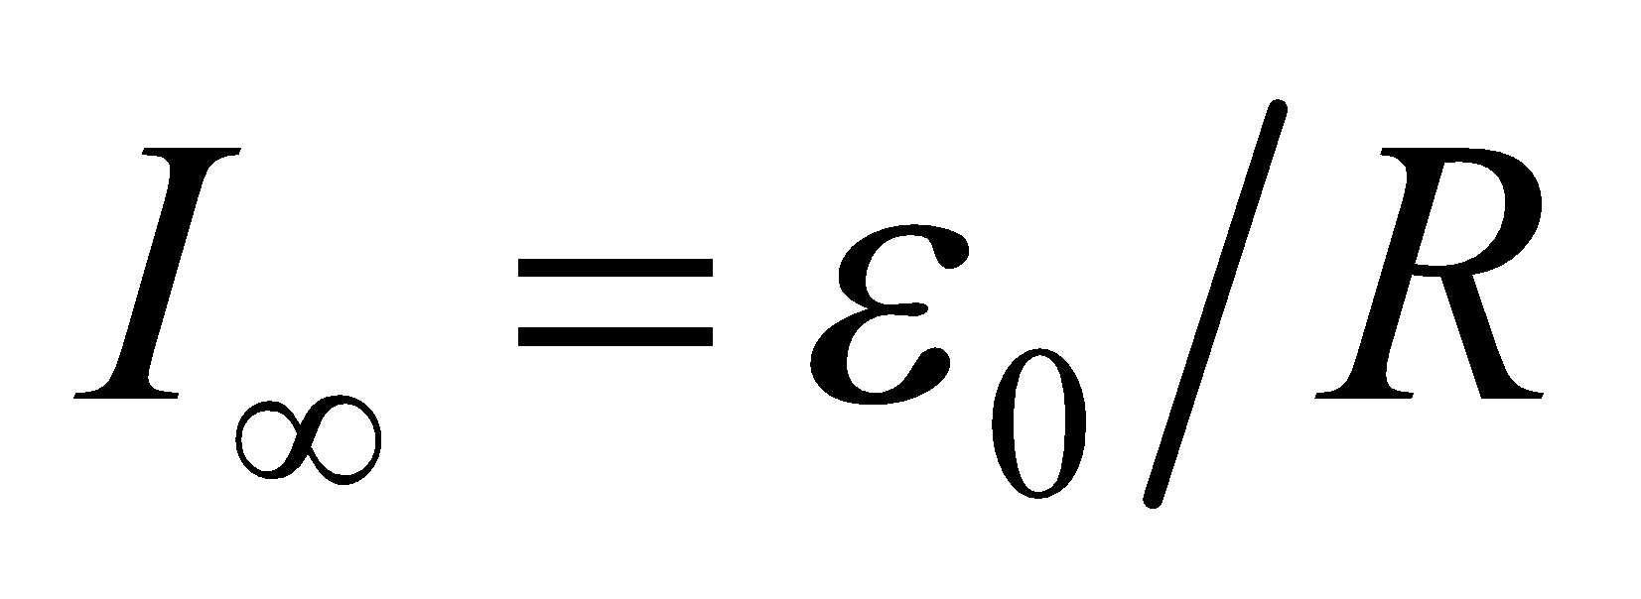 is the final current.

**Evaluate** From Equation 27.7, the time constant is

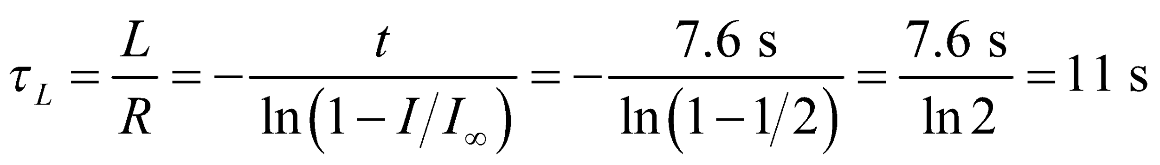

**Assess** The time constant is inversely proportional to the resistance *R*. The physical meaning of the time constant 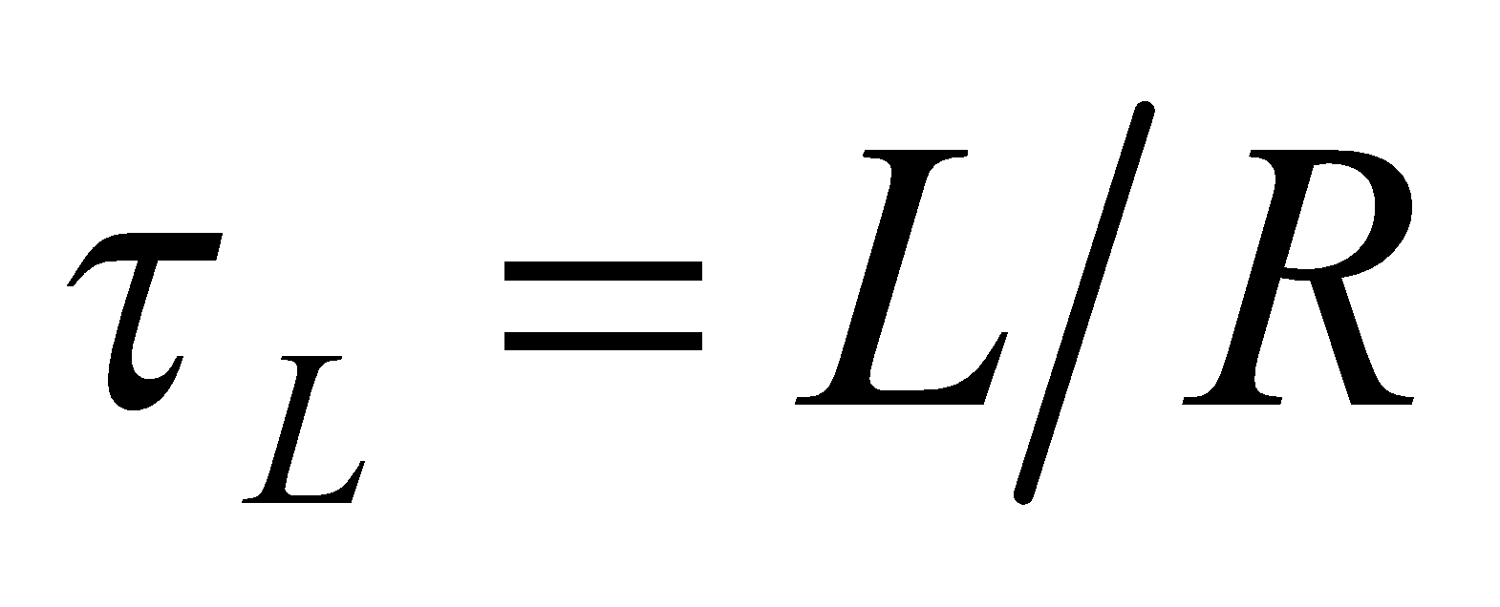 is that significant changes in current cannot occur on time scales much shorter than 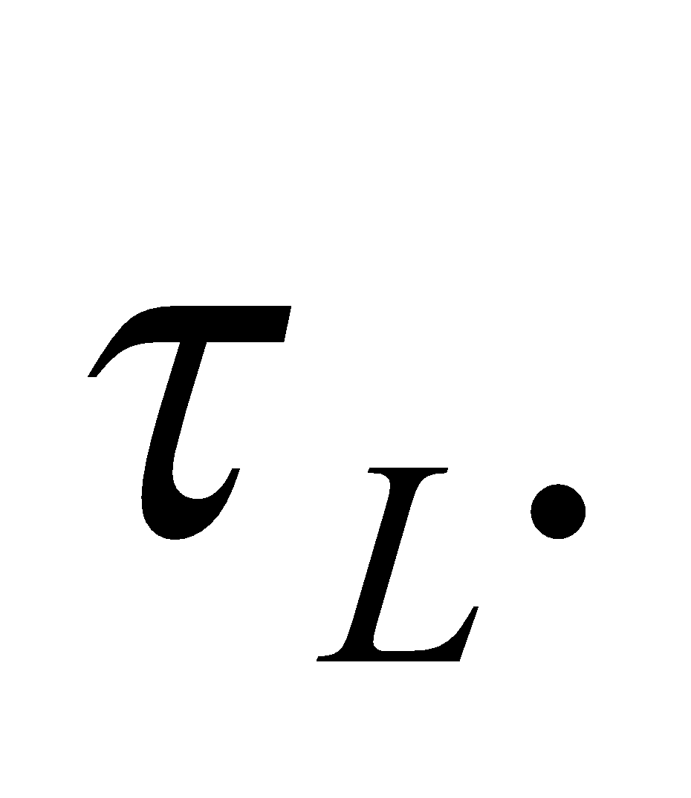

**53. Interpret** This problem involves an *RL* circuit for which we are to find the time for which the circuit has been completed (i.e., switch closed).

**Develop** When the switch is closed, the current starts to increase, as shown in Figure 27.24. The current rise is given by Equation 27.7:

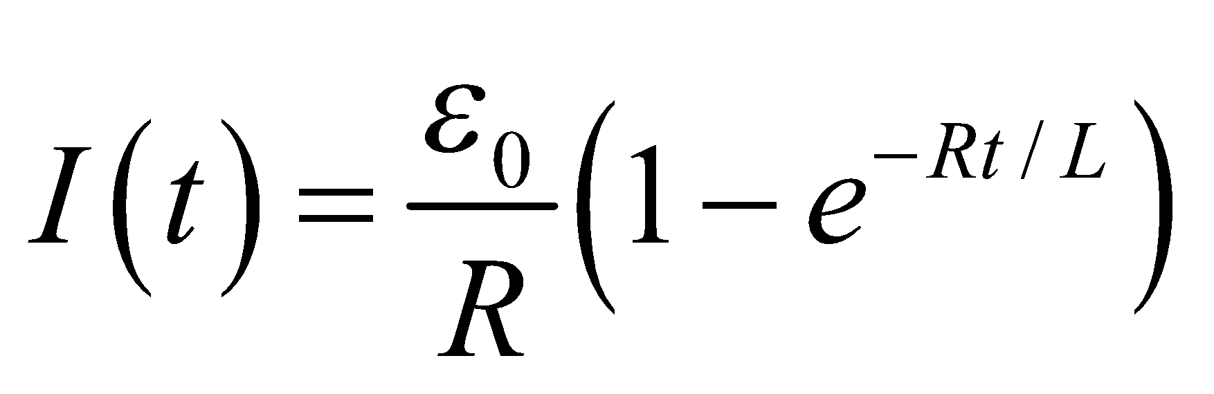

which we can solve for the time *t*.

**Evaluate** Solving for the time *t* gives

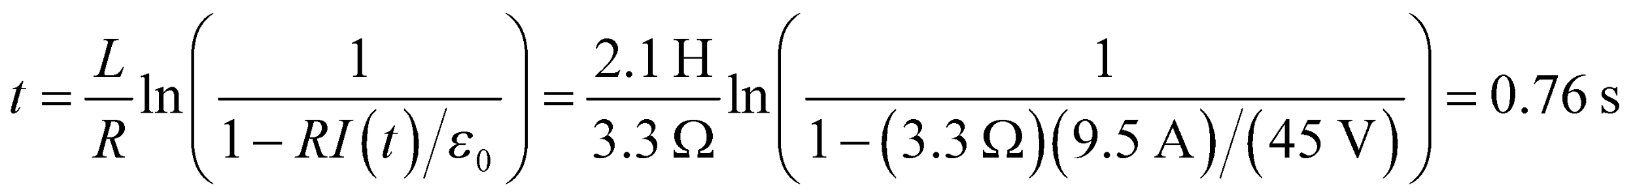

**Assess** The time constant for this circuit is *RL* = 6.9 s, so the current in this circuit will continue to grow for about 21 s (about three time constants).

**54. Interpret** In this problem we are asked to find the inductance and the long-time behavior of a series *RL* circuit.

**Develop** In a series *RL* circuit, the rising current as a function of time is given by Equation 27.7:

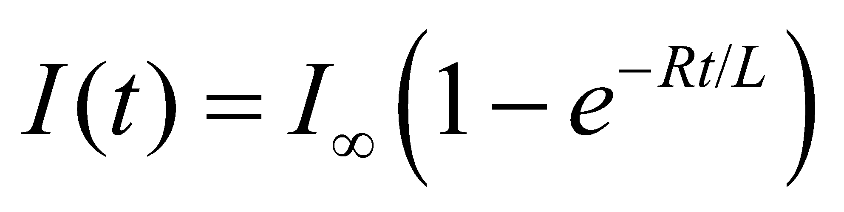

where  is the final current. Solve this for the inductance.

**Evaluate** **(a)** The current is 10 mA at 30 μs [i.e. *I*(30 μs) = 10 mA]. Thus, the inductance is

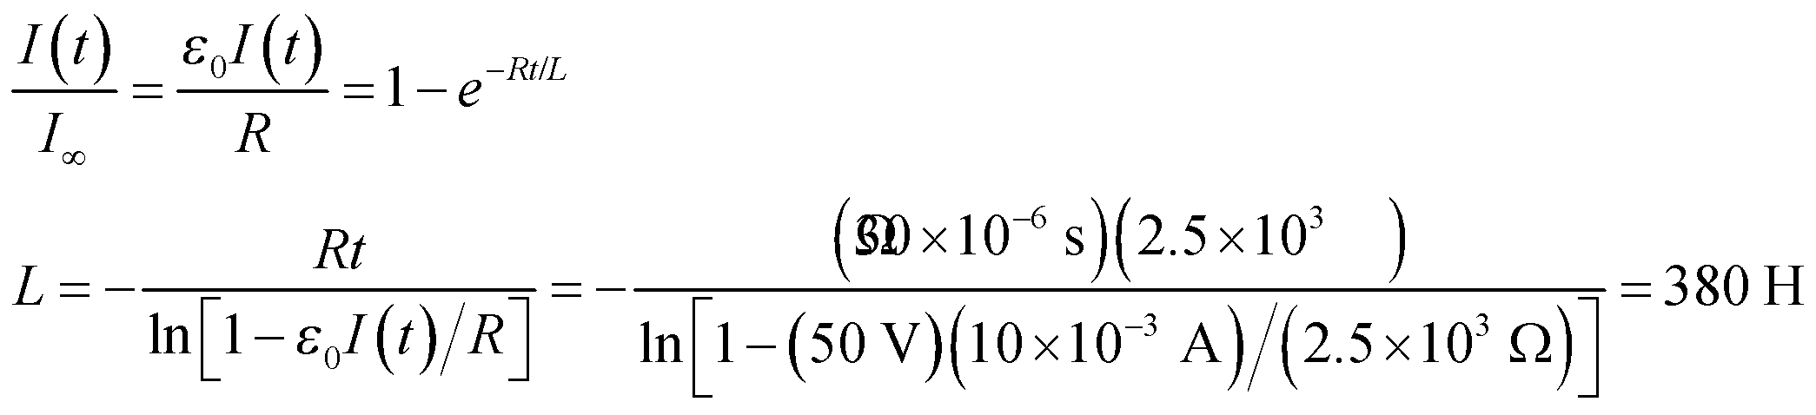

**(b)** After a long time 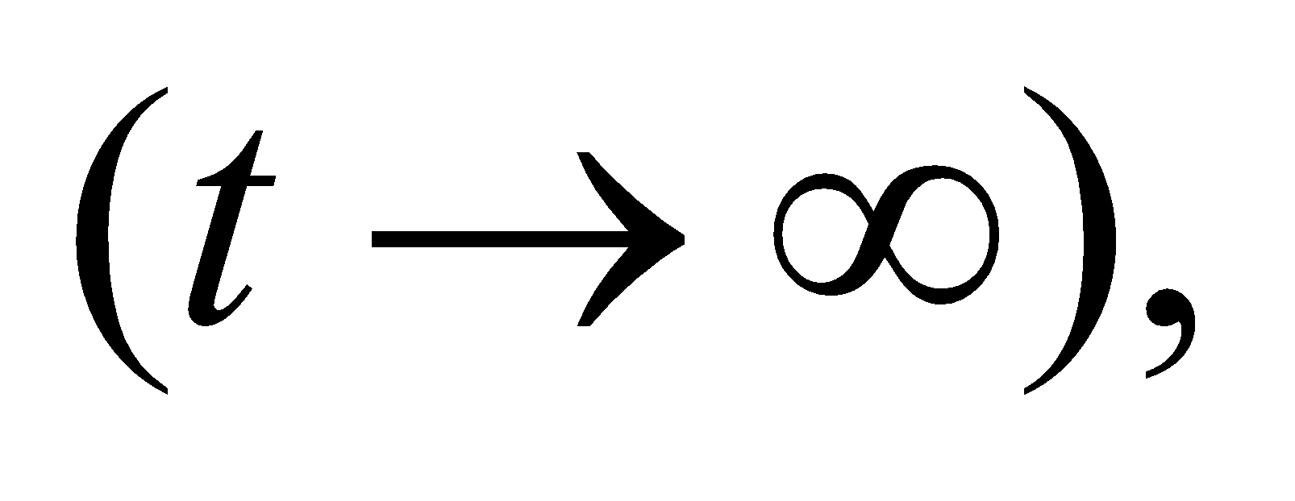 the exponential term in Equation 27.7 is negligible, and the current is

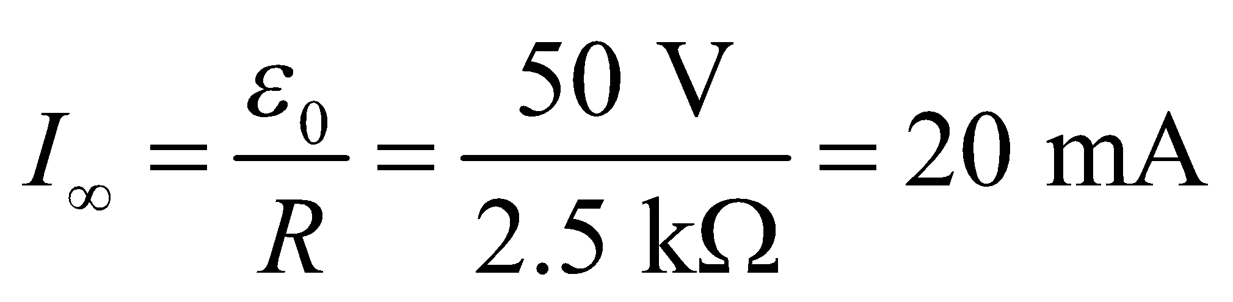

**Assess** After many time constants, there is no induced emf in the inductor and we can simply think of the inductor is a conducting wire connecting the different parts of the circuit. Note that 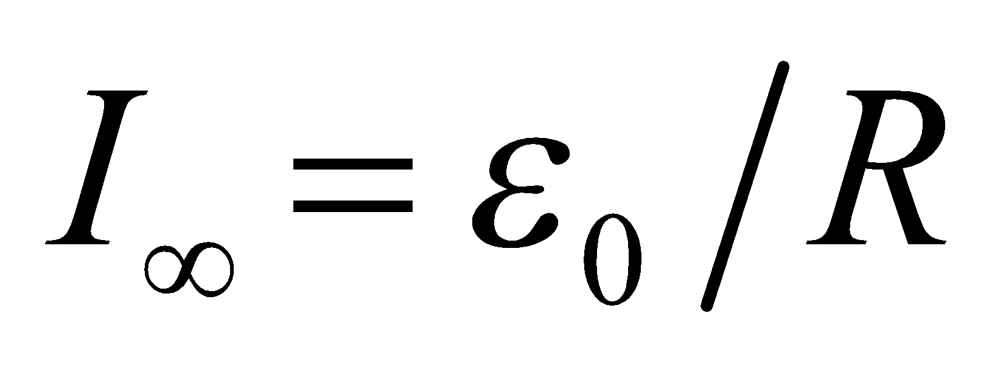 is what you would get by neglecting the inductance and using Ohm’s law.

**55. Interpret** This problem involves the current decay in an *RL* circuit. We use the equation for current decay in an inductor, and energy stored in an inductor, to find the time it takes to lose 90% of the energy stored in an inductor when the circuit becomes resistive.

**Develop** The energy initially stored in the inductor is 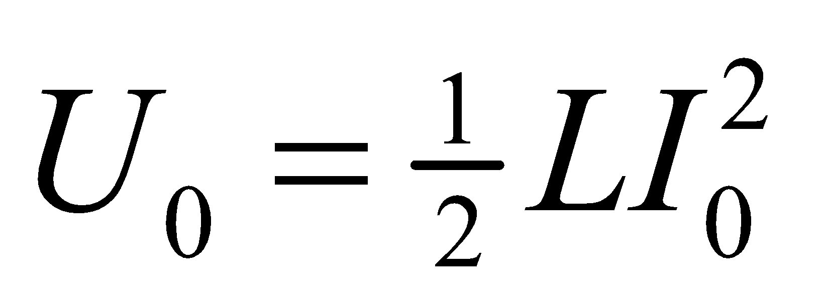 (Equation 27.9). The decaying current through an *RL* circuit is given by 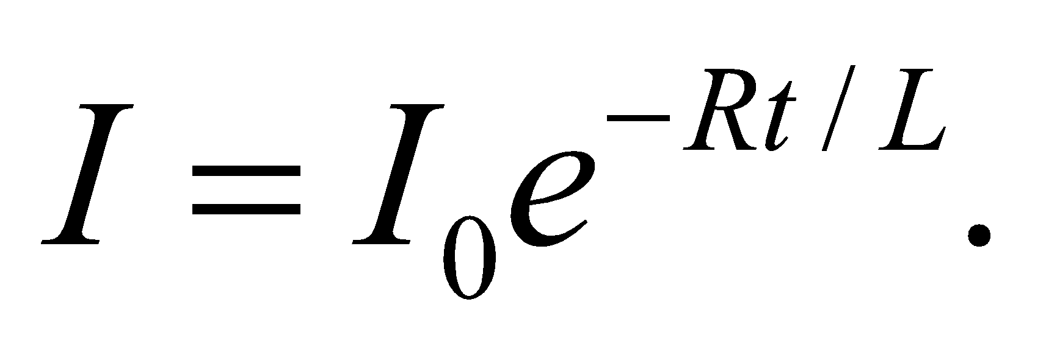 (Equation 27.8). For this problem, the initial current is *I*0 = 2.4 kA, the inductance is *L* = 0.53 H, and the resistance is *R* = 21 mΩ. We want to calculate the time required to dissipate 90% of the initial energy.

**Evaluate** The time-dependent energy stored in the inductor is

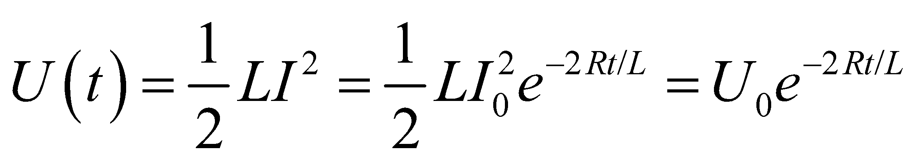

so the time we’re looking for is

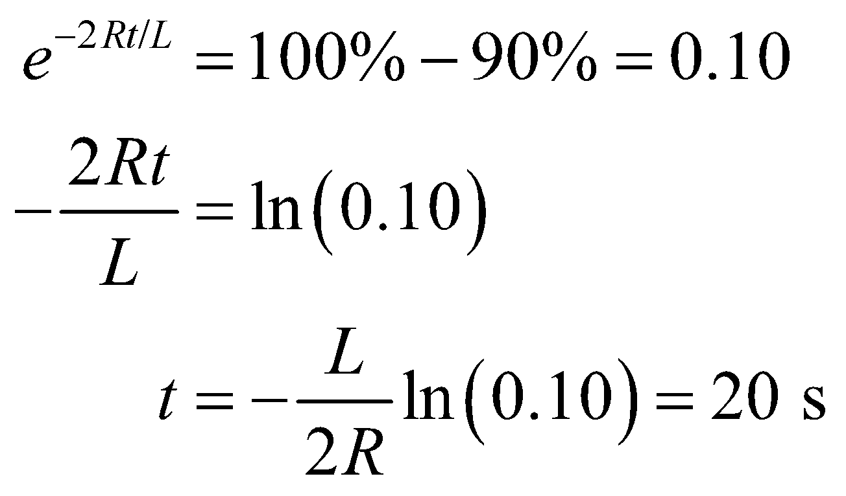

**Assess** The initial energy stored is 1.5 MJ, so the average power loss is nearly 69 kW! Note also that the initial current was not needed in this calculation.

**56. Interpret** This problem involves finding the rate of change of current in a series *RL* circuit at different instants.

**Develop** In a series *RL* circuit, the rising current as a function of time is given by Equation 27.7:



where  is the final current. The rate of change of current is

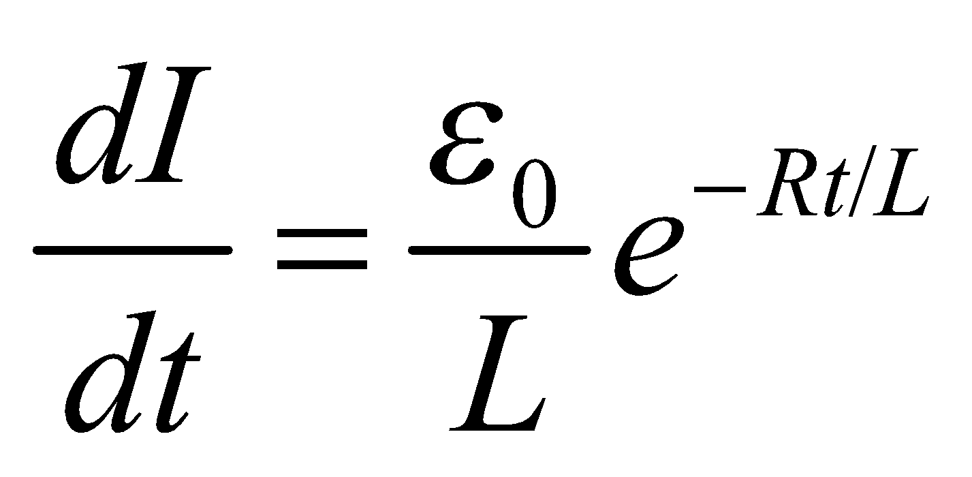

**Evaluate** **(a)** For *t* = 0,

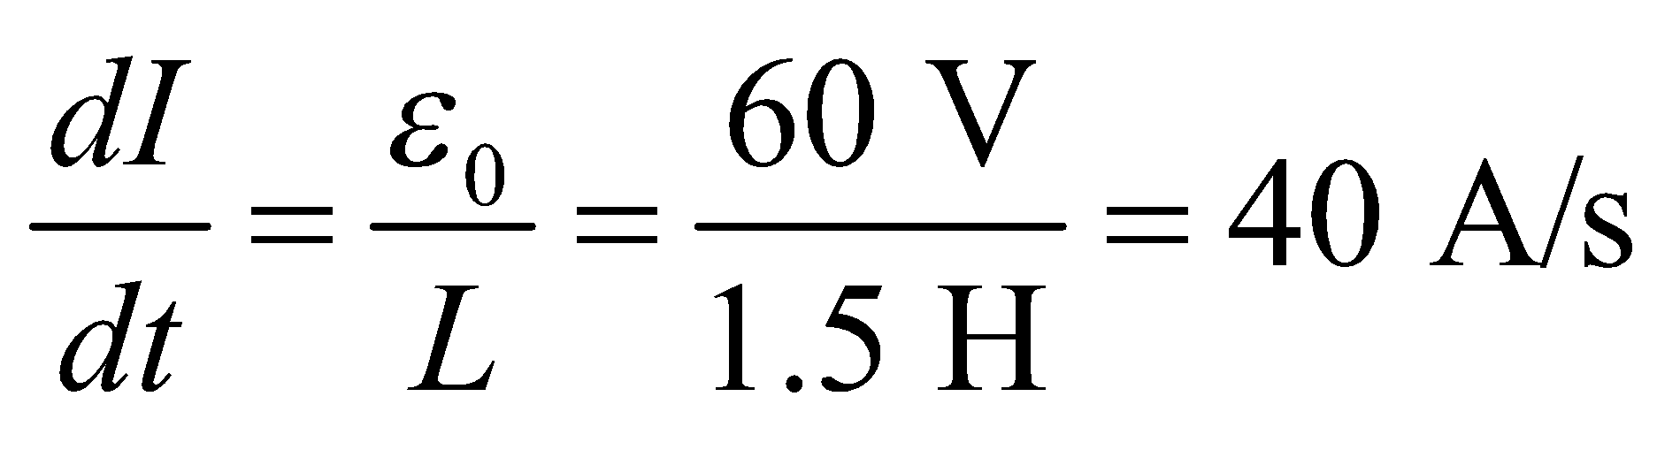

**(b)** Similarly, for t = 100 s, the rate is

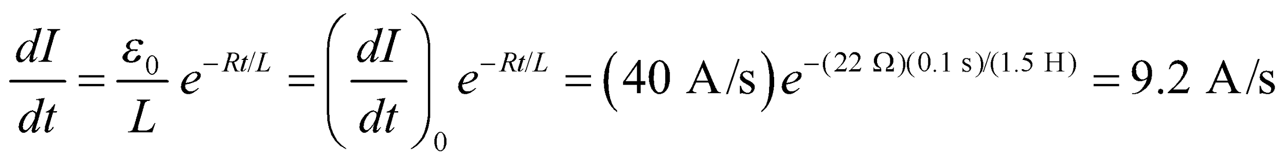

**Assess** The rate of change of current decreases exponentially with time. After many time constants, the current is approximately equal to 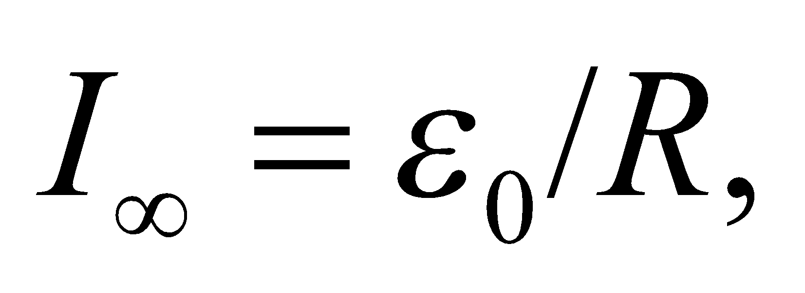 and the rate of change goes to zero.

**57. Interpret** You want to limit the voltage across elevator motors when the supplied current is suddenly switched off. Because the motors have a high inductance, they will try to keep the same current flowing through them even when the circuit is opened. A resistor placed in parallel with the motor will give a safe path for this current to flow out.

**Develop**In Conceptual Example 27.1, a description is given of the behavior of a circuit with a power supply connected to an inductor and resistor in parallel. You can imagine that the inductor in this example is an elevator motor and the parallel resistor is the safety element you want to install. When the elevator is in operation, a current of 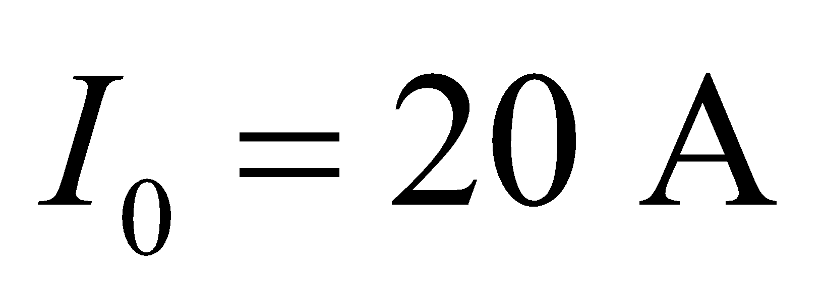flows through the motor. If a switch is suddenly opened, the motor's inductance will respond by driving the same current through the mini-circuit defined by the inductor and resistor (see Figure 27.26d). The voltage across the resistor, 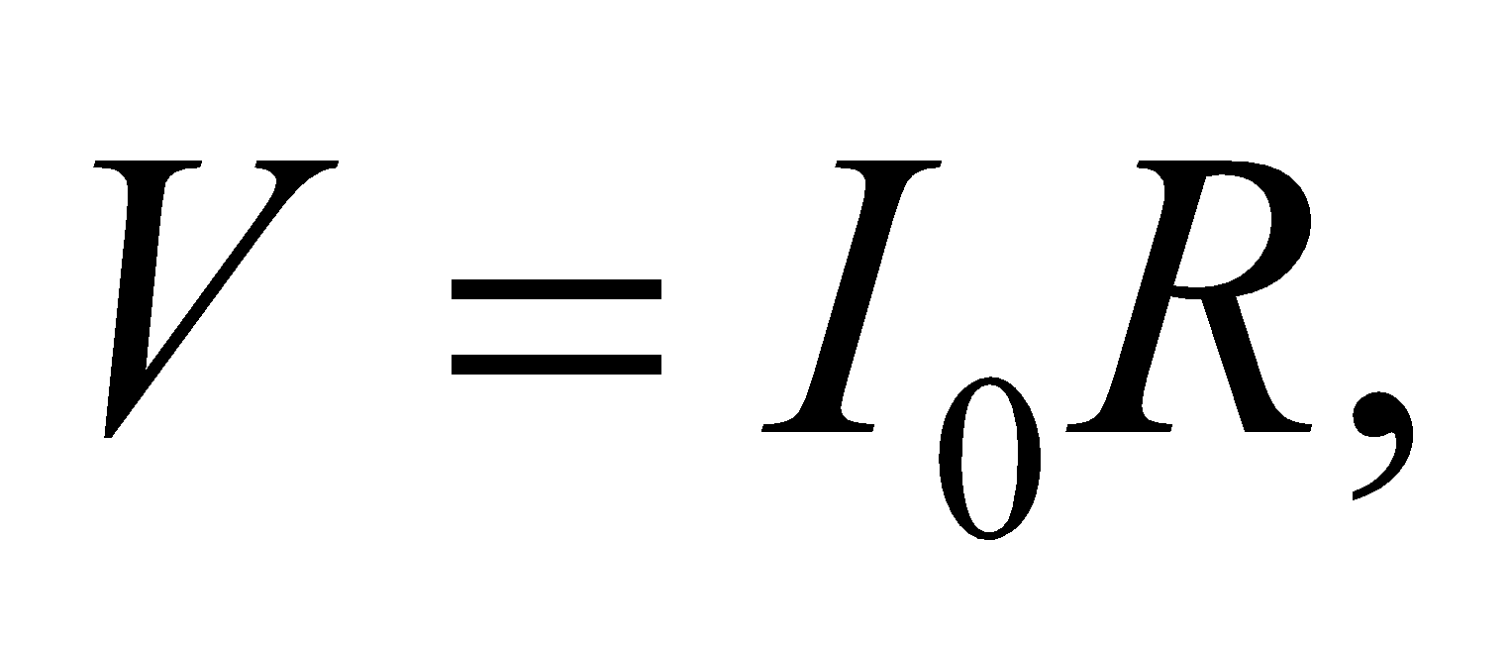will be equal to the voltage across the motor (inductor).

**Evaluate**(a) To limit the voltage across the motor to less than 100 V, you'll need resistors of

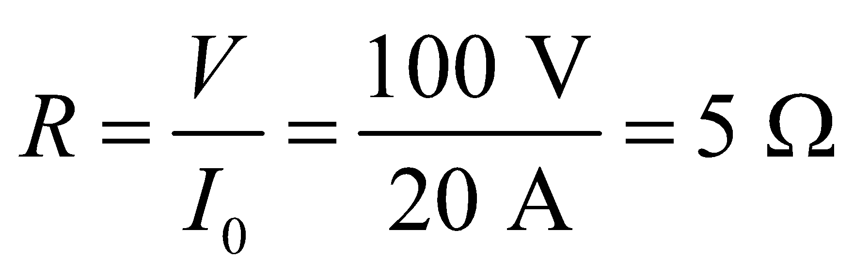

(b) The current does not stay at the initial value. It decays exponentially according to Equation 27.8: 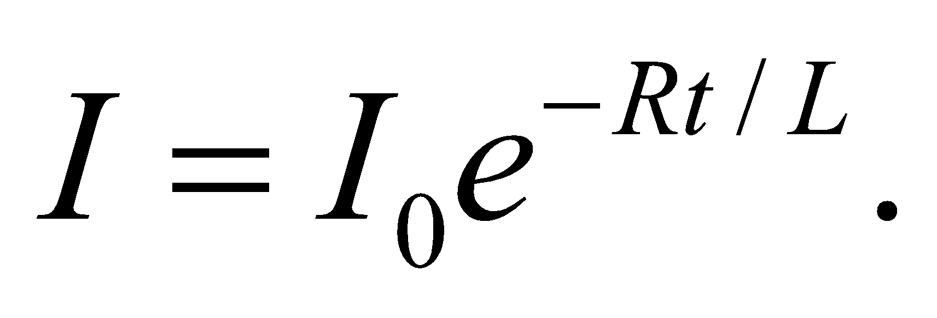 To find how much energy the resistor dissipates, you can integrate the power,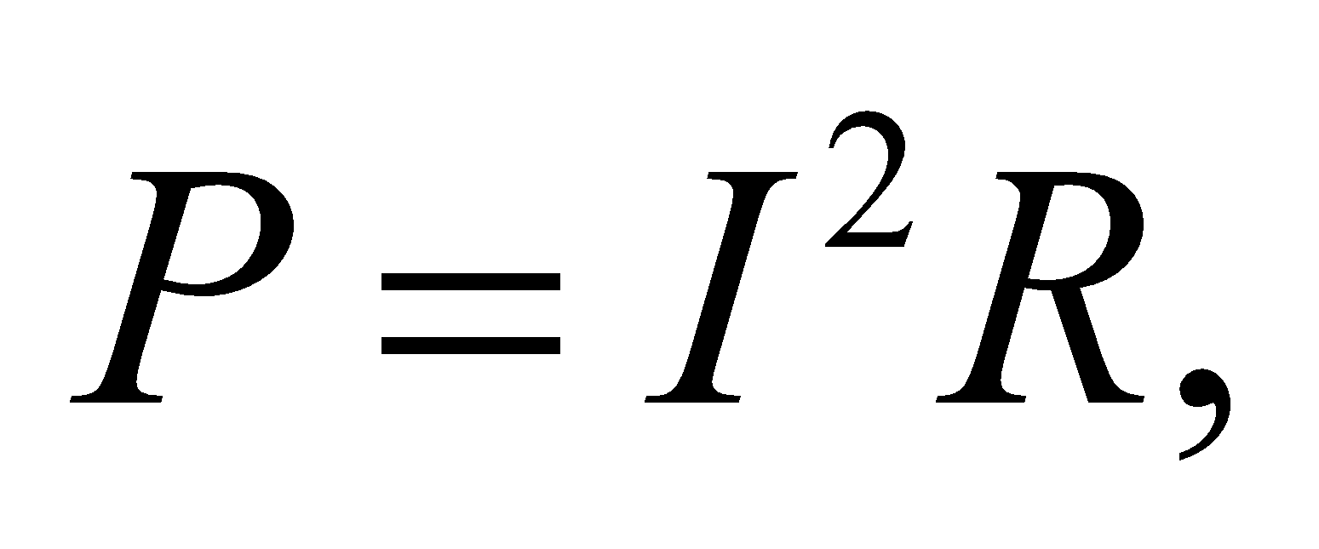over the time it will take for all the current to theoretically disappear (i.e., 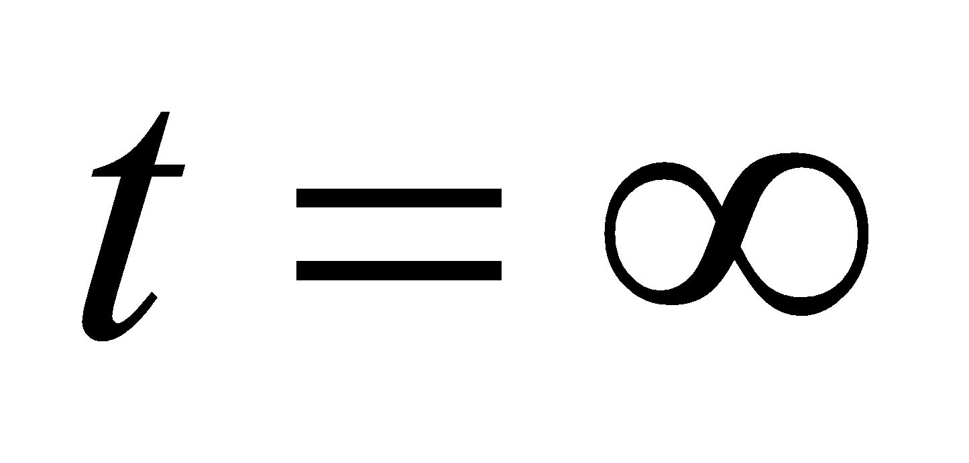).



**Assess**Just as you might expect, the energy dissipated by the resistor is just the energy that was initially stored in the inductor (Equation 27.9).

**58. Interpret** This problem is about the buildup and decay of current in a series *RL* circuit. For the first 10 s, the current will grow towards its steady-state value. After 10 s, the switch is opened and the current decays exponentially.

**Develop** In a series *RL* circuit, the rising current as a function of time is given by Equation 27.7:



where  is the final current. When the switch is thrown back to position *B*, the battery is removed from the circuit and the current decays according to Equation 27.8:

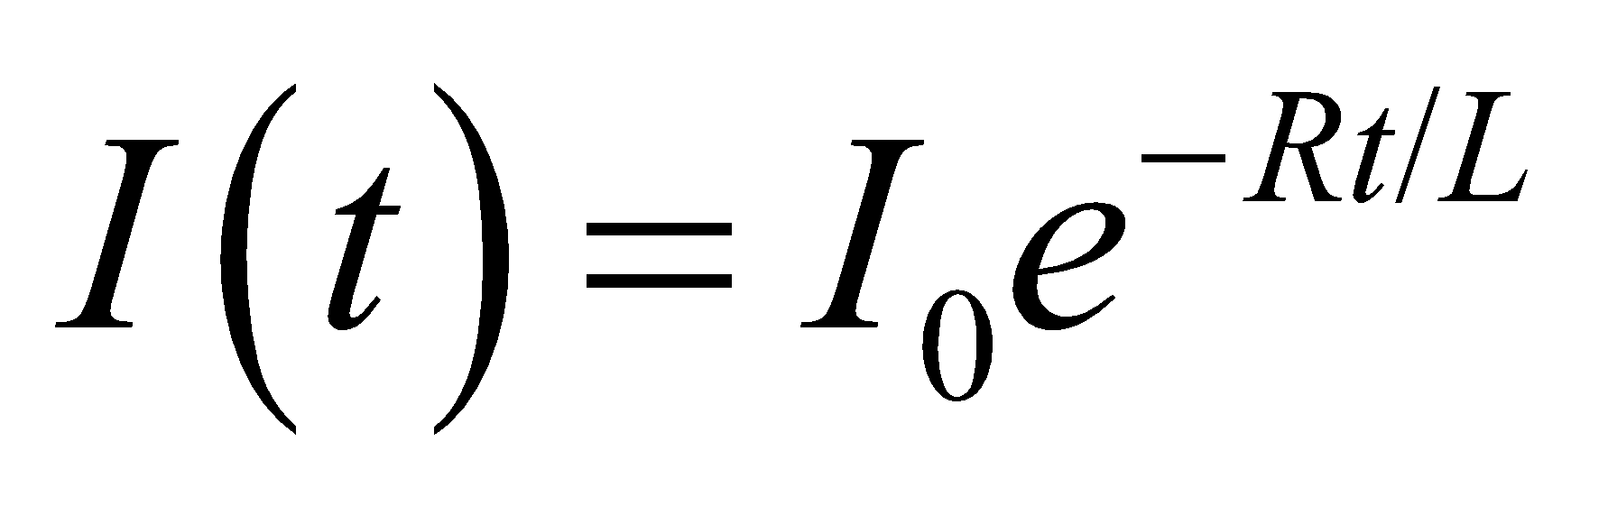

**Evaluate** **(a)** When the current is building up from zero, Equation 27.7 gives

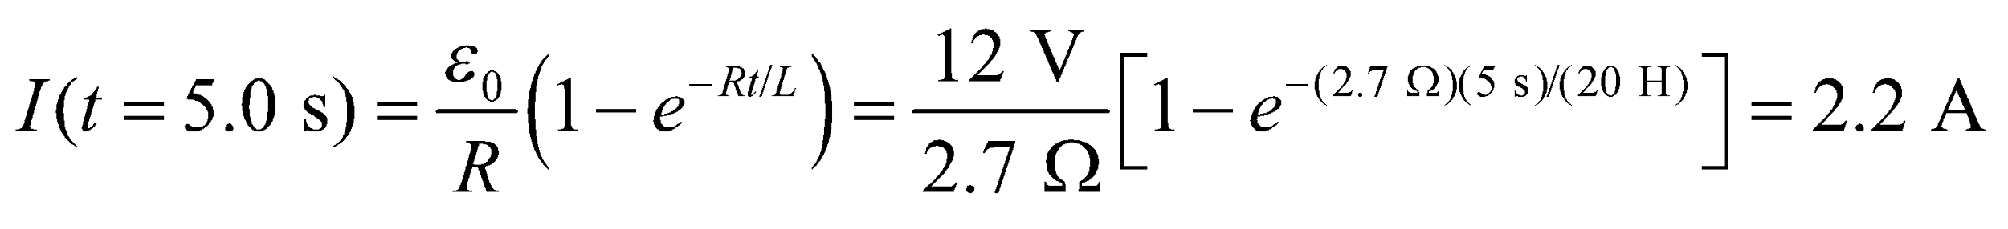

**(b)** At t = 10 s, the current has built up to

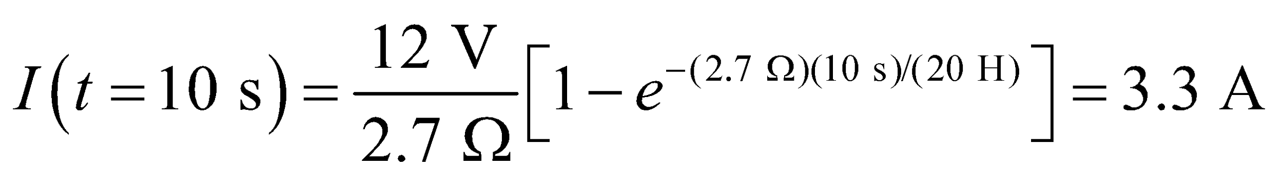

This current decays when the switch is thrown back to *B*. Equation 27.8 (where *t* is the time since 10 s) gives



where we have used the result from above to three significant figures because it is an intermediate result.

**Assess** The time constant of the circuit is 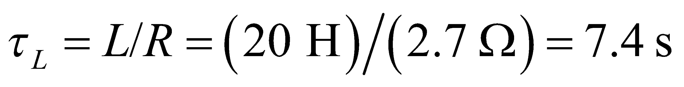 so t = 10 s corresponds to only

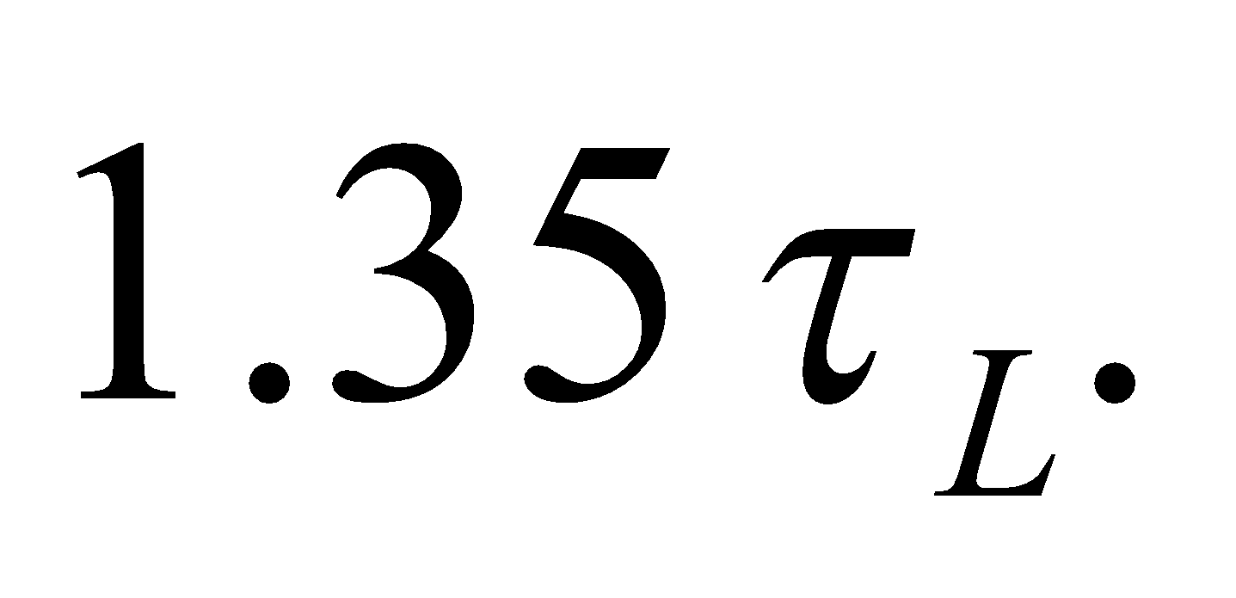 At this instant, the current is only 74% of its steady-state value 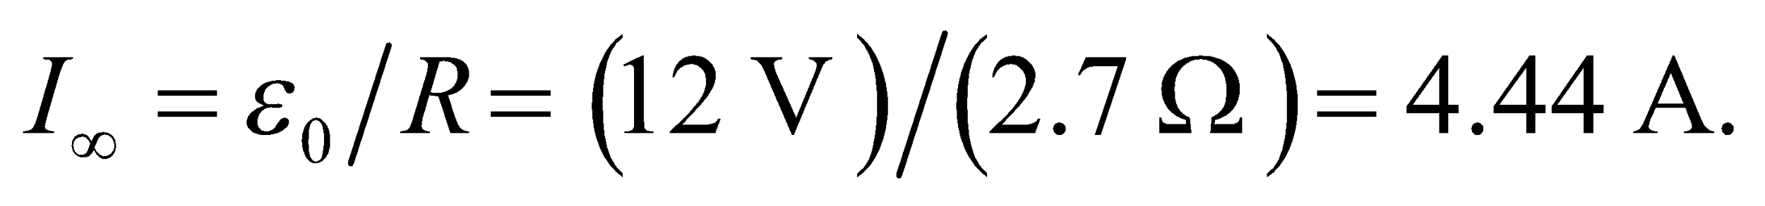

One needs to wait at least three time constants for the current to approach 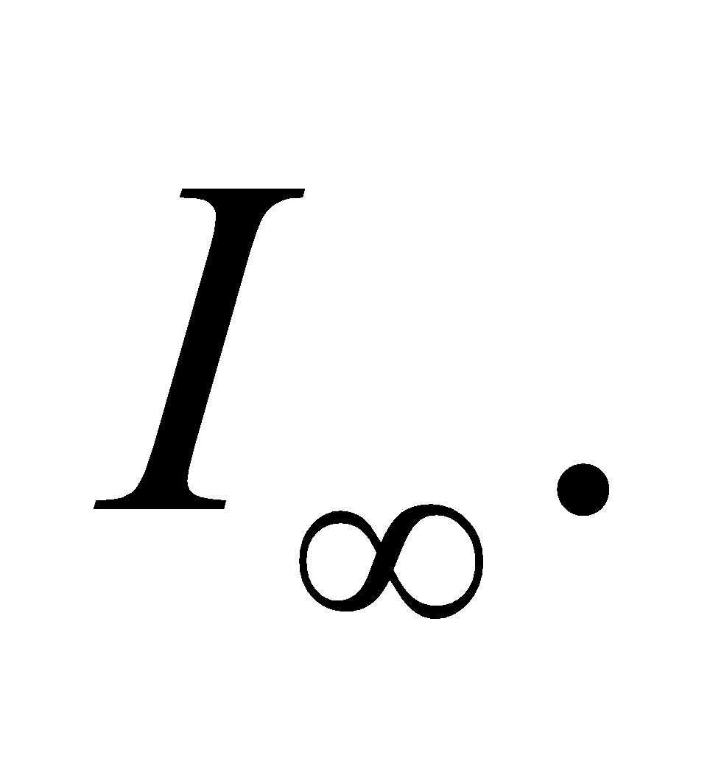

**59. Interpret** We're asked to find the current in an *RL* circuit at different time points.

**Develop**We are considering the short-term and long-term behavior of a circuit with an inductor, as was done in Conceptual Example 27.1.

**Evaluate**(a) Just after the switch is closed, the inductor current is zero. We can consider this branch of the circuit as being opened 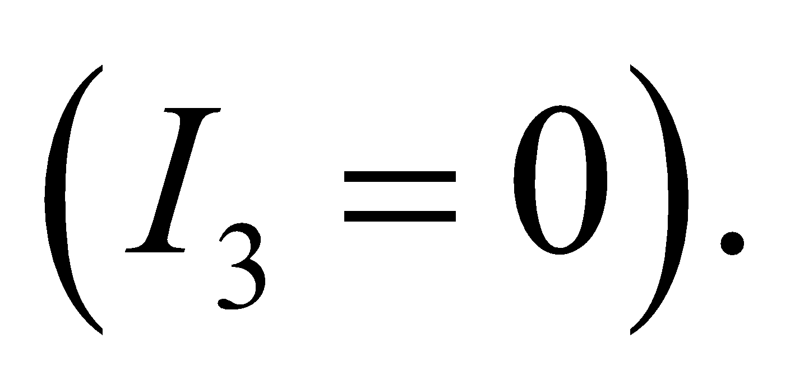 Current will instead flow through *R*2, which is in series with *R*1 (see the figure below). The current *I*2 will be

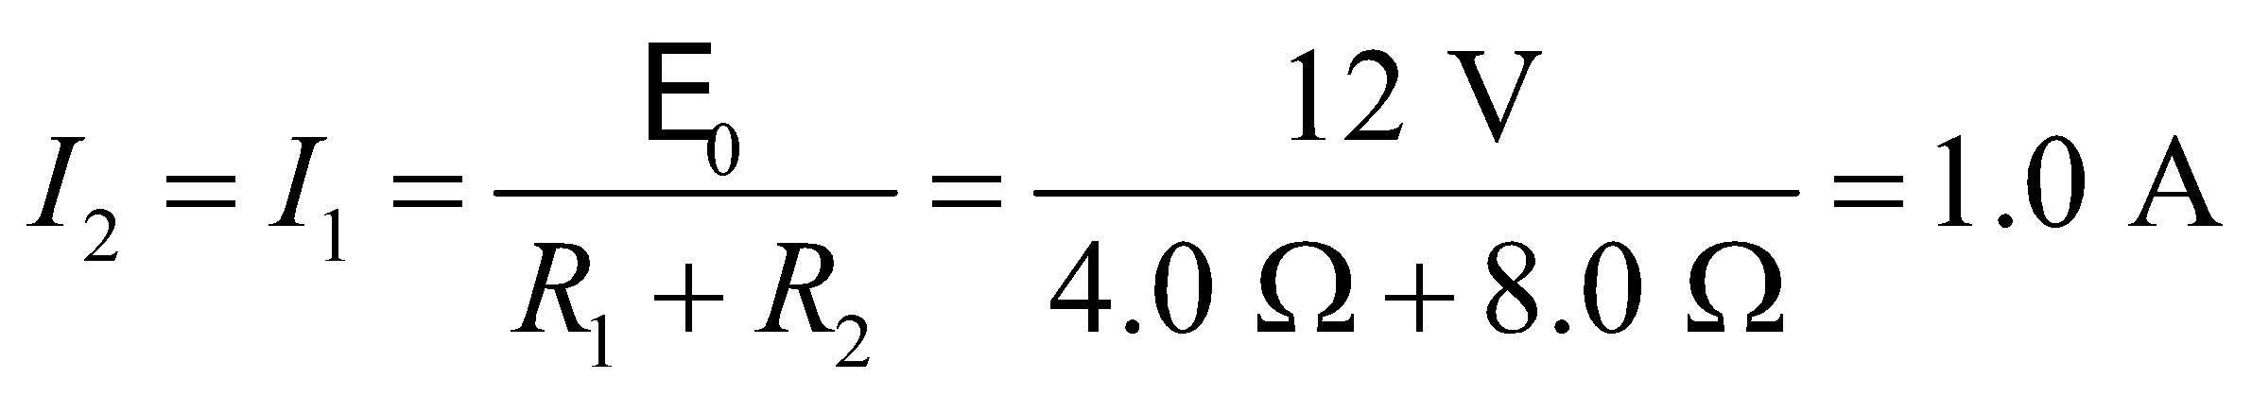



(b) After the currents have been flowing a long time, they reach steady values 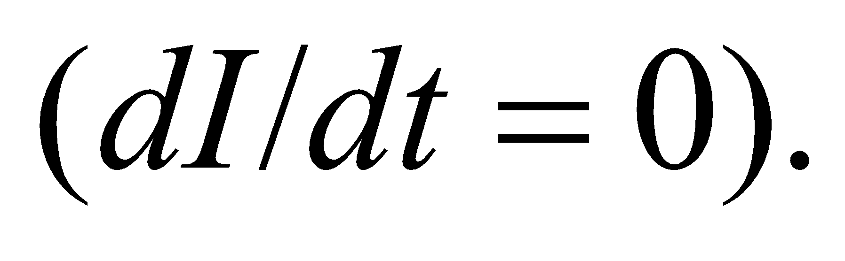 This means the voltage across the inductor is zero, and we can treat it like a short-circuit. Now, *R*2 and *R*3 are in parallel with each other and in series with *R*1 (see the figure below). This implies that the current *I*1 is

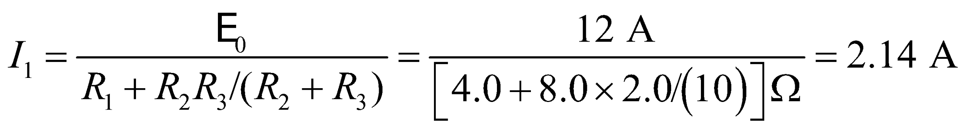

By Kirchhoff's rules, 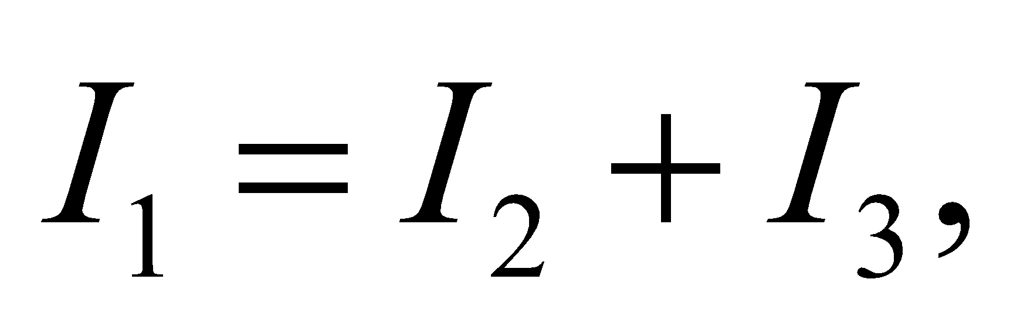 and 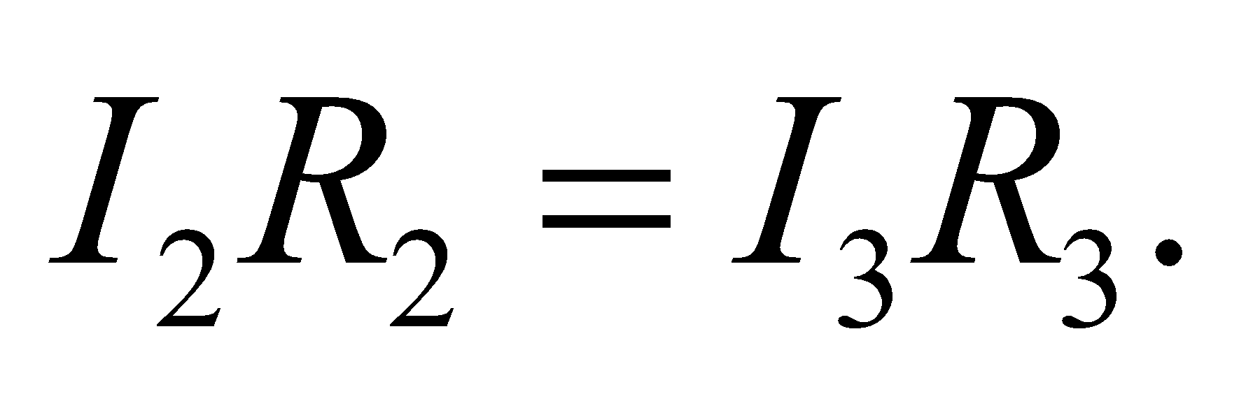 Solving for the current *I*2 gives

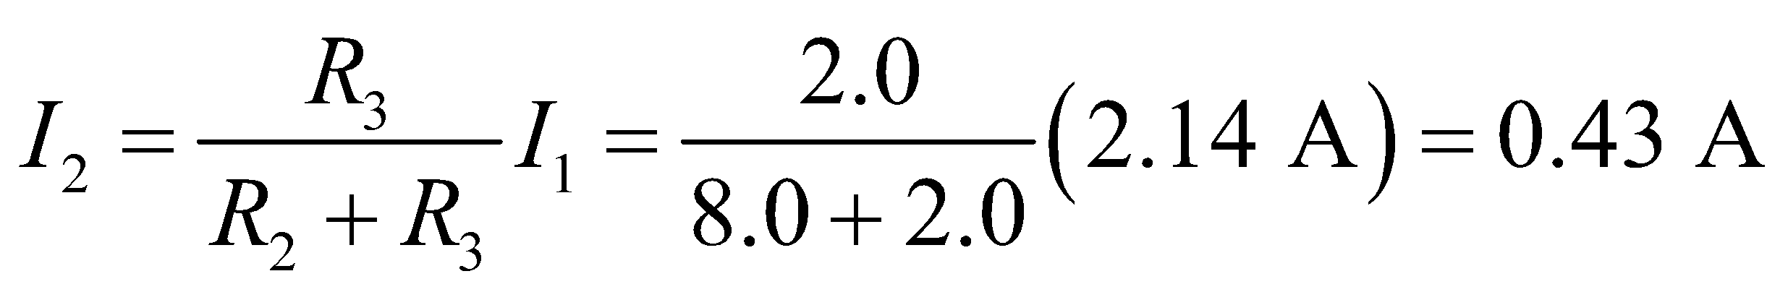

The current *I*3 makes up for the difference: 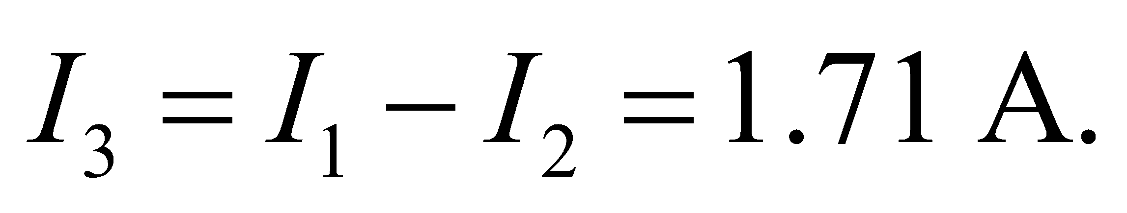



(c) When the switch is reopened, no current flows through the battery’s branch, 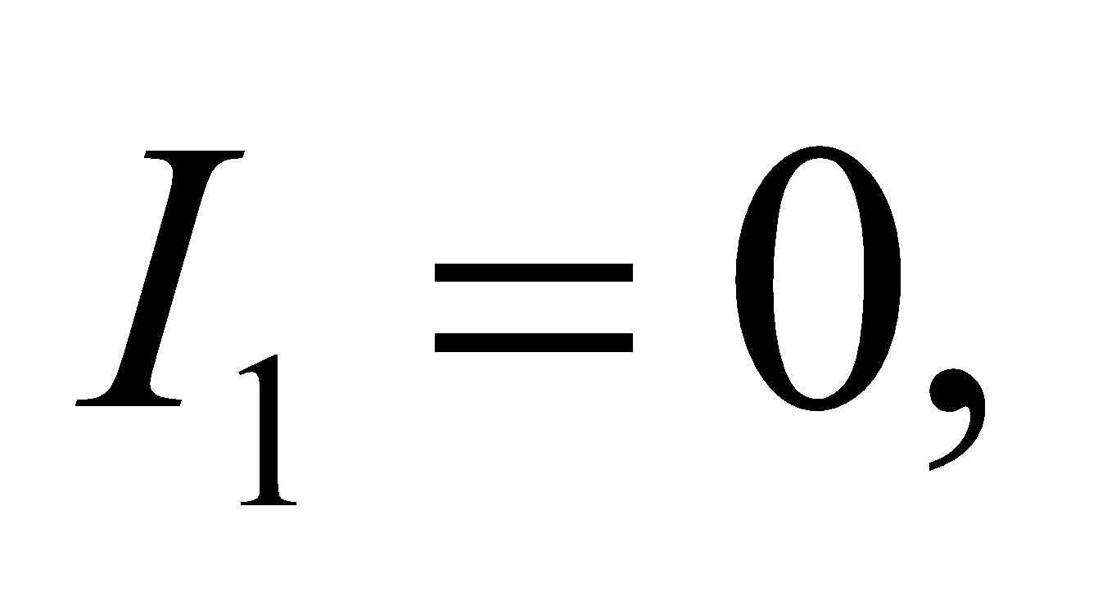 so we can remove it from the circuit (see the figure below). As explained in Conceptual Example 27.1, the induced emf acts to keep the current flowing through the inductor as it was before the switch was opened, i.e., 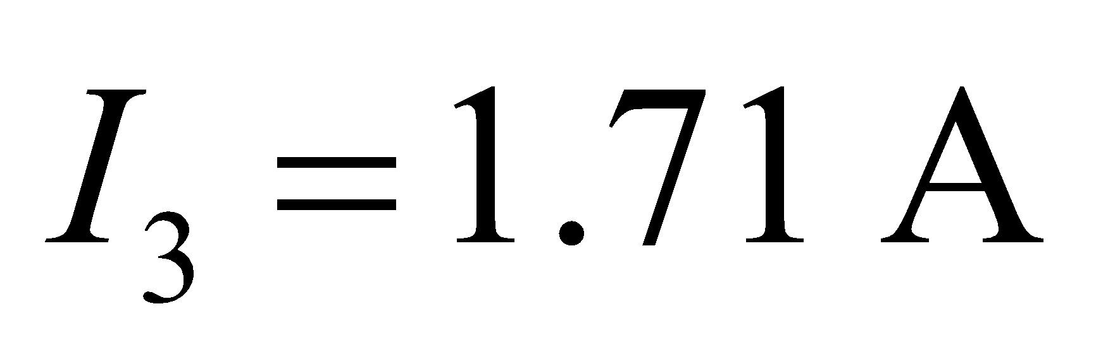 from part (b). The current in *R*2 will be the same as in the inductor, but it will be flowing in the opposite direction as before:

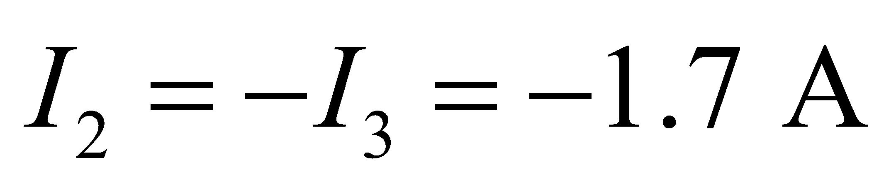



**Assess**Notice that the value of the inductance in *L* was not needed, since we are only considering the short and long term behavior of the circuit. If we wanted to calculate the currents at some intermediate time, then we would need the inductance to plug into Equation 27.7 or 27.8.

**60. Interpret** This problem is about the magnetic energy stored in a series *RL* circuit as a function of time, which we are to deduce from the given dynamics of the circuit.

**Develop** The magnetic energy stored in an inductor is given by Equation 27.9, 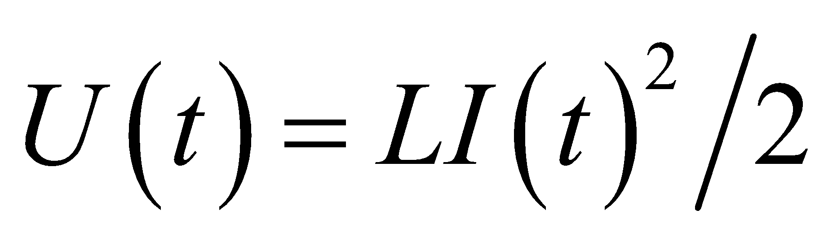, where the rising current is given by Equation 27.27.7; 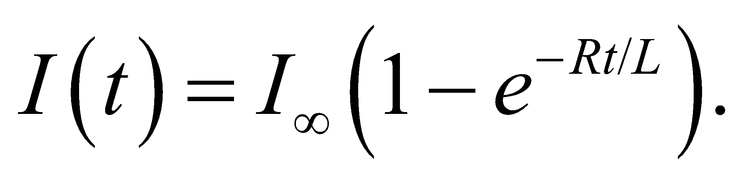 Combining the two equations, the stored magnetic energy as a function of time is

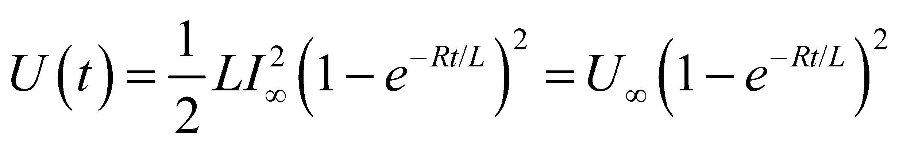

where 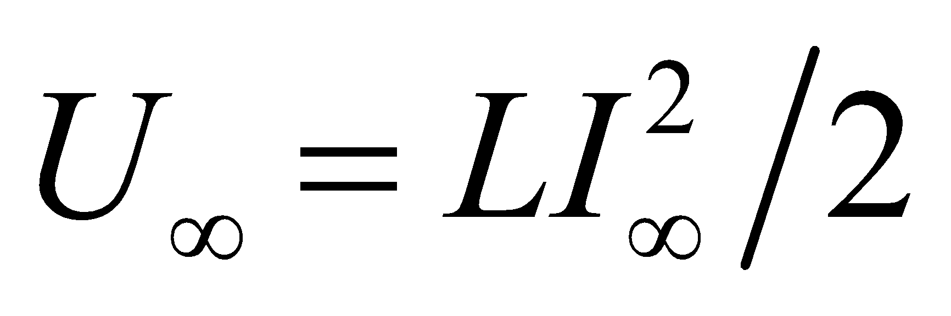 is the steady-state value of the magnetic energy. When the stored energy is half its steady-state value, 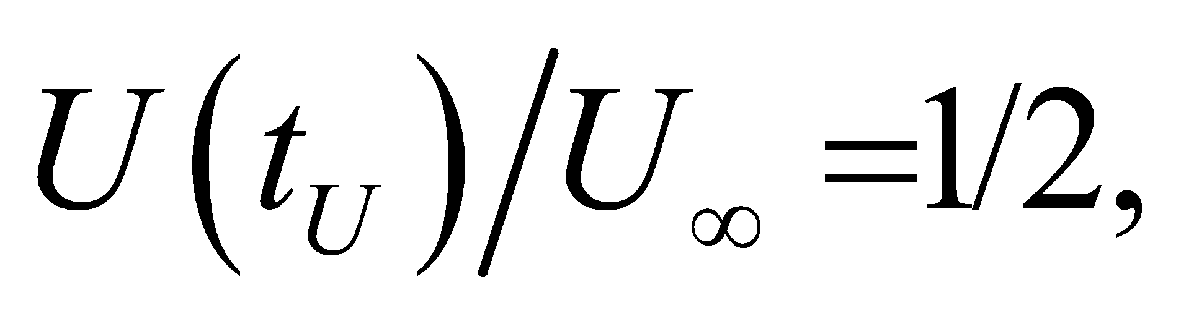 we have

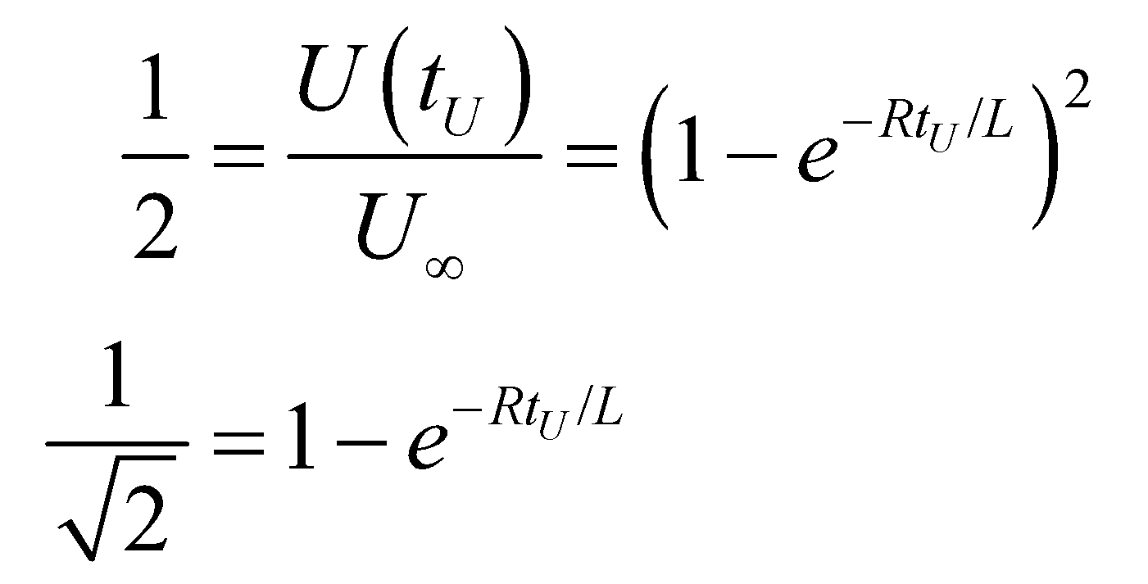

**Evaluate** Solving the above equation for 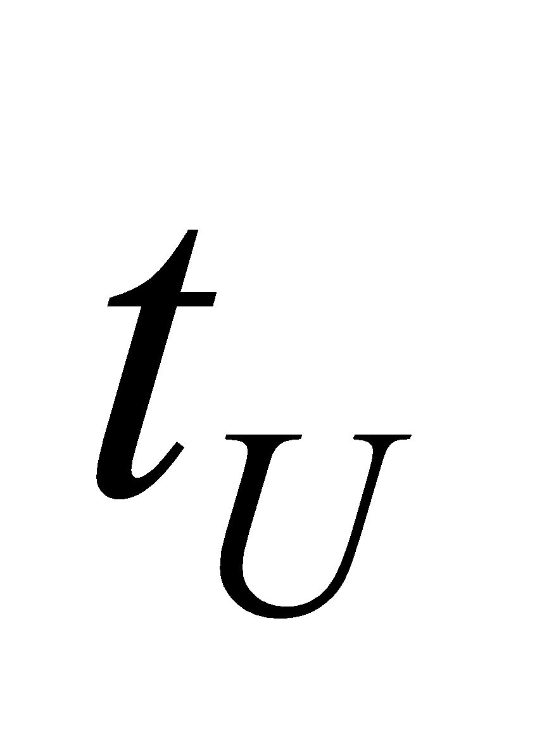 yields

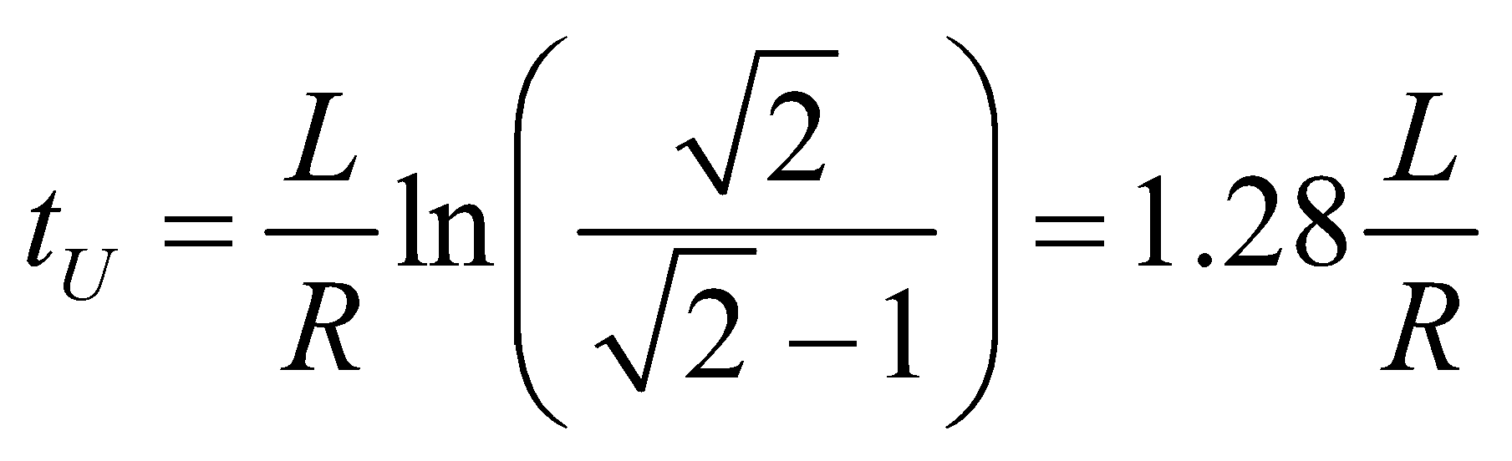

On the other hand, the current is half its steady-state value when 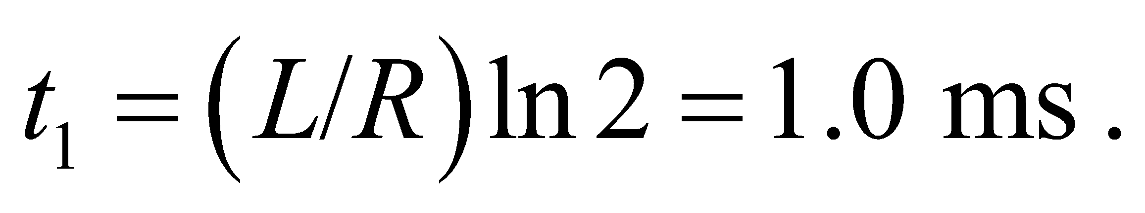 Dividing these results, we find

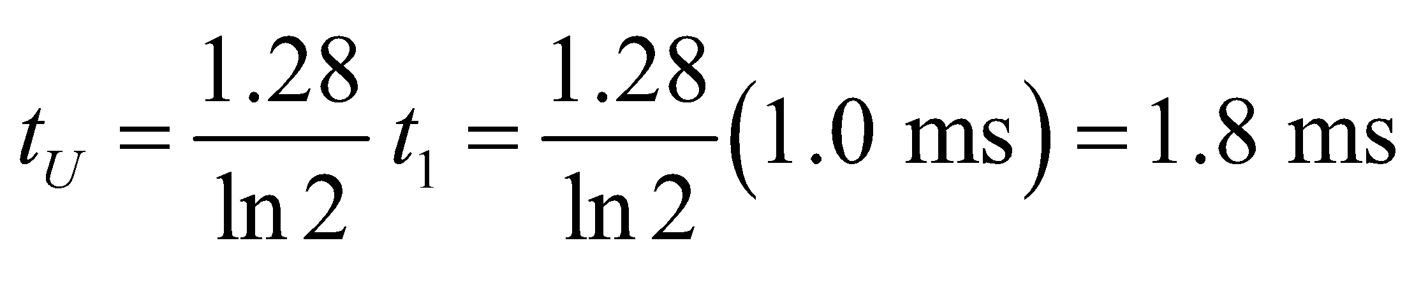

**Assess** Since 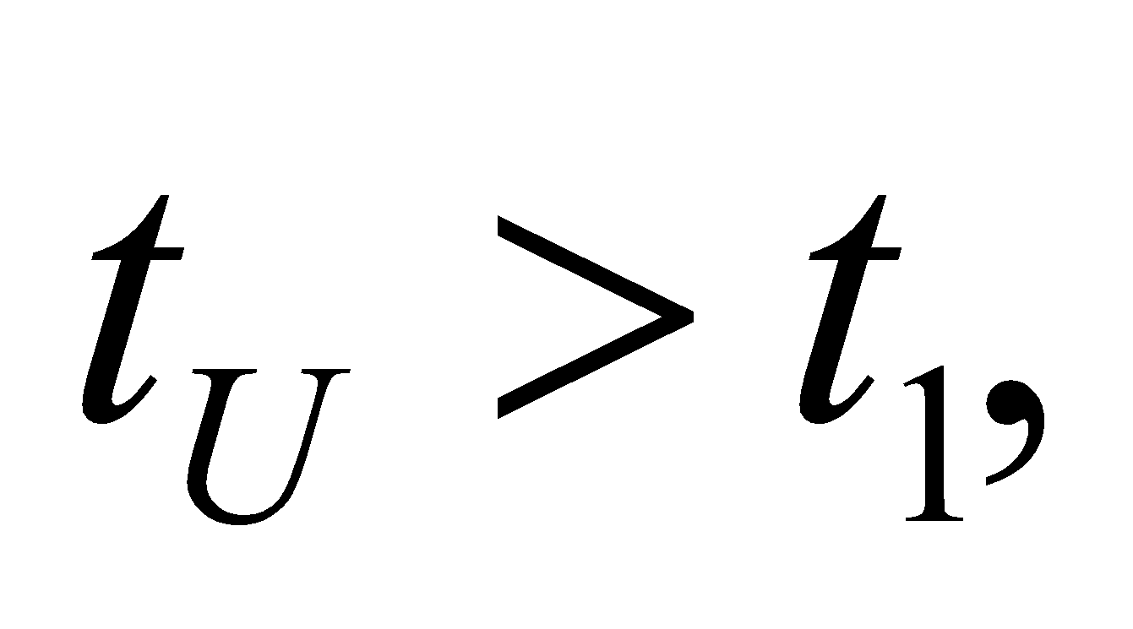 the magnetic energy reaches half its steady-state value after the current has already surpassed half its steady-state value. In fact, the current at 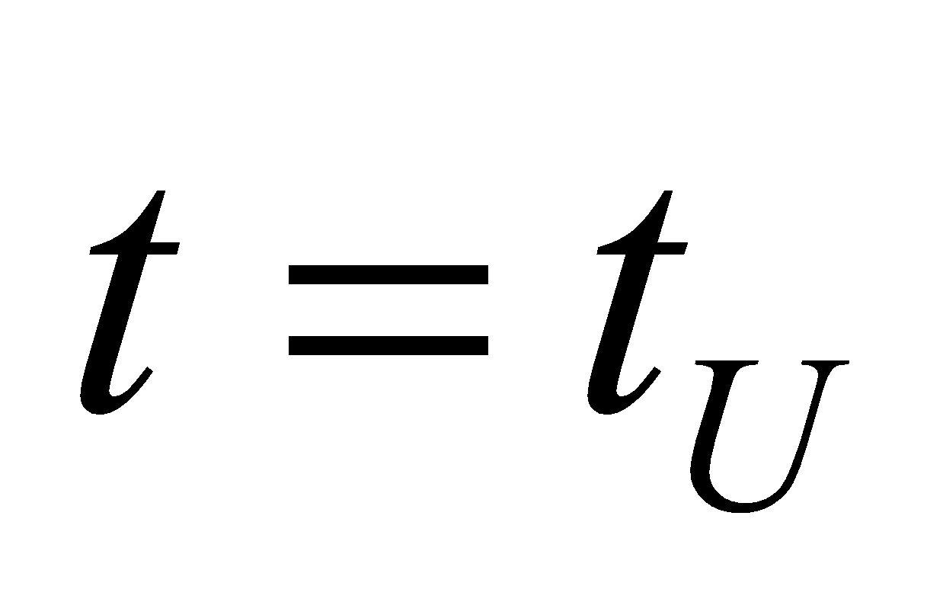 is

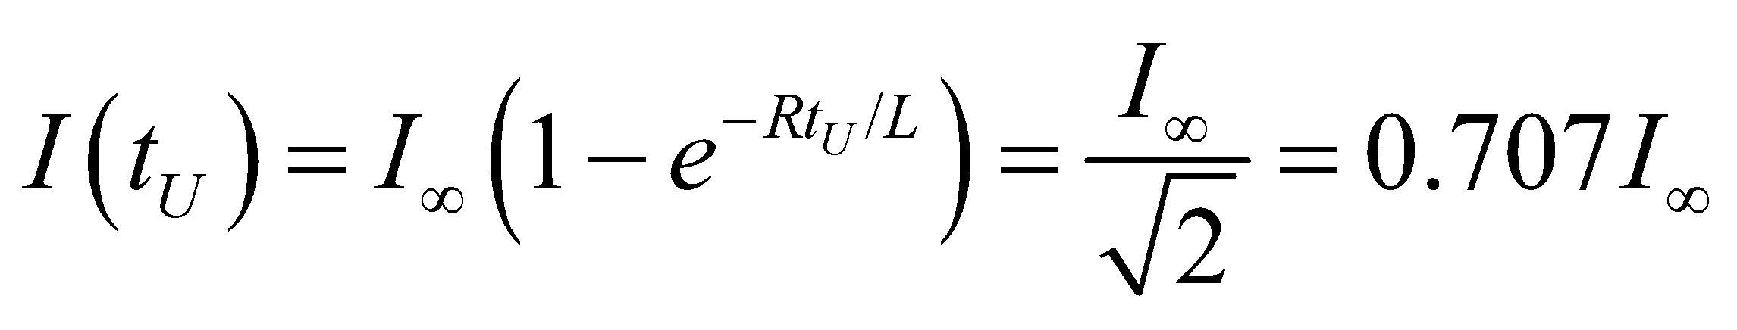

**61. Interpret** This problem involves an *RL* circuit with a given inductance. The energy in the inductor drops by 75% in the given time and we are to find the resistance.

**Develop** From Equation 27.9, *U* = *LI*2/2, we find

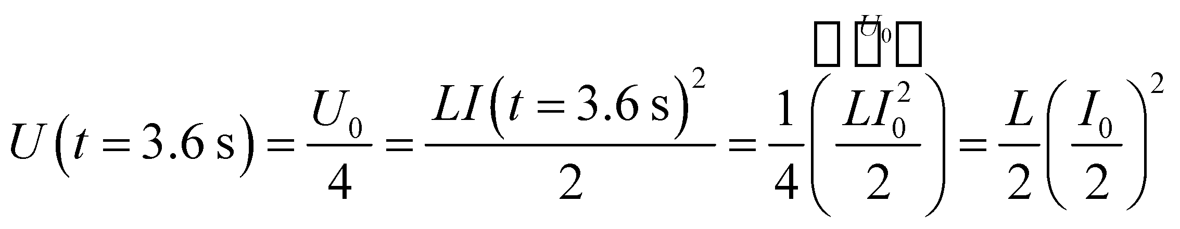

from which we deduce that *I*(*t* = 3.6 s) = *I*0/2. Insert this into Equation 27.8, 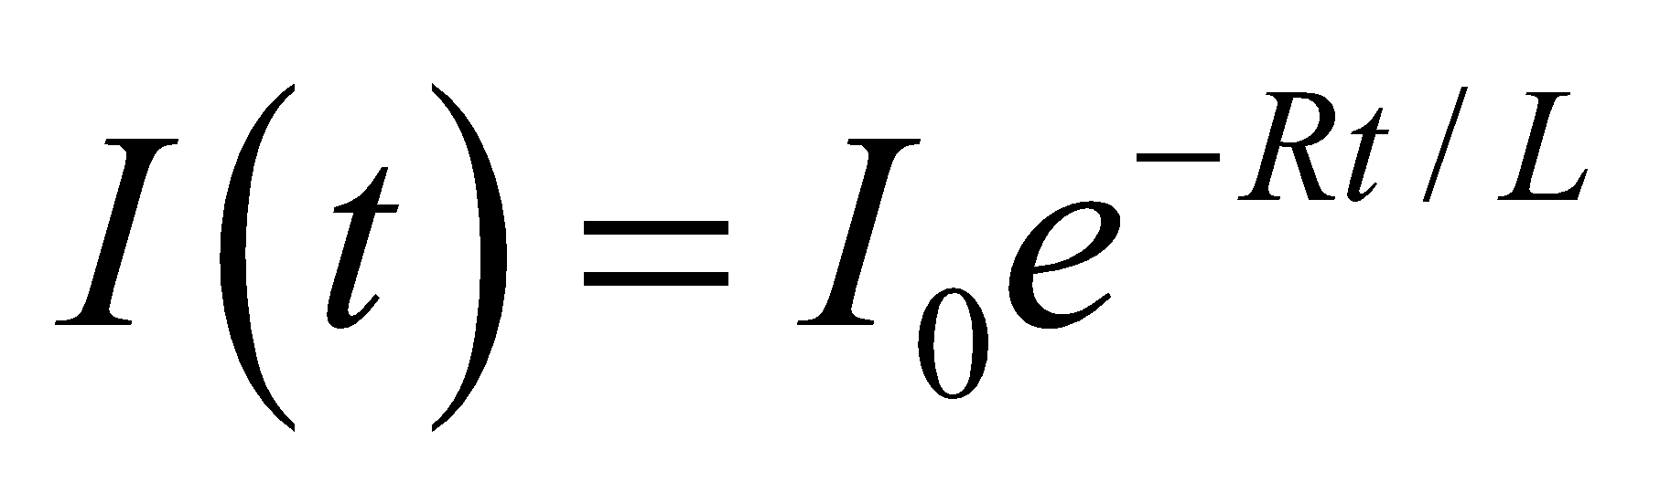, to find the resistance *R*.

**Evaluate** Solving Equation 27.8 for the resistance *R* and inserting the given quantities gives

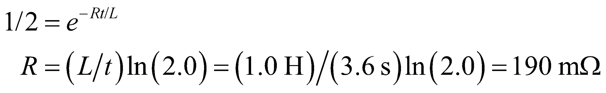

to two significant figures.

**Assess** The current and the resistance do not have the same time constant. Because the current is squared in the expression for energy, the time constant for the energy in the inductor is twice that for the current. Thus, the energy grows and decays at twice the rate compared to the current.

**62. Interpret** You need to specify the maximum resistance needed in the wires of an MRI scanner in the eventuality that superconductivity is lost suddenly.

**Develop**If so-called "quenching" occurs, the solenoid wire will suddenly acquire a resistance. But since the solenoid is an inductor, the current will not immediately change. It will initially be the same as it was before quenching, so the power in the resistor immediately after the loss of superconductivity will be 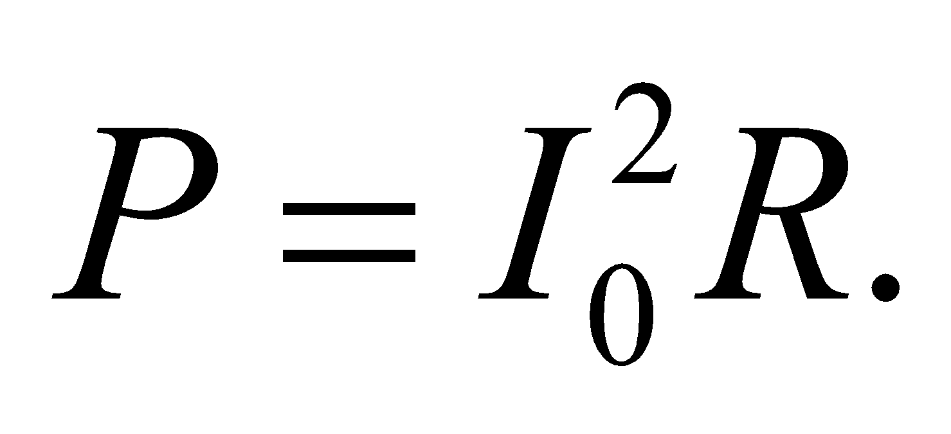 Since the inductor and the resistance are effectively in series, the current will drop according to Equation 27.8:  From this we can solve for the time it will take for the power in the resistor to drop to 50 kW.

**Evaluate**(a) Right after quenching, the maximum resistance needed to keep the power dissipated below 100 kW is

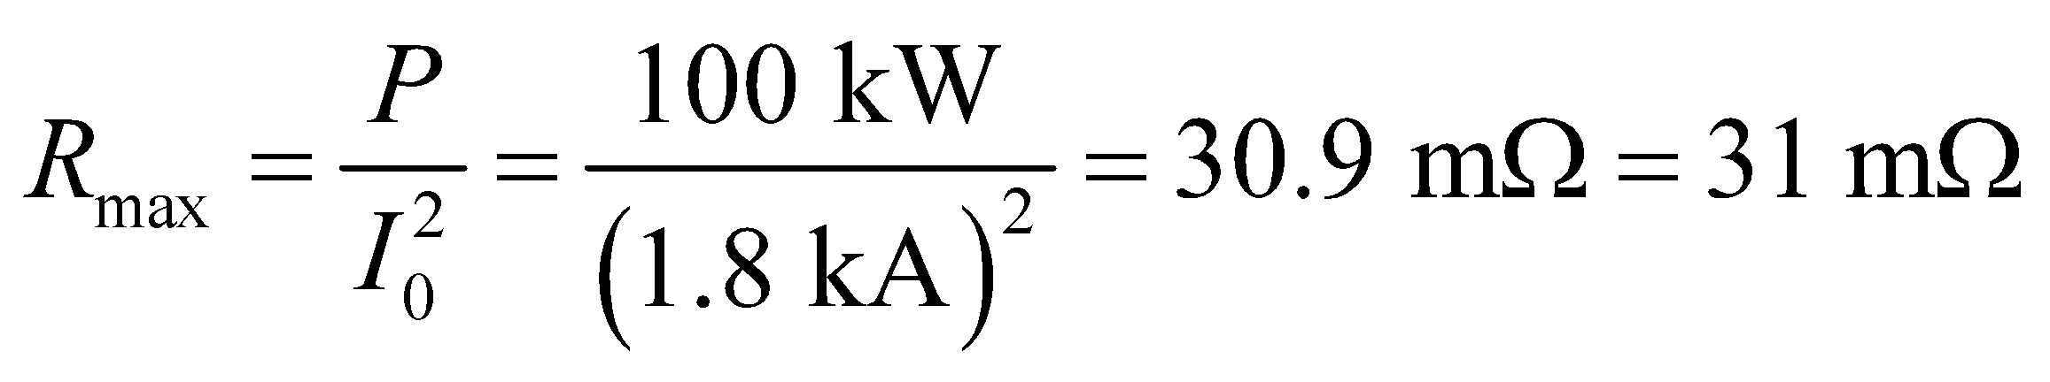

(b) If we assume the maximum resistance from part (a), and we assume that there are no other elements in the circuit except the inductance and the resistance, then the power will drop to half its initial value in a time of

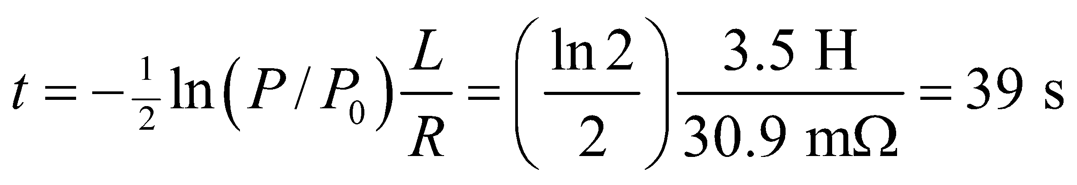

**Assess**Notice that you could put in a smaller resistance, but then it will take longer for the power to drop by half. This is because the resistance must dissipate all the energy that was initially stored in the inductance: 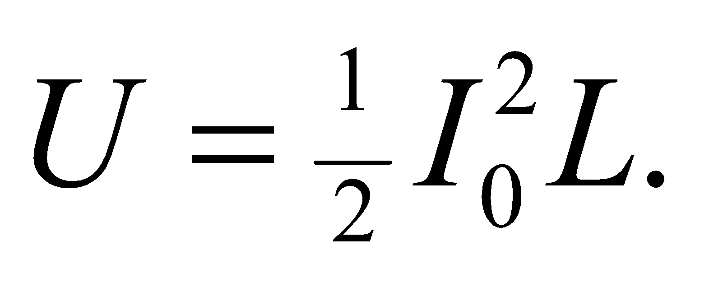 Either you use a relatively large resistance that dissipates the energy quickly over a short time, or you use a relatively small resistance that dissipates the energy slowly over a long time.

**63. Interpret** This problem involves finding the energy density in the magnetic field of a neutron star and comparing that density with other sources of energy.

**Develop** Apply Equation 27.10,

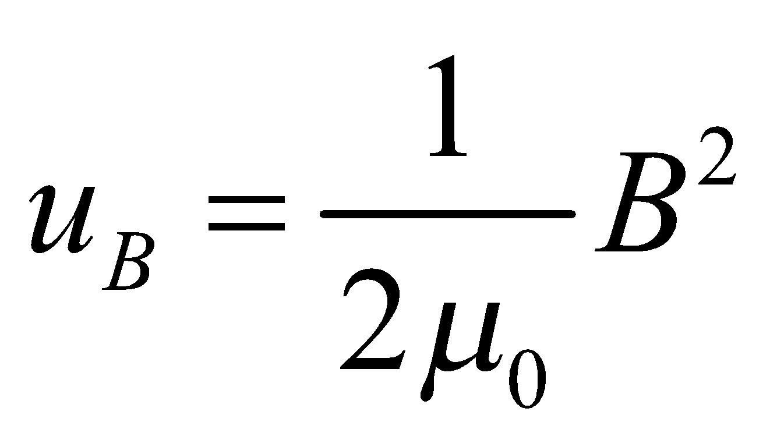

to find the energy density in the magnetic field of the neutron star.

**Evaluate** The energy density in a magnetic field of the neutron star is

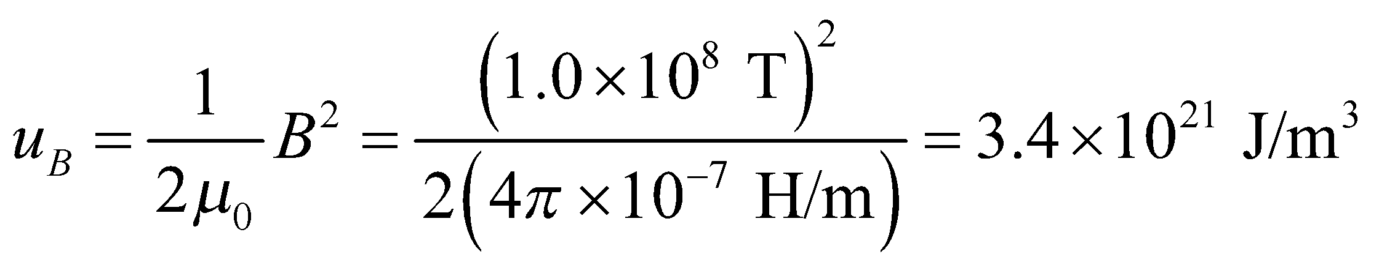

This is about **(a)** 1.1 × 1011 times the energy density content of gasoline 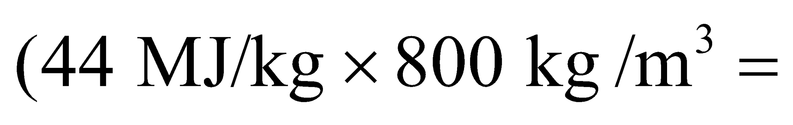 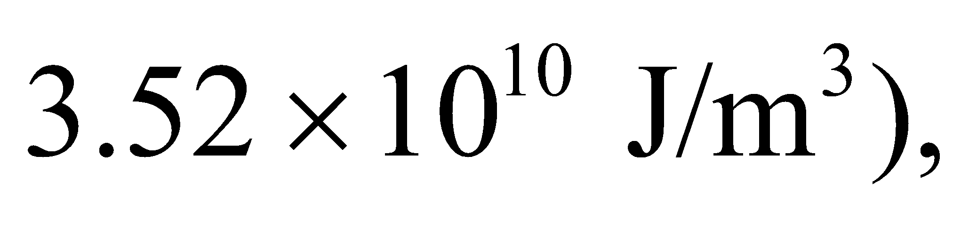and **(b)** 2600 times that of pure 

**Assess** The energy density in the magnetic field of the neutron star is very high compared to that of common energy sources found on Earth.

**64. Interpret** In this problem, we are asked to compare the magnetic energy density between a current-carrying loop and a solenoid of the same radius.

**Develop** The magnetic field at the center of the loop is 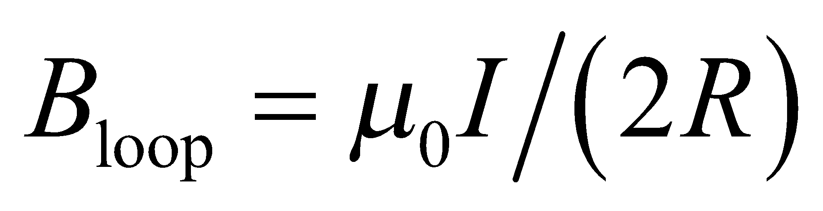 (see Equation 26.9 with *x* = 0 and *a* = *R*). On the other hand, the magnetic field inside a solenoid is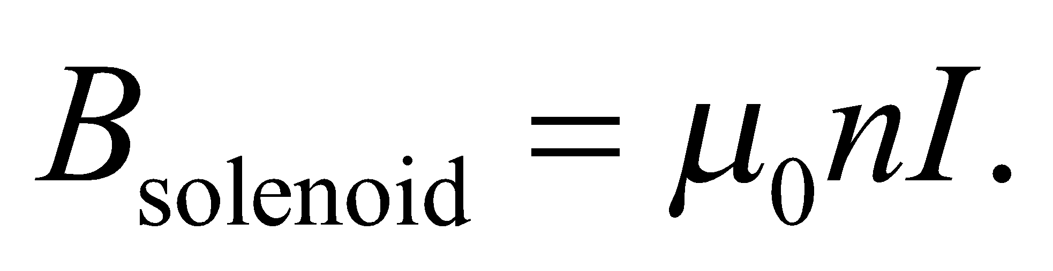(Equation 26.21). The energy density can be found by using Equation 27.10: 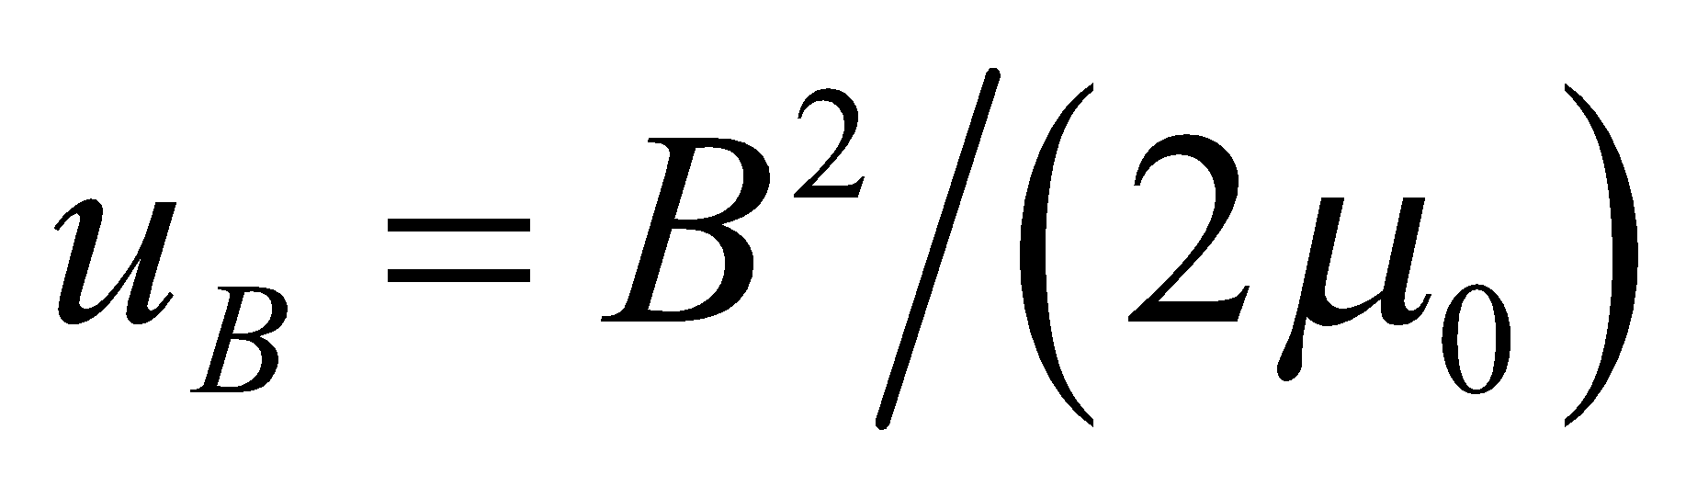.

**Evaluate** Using the equations above, we find the energy density at the center of the loop to be

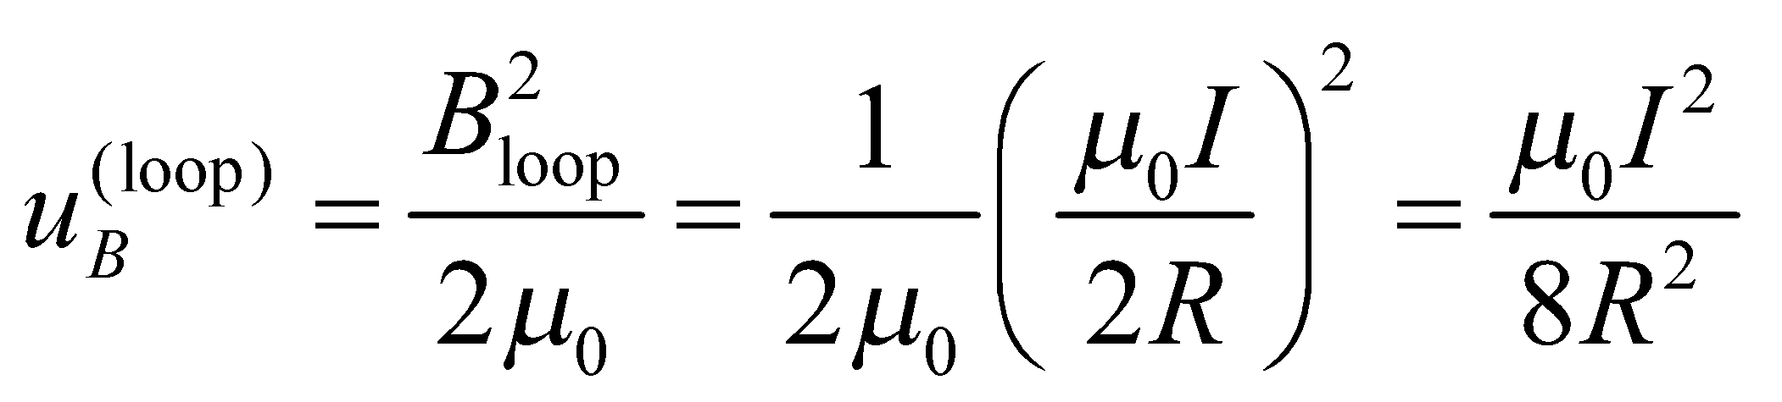

In a long thin solenoid of the same radius,

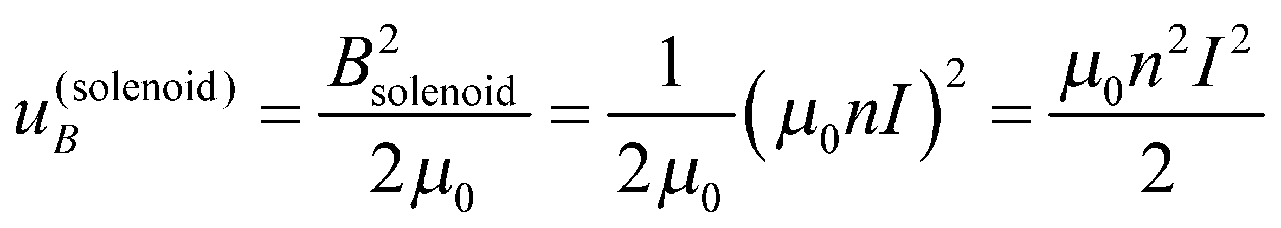

so the ratio is

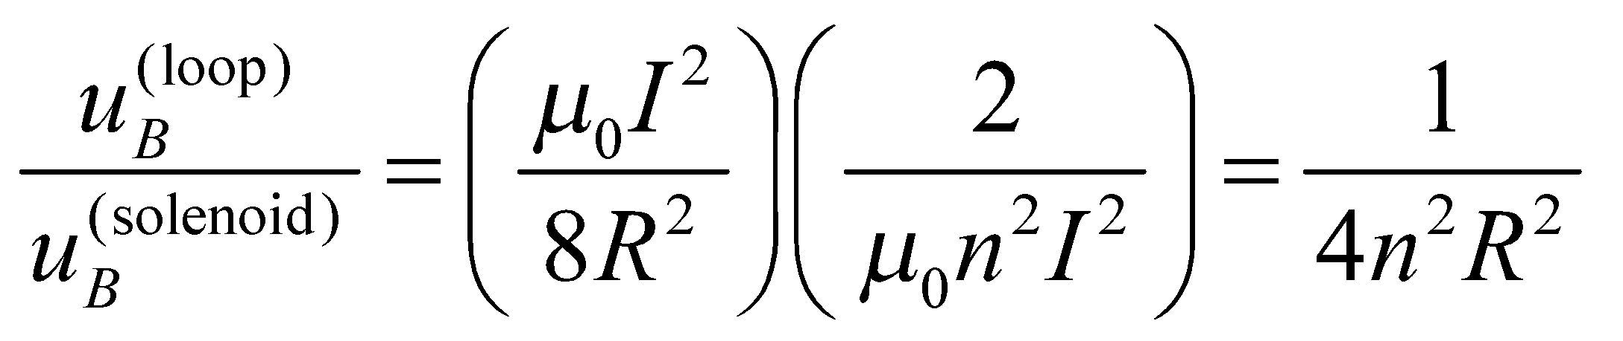

**Assess** As expected, the ratio is dimensionless (recall that *n* represents the number of turns per unit length of a solenoid). The result shows that the energy density inside a solenoid is greater than that at the center of a loop by a factor of 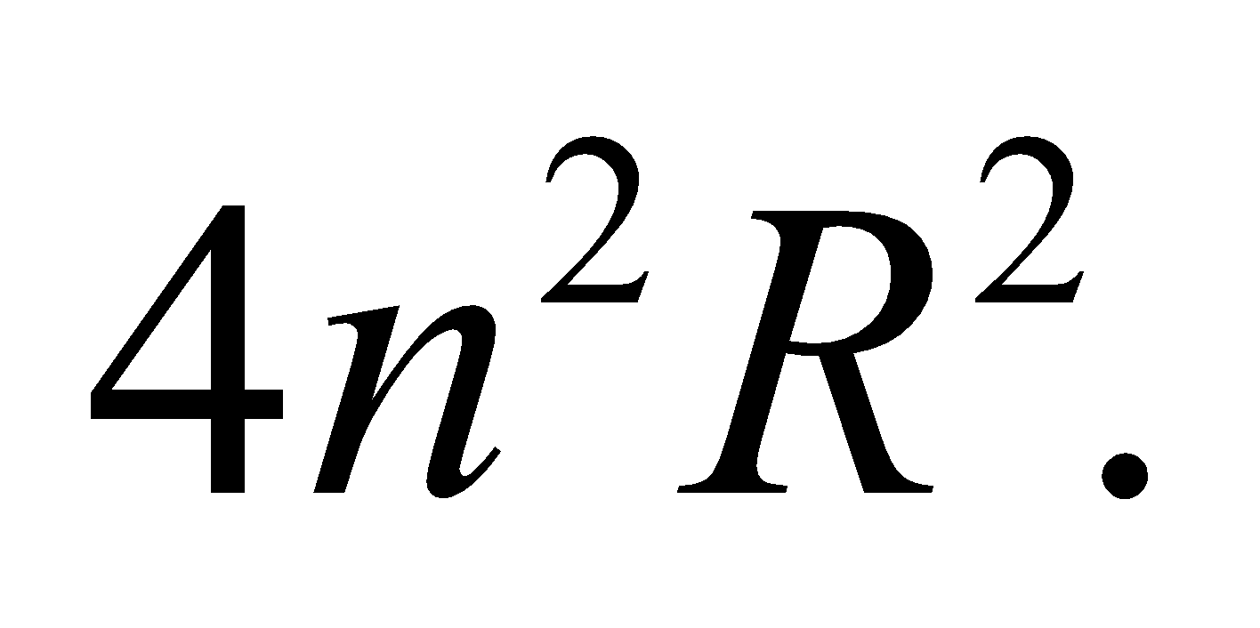

**65. Interpret** We are to find the energy per unit length within a wire that carries a given current distributed uniformly throughout the wire.

**Develop**  Equation 26.19 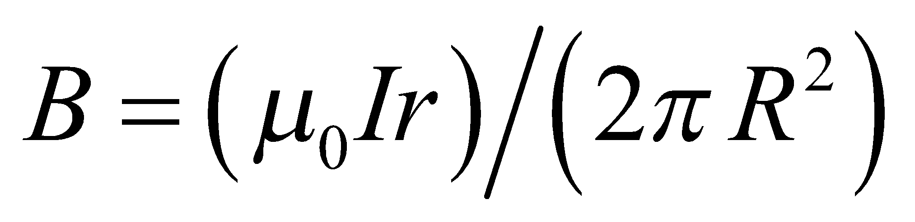 gives the magnetic field strength inside a wire at radius *r*. The energy density power unit length is (Equation 27.10) . Combine these equations and integrate to find the energy density per unit length.

**Evaluate** Using 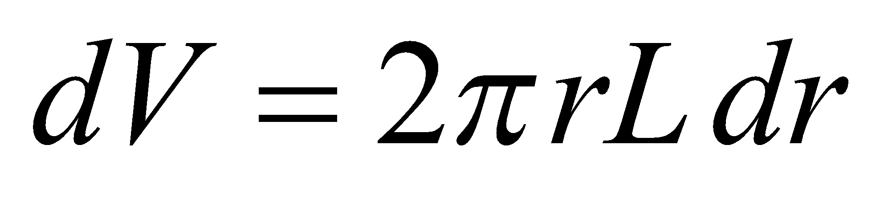, the energy density per unit length is

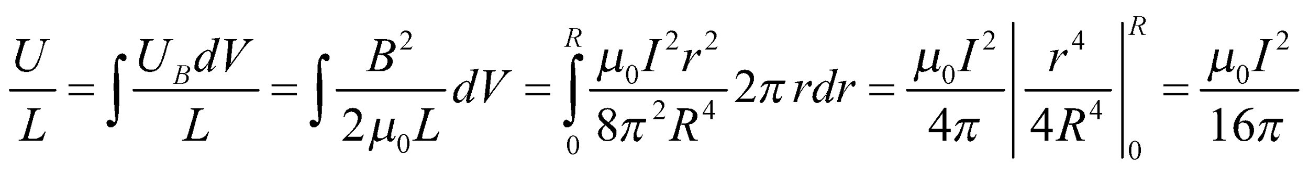

**Assess** The energy density, like the energy, is proportional to the current squared.

**66. Interpret** In this problem we want to verify that the time integral of the power dissipated through the resistor in a series *RL* circuit is equal to the energy initially stored in the inductor.

**Develop** Equation 27.8,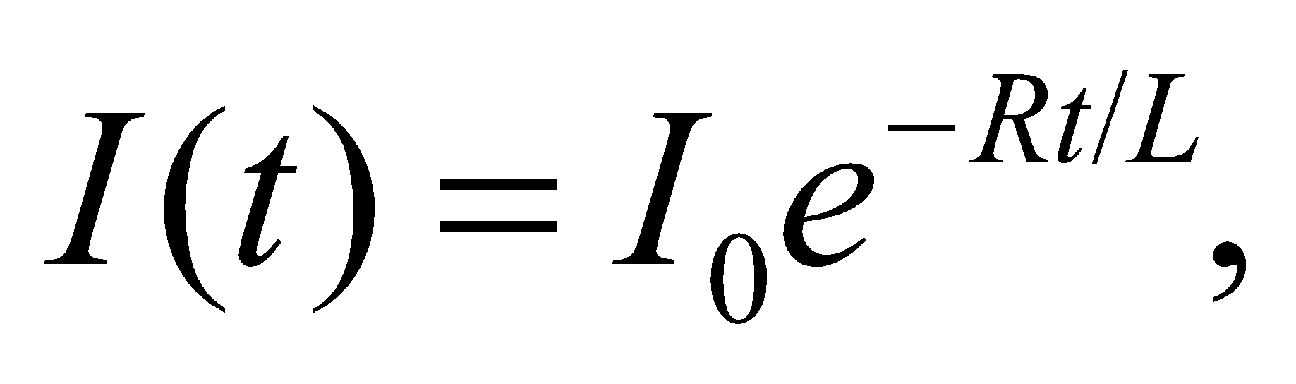gives the current decaying through a resistor connected to an inductor carrying an initial current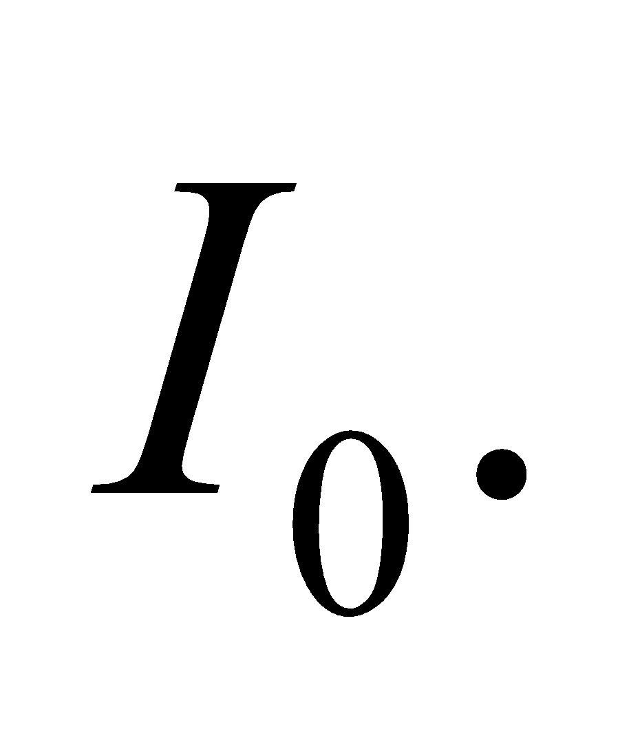The instantaneous power dissipated in the resistor is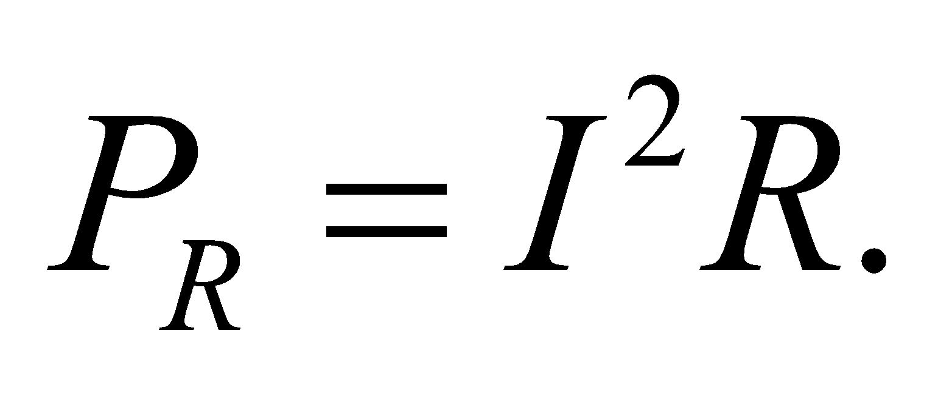

**Evaluate** **(a)** Using the two equations above, the power dissipated in the resistor as a function of time is

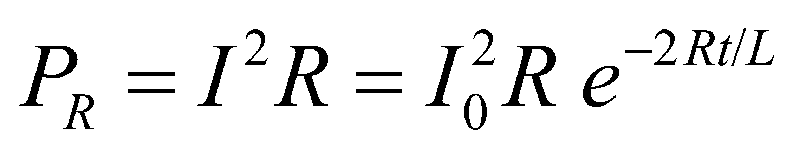

**(b)** In a time interval *dt*, the energy dissipated is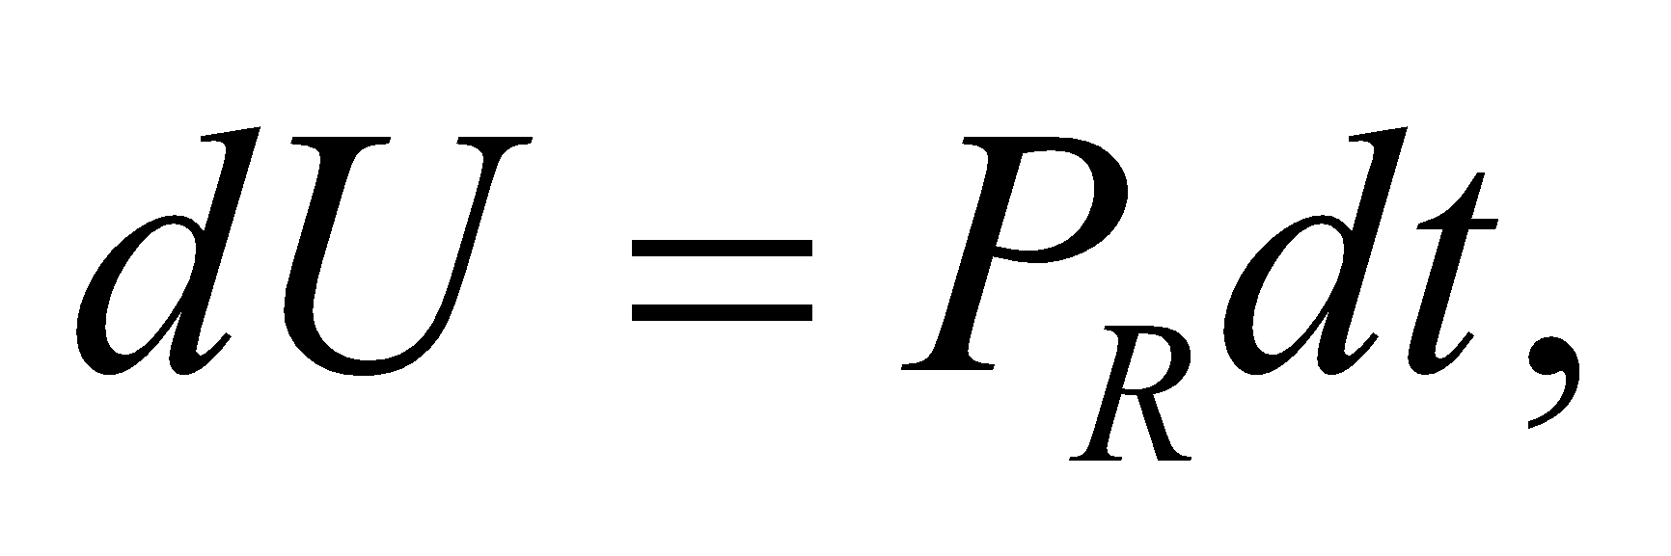so the total energy dissipated is

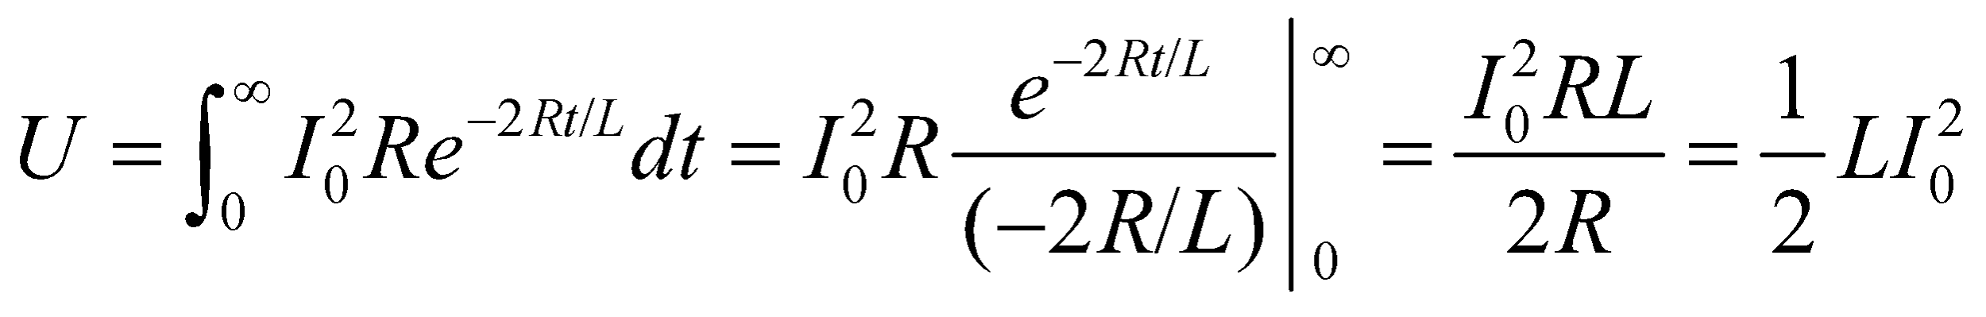

**Assess** This is precisely the energy initially stored in the inductor. The result must hold true by energy conservation.

**67. Interpret** We are to compare the ratio of the electric to magnetic fields given that they have the same energy density.

**Develop** The energy density due to the electric field is (Equation 23.7) is 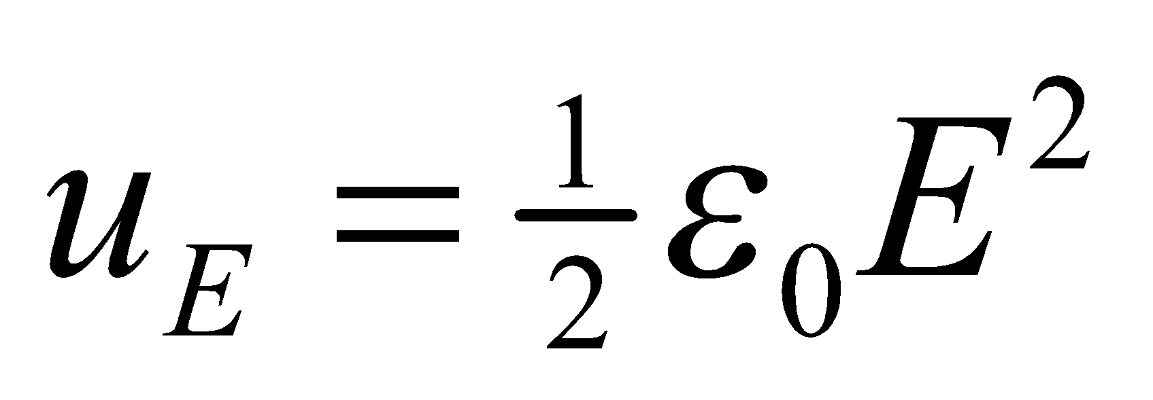 and that due to the magnetic field is (Equation 27.10) 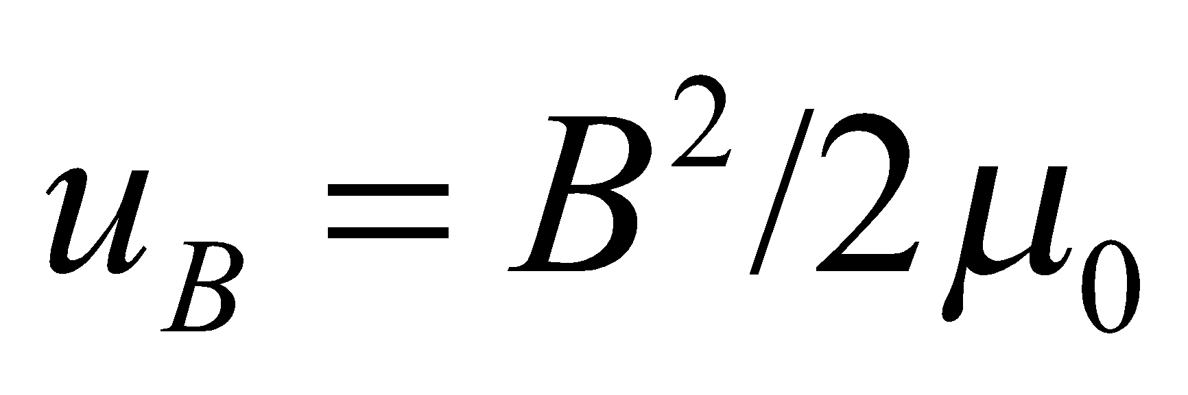.

**Evaluate** When these two energy densities are equal, their ratio is unity, which gives

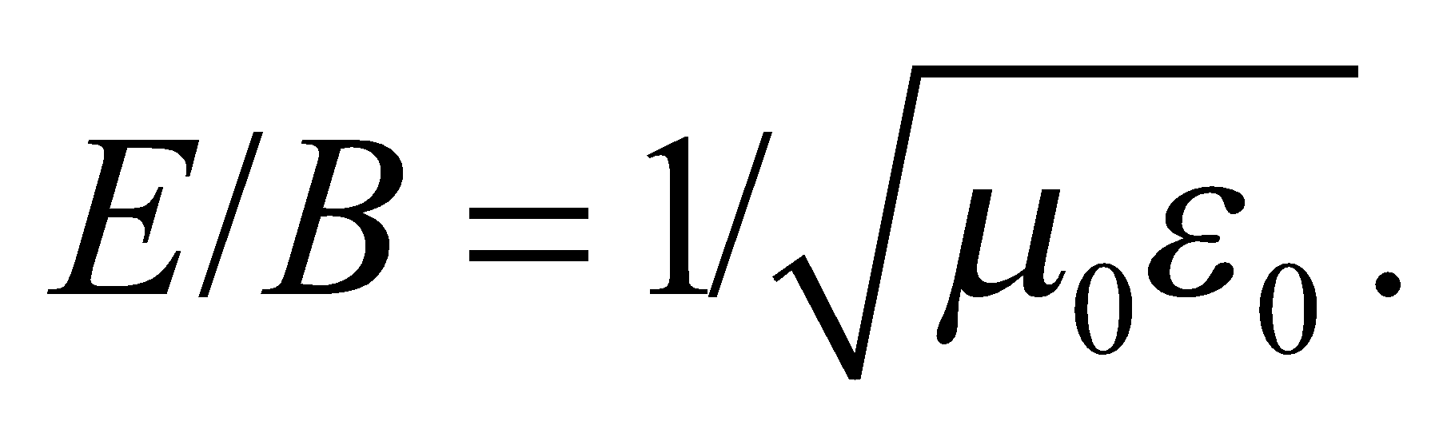

Numerically, 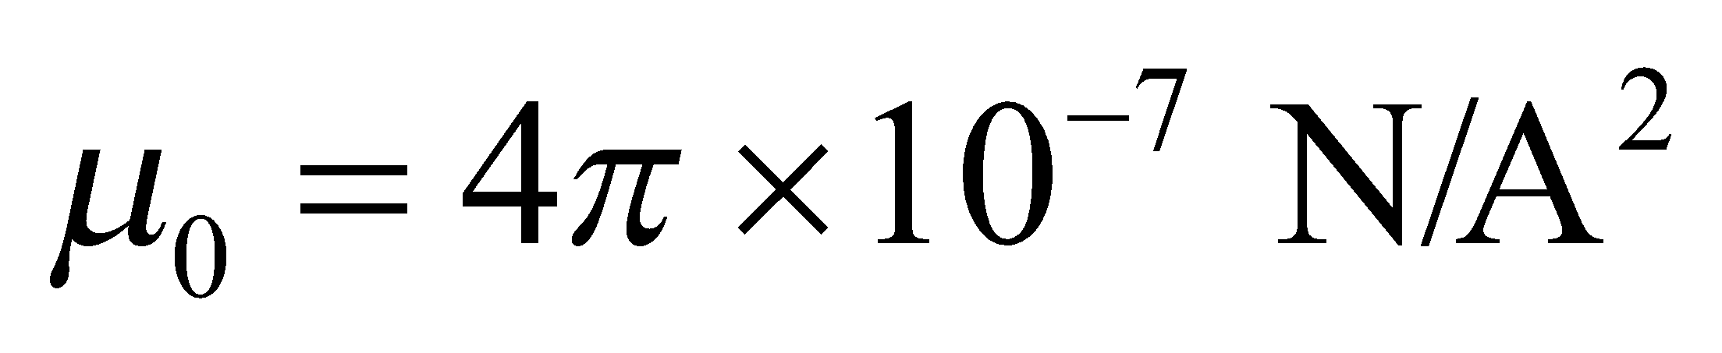 and 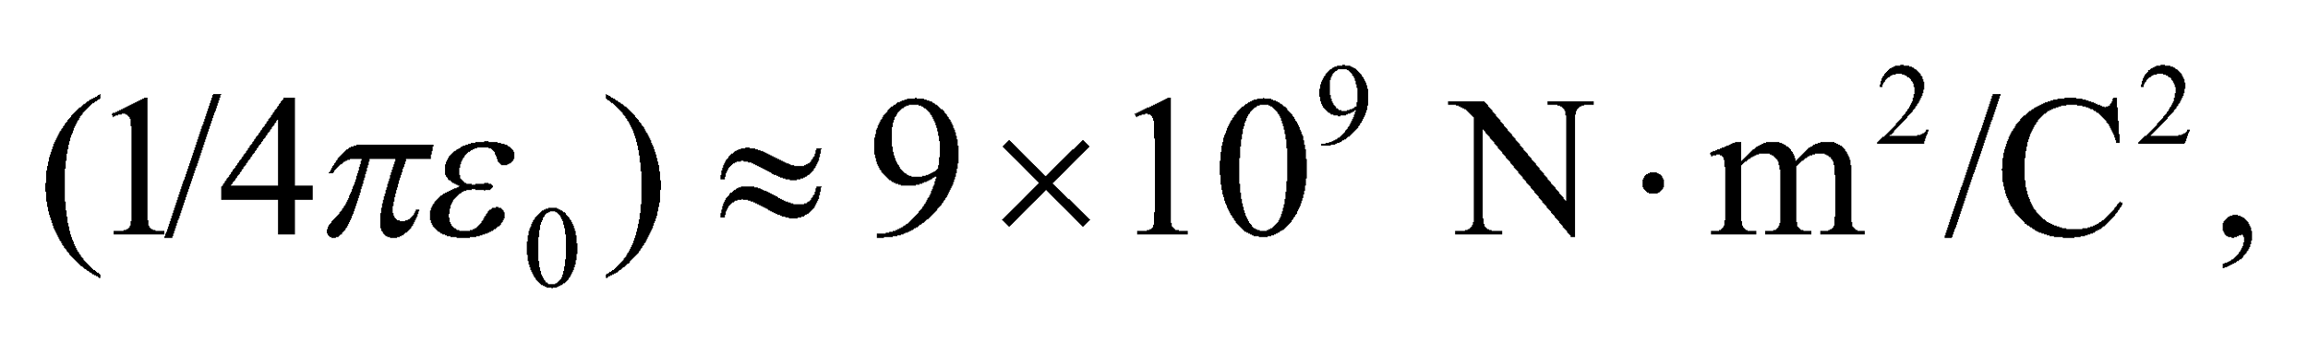 so

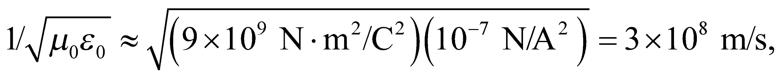

which is, in fact, the speed of light (see Section 29.5).

**Assess** The speed of light is a fundamental constant of nature that can be derived from measurements of the constants of electricity and magnetism. Because these latter are the same in all inertial frames of reference, the speed of light must also be the same in all inertial frames of reference.

**68. Interpret** The magnetic flux in the loop is changing due to the increase in the area exposed to the field. The induced current will experience a force from the magnetic field.

**Develop**The magnetic flux through the loop is proportional to the vertical distance *y* that it falls into the field region,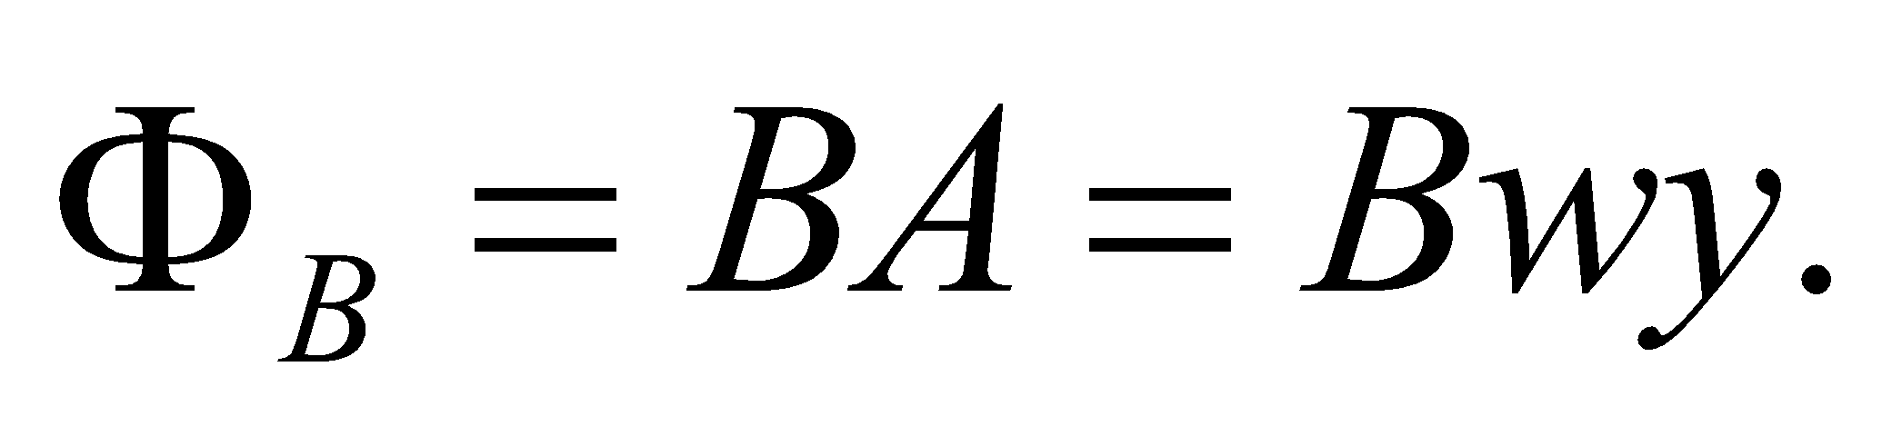 The rate of change of the flux is

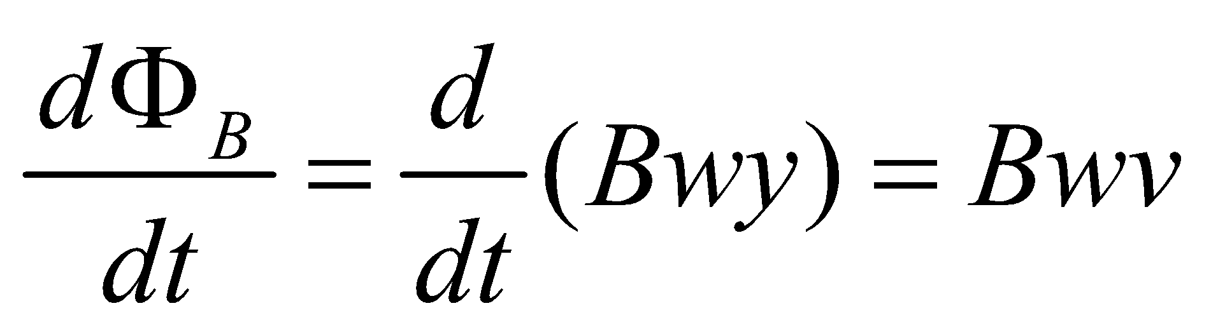

where 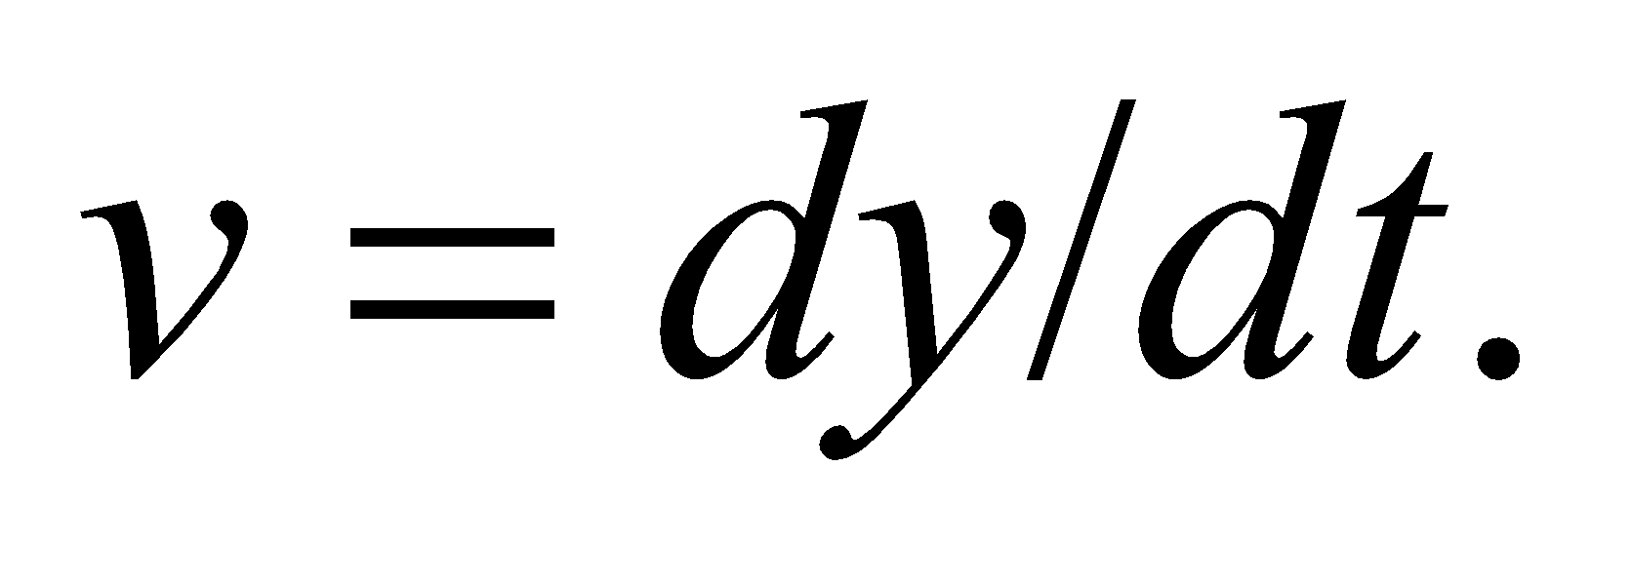

**Evaluate**(a) The changing magnetic flux induces an emf in the loop: 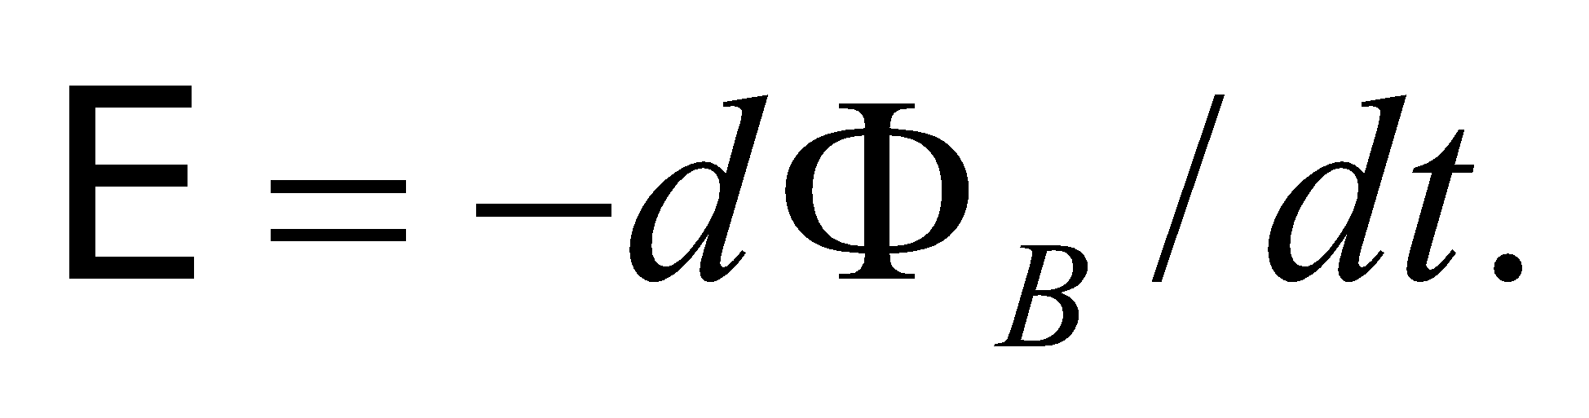 By Lenz's law, the resulting current, 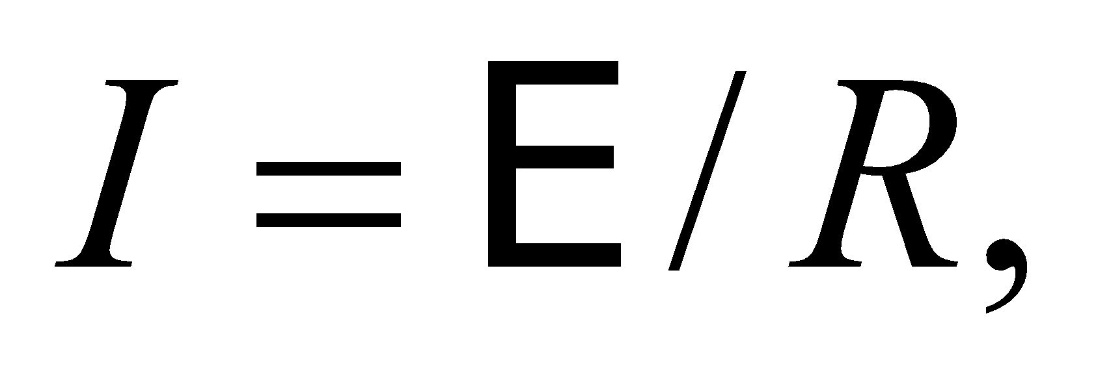will move in a counterclockwise direction, so as to generate a magnetic field out of the page and thus reduce the increase in magnetic flux. The external magnetic field will exert a force on the bottom of the loop: 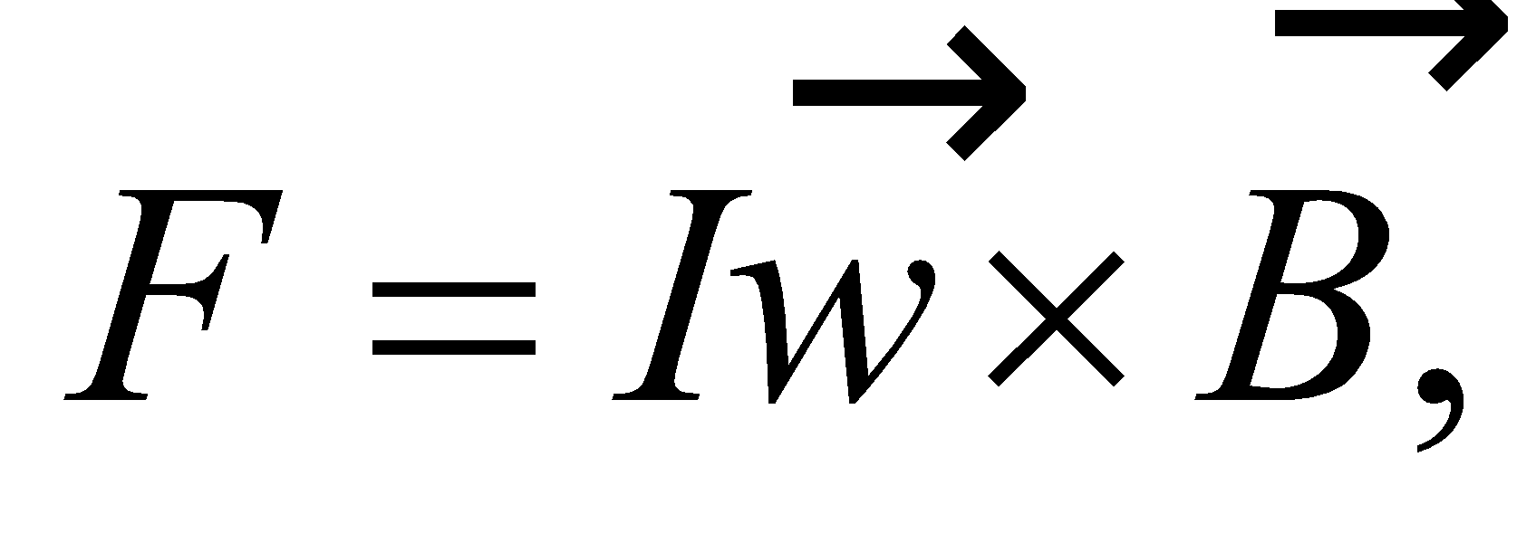 which will point upwards in the opposite direction of gravity. (There will be forces also on the left and right sides of the loop but they will be equal and opposite to each other.) So assuming the loop is long enough, it will accelerate downwards until it speed is high enough that the magnetic force cancels the gravitational force. With net force of zero, the loop will have reached terminal speed.

(b) From the arguments above, the terminal speed occurs when the magnitude of the magnetic force 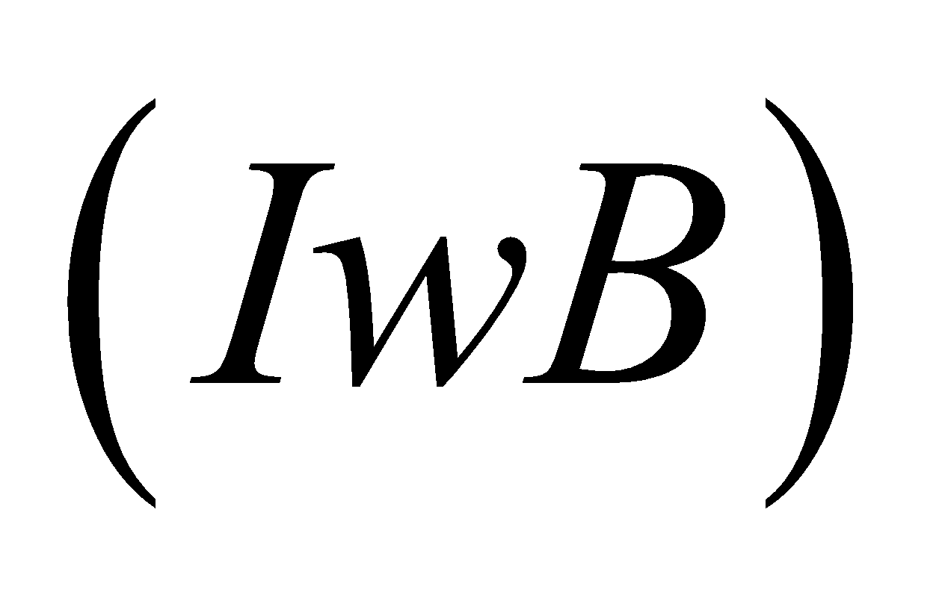 is equal to that of the gravitational force 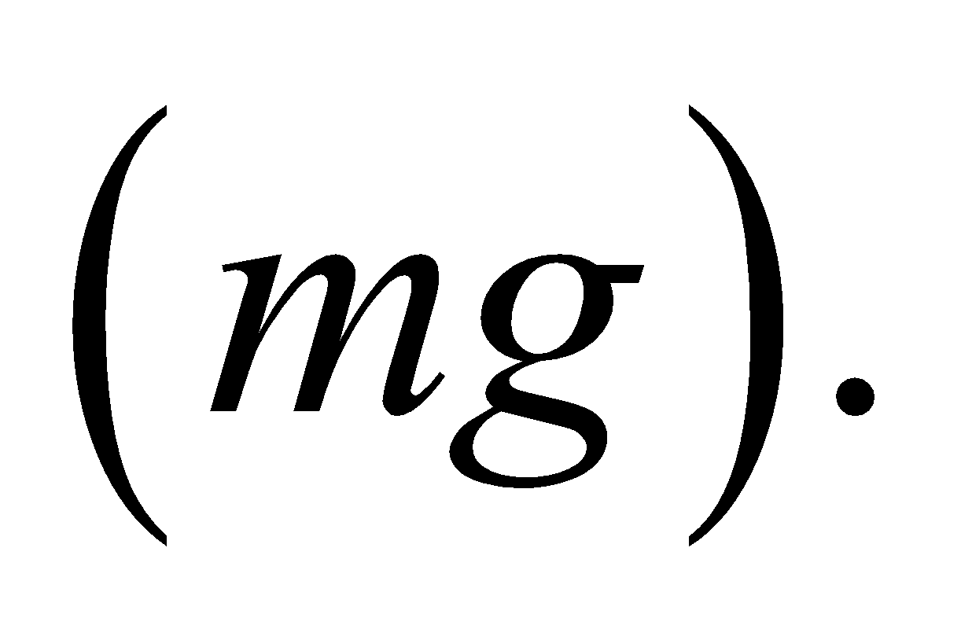 The induced current in this case is 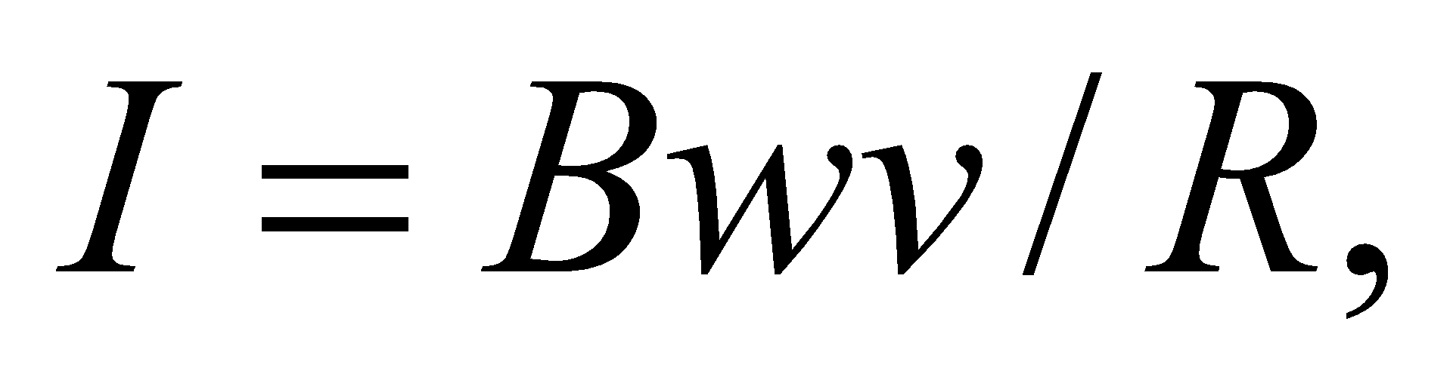so the terminal speed equals

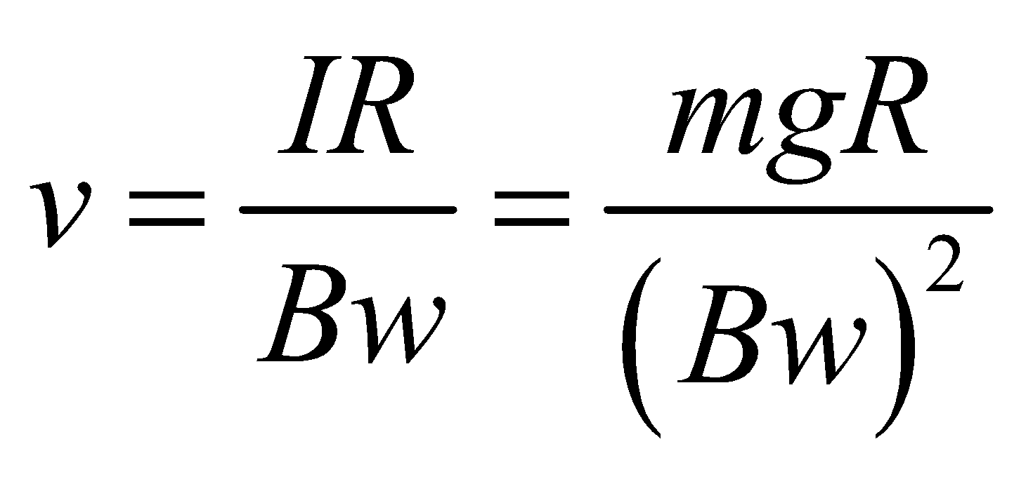

**Assess**Once the loop falls far enough that its top end enters into the magnetic field, there will be no more change in the magnetic flux. This will shut off the induced emf and the induced current. With no more magnetic force, the loop will start to accelerate again due to gravity.

**69. Interpret** A conductive disk is in a changing magnetic field, and we are asked to find the current density in the disk and the rate of power dissipation in the disk. We will use Faraday’s law and the resistance of the individual loops that make up the disk.

**Develop** We will treat the disk as a set of infinitesimal loops with radius *r*, thickness *h*, resistivity *ρ*, and width *dr*. The resistance of each such loop, using 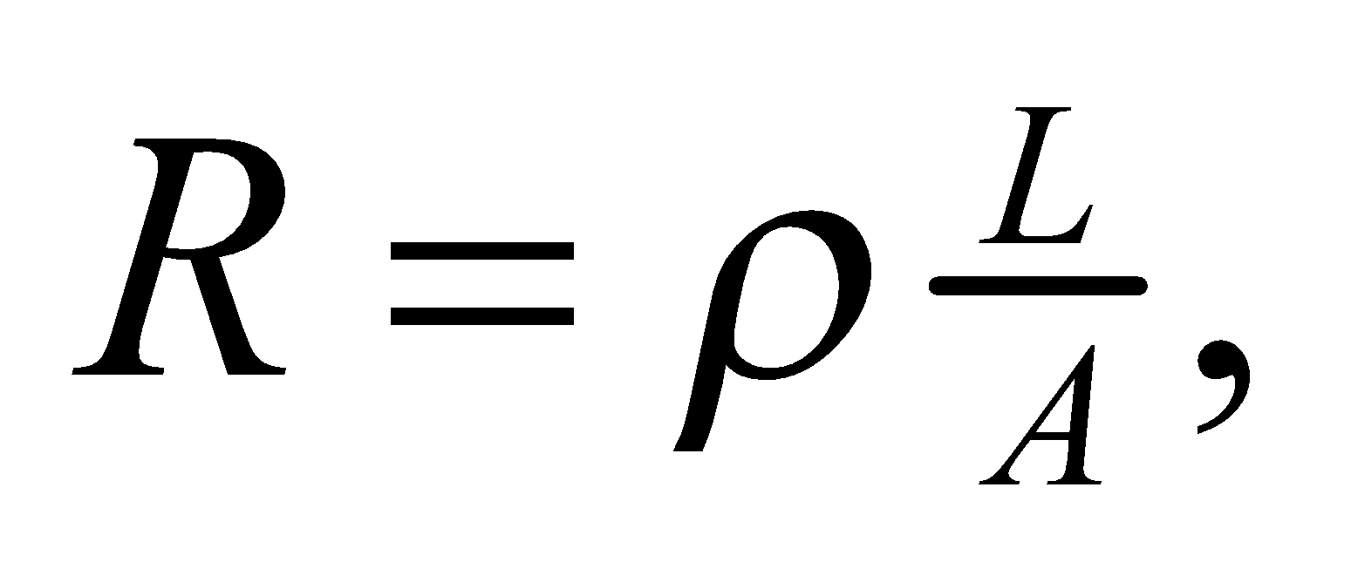 is 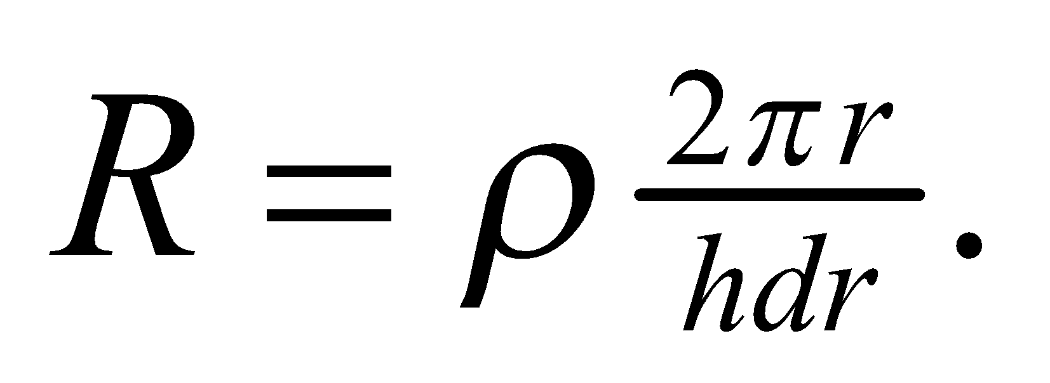 The magnetic flux through each loop is the magnetic field dotted with the area normal, or

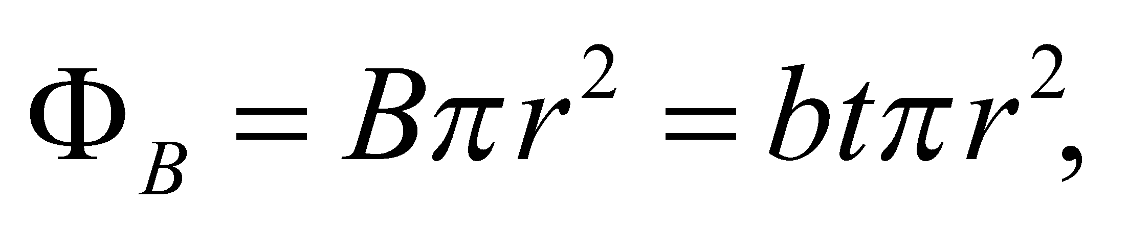

The induced emf around the loop is (Faraday’s law, Equation 27.2)

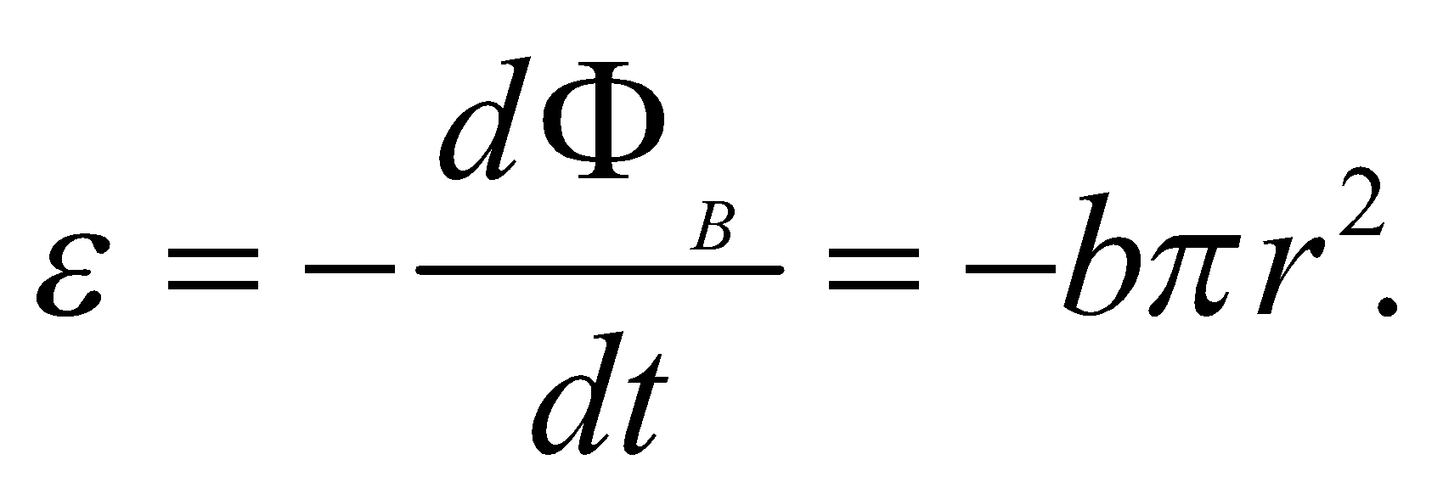

The current density is given by 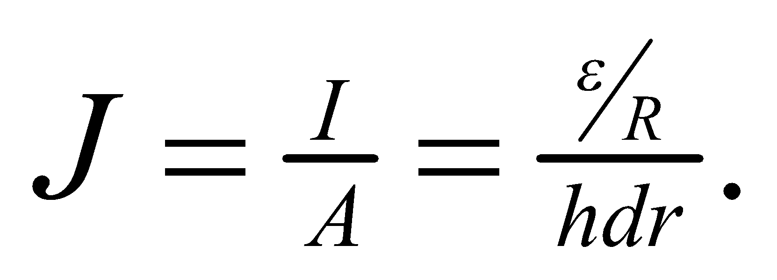 To find the total power, we will integrate the power in each infinitesimal loop:

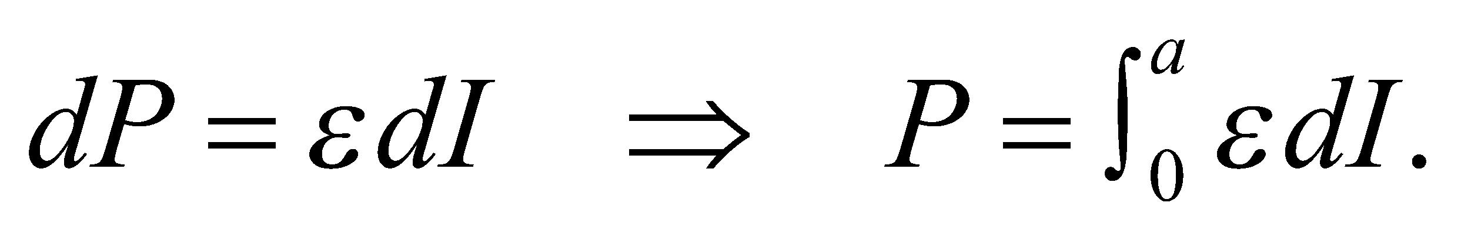

**Evaluate** **(a)** The current density is

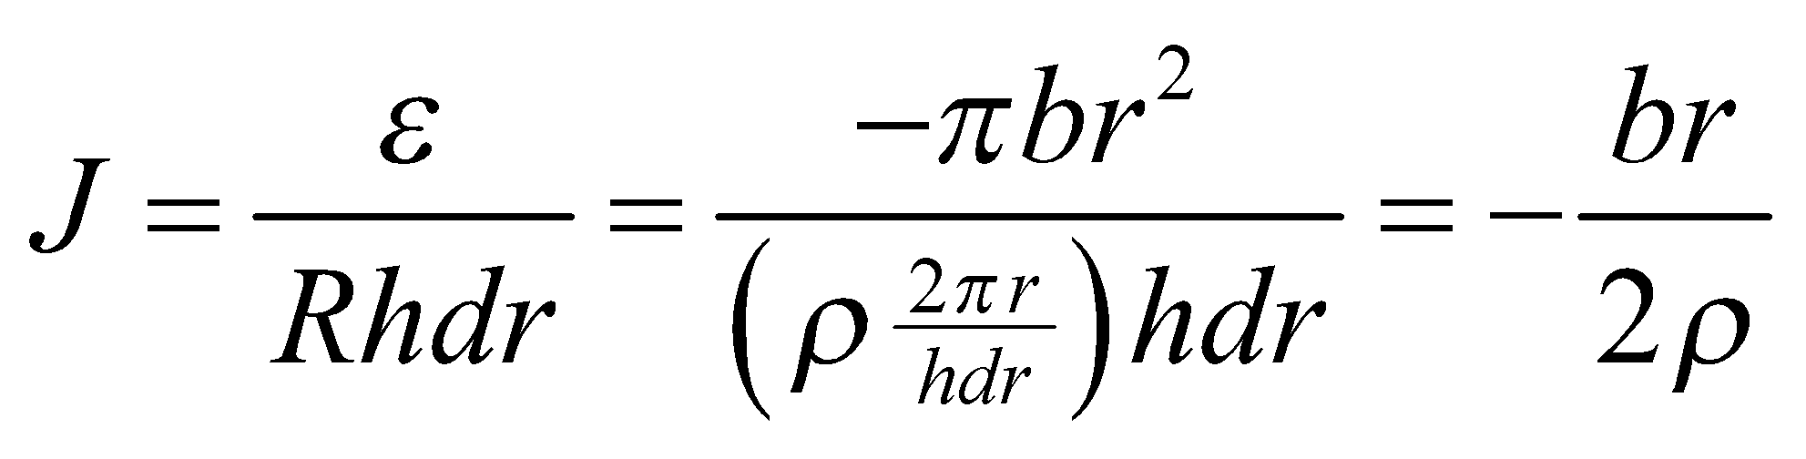

**(b)** The power dissipation is

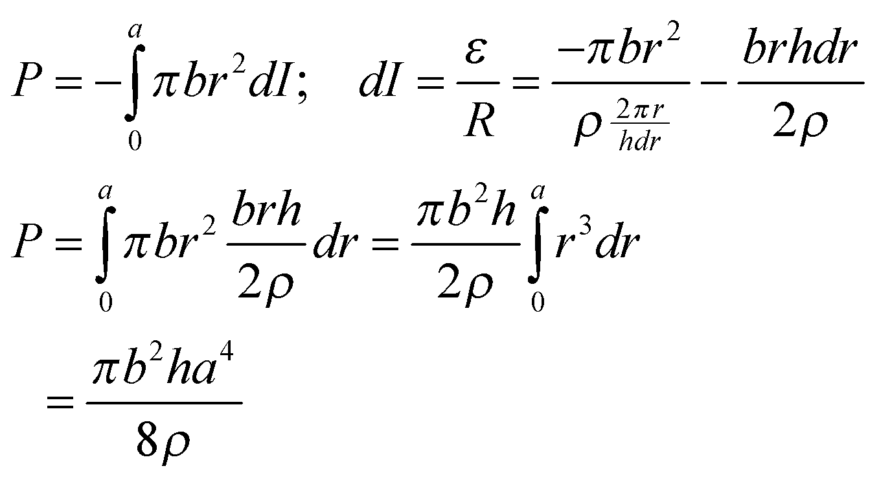

**Assess**There are several interesting aspects of this problem. First, the current density is linear with *r*, and is independent of the thickness *h*. This makes sense: a thicker disk would have more current, but the current density would be the same. Second, the power actually depends on the fourth power of disk radius *a*, so increasing the size of this disk increases the power dissipation dramatically. This phenomenon is used in metal detectors, and explains why large metal objects are easier for metal detectors to find than small ones.

**70. Interpret** We qualitatively sketch current and power in a loop as a magnet passes through the loop.

**Develop**As the magnet is approaching the loop, the flux through the loop is increasing to the right, which creates a current opposing this change in flux. By the right-hand rule, this current will be in the (negative) clockwise direction. Later, the magnet will have passed through the loop and will be moving away. The flux will be decreasing in this case, so the induced current will be in the (positive) opposite direction. The power depends on current squared, so it will be positive throughout the magnet's movement.

**Evaluate**To sketch the current, we imagine that when the magnet is far from the loop, the flux is not changing very much, so the induced current should be close to zero. As the magnet approaches the loop, the field lines going through it are diverging, so the flux should change rapidly resulting in a large induced current. However, the field lines through the magnet are essentially parallel, so the flux won't be changing very much when the magnet passes through the loop. The induced current will drop to zero and switch direction when the magnet is centered in the loop. See the figure below.



**Assess**The graph is symmetric because the magnet is moving at a steady rate.

**71. Interpret** In Problem 47, we are shown a movable bar which completes a circuit in a magnetic field. That problem uses Faraday’s law to find the direction of the current and the power. Here we extend the problem to find the speed of the bar as a function of time with a constant force pulling the bar.

**Develop**There are two forces on the bar: the constant applied force, *F*, and the magnetic force due to the induced current in the bar: 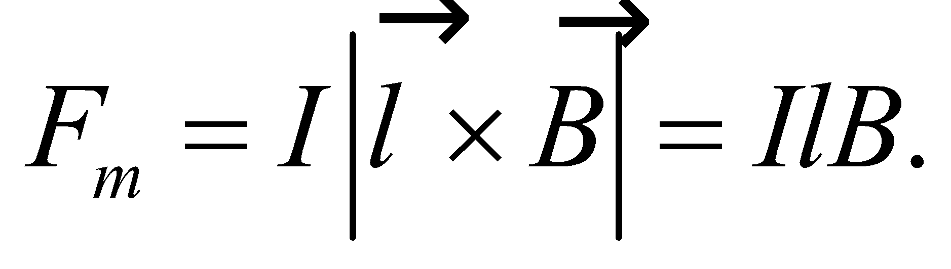 This current *I* follows from Faraday’s law and the fact that the area of the loop is increasing:

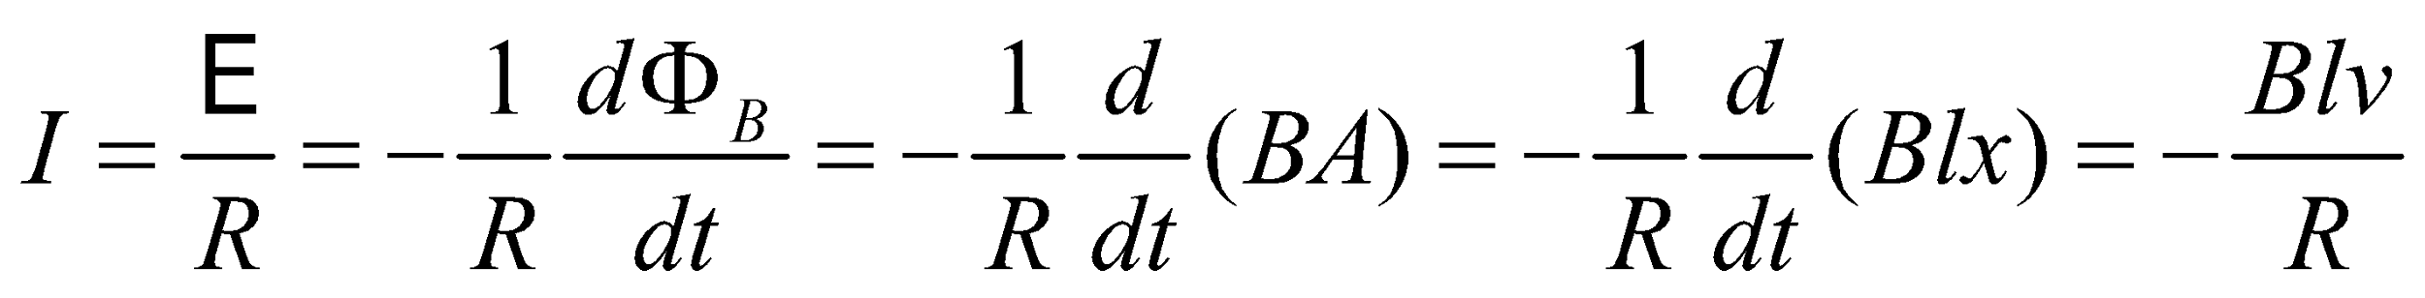

According to Lenz's law, the current will flow counterclockwise in order to reduce the change in the magnetic flux. This means the magnetic force will point to the left, in the opposite direction of the applied force. Therefore, the total force on the bar is

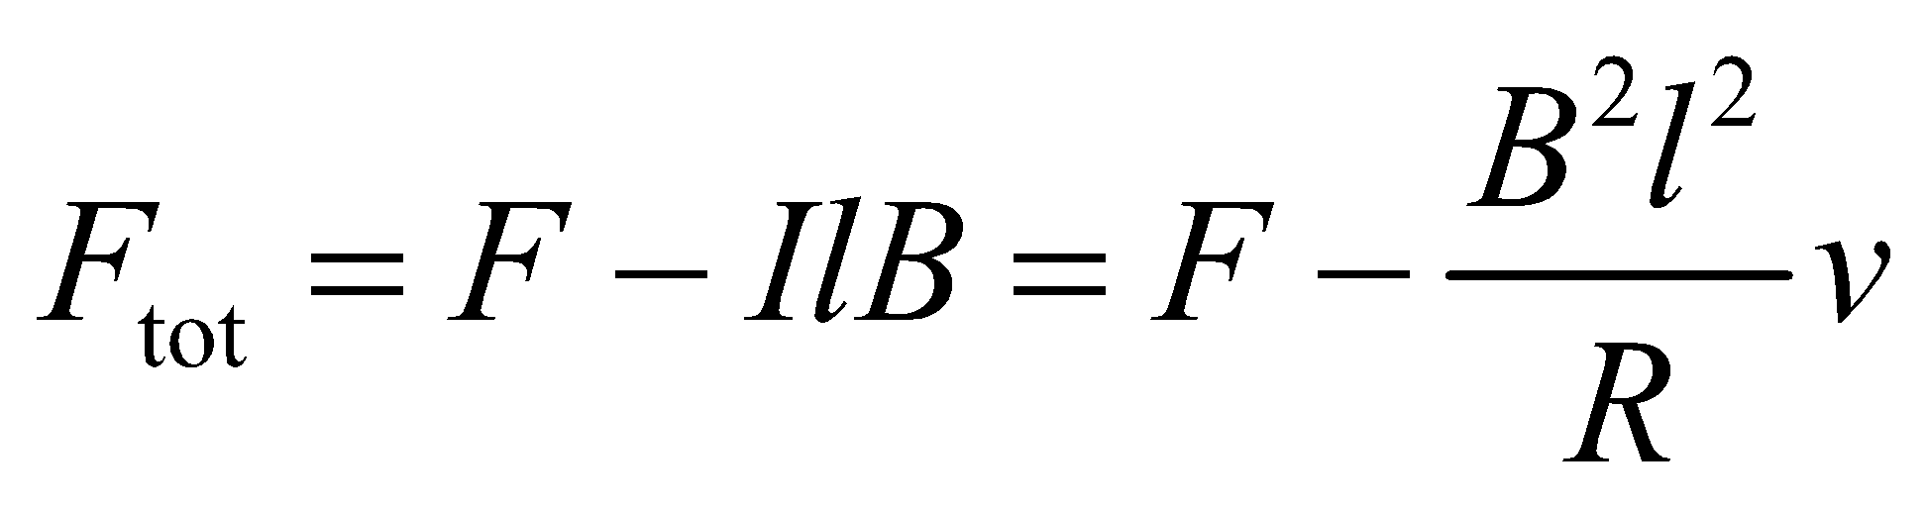

**Evaluate**From Newton's second law, 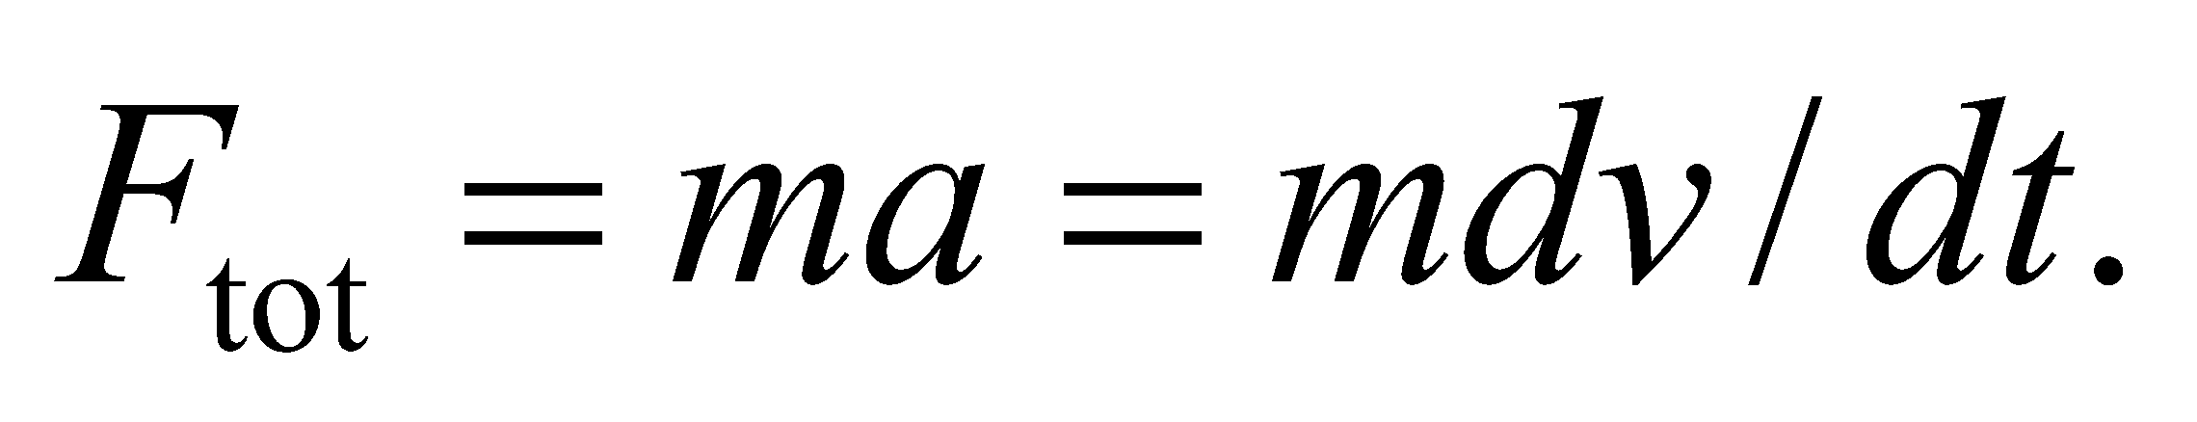 With the above equation, we get a differential equation for 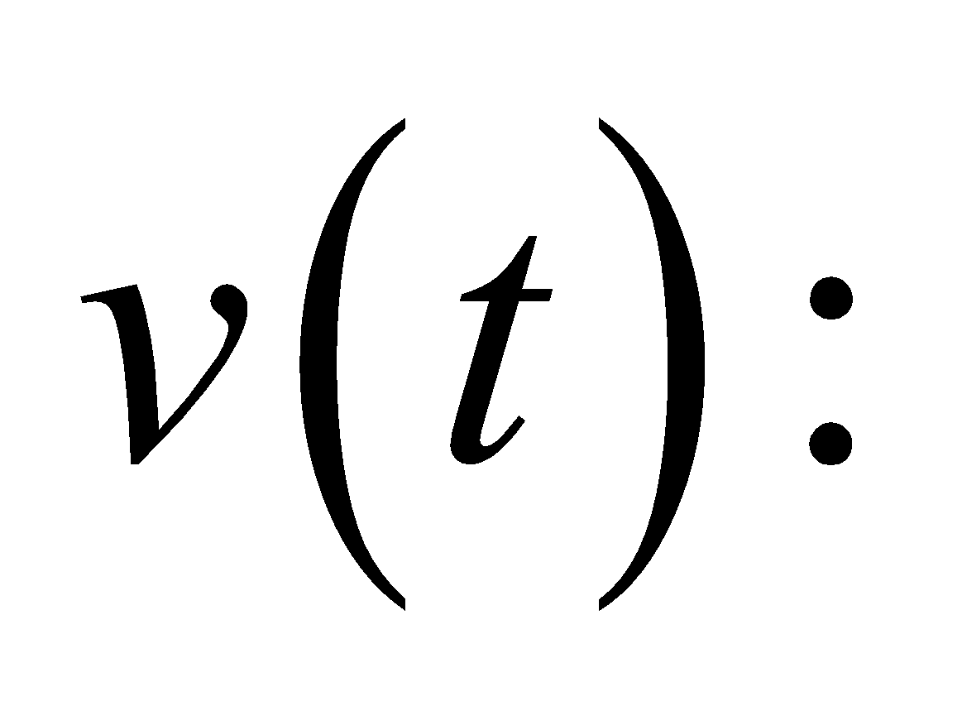

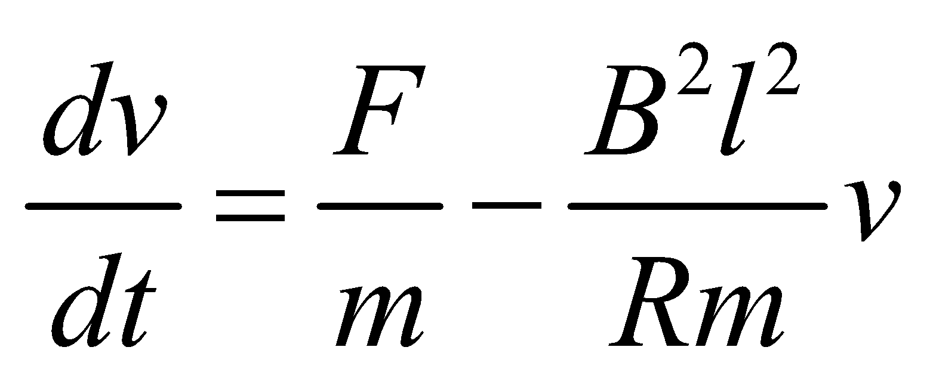

We can guess that the solution will have a form of 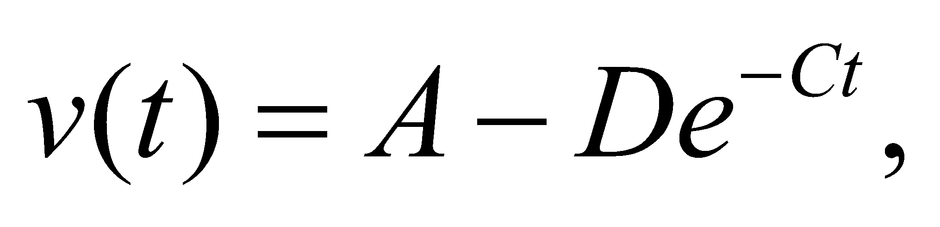where *A*, *D* and *C* are constants. Plugging this solution into the differential equation gives

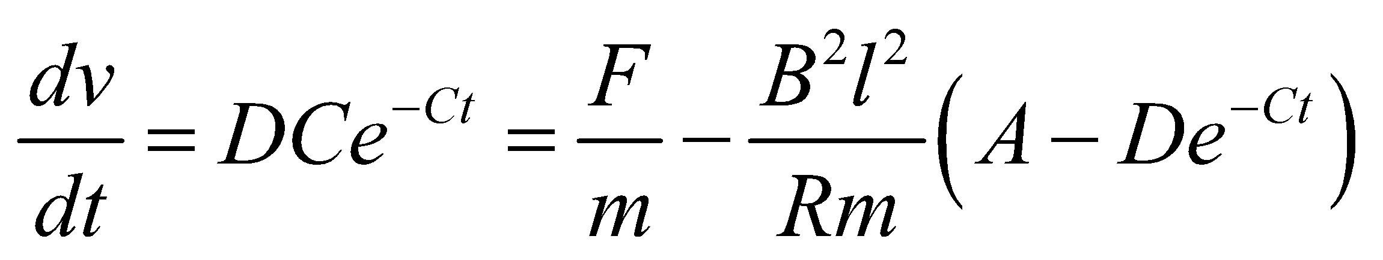

When 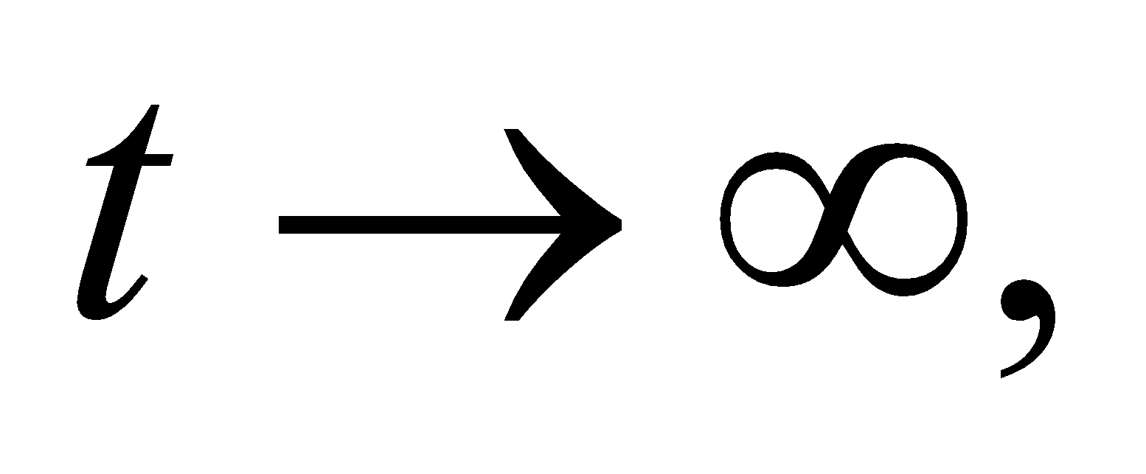the exponential terms disappear, and we are left with

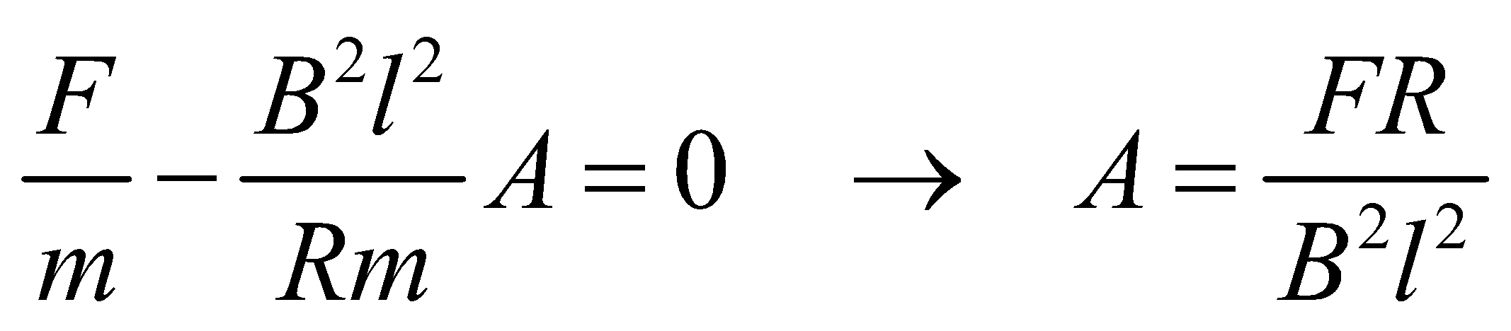

That means the factors in front of the exponential terms must sum to zero on their own:

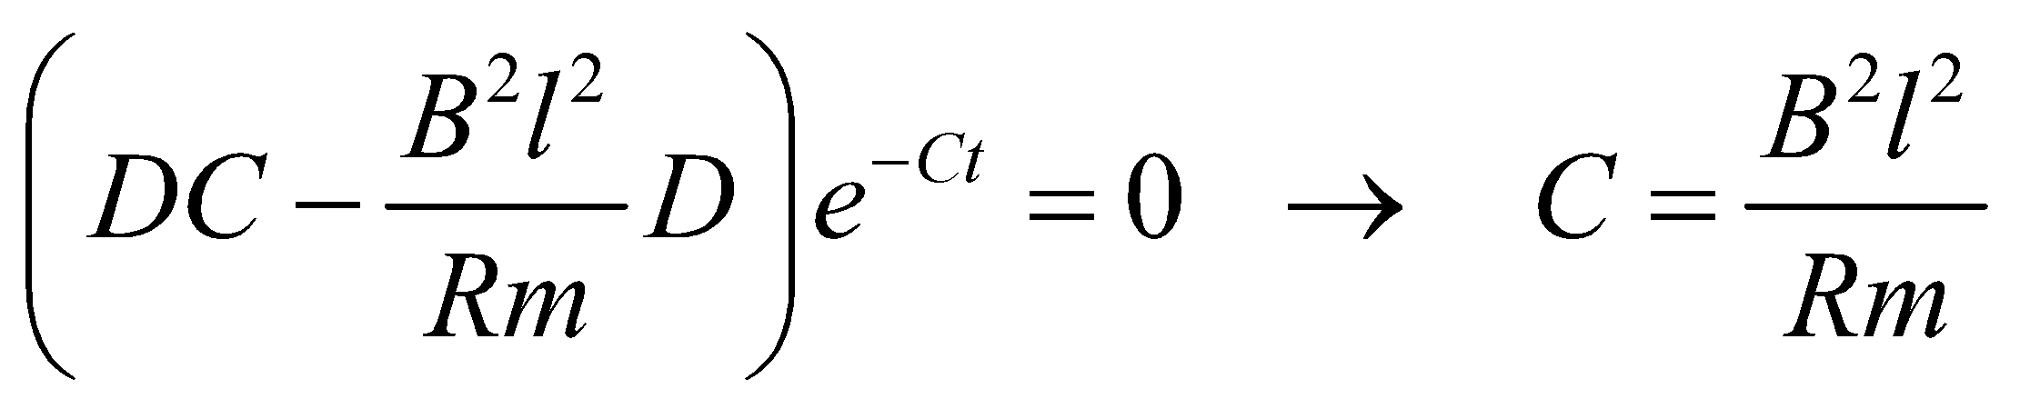

Lastly, we are told that the bar starts from rest, which means 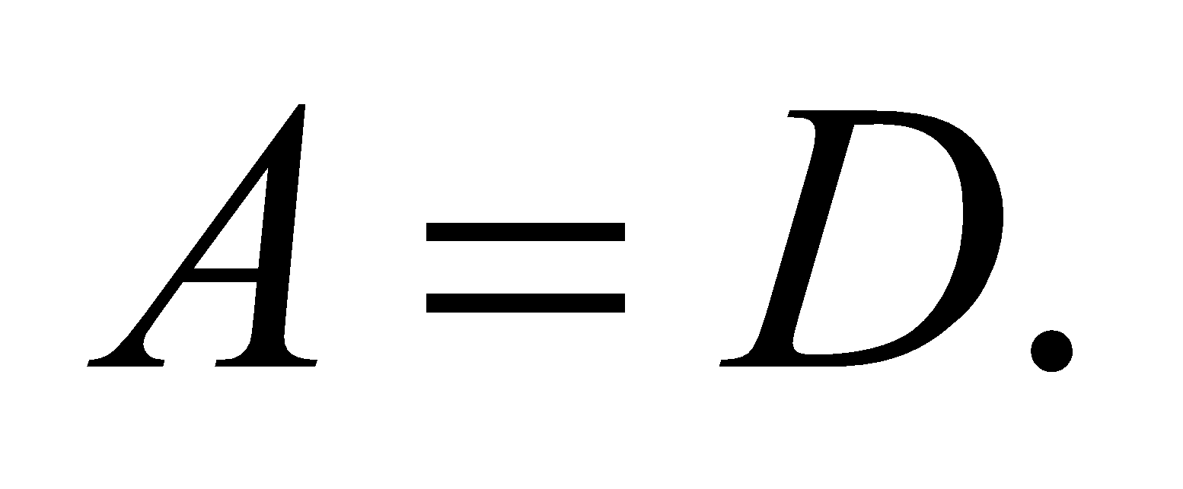 Putting all this together:

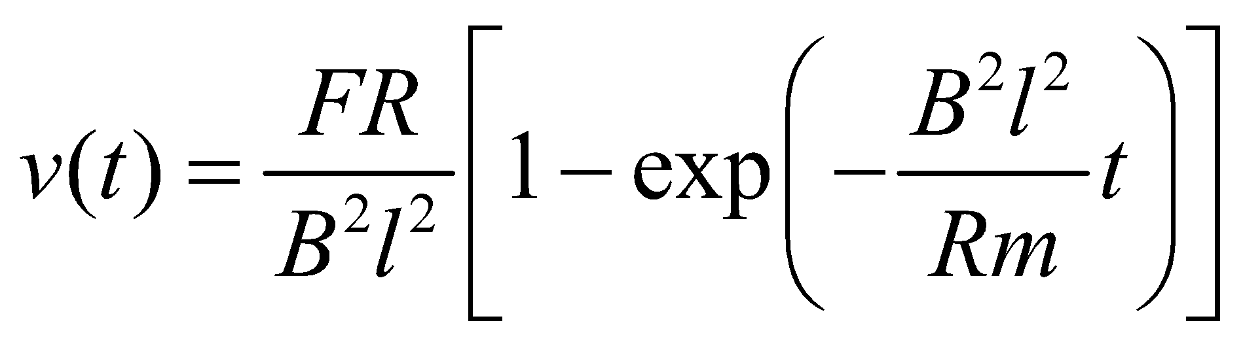

**Assess**Notice that there is a terminal velocity: 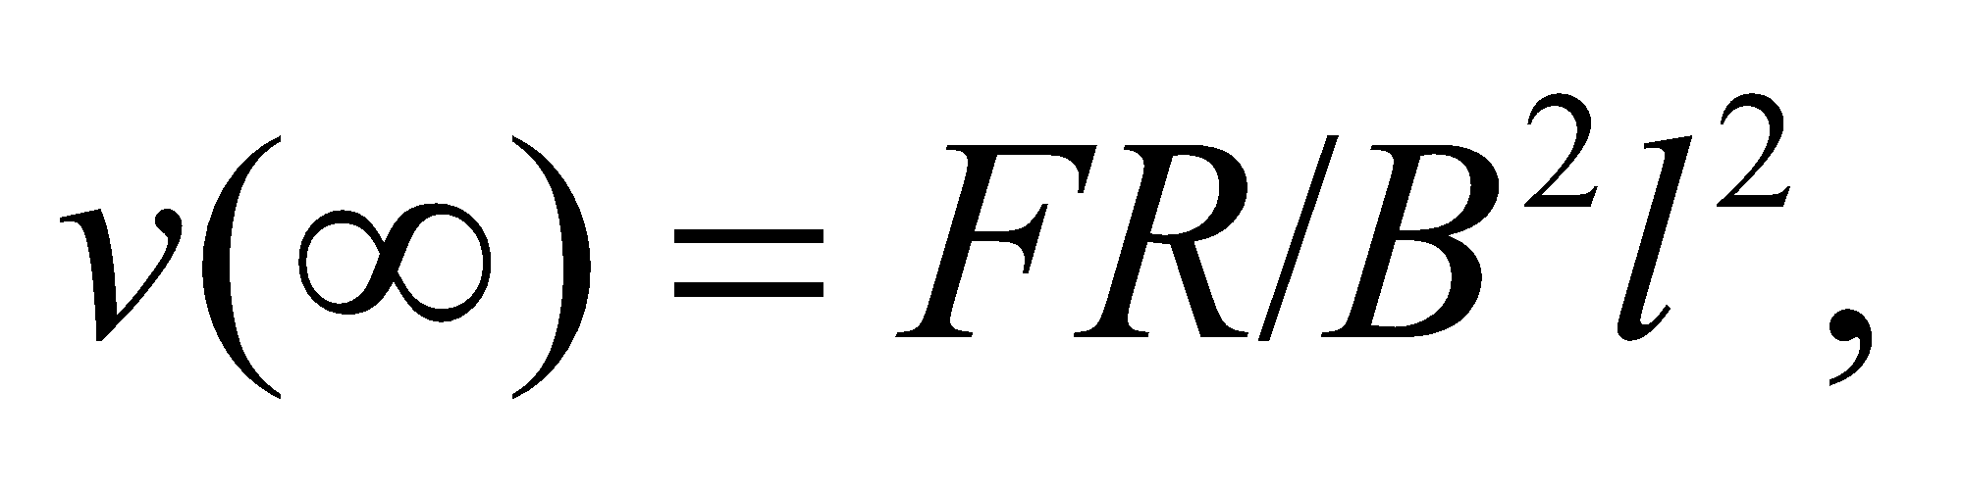 which is the highest speed reached by the bar.

**72. Interpret** We are to use Kirchhoff’s laws to find the current in a circuit element. The circuit includes an inductor, so the equations we obtain using Kirchhoff’s laws will be differential equations.

**Develop** We start by drawing our loops and nodes as shown in the figure below. Node *A* and node *B* give the same information, so we will use only loop 1, loop 2, and node *A*. From node *A* we get 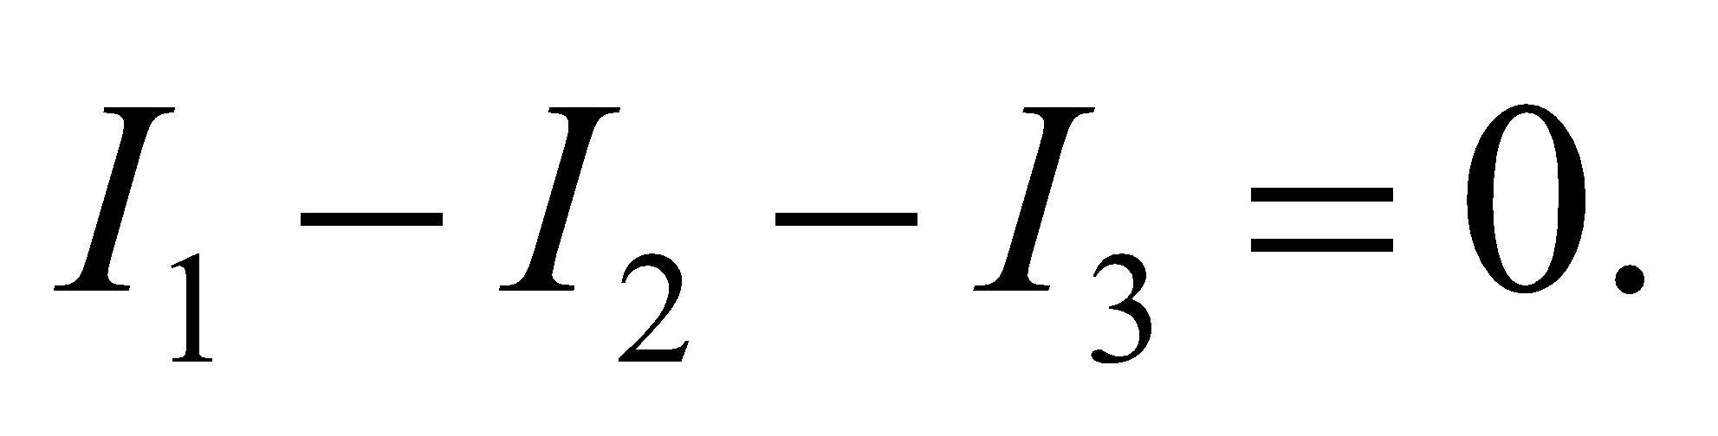 From loop 1, we obtain 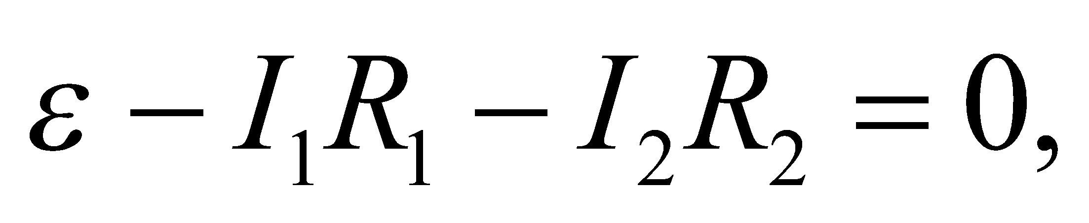 and from loop 2 we have 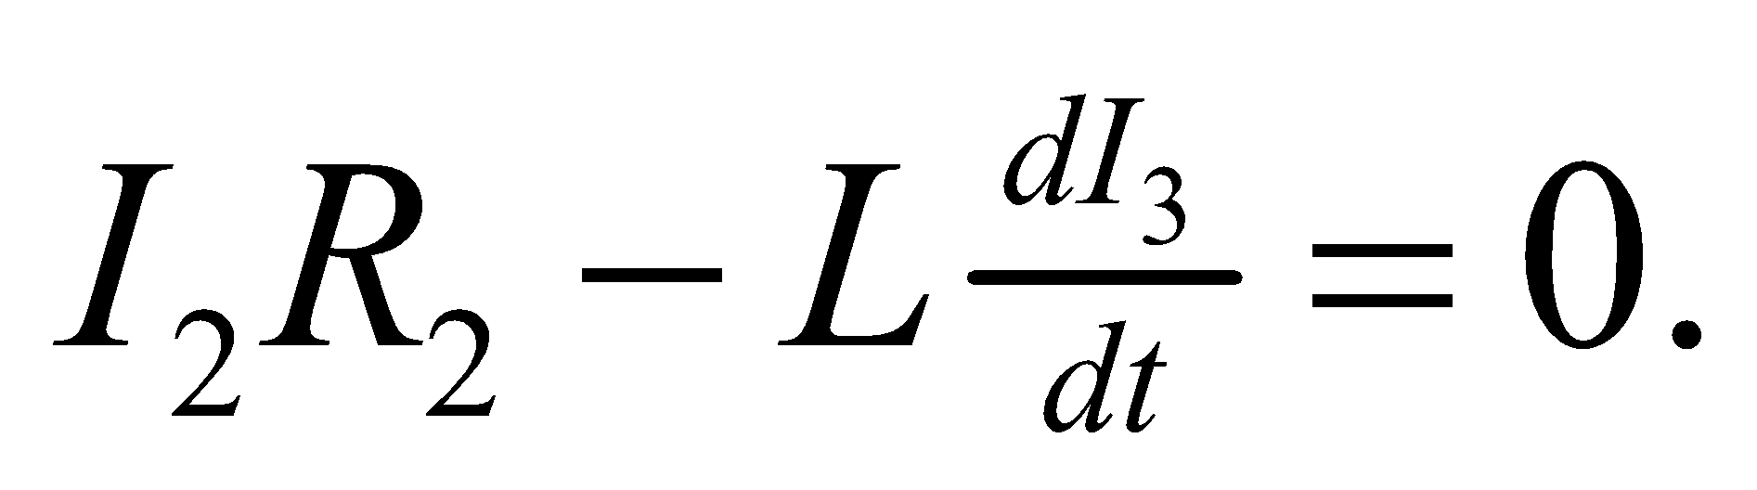 We want to find the current *I*2 as a function of time.



**Evaluate** From node *A*: 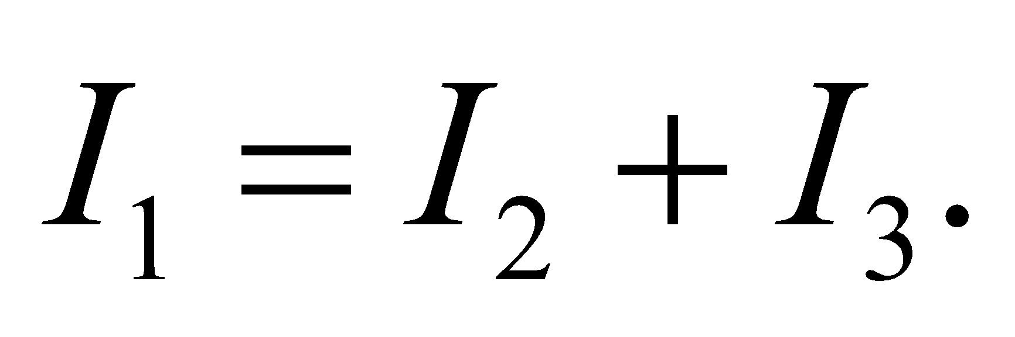

Substitute this result into loop 1:

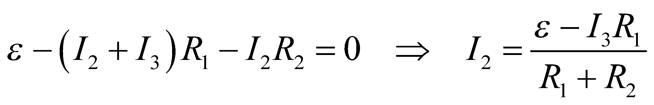

Substitute this result into loop 2:

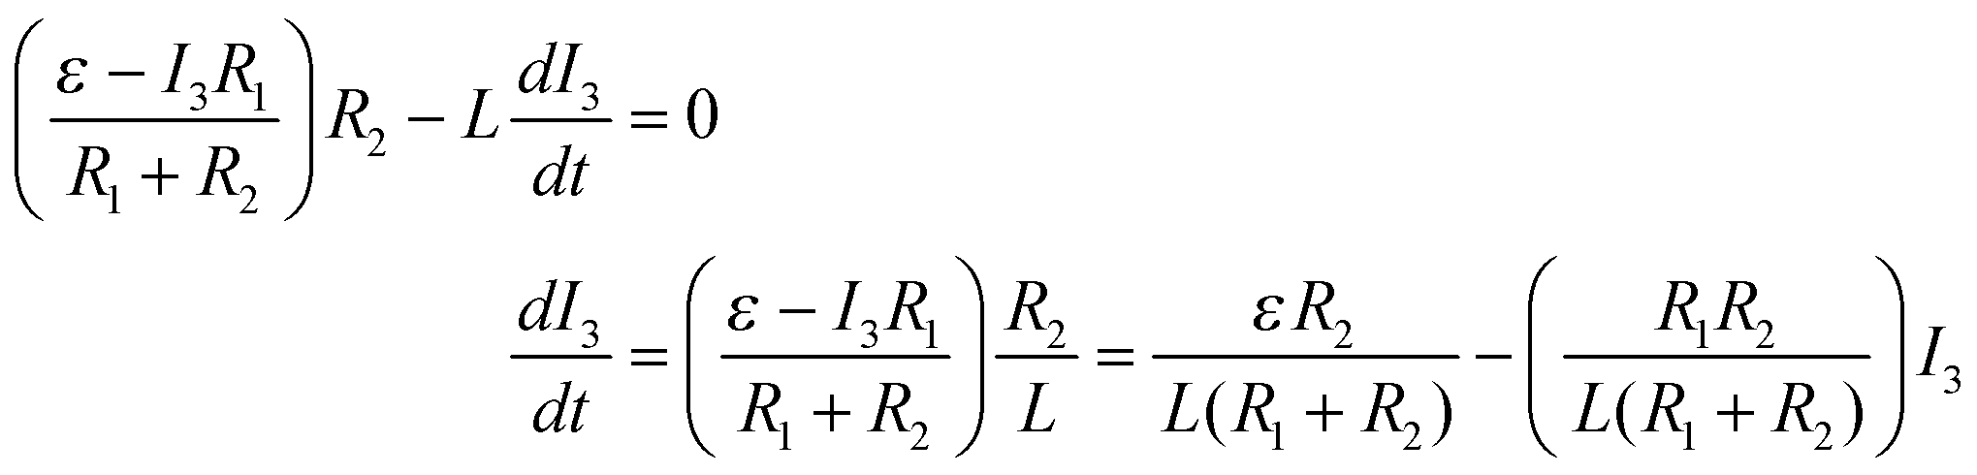

We guess at a solution of the form 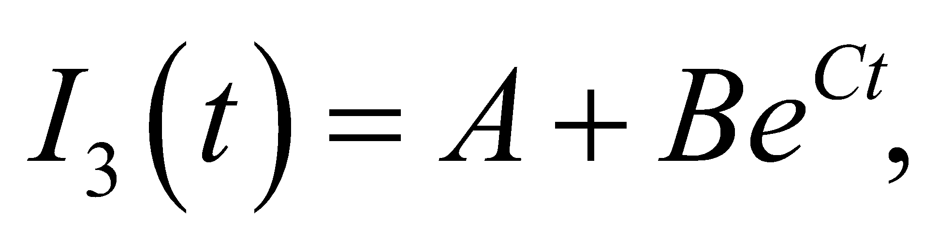 with initial condition 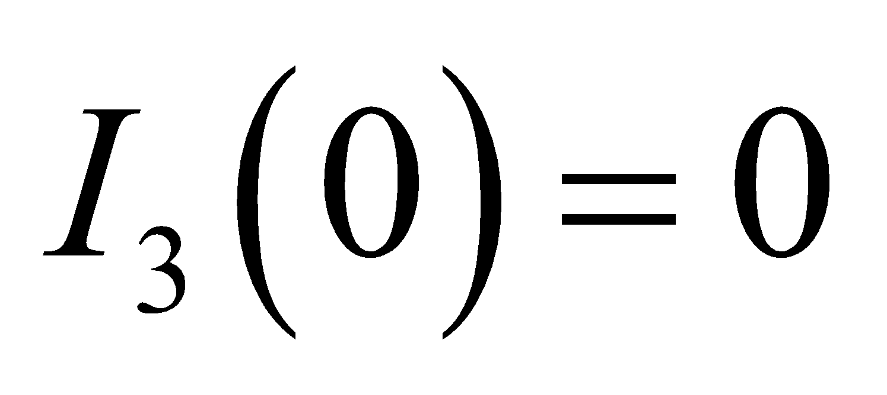 since the inductor acts as an open circuit at first.

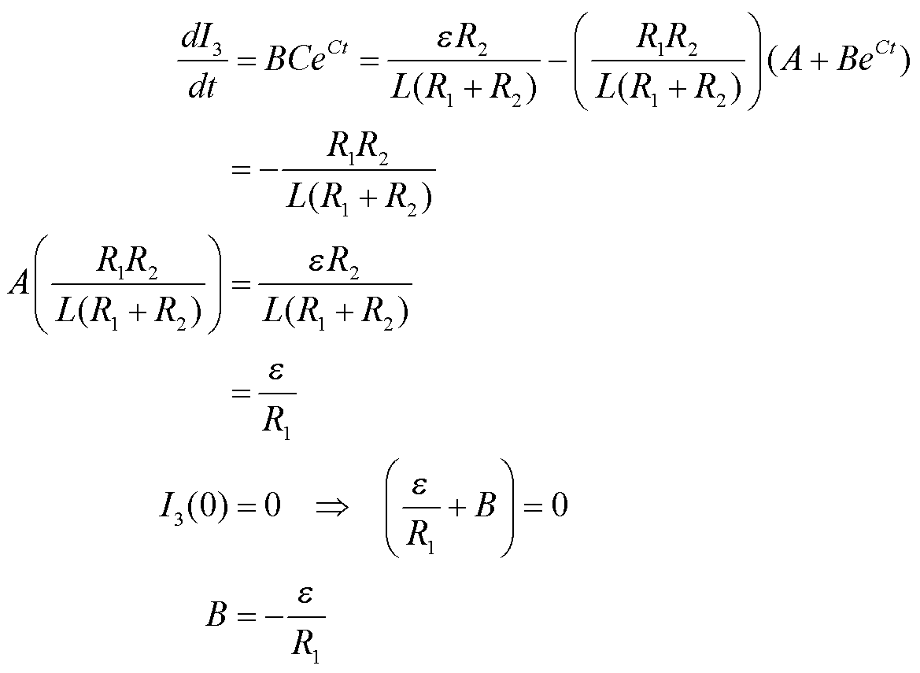

So

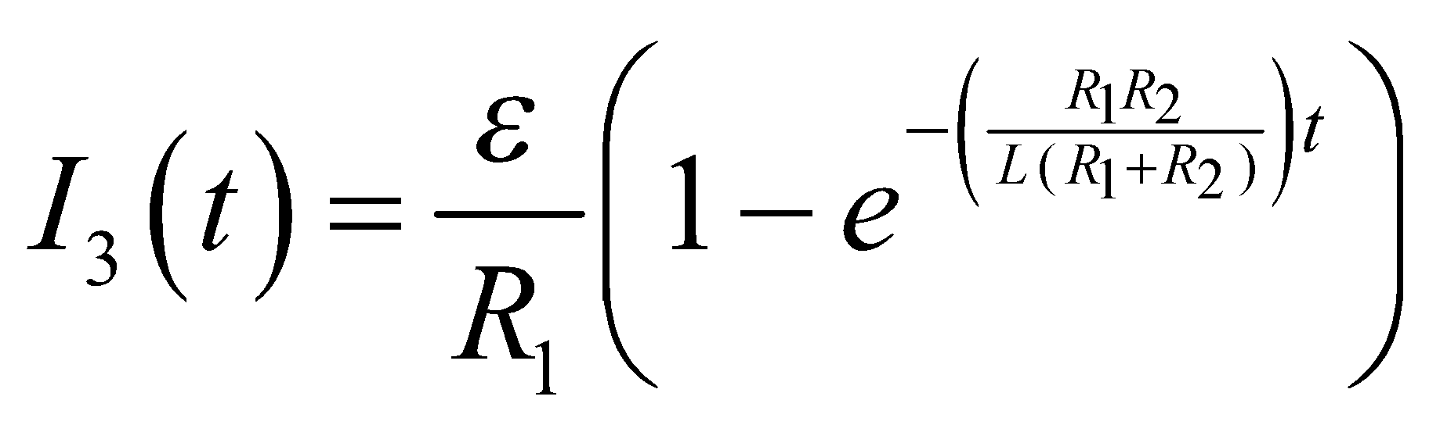

**Assess** The current gradually increases, with a time constant of 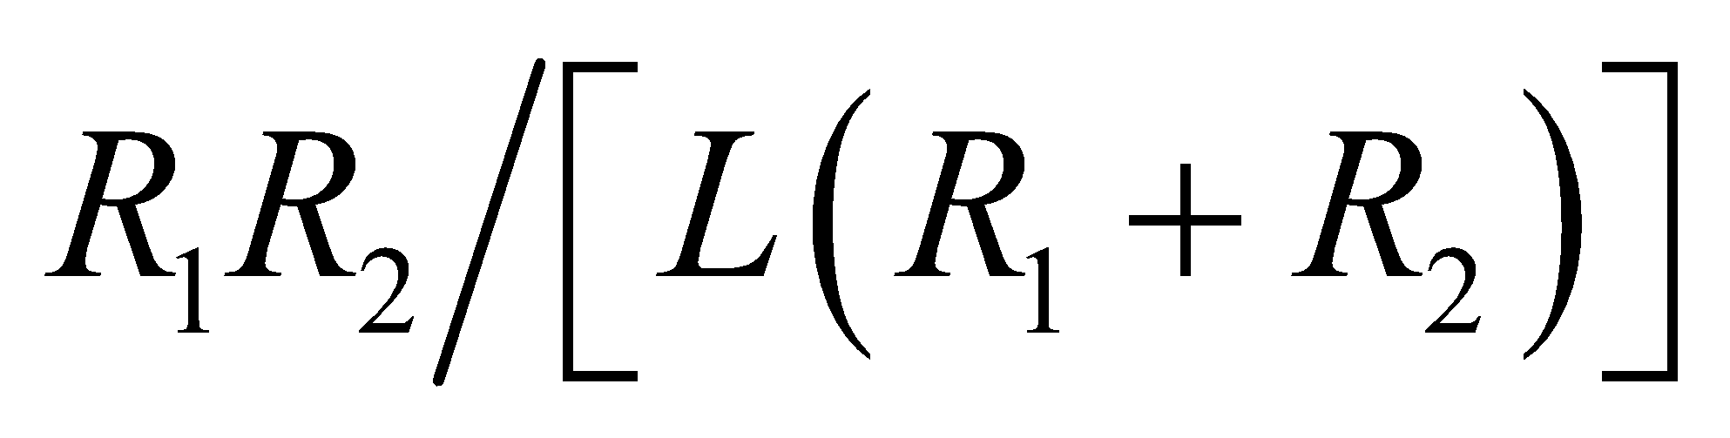.

**73. Interpret** We calculate the self-inductance per length of a coaxial cable, using the flux through the area between the two conductors.

**Develop**The self-inductance is defined in Equation 27.3 as 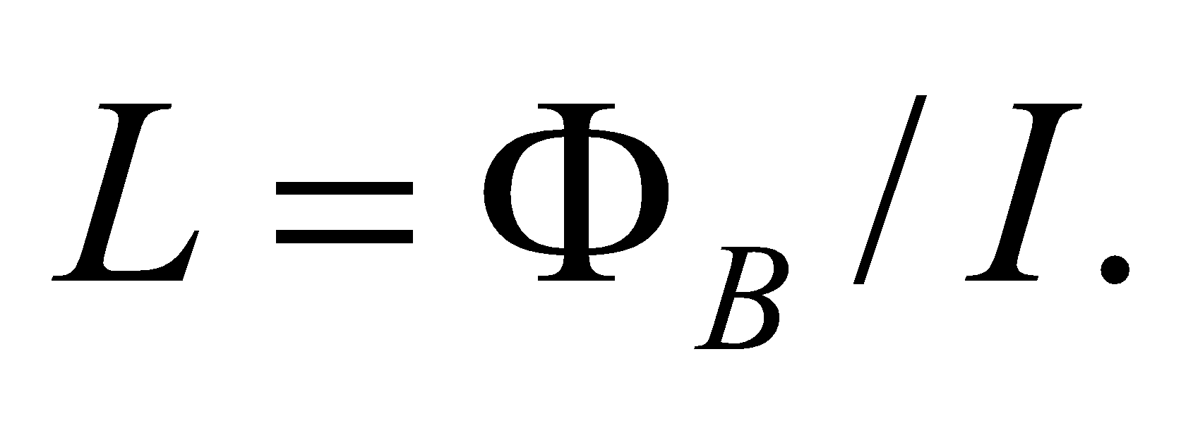 To find the magnetic flux, we recall Example 26.7, where it was shown that the magnetic field lines around a single wire form concentric circles with magnitude 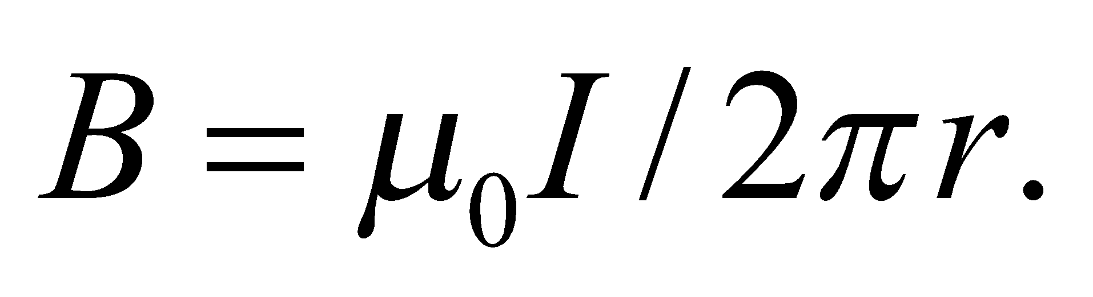 With a coaxial cable, there is an outer conductor that carries the opposite current, so the encircled current is zero outside the cable, and by Ampère's law, the field is zero as well (recall Problem 26.71). Therefore, we only need to concern ourselves with the magnetic flux in between the two conductors.

**Evaluate**Since the magnetic field lines wrap around the inner conductor, we imagine the flux flowing through a strip of length *l* and width *dr*, at a distance *r* from the center of the cable. See the figure below.



Since by construction the field is normal is normal to the strip's area, the flux through it is

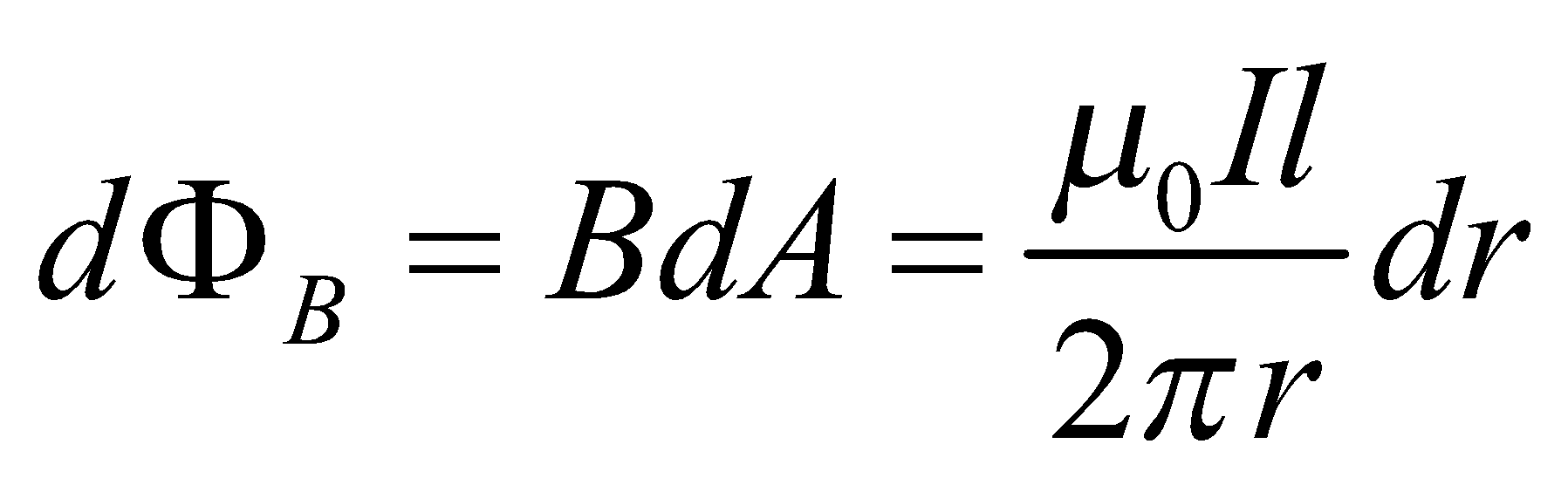

We now integrate this over the region where the field is nonzero, i.e. from the inner conductor's radius, *a*, to the outer conductor's radius, *b*.

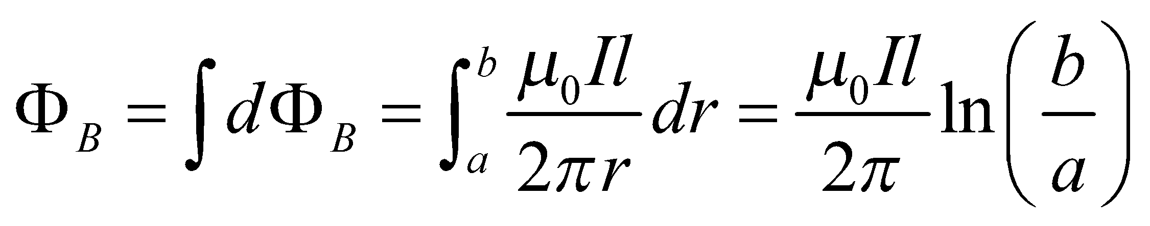

The self-inductance per unit length is therefore

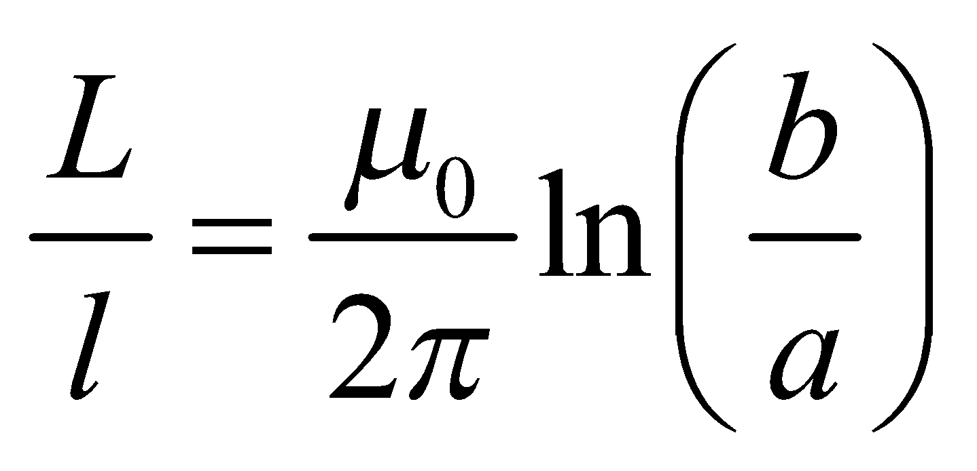

**Assess**We check this result by calculating the energy stored in the magnetic field of the coaxial cable. From Equation 27.10, the magnetic energy density is  Integrating this over the volume of a section of the cable with length *l* gives

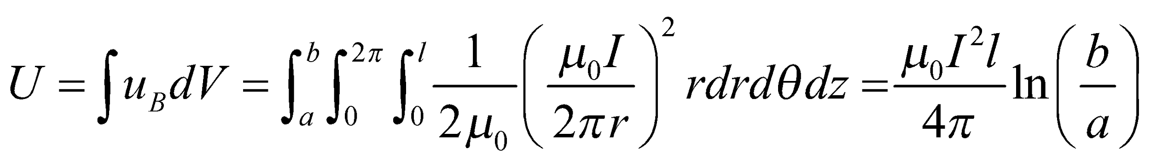

Comparing this to Equation 27.9, 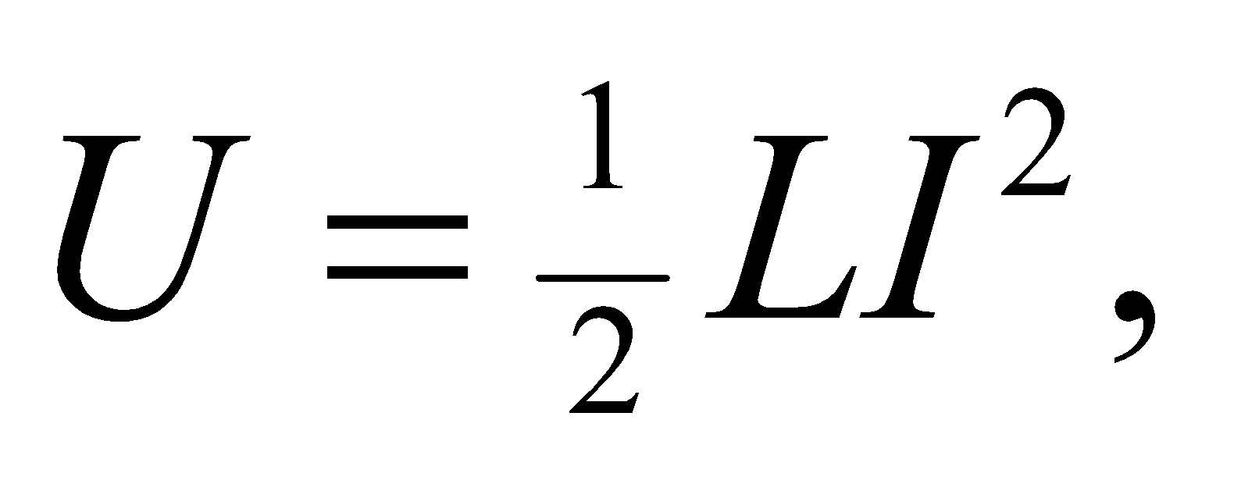we get the same answer for the self-inductance per unit length, 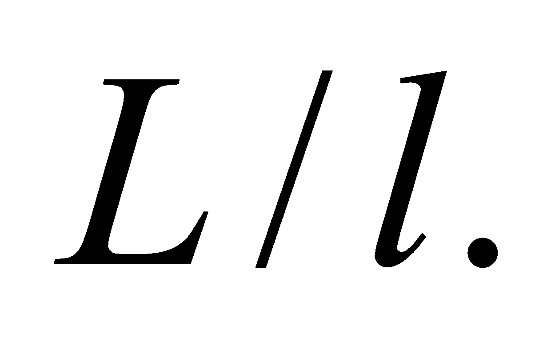

**74. Interpret** We determine the voltage induced across the wingtips of a plane flying through a magnetic field, using Faraday’s law. The wings of the plane sweep out area at a certain rate, and the resulting change in flux generates a voltage. The wings are an open circuit, so the induced emf will result in a buildup of charge at the wingtips (see Figure 27.17).

**Develop**The induced emf comes from the change in the magnetic flux, which will be proportional to the rate at which area is swept out by the wings of the plane:

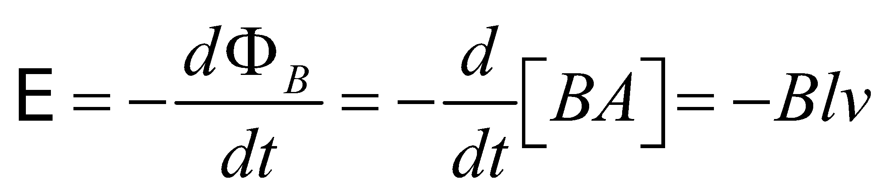

Here, *l* is the plane's wingspan and *v* is the plane's velocity. We have assumed that the plane, and the plane’s velocity, are both perpendicular to Earth's magnetic field.

**Evaluate**Neglecting the sign, the induced voltage is



This is too small to run a portable music player, or anything else.

**Assess**In reality, this voltage cannot be used by any device on the plane. If you hooked up wires to the wingtips, those wires would have the same induced voltage, and no current would flow.

**75. Interpret** We're asked to derive the formula for the volume flow rate in a blood vessel being probed by an electromagnetic flowmeter.

**Develop**The magnetic field from the flowmeter will deflect some of the moving charges in the blood, as described previously for the Hall effect. This deflection will result in an electric field across the blood vessel. Charges will continue to be deflected until the force from the electric field balances out the force from the magnetic field: 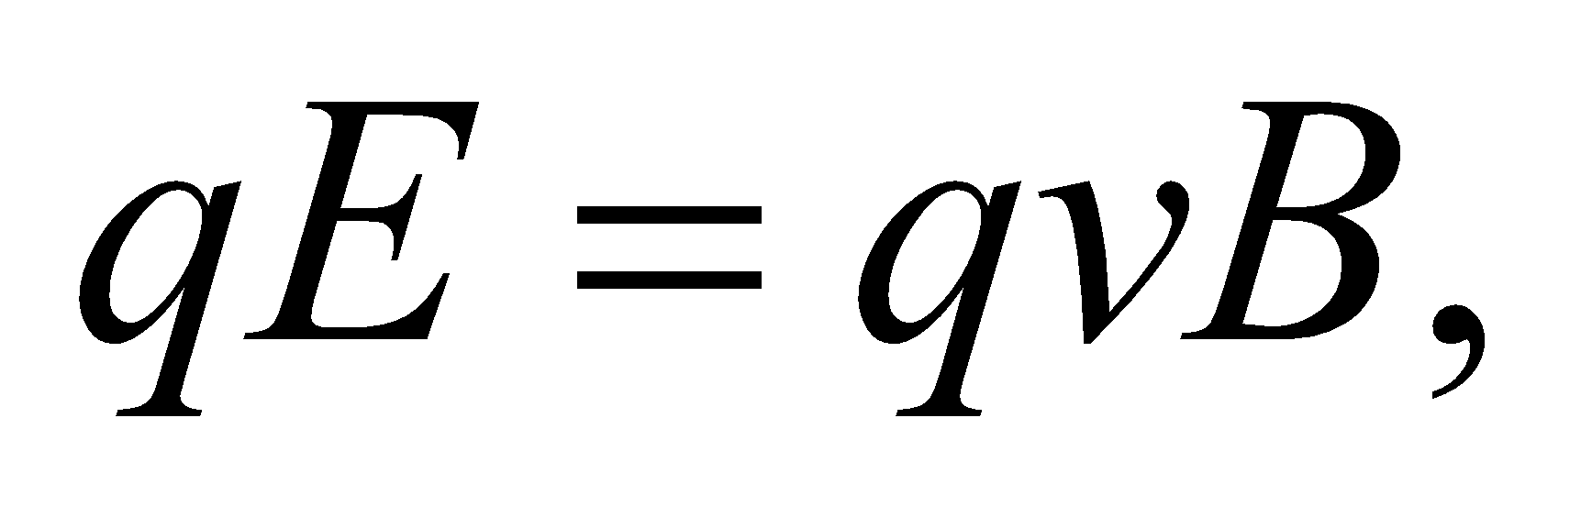where we assume that the magnetic field is perpendicular to the blood flow. The "drift" velocity, 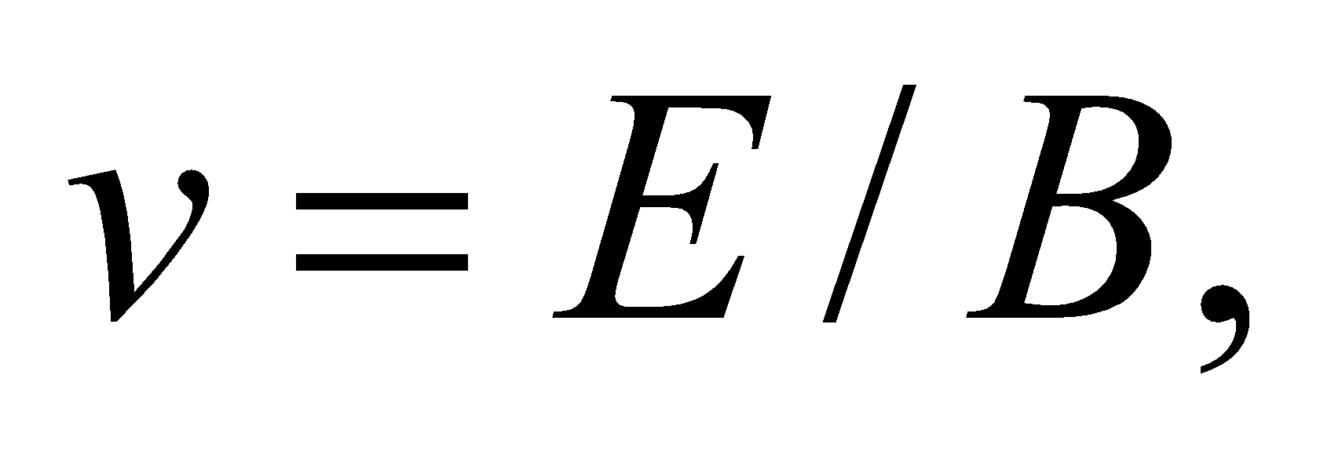multiplied by the cross-sectional area of the vessel, 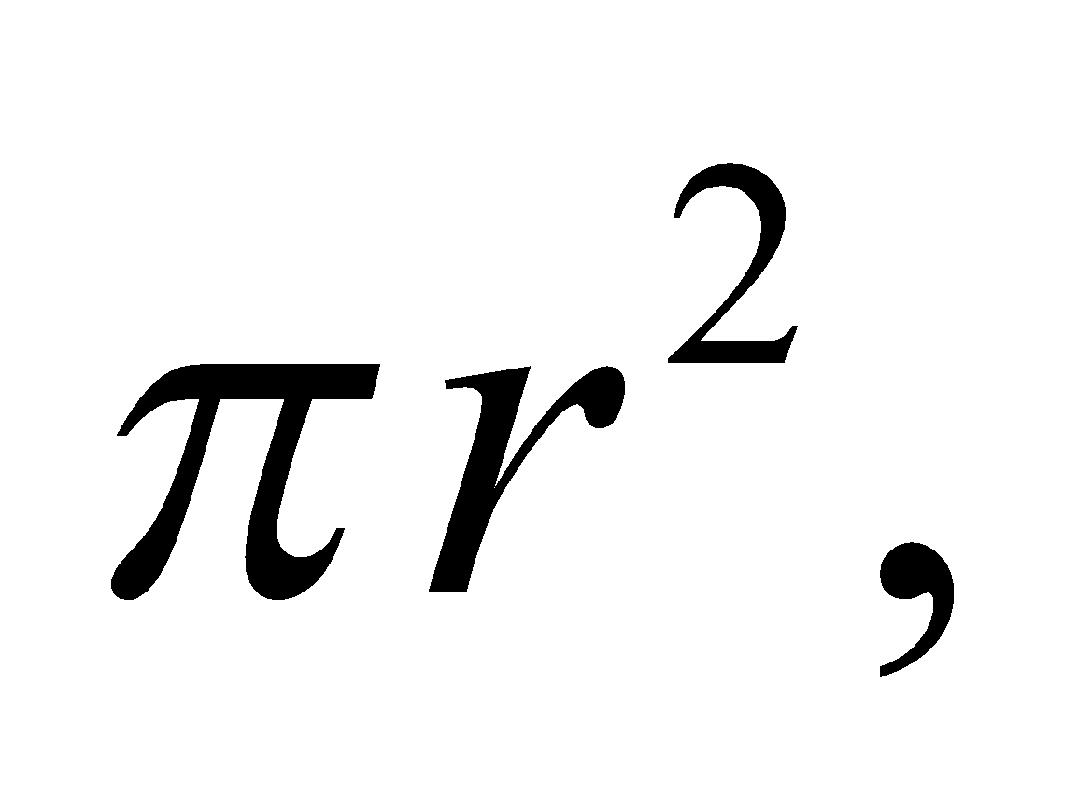gives the volume flow rate that we are looking for.

**Evaluate**The flowmeter measures the voltage. If we assume the electric field is uniform, then the relationship between the voltage and the field is just 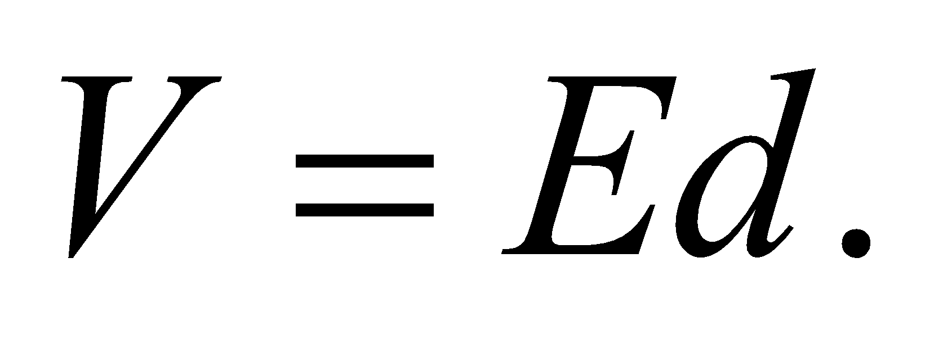 Combining this with the electromagnetic force equation above, we get a volume flow rate of

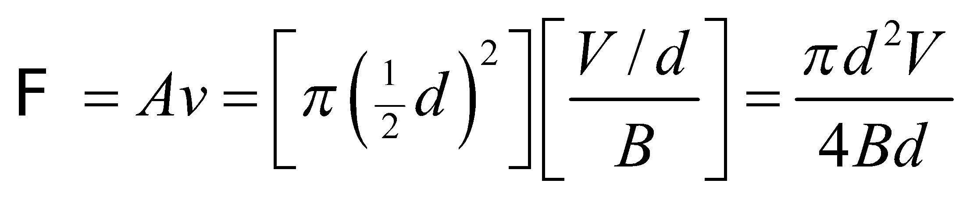

**Assess**The formula indicates that a higher voltage reading is indicative of a greater flow rate. This is because a greater flow rate results in a larger magnetic force, which requires a larger electric field to achieve equilibrium.

**76. Interpret** We consider how electric power might be "stolen" using electromagnetic induction.

**Develop**The current in the power line will produce magnetic field lines that wrap around the wire in concentric circles (see Example 26.4). The magnetic flux through the rectangular wire loop, 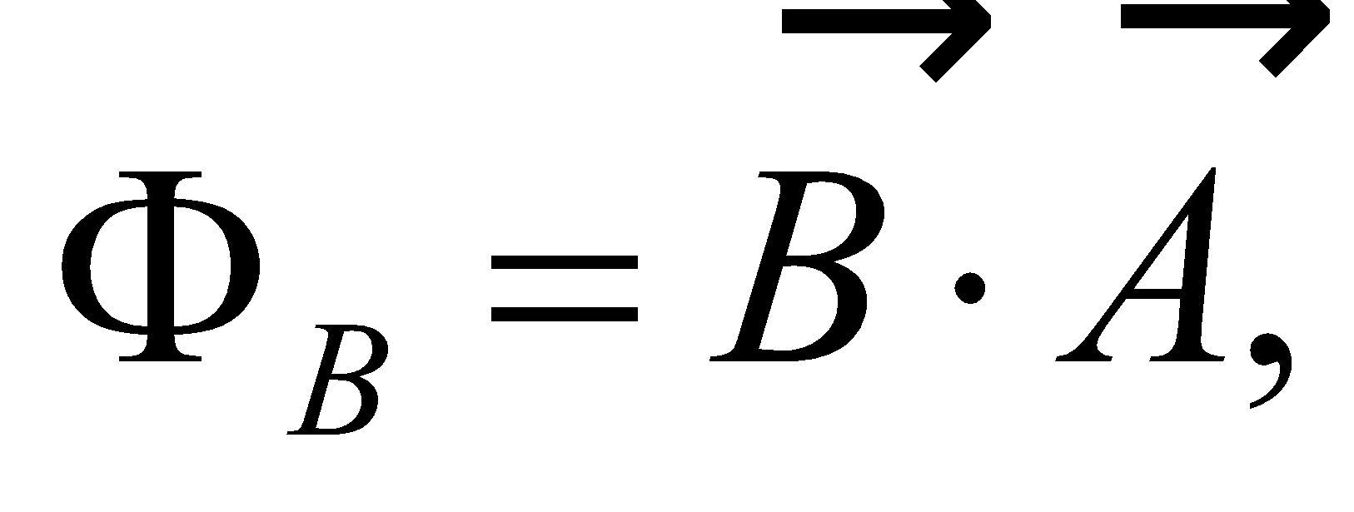 is changing due to the fact that the current in the power line is alternating: 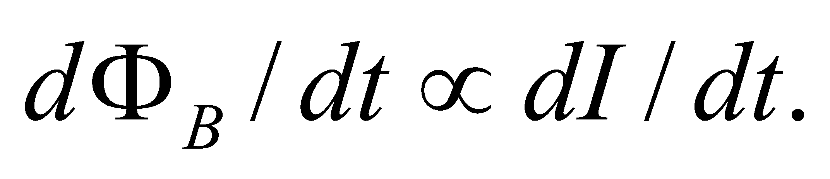 This will induce an emf in the rectangular loop.

**Evaluate**In Figure 27.42, the magnetic field from the power line will be perpendicular to the vertically-oriented loop, which maximizes the magnetic flux through the loop. However, if the loop were horizontally-oriented, there would essentially be no more flux through it. This would result in the induced emf essentially dropping to zero.

The answer is (d).

**Assess**Tilting the loop horizontally would make sense if it were at the same height as the wire, in which case the magnetic field would be pointing in the vertical direction.

**77. Interpret** We consider how electric power might be "stolen" using electromagnetic induction.

**Develop**The magnetic field is not uniform around the wire, so doubling the area won't necessarily double the magnetic flux. To be precise, the magnetic field is inversely proportional to the distance from the wire:  Let's imagine the loop has length *l* and width *a*, and that the top of the wire is a distance *y* from the power line. Then, the flux through the loop is:

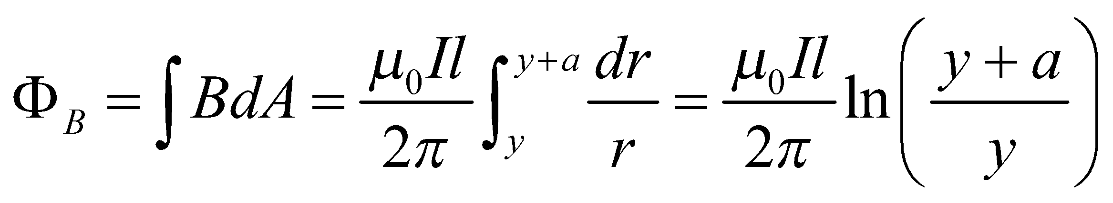

**Evaluate**If the loop doubles in size by extending a distance *a* towards the wire, the flux will increase by

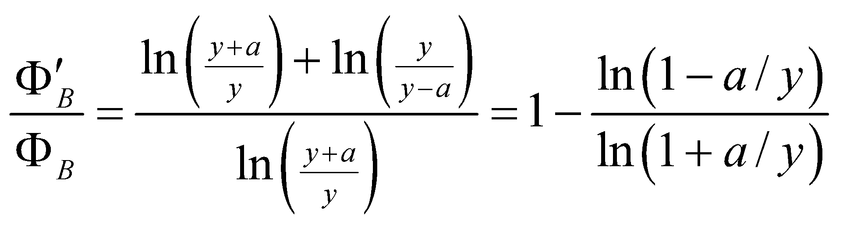

If we assume 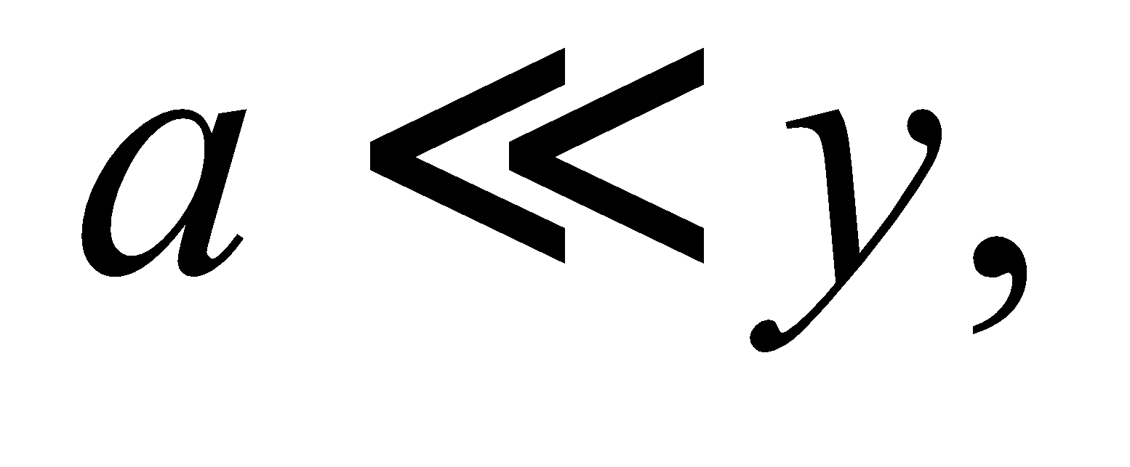then we can use the approximation 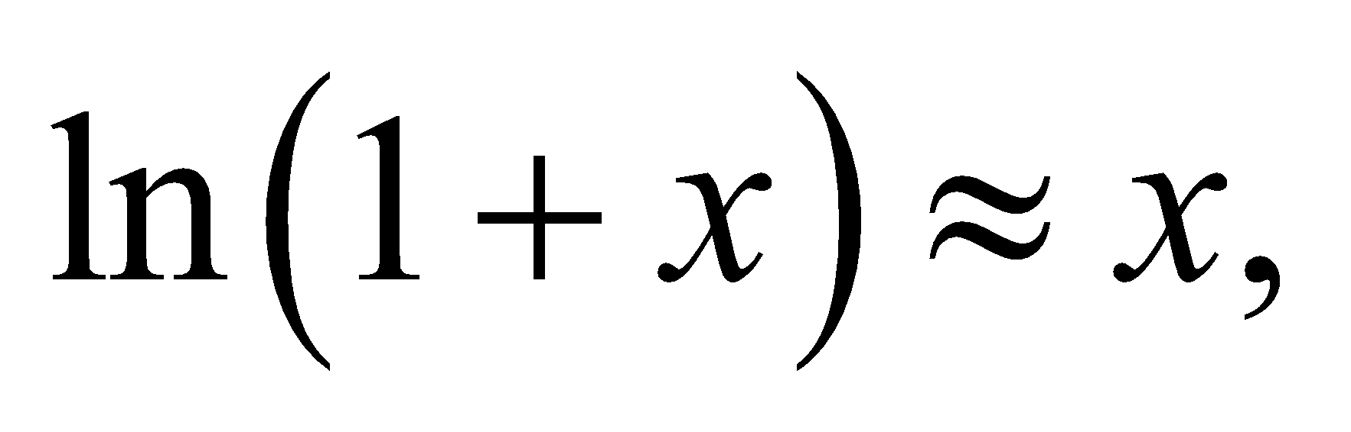in which case 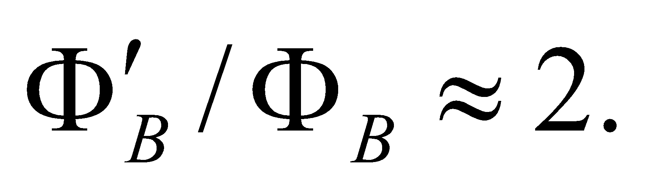 However, if *a* is nearly as big as *y*, then 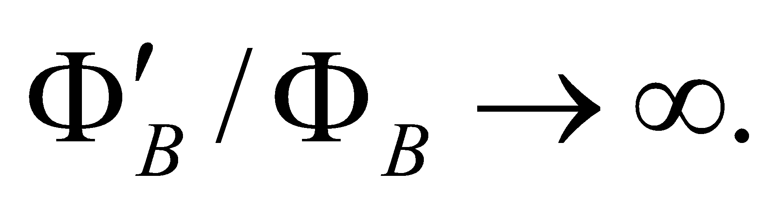 Therefore, the flux increases by some factor greater than 2. Since the induced emf is directly related to the flux: 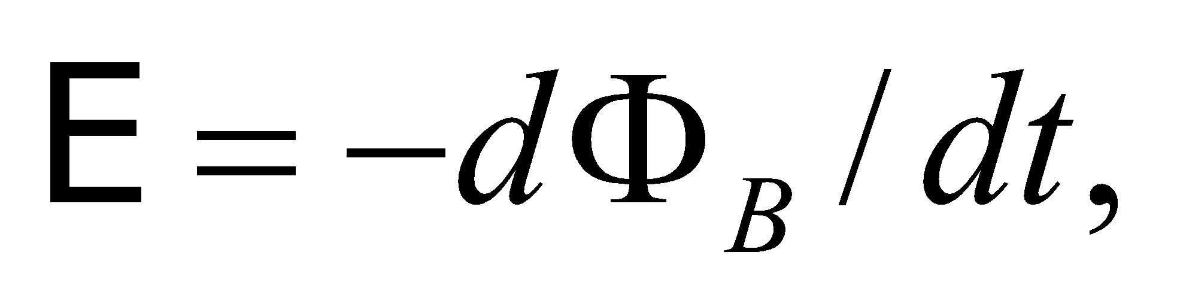it will increase by the same factor.

The answer is (c).

**Assess**The magnetic field is greater near the wire 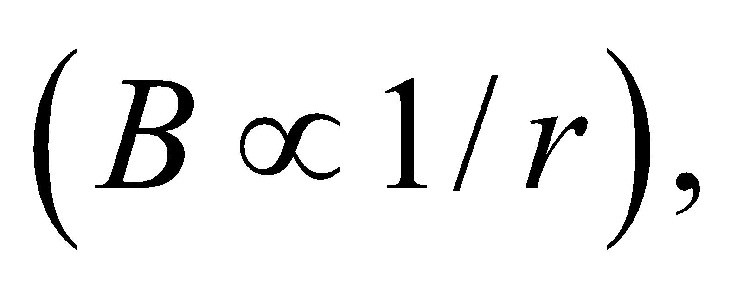so the closer a farmer can place the loop to the wire, the more power he will be able to siphon off.

**78. Interpret** We consider how electric power might be "stolen" using electromagnetic induction.

**Develop**The current in the power line is alternating at a given frequency: 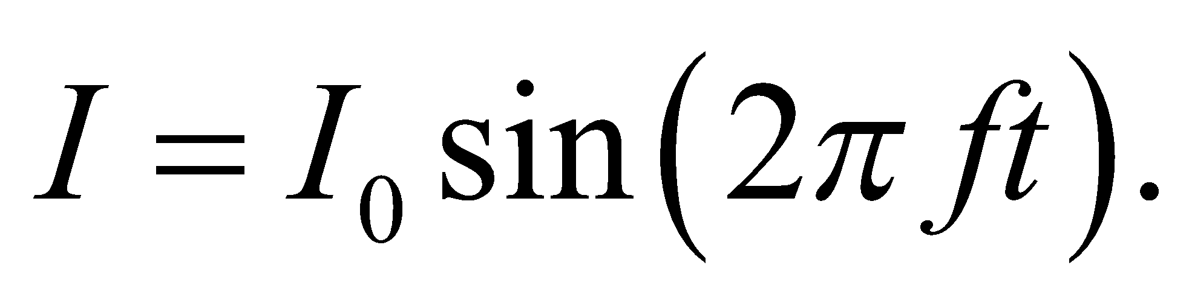 This causes the magnetic field to vary, which induces an emf in the loop. Using the geometry from the previous problem, we have

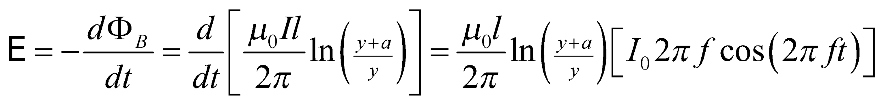

**Evaluate**Since 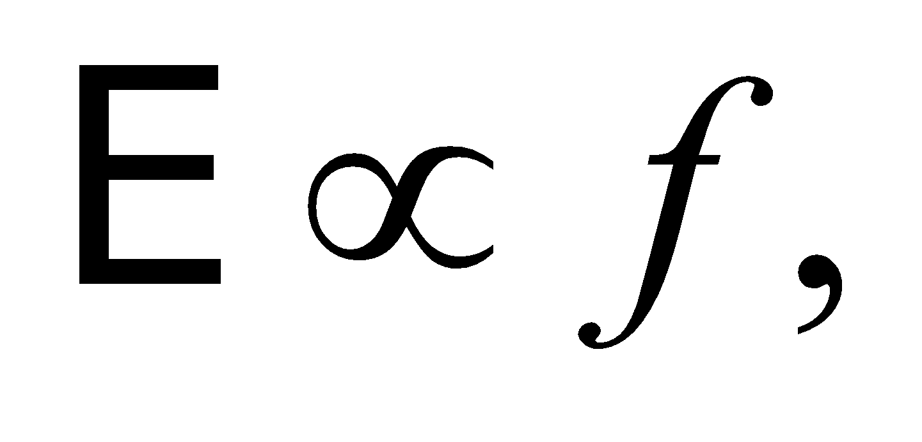the induced emf in Europe with 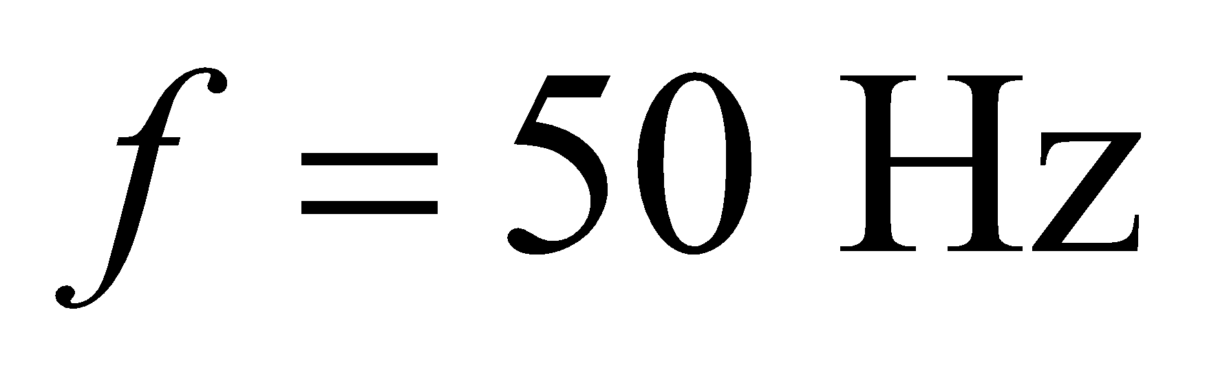 will be slightly less than in the U.S., where 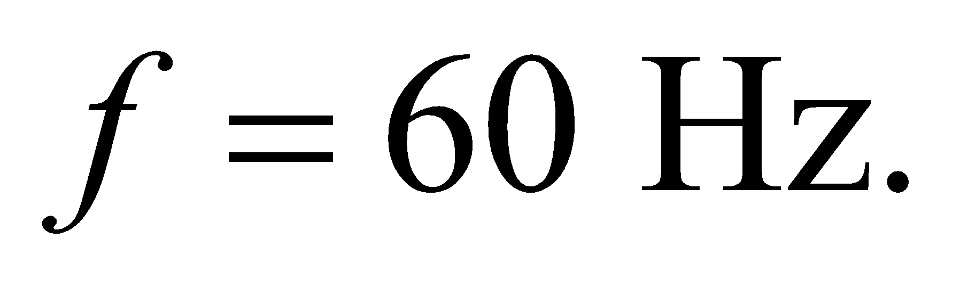

The answer is (b).

**Assess**The relationship 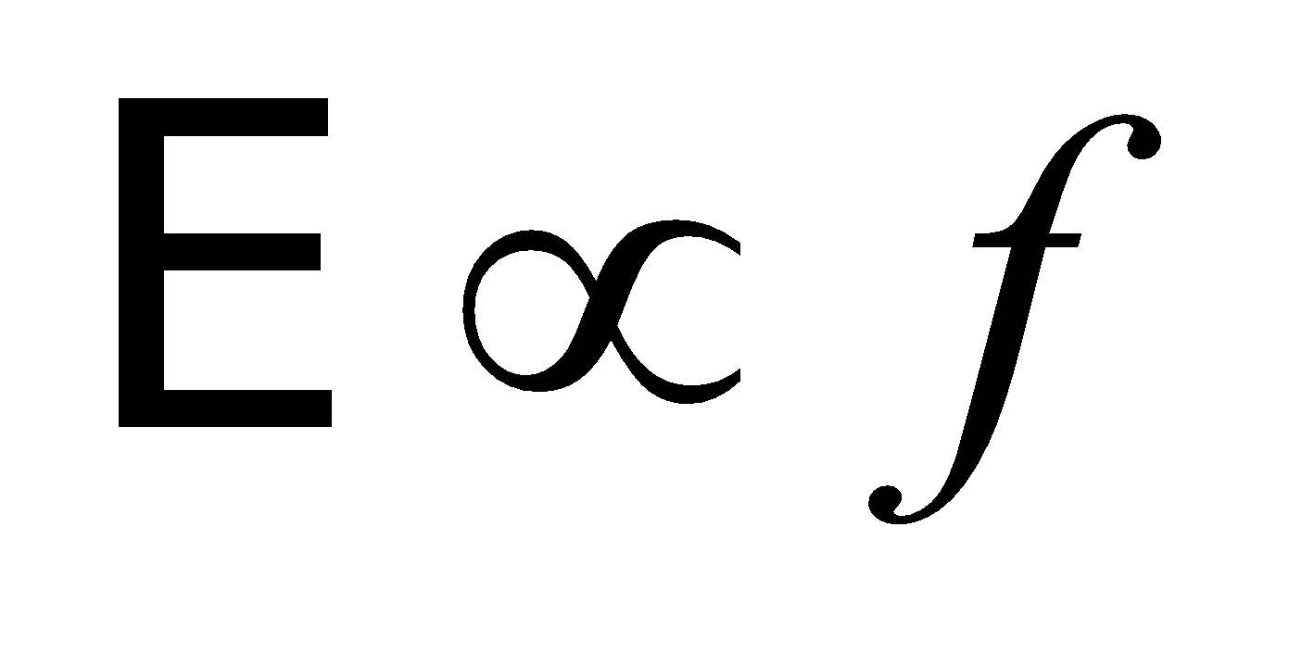makes sense. The higher the frequency in the current, the faster the magnetic field is changing and the greater the induced emf. Likewise, if the frequency goes to zero, the current and the magnetic field become static, and no emf is induced.

**79. Interpret** We consider how electric power might be "stolen" using electromagnetic induction.

**Develop**You might think that power lines are always generating time-varying magnetic fields and the induced emfs that go with them, so the power company won't notice if a farmer uses some of this energy that is just being "lost" anyway. But in fact this is wrong. The magnetic field energy around a wire is not radiated away but only temporarily stored and then later given back to the power lines. During each cycle of the AC current, the magnetic fields will decrease in strength, thus inducing an emf back into the power line that helps to drive current in the next part of the cycle.

**Evaluate**By the above logic, if the farmer's loop had no resistance, then current would slosh back and forth in the loop, but no energy would be expended. However, as soon as the farmer puts a load in the loop circuit (like a light bulb, for instance), some of the magnetic field energy is used to do work, and therefore less energy will cycle back from the field into the power line. As a result, more fuel must be consumed at the power plant supplying the line.

The answer is (a).

**Assess**Another way to think about this is that the loop and the wire have a mutual inductance, *L*. When there's no resistance, the voltage across this inductor is just: 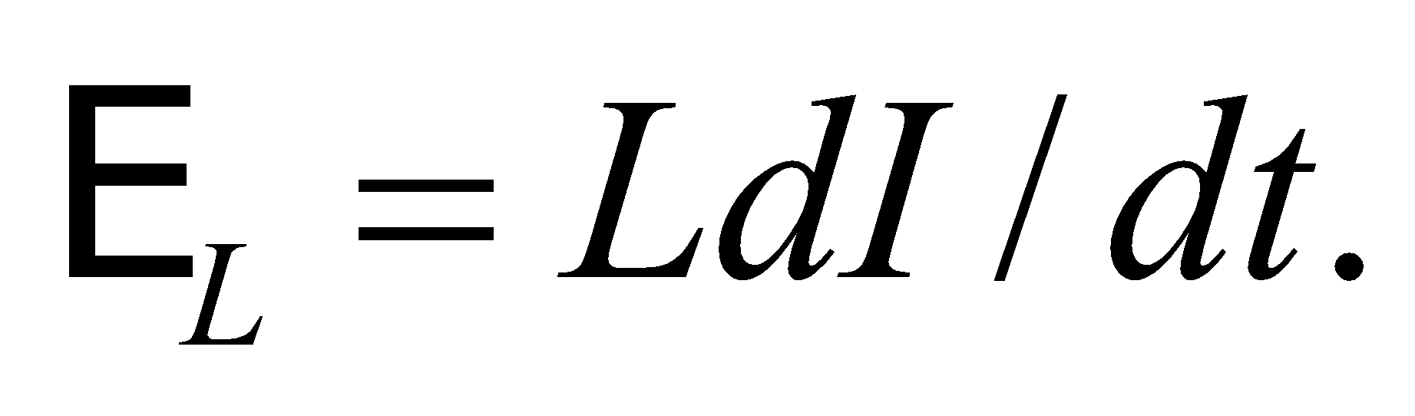 Since this voltage is 90° out of phase with the current, the total energy lost over a full cycle is zero:

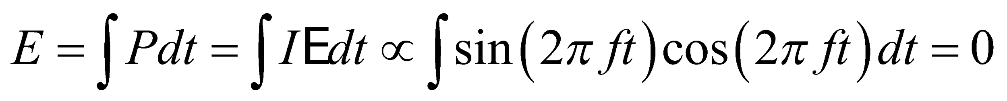

But as soon as a resistor is added to the loop, the voltage and current will no longer be out of phase, and the energy lost over a full cycle will be non-zero.